**Before to start**

* please remove the debug banner the top of the screen

**Page 1 : Term and condition**

* Make the content scrollable except the image , the image should always appear on the top of the screen
* You must make sure the user finish reading all the content and there is a checkbox “I have read all the term and condition” for them to agree the term and condition
* After the user confirm reading the term and condition, the button “Accept Term and Condtion” is enable

**Page 2 : Date Validation**

* The user able to choose the start date and end date
* The start date and end date that selected by the user should display to the user
* The system should validate the start date cannot later than the end date
* In case the date are in conflict, update the both date to the latest selected date and show a alert message to the user
* After completing the date, please try to duplicate the same design and functionality for the time (start time and end time)

**Page 3: Price Formating**

* Please complete the auto formatting the text field
* Please try to restrict user input to numeric only
* The behaviour of the format should same as you are entering the amount in the touch n go app
* The example format that is acceptable : RM 10.00, RM 0.01, RM 123.34
* The example format that is not acceptable : RM 100.0, RM 1, 123.34
* After u completing this feature, click “Validate Result” to check your answer
* The scenario that need to concern :

“++++”(when the user key in the symbol),

“0” or “1” (when user key in one digit only),

“del del del” (when user delete all the input),

“123456” (normal input, and the result is RM 1234.56)

**Page 4 : To Do List**

* Please apply the filter using the radio button
* Please try to retrieve the data from the lib/assets/item.json
* The colour of the to do list should change after the user update the status

**Page 5: Button Alignment**

* Please align the button as shown
* 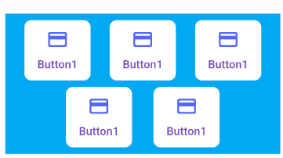
* Please put a new button at the right bottom (fixed position) in this page, when the user scroll down and up, the position of that button should not changed

**Home Page**

* When the user click the menu (in the blue container) from the drawer, the user should go back to the main page
* When the user click the button “Please provide your information”, a dialog should pop out and ask the user name and the age (numeric input only)
* When the user click submit in the dialog but at least one of the input field is left blank, the dialog will close and a snackbar will display at the bottom of the screen to show the error message
* When the user click the submit button and all the information is completed, then the information of the user will be display in the screen, the button “Please provide your information” will be hidden
* When the dialog is prompting to the user, the user could have a option “cancel”, the changes made by user will be discard and not changes was made.