Candy  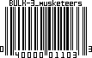 |  | Candy  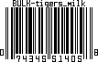 |  | Drinks  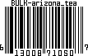 |  | Frozen Food  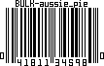 |  | Popcorn / Chips  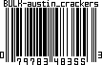 |  | Misc  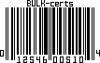
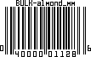 |  | 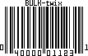 |  | 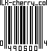 |  | 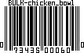 |  | 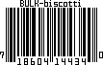 |  | 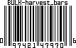
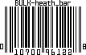 |  | 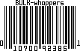 |  | 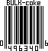 |  | 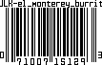 |  | 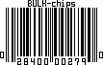 |  | 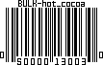
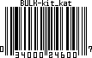 |  |  |  | 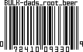 |  | 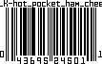 |  | 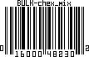 |  | 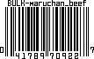
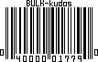 |  |  |  | 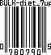 |  | 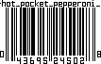 |  | 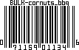 |  | 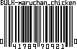
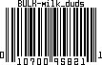 |  |  |  | 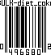 |  | 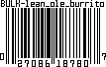 |  | 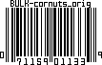 |  | 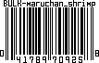
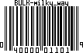 |  |  |  | 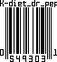 |  | 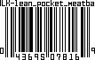 |  | 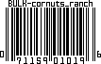 |  | 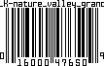
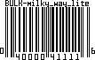 |  |  |  | 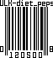 |  |  |  | 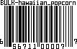 |  | 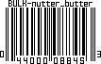
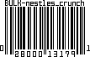 |  |  |  | 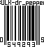 |  |  |  | 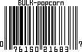 |  | 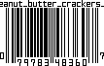
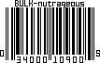 |  |  |  | 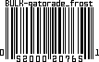 |  |  |  | 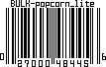 |  | 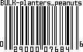
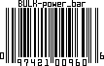 |  |  |  |  |  | 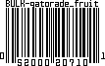 |  |  |  | 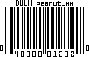
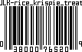 |  |  |  |  |  | 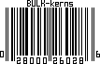 |  |  |  | 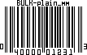
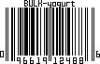 |  |  |  |  |  | 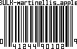 |  |  |  | 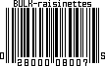
 |  |  |  |  |  | 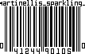 |  |  |  | 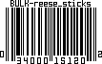
 |  |  |  |  |  | 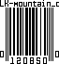 |  |  |  | 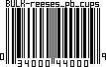
 |  |  |  |  |  | 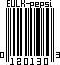 |  |  |  | 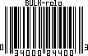
 |  |  |  |  |  | 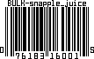 |  |  |  | 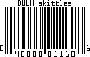
 |  |  |  |  |  | 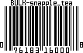 |  |  |  | 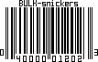
 |  |  |  |  |  | 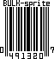 |  |  |  | 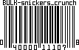
 |  |  |  |  |  | 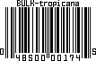 |  |  |  | 