For database design, analysis and modification I used the SQLite browser.

It’s free and can be downloaded here.

[https://sqlitebrowser.org](https://sqlitebrowser.org/)

The database is in the App_Data folder of the Web Application.

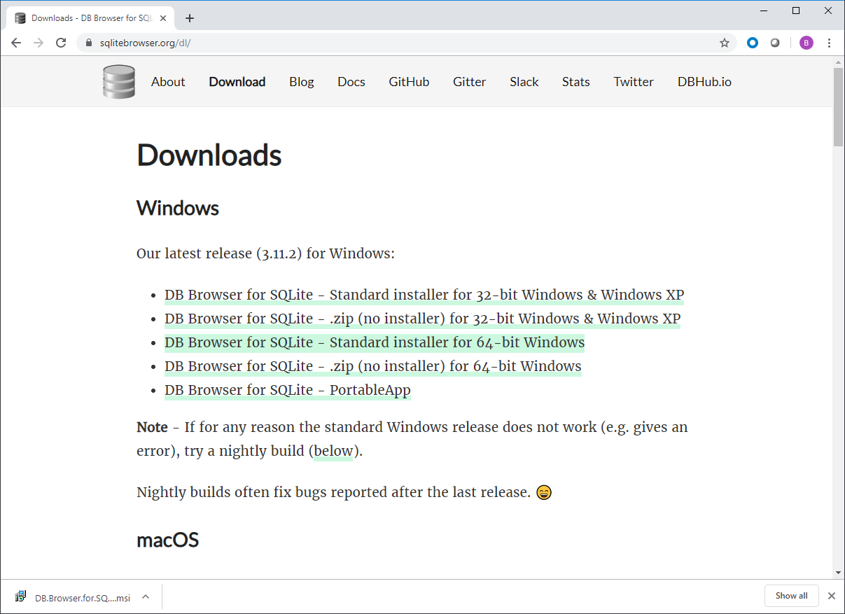

Install just the core package from the NuGet packages screen.

