**Lesson 10**

# **Demo 10: How to Push a Docker Image on Docker Hub**

## **Code_01: app.py**

***from flask import Flask***

***import os***

***import socketapp = Flask(__name__)@app.route(“/”)def hello():***

***html = “<h3>Hello {name}!</h3>” \***

***“<b>Hostname:</b> {hostname}<br/>”***

***return html.format(name=os.getenv(“NAME”, “world”), hostname=socket.gethostname()) if __name__ == “__main__”:***

***app.run(host=’0.0.0.0', port=80)***

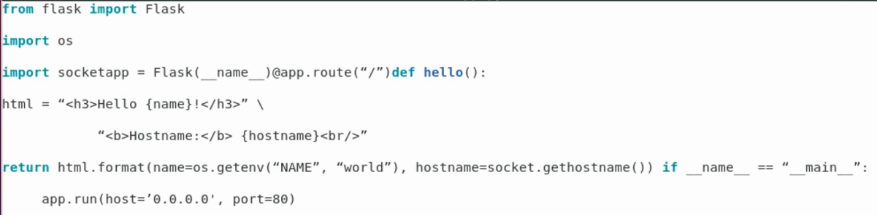

## **Code_02: Dockerfile**

***FROM python***

***WORKDIR /app***

***ADD . /app***

***RUN pip install -r requirements.txt***

***EXPOSE 80***

***ENV NAME world***

***CMD [“python”, “app.py”]***

