A Real-Time Research Project Report

on

**SMART GLASSES FOR BLIND**

(Submitted in partial fulfilment of the requirements for the award of Degree)

Bachelor of Technology

in

**COMPUTER SCIENCE & ENGINEERING (DATA SCIENCE)**

By

**KORRA KHOUSHIK (227R1A67F5)**

**SADURLA JAYANTH (2227R1A67H4)**

**MAMINDLA KARUNAKAR (237R5A6717)**

Under the guidance of

**Mr. A. Lakshman**

Assistant Professor

**Department of Computer Science & Engineering (Data Science)**

**CMR TECHNICAL CAMPUS**

**UGC AUTONOMOUS**

**Accredited by NBA & NAAC with 'A' Grade**

**Approved by AICTE, New Delhi and JNTU, Hyderabad.**

June, 2023

**DEPARTMENT OF COMPUTER SCIENCE & ENGINEERING (DATA SCIENCE)**

**CERTIFICATE**

This is to certify that the project entitled **“Smart glasses for blind”** being submitted by **KORRA KHOUSHIK (227R1A67F5), SADURLA JAYANTH (227R1A67H3), MAMINDLA KARUNAKAR (237R5A6717)** in partial fulfilment of the requirements for the award of the degree of B. Tech in Computer Science and Engineering (Data Science) to the Jawaharlal Nehru Technological University Hyderabad, is a record of bonafide work carried out by them under our guidance and supervision during the year 2023-24.

The results embodied in this thesis have not been submitted to any other University or Institute for the award of any degree or diploma.

**Guide Name : Mr . A. Lakshman**

**Designation : Assistant Professor Dr. K. Srinivas**

**Internal Guide** Professor & HoD

**Dr. A. Raji Reddy**

**Director**

**ABSTRACT**

Smart glasses for the visually impaired are an innovative technological solution designed to enhance the quality of life for individuals with blindness or severe visual impairments. These advanced devices employ a combination of sensors, to interpret the surrounding environment and convey information to the user through audio feedback or haptic signals. The primary objective of smart glasses is to provide a form of ‘artificial vision’ by recognizing and narrating objects, text, and people in the user’s vicinity. They can detect obstacles, read signs, and even assist in navigation by connecting to GPS systems. Some models are equipped with facial recognition technology, enabling users to identify known individuals in social settings. The design of these glasses often emphasizes comfort and ease of use, with intuitive controls that allow users to interact with the device effortlessly. The integration of bone conduction headphones is a common feature, which transmits sound through vibrations in the skull rather than traditional earphones, keeping the ears unobstructed for ambient sounds and enhancing situational awareness. Research and development in this field are ongoing, with advancements focusing on improving the accuracy of object detection, expanding the range of recognizable items, and refining the user interface for a more seamless experience. The potential impact of smart glasses on the blind community is profound, offering a level of independence and engagement that was previously unattainable.

**TABLE OF CONTENTS Page No**

|  |  |  |  |  |
| --- | --- | --- | --- | --- |
| Certificates | | |  | ii |
| Abstract | | |  | Ⅲ |
| Table of Contents | | |  | Ⅳ |
| List of Figures | | |  | Ⅵ |
| **1. introduction** | | | | **1** |
| 1.1 | | Introduction P1 | | 1 |
| 1.2 | | Objectives | | 2 |
| 1.3 | | Problem Statement | | 3 |
| 1.4 | | Scope of the Project | | 4 |
| 1.5 | | Significance of the Study | | 4 |
| 1.6 | | Methodology | | 5 |
| **2. LITERATURE SURVEY** | | | | **6** |
| 2.1 | C Survey | | | 6 |
| 2.2 | Historical Development of Smart Glasses | | | 7 |
| 2.3 | Advances in IoT Sensors and Connectivity | | | 8 |
| 2.4 | Challenges and Limitations of sensors | | | 8 |
| 2.5 | Literature review | | | 9 |
| **3. REQUIREMENT ANALYSIS** | | | | 10 |
| 3.1 | Hardware Requirements | | | 10 |
| 3.2 | Software Requirements | | | 16 |
| 3.3 | Functional Requirements | | | 17 |
| **4. IMPLEMENTATION** | | | | 18 |
| 4.1 | Implementation  4.11 Ultrasonic sensor  4.12 NE 555IC 21  4.13 Capacitors 23  4.14 Resistors 25 | | | 18 |
| 4.2 | Transmitter and receiver 27 | | |  |
| 4.3 | Signal transmitting 32 | | |  |
| 4.4 | Flow chart 35 | | |  |
| **5. TESTING AND RESULTS** | | | | 37 |
| 5.1 | Introduction to Testing | | | 37 |
| 5.3 | Test Cases | | | 38 |
| 5.4 | Results and Analysis | | | 39 |
| **6.** **CONCLUSION** | | | | 42 |
| 6.1 | Conclusion | | | 42 |
| 6.2 | Future Scope | | | 45 |
| **REFERENCE / BIBLIOGRAPHY** | | | | 44 |

**LIST OF FIGURES**

|  |  |  |
| --- | --- | --- |
| **FIGURE NO** | **DESCRIPTION** | **Page no** |
| Fig: 3.1 | Ultrasonic sensor | 10 |
| Fig: 3.2 | NE 555 IC | 11 |
| Fig: 3.3 | Capacitor | 12 |
| Fig: 3.4 | Resistor | 13 |
| Fig: 3.5 | connecting wires | 14 |
| Fig: 3.6 | Buzzer | 15 |
| Fig: 4.1 | Wave of ultrasonic sensor | 18 |
| Fig: 4.2 | NE 555 IC circuit | 21 |
| Fig: 4.3 | Capacitor working | 23 |
| Fig: 4.4 | Resistor working | 25 |
| Fig: 4.5 | ECHO WAVE | 28 |
| Fig: 4.6 | Signal passing | 29 |
| Fig: 4.7 | Length of ultrasonic | 30 |
| Fig 4.8 | Components of Ultrasonic sensor | 31 |
| Fig 4.9 | Signal transmitter chart | 32 |
| Fig 5.1 | Output | 41 |

**1. INTRODUCTION**

**1.1. Background**

The development of assistive technologies for individuals with visual impairments has seen significant advancements over the years. Blindness and severe visual impairment affect millions of people worldwide, posing daily challenges in navigation, object recognition, and interaction with the environment. Traditional assistive tools, such as canes and guide dogs, have been instrumental in providing mobility and independence. However, these solutions have limitations in terms of range, functionality, and accessibility.

In recent years, the advent of Internet of Things (IoT) technologies has opened new avenues for creating sophisticated assistive devices. IoT refers to the interconnection of everyday objects via the internet, allowing them to send and receive data. This technology has the potential to revolutionize assistive devices by integrating real-time data processing, cloud computing, and advanced sensor technologies.

The motivation behind developing smart glasses for the blind is rooted in the desire to enhance the quality of life and independence of visually impaired individuals. The primary goals are to:

1. **Improve Navigation and Mobility:** Traditional mobility aids like canes provide limited information about the surroundings. Smart glasses equipped with IoT sensors can detect obstacles, provide directional guidance, and offer a comprehensive understanding of the environment, thereby improving safety and mobility.
2. **Enhance Object Recognition:** Recognizing objects and identifying their locations is a significant challenge for the blind. By utilizing camera sensors and machine learning algorithms, smart glasses can provide real-time audio descriptions of nearby objects, enhancing situational awareness.
3. **Facilitate Social Interaction:** Social interactions can be challenging for visually impaired individuals due to the inability to recognize faces or read social cues. Smart glasses can assist by identifying people, reading facial expressions, and conveying this information through audio feedback, thereby promoting better social engagement.

**1.2 Objectives**

This project aims to develop smart glasses tailored for visually impaired individuals, with a primary focus on detecting objects in their surroundings. The objectives are centered around integrating effective hardware components, including cameras and ultrasonic sensors, strategically placed on the glasses to maximize coverage and accuracy in object detection. These sensors will be interfaced with a microcontroller to enable real-time data processing, essential for providing timely feedback to the user.

Software development will be critical, involving the creation of sophisticated algorithms capable of recognizing and classifying objects in real-time. The goal is to ensure that the smart glasses can swiftly identify obstacles, signage, and other relevant objects, enhancing the user’s awareness and safety.User feedback mechanisms will be implemented to convey detected object information to the user. This includes developing an intuitive audio feedback system that relays real-time information about the type, distance, and direction of detected objects. Optionally, haptic feedback mechanisms may be explored to provide tactile alerts for object proximity, further enhancing the user’s spatial awareness.Prototyping and rigorous testing phases will be conducted to validate the functionality and usability of the smart glasses. User testing sessions will gather valuable feedback from visually impaired individuals to refine and improve the system’s performance, ensuring it meets their needs effectively. Finally, accessibility remains a core objective, aiming to keep the solution affordable, provide comprehensive user training, and lay the groundwork for future enhancements and technological advancements in assistive technologies.

**1.3 Problem Statement:**

Visually impaired individuals face significant challenges in navigating their surroundings independently and safely due to limited awareness of objects in their path. Traditional aids such as canes provide basic tactile feedback but lack real-time information about obstacles, signage, and other objects. Existing assistive technologies, while beneficial, often do not integrate seamlessly or provide comprehensive object detection capabilities.

There is a clear need for a wearable solution that enhances the perceptual abilities of the visually impaired by providing instant and accurate feedback about their environment. The current technology landscape lacks a compact, affordable, and efficient system that can reliably detect and classify objects in real-time, thereby empowering individuals with visual impairments to navigate with confidence and autonomy.

The objective of this project is to develop smart glasses equipped with advanced sensors and intelligent algorithms that can detect and identify objects in the user’s surroundings. By addressing these challenges, the project seeks to improve the quality of life for visually impaired individuals by providing them with enhanced spatial awareness and navigation capabilities through innovative assistive technology.

**1.4 Scope of the Project:**

This project focuses on designing and developing smart glasses for visually impaired individuals. The scope includes integrating sensors (cameras, ultrasonic sensors) and a microcontroller for real-time object detection and navigation assistance.

It encompasses software development for efficient data processing, user-friendly interfaces with audio feedback, and optional haptic feedback. Testing will ensure functionality across various environments, with documentation and training materials provided for user adoption. Ethical considerations, compliance with regulations, and scalability for future enhancements are also addressed.

**1.5 Significance of the Study**

The significance of studying object detection sensors, particularly in the context of smart glasses for visually impaired individuals, is multifaceted and impactful:

1. **Enhanced Independence and Safety:** Object detection sensors empower visually impaired individuals by providing real-time information about their surroundings. This capability enhances their ability to navigate independently and safely, reducing the risk of collisions with obstacles and hazards.
2. **Improved Quality of Life:** By augmenting sensory perception through technology, object detection sensors contribute significantly to improving the quality of life for visually impaired users. It enables them to engage more confidently in daily activities such as commuting, shopping, and navigating public spaces.
3. **Accessibility and Inclusivity:** Smart glasses equipped with object detection sensors promote accessibility by bridging the gap between visually impaired individuals and the visual world. This technology enables users to interact more effectively with their environment, fostering greater inclusivity in society.

**1.6 Methodology:**

The methodology employed in this study involves rigorous experimentation and analysis of object detection sensors.

* It outlines the criteria for selecting sensors, the design of experiments to assess their performance, and the procedures for data collection and analysis.
* The integration of sensors with smart glasses is detailed, emphasizing the architecture and software algorithms developed to enable real-time object detection capabilities.

Object detection is a computer vision technique that can detect multiple objects in an image or video. The methodology for object detection can vary depending on the type of object being detected, such as moving objects or objects in images:

* Image object detection

Involves looking at a picture, finding clues like shapes, colors, and patterns, and making guesses about what might be in the picture. The computer then checks each guess by comparing it to things it already knows, and draws a box around anything it's sure of. Finally, it double-checks its guesses to make sure it got things right.

* Moving object detection

Traditional methods include background subtraction, frame differencing, temporal differencing, and optical flow.

**2. LITERATURE SURVEY**

**2.1 Survey:**

Various aids have been designed to develop a system that provide visual assistance and which help the persons facing vision problems in their daily routine life by communicating about the obstacles present in front of them. The following literature review presents the outcome and the limitations of some of the existing assistive solutions for blind and visually impaired.

One of the primary goals of these assistive solutions is to ensure that visually impaired individuals can move about independently and safely. By leveraging different types of sensors, these systems can detect and identify obstacles that could pose risks.

* For instance, ultrasonic sensors are commonly used for their reliability in detecting nearby objects and providing accurate distance measurements.
* Cameras, on the other hand, offer detailed visual information and are capable of identifying a broader range of obstacles. However, they can be significantly affected by lighting conditions, which may limit their effectiveness in certain environments.  
  The integration of these sensors into wearable devices, such as smart glasses, is another pivotal aspect of assistive technology.

These devices are designed to be comfortable and unobtrusive, allowing users to go about their daily routines without significant interference. Strategic placement of sensors is crucial to maximizing their field of view and ensuring comprehensive environmental scanning.

* The design must also consider factors like battery life, weight, and overall usability to make the devices practical for everyday use.

This literature review aims to critically evaluate the outcomes and limitations of various assistive solutions currently available. By understanding the strengths and weaknesses of these technologies, we can identify areas for improvement and guide future research towards developing more effective, reliable, and user-friendly assistive devices for the visually impaired. The goal is to enhance their independence, safety, and overall quality of life through innovative technological solutions.

**2.2 Historical Development of Smart Glasses**

The development of object detection sensors for aiding visually impaired individuals has evolved significantly over the past few decades. This progression has been driven by advancements in technology, a deeper understanding of the needs of the visually impaired, and a commitment to improving accessibility and independence for this population.

Early Innovations and Basic Sensors

In the early stages, assistive devices for the blind primarily relied on simple tactile and auditory cues. The white cane, a fundamental tool, was one of the earliest forms of assistive technology. It helped users detect obstacles by physically touching them. However, it was limited in range and could only detect obstacles that were directly in the user’s path.

The introduction of the ultrasonic sensor marked a significant leap in assistive technology. Ultrasonic sensors work by emitting sound waves and measuring the time it takes for the echo to return after bouncing off an object. This technology was first adapted for use in mobility aids in the late 1960s and early 1970s. The Sonic Pathfinder, developed in the early 1980s, was one of the first electronic travel aids (ETAs) to use ultrasonic sensors. It provided

**2.3 Advances in IoT Sensors and Connectivity:**

Advances in IoT sensors and connectivity have revolutionized various industries, including healthcare, agriculture, smart cities, and particularly assistive technologies for the visually impaired. IoT sensors have become increasingly sophisticated, offering enhanced accuracy, miniaturization, and energy efficiency. Modern sensors can detect a wide array of environmental factors such as temperature, humidity, light, motion, and even specific objects, providing comprehensive data that can be processed and analyzed in real-time. Coupled with advances in wireless connectivity technologies like 5G, Wi-Fi 6, and low-power wide-area networks (LPWAN), IoT devices can now communicate more reliably and at higher speeds, facilitating the seamless integration of multiple devices and systems.

**2.4 Challenges and Limitations of sensors**

Despite significant advancements, several challenges and limitations persist in the development and application of sensors for assistive devices, particularly for the visually impaired. Ensuring consistent accuracy and reliability in diverse and dynamic environments remains a major hurdle. Sensors such as cameras can struggle with varying lighting conditions, and ultrasonic sensors may not detect small or distant objects accurately. Processing speed and latency also pose challenges, as real-time object detection and feedback are critical for user safety. High-performance algorithms require substantial computational resources, which can introduce delays and make it difficult for portable, battery-powered devices to function efficiently.**Accuracy and Reliability:** One of the primary challenges with current sensor technology is ensuring consistent accuracy and reliability in diverse and dynamic environments

**2.5 Literature review**

Various aids have been designed to develop systems that provide visual assistance to individuals facing vision problems, significantly improving their ability to navigate daily life. These systems aim to bridge the gap between visual impairment and environmental awareness by effectively communicating information about obstacles and other pertinent features in the user’s surroundings. Ultrasonic sensors are commonly used due to their reliability in detecting nearby objects and providing accurate distance measurements.

Cameras, on the other hand, offer detailed visual information and can identify a broader range of obstacles, though they can be significantly affected by lighting conditions, limiting their effectiveness in certain environments. The integration of these sensors into wearable devices, such as smart glasses, is another pivotal aspect of assistive technology. These devices are designed to be comfortable and unobtrusive, allowing users to go about their daily routines without significant interference. Strategic placement of sensors is crucial to maximizing their field of view and ensuring comprehensive environmental scanning.

**3. REQUIREMENT ANALYSIS**

**3.1 Hardware Requirements:**

**1. Ultrasonic sensor (HC – SR04):**

Ultrasonic sensors are devices that utilize sound waves to measure the distance to an object. These sensors are particularly valuable in various applications, including assistive technologies for the visually impaired, where they help in detecting obstacles and providing navigational aid. Here is a detailed description of how ultrasonic sensors work and their key features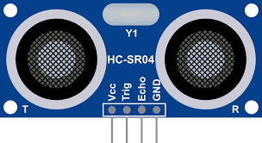

Fig 3.1 Ultrasonic sensor

* **Transmitter (Transducer)**:
  + Generates ultrasonic waves.
  + Converts electrical signals into sound waves.
* **Receiver**:
* Detects the reflected sound waves (echoes).
* Converts sound waves back into electrical signals.
* **Control Circuit**:
  + Manages the timing and processing of signals.
  + Calculates the distance based on the time delay between transmission and reception.

**3.2 NE 555 IC:**

The NE555 is a highly popular integrated circuit (IC) used in various timer, delay, pulse generation, and oscillator applications. It was first introduced by Signe tics (now owned by ON Semiconductor) in 1972 and has since become a staple in electronics projects and designs. Its versatility, reliability, and ease of use make it a preferred choice for both hobbyists and professionals.

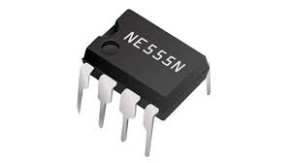

Fig 3.2 NE 555 IC

The NE555 IC Is an 8-pin dual in-line package (DIP), and the pinout is as follows:

1. **Ground (GND)**: This pin is connected to the ground of the circuit.
2. **Trigger (TRIG)**: When the voltage drops below 1/3 of the supply voltage, it causes the output to go high (start timing).
3. **Output (OUT)**: This pin provides the output signal.
4. **Reset (RESET)**: A low signal on this pin resets the timer, overriding the control voltage.
5. **Control Voltage (CONT)**: This pin can be used to adjust the threshold and trigger levels.
6. **Threshold (THRESH)**: When the voltage on this pin exceeds 2/3 of the supply voltage, it causes the output to go low (stop timing).
   1. **Capacitor:**

Capacitors are essential electronic components that store and release electrical energy through an electric field formed between two conductive plates separated by a dielectric. They are characterized by their capacitance, voltage rating, and equivalent series resistance (ESR), with common types including ceramic, electrolytic, film, tantalum, and super capacitors.

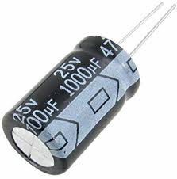

Fig 3.3 capacitor

Ceramic capacitors are valued for their small size and cost-effectiveness, electrolytic capacitors for high capacitance and power supply filtering, and supercapacitors for significant energy storage.

**3.4 Resistors**

Resistors are essential passive components that regulate the flow of electrical current in circuits, working according to Ohm’s Law (V = IR).

* They come in various types, including fixed resistors like carbon composition, metal film, and wire-wound resistors, as well as variable resistors like potentiometers and
* 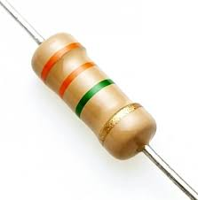rheostats. Each type has specific characteristics suited to different applications.

Fig 3.4 Resistor

* Key parameters include resistance (measured in ohms), power rating, tolerance, and temperature coefficient. Resistors are used for current limiting, voltage division, biasing active components, and ensuring stable logic levels in digital circuits.
  1. **Connecting wires**

1. Single strand connecting wires, also known as solid core wires, consist of a single, solid conductor encased in an insulating material. These wires are commonly used in various electronic and electrical applications due to their distinct advantages and specific characteristics.
2. **Conductor**:
   * Made of materials like copper or aluminum, which provide good electrical conductivity.
3. **Insulation**:
   * Typically made from materials such as PVC, Teflon, or silicone, providing 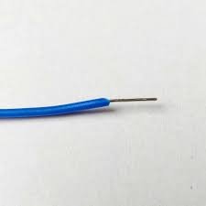electrical insulation and protection against physical damage.

Fig 3.5 connecting wires

1. **Gauge**:

* The thickness of the wire is measured in gauge (AWG – American Wire Gauge), with lower numbers indicating thicker wires. Common gauges for single strand wires range.

1. **Stability**:
   * Solid core wires maintain their shape once bent, making them ideal for breadboarding and stable, fixed installations.
2. **Ease of Use**:
   * The rigidity of single strand wires makes them easy to insert into and remove from connectors, terminal blocks, and breadboards.
3. **Reliable Connections**:
   * Provide stable and reliable electrical connections, which are less prone to loosening over time compared to stranded wires.
4. **Simplicity**:
   * Easier to strip and prepare for connections since there is only a single conductor to work with.
5. **Breadboarding**:

* Widely used in prototyping and testing circuits on breadboards due to their stiffness, which allows them to stay firmly in place.

**BUZZER**

A buzzer is an audio signalling device that produces sound when an electrical signal is applied to it. In the context of a smart glasses project for the blind, the buzzer serves a critical role by providing auditory feedback to the user, alerting them to the presence of obstacles detected by the ultrasonic sensor.

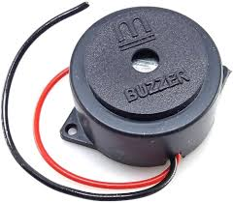

Fig 3.6 Buzzer

This component is typically small and compact, making it suitable for integration into wearable devices. The buzzer operates on a simple principle: when a voltage is applied, it causes a diaphragm or piezoelectric element within the buzzer to vibrate, producing sound. This sound can be continuous or intermittent, depending on the circuit design and the nature of the electrical signal applied.

* The buzzer is connected to the output of the NE555 timer IC, which triggers it based on the sensor’s.

**3.2 Software requirements**

For this project, no specific software requirements are necessary. We’ve designed it to be versatile and accessible without reliance on particular software installations. This approach ensures seamless integration and flexibility, allowing us to focus on functionality and user experience without additional constraints.

As we are exclusively utilizing sensors and capacitors for this project, there are no software requirements needed. Our focus remains solely on the hardware components—ensuring they are integrated and calibrated effectively to achieve the project’s objectives. This approach simplifies implementation and maintenance, emphasizing robust hardware functionality over software dependencies.

This design choice streamlines development and ensures a straightforward implementation process. By prioritizing the integration and calibration of hardware components, we aim to achieve optimal performance and reliability without the complexities associated wit

**3.3 Functional requirements**

Functional requirements for an object detection sensor system designed for assisting the blind typically include:

1. **Detection Range**: The sensor should detect obstacles and objects within a specified range, adjustable to different environments and user preferences.
2. **Accuracy and Precision**: It must provide accurate distance measurements to objects, ensuring reliable detection to avoid collisions.
3. **Real-time Feedback**: The sensor should provide real-time feedback to the user, either through auditory, tactile, or verbal cues, indicating the presence and proximity of objects.
4. **Obstacle Differentiation**: It should distinguish between different types of obstacles (e.g., walls, furniture, people) to convey relevant information to the user.
5. **Adaptability to Environmental Conditions**: The sensor should operate effectively in various lighting conditions (day and night), different weather conditions, and diverse indoor/outdoor environments.
6. **Battery Life**: It should have a sufficient battery life to support extended use throughout the day without frequent recharging.
7. **Portability and Ergonomics**: The device should be lightweight, compact, and easy to carry or integrate into existing mobility aids (such as canes or glasses).
8. **User Interface**: The interface should be intuitive and user-friendly, allowing for easy customization of settings and feedback preferences.
9. **Reliability and Durability**: The sensor system should be robust and durable, capable of withstanding daily use and occasional impacts.
10. **Compliance with Accessibility Standards**: Ensure that the sensor system meets relevant accessibility standards and guidelines to ensure usability by individuals with visual impairments.

**4. IMPLEMENTATION**

**4.1 Implémentation:**

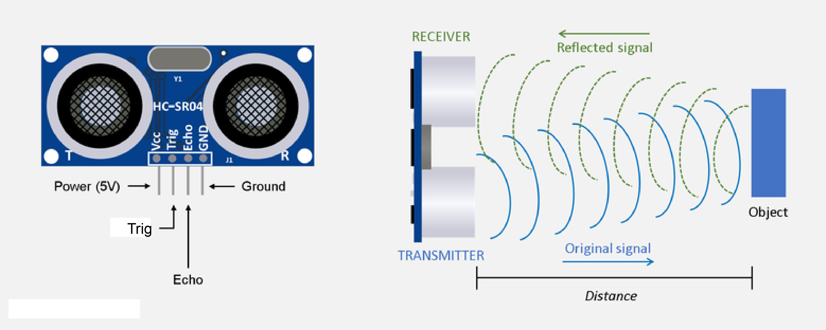**4.1.1 Ultrasonic sensor:**

Fig 4.1 Wave of ultrasonic sensor

An ultrasonic sensor works on the principle of sending and receiving sound waves. Here’s a basic explanation of how it operates in object detection:

1. **Sound Wave Generation**: The ultrasonic sensor emits a high-frequency sound wave (typically in the range of 40 kHz) from its transmitter.
2. **Wave Propagation**: This sound wave travels through the air until it encounters an object in its path.
3. **Object Interaction**: When the sound wave strikes an object, it reflects back towards the sensor.
4. **Reception**: The sensor’s receiver detects the reflected sound wave.
5. **Calculating Distance**: By measuring the time it takes for the sound wave to travel to the object and back (round-trip time) and using the speed of sound in air (which is approximately 343 meters per second at room temperature), the sensor calculates the distance to the object.

### Key Points:

* **Non-Contact Sensing**: Ultrasonic sensors are non-contact sensors, meaning they do not physically touch the object they are sensing.
* **Distance Measurement**: They are commonly used for measuring distances between the sensor and the object, typically in a range from a few centimeters to several meters, depending on the sensor’s design.
* **Environment Considerations**: The accuracy and performance of ultrasonic sensors can be affected by factors such as the shape, size, and material of the object being detected, as well as environmental conditions like temperature and humidity.
* **Applications**: These sensors are widely used in various applications such as industrial automation (for object detection and distance measurement), automotive parking assistance systems, robotics, and even in some consumer electronics for touch less interfaces.

Ultrasonic sensors operate by leveraging the principles of sound wave propagation. These sensors typically consist of a transmitter and a receiver. The transmitter emits a high-frequency sound wave, usually around 40 kHz, into the environment. This sound wave travels through the air at the speed of sound, approximately 343 meters per second at room temperature, until it encounters an object in its path.

When the emitted sound wave strikes an object, it gets reflected back towards the sensor. The receiver in the ultrasonic sensor then detects this reflected wave. By precisely measuring the time interval between the emission of the sound wave and the reception of its reflection, the sensor calculates the distance to the object. This calculation is based on the formula distance = (time * speed of sound) / 2, considering the round-trip travel of the sound wave.

Ultrasonic sensors are highly effective for non-contact object detection and distance measurement. They are capable of detecting objects ranging from a few centimeters to several meters away, depending on the specific sensor model and environmental conditions. Factors such as the size, shape, and material of the object can influence the accuracy of distance measurements. Similarly, environmental variables like temperature and humidity can affect the speed of sound and thus the sensor's performance.

Due to their reliable performance and versatility, ultrasonic sensors find applications across various industries. In industrial automation, they are used for detecting objects on conveyor belts, measuring fill levels in tanks, and guiding robots. Automotive applications include parking assistance systems, where these sensors help drivers avoid collisions by detecting nearby obstacles. In consumer electronics, ultrasonic sensors are employed for touchless interfaces, enhancing user interaction with devices such as smartphones and home appliances.

In conclusion, ultrasonic sensors provide robust object detection capabilities by utilizing sound waves to measure distances accurately and efficiently. Their ability to operate in diverse environments and their reliability make them indispensable in numerous technological applications where non-contact sensing and precise distance measurement are essential.

* 1. **NE 555 integrated circuit:**

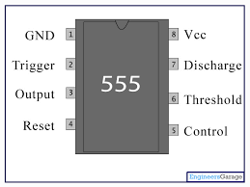

Fig 4.2 NE 555 IC circuit

The NE 555 IC (Integrated Circuit), commonly known as a timer IC, can be used in object detection sensors in various ways, typically in conjunction with other components to form a complete detection circuit. Here’s an explanation of how the NE 555 IC might work in such a sensor:

### 1. Pulse Generation:

One common use of the NE 555 IC in object detection is to generate periodic pulses. By configuring the NE 555 IC in astable mode, it can produce a continuous square wave output. This square wave signal can serve as a timing reference or trigger signal for the detection circuitry.

### 2. Timing Control:

In object detection applications, the timing of pulses generated by the NE 555 IC can be crucial. The frequency and duty cycle of the output pulses can be adjusted by external resistors and capacitors connected to the NE 555 IC. These parameters determine how often the detection circuit checks for the presence of an object and how long it waits for a response.

### 3. Signal Processing:

The pulses from the NE 555 IC can be further processed by other components such as amplifiers, filters, and comparators. For instance, the pulses might be sent to a comparator circuit that compares the received signal (possibly reflected from an object) against a reference voltage. This comparison helps determine if an object is present within the detection range.

### 4. Echo Detection (Ultrasonic Sensors):

In the context of ultrasonic object detection sensors, the NE 555 IC can be used to control the timing of ultrasonic pulse transmission. It can trigger an ultrasonic transmitter to emit a burst of sound waves (ultrasonic pulses) and then time the interval until the receiver detects the reflected pulses from an object. This timing information is crucial for calculating the distance to the object.

### 5. Interface with Transducers:

The NE 555 IC can interface with transducers (like ultrasonic transducers) through appropriate driver circuits. For example, it can drive the transmitter side of an ultrasonic sensor to emit pulses and then synchronize with the receiver to detect the echoes

* 1. **Capacitor:**

### Basic Concept

Capacitive proximity sensors detect objects by measuring changes in capacitance caused by the presence of the object. Capacitance is the ability of a system to store an electric charge and is influenced by the area of the plates, the distance between them, and the dielectric constant of the material between the plates. When an object comes near the sensor, it alters the dielectric constant, thereby changing the capacitance.

### Sensor Construction

The sensor consists of two conductive electrodes: the sensor electrode and the reference electrode. An oscillator circuit generates an AC signal that is applied to the sensor electrode, creating an electric field around it. The detection circuit then measures changes in the capacitance between the sensor electrode and the reference electrode. This setup is crucial for detecting the presence of an object based on its effect on the electric field.



Fig 4.3 Capacitor working

### Detection Mechanism

When an object enters the electric field of the sensor, the dielectric constant between the electrode’s changes. This change in the dielectric constant alters the capacitance value. The detection circuit senses this change in capacitance and processes this information to determine the presence or absence of the object. The sensor’s ability to detect small changes in capacitance makes it highly sensitive and accurate.

### Signal Processing

The sensor’s detection circuit converts the change in capacitance into an electrical signal. This signal is then processed, which can trigger various outputs, such as turning on a light, activating an alarm, or sending data to a control system. The processed signal ensures that the presence of the object is accurately detected and appropriately responded to by the system.

### Advantages of Capacitive Sensors

Capacitive sensors offer several advantages. They can detect objects without physical contact, making them suitable for fragile or delicate objects. These sensors are versatile, capable of detecting a wide range of materials, including metals, plastics, and liquids. Their high sensitivity to small changes in capacitance allows for precise detection, making them reliable in various applications.

### Applications

Capacitive sensors are used in numerous applications. In industrial automation, they detect the presence or absence of parts on a production line. In consumer electronics, such as touchscreens on smartphones and tablets, they detect touch points by measuring changes in capacitance caused by a human finger. They are also used for level sensing to measure the level of liquids or granular materials in containers.

### Example: Touchscreen Technology

In touchscreens, capacitive sensors detect the position of a touch. The human finger acts as a conductive object that changes the capacitance at the touchpoint. The touchscreen controller processes these changes in capacitance to determine the location of the touch accurately. This technology allows for precise and responsive touch input, enhancing the user experience.

* 1. 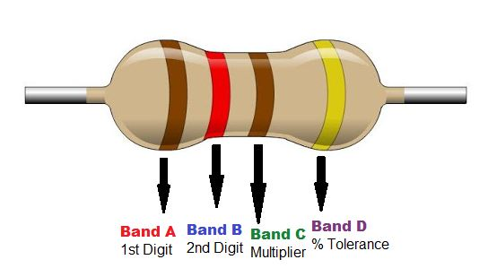**Resistors:**

4.4 Resistor working

Resistors play a crucial role in the operation of object detection sensors, especially in devices designed to aid the visually impaired. These sensors often employ technologies like infrared (IR), ultrasonic, and capacitive sensing. Resistors help control the current and voltage within the sensor's circuits, ensuring stable and accurate performance.

In the construction of these sensors, resistors are used in both the signal emission and reception stages. For ultrasonic sensors, resistors limit the current to the piezoelectric transducer, ensuring it operates safely. In IR sensors, a resistor in series with the IR LED controls the current to prevent burnout and ensure consistent light output. On the reception side, resistors set the correct biasing conditions for the receiver, which is crucial for amplifying weak signals.

Resistors also play a vital role in the detection mechanism by regulating current and voltage levels, maintaining signal integrity, and contributing to the RC (resistor-capacitor) circuits in capacitive sensors, which help stabilize oscillation frequencies. In the signal conditioning phase, resistors filter and amplify the received signal, removing noise and ensuring it is suitable for further processing. Pull-up or pull-down resistors ensure that digital inputs to microcontrollers are at known voltage levels.

During signal processing, resistors are used in voltage divider circuits to scale analog signals for analog-to-digital converters (ADCs), ensuring accurate digital representation of the distance to or presence of an object. They also protect microcontroller I/O pins by limiting current and ensuring proper synchronization with the clock.

The advantages of resistors in these sensors include enhanced stability and reliability of the sensor’s operation, maintained signal integrity for accurate detection, and protection of sensitive electronic components from voltage spikes and excessive current. These benefits are critical in assistive devices for the visually impaired, such as wearable or handheld gadgets that detect obstacles and provide feedback through vibrations or sounds.

In ultrasonic sensors used in blind assist devices, the transmitter emits sound waves that bounce back from objects. Resistors ensure the transmitter and receiver operate correctly, and the processed signal alerts the user if an obstacle is detected. Thus, resistors are integral to the accuracy, reliability, and longevity of object detection sensors, significantly enhancing the safety and independence of visually impaired individuals.

**4.2 TRANSMITTER AND RECEIVER**

Ultrasonic sensors, commonly used in assistive devices for the visually impaired, operate based on the emission and detection of ultrasonic waves. The sensor comprises a transmitter and a receiver, both playing crucial roles in detecting objects and providing feedback to the user. The transmitter's primary function is to emit ultrasonic pulses. The process begins with the control circuit generating an ultrasonic pulse, which is then emitted by the transmitter into the environment. This pulse travels through the air until it encounters an object. The transmitter's role is critical as it determines the initial conditions for the sensing process, ensuring that the emitted pulse is strong and well-defined to travel the required distance and reflect back from objects.

### Object Detection

Once the ultrasonic pulse is emitted, it propagates through the air. If there is an object in its path, the pulse will hit the object and reflect back towards the sensor. The detection phase relies on the time it takes for the pulse to return to the sensor. This time interval is directly related to the distance of the object from the sensor. If the pulse does not encounter any object, it dissipates, and the cycle restarts.

### Receiver Function

The receiver's job is to capture the reflected ultrasonic pulse. It waits for the echo (the reflected pulse) after the transmitter emits the initial pulse. The receiver is sensitive to the specific frequency of the emitted pulse, which helps in accurately capturing the reflected signal. Once the echo is received, the receiver converts this physical signal into an electrical signal, which is then sent to the processing unit.

After the receiver captures the echo, the system measures the time taken for the pulse to travel to the object and back. This time measurement is crucial for calculating the distance to the object, using the speed of sound as a reference. The processing unit then calculates the distance by multiplying the travel time by the speed of sound and dividing by two (to account for the round trip).

If the calculated distance indicates that an object is within a predefined threshold range, the system triggers an output to alert the user. This output can be in the form of vibrations or auditory signals, providing immediate feedback to the visually impaired user about the presence and proximity of obstacles. This feedback mechanism is essential for helping users 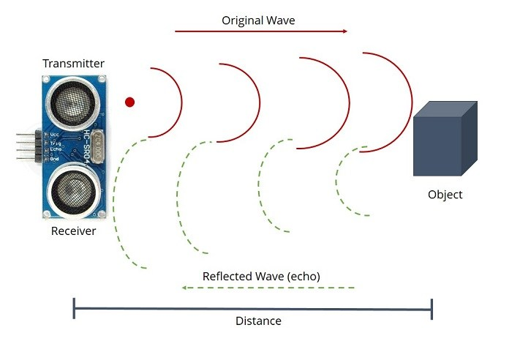navigate their environment safely.

Fig 4.5 ECHO WAVE

Moving from theory to reality, an ultrasonic sensor requires two parts, both a transmitter and a receiver. In the most standard configuration, these are placed side-by-side as close together as reasonably possible. With the receiver close to the transmitter, sound travels in a straighter line from the transmitter to the detected object and back to the receiver, yielding smaller errors in the measurements. There are also ultra sonic transvers where the transmitter and receiver functions are integrated into a single unit, minimizing error as much as physically possible while also significantly reducing the PCB footprint.

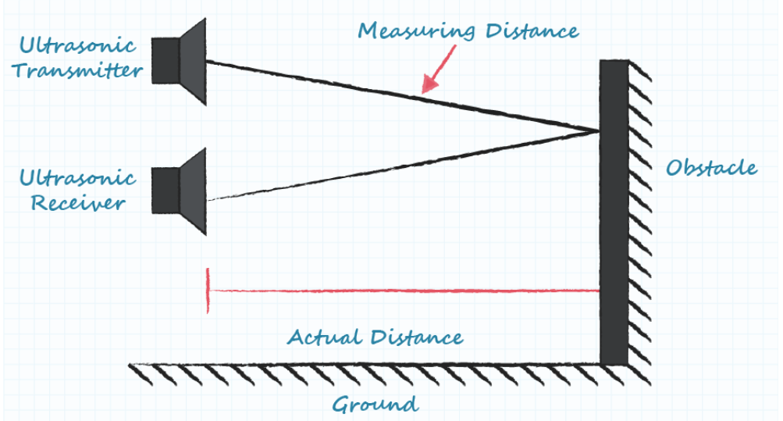

Fig 4.6 Signal passing

The acoustic waves that leave the transmitter are more similar in shape to light leaving a flashlight than a laser, so spread and beam angle must be considered. As the sound waves travel farther from the transmitter, the area of detection grows laterally and vertically. This changing area is why ultrasonic sensors give their coverage specification in either beam width or beam angle instead of a standard detection area. When comparing this beam angle between manufacturers, it is recommended to verify that the beam angle is either the full angle of the beam or the angle of variation from the straight line from a transducer.

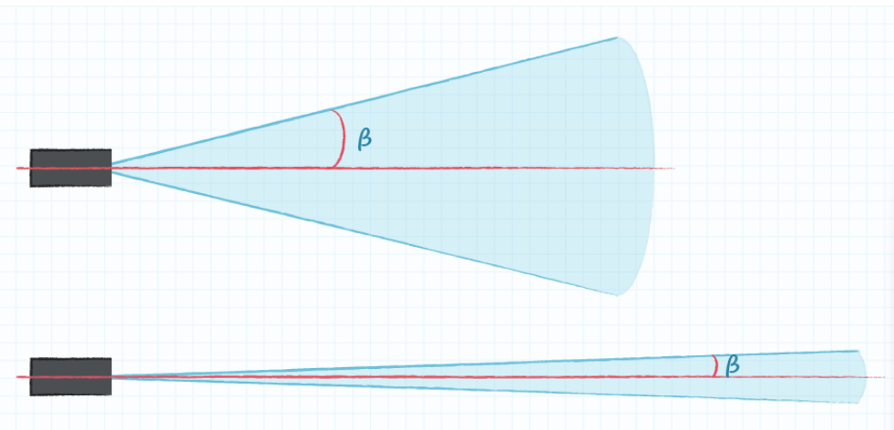

Fig 4.7 Length of ultrasonic

A secondary effect of the beam angle is the range of the device. In general, a narrow beam yields a greater detection range as the energy of the ultrasonic pulse is more focused and can go farther before dissipating to unusable levels. Inversely, a wider beam spreads that energy in a wider arc, reducing the expected detection range. Choosing the ideal beam width is highly dependent on the application, with wide beams better at covering larger areas and general detection, while more narrow beams avoid false positives by limiting the detection area.

When searching for individual components, ultrasonic sensors can be acquired as independent transmitters and receivers or as a combination of the two in a single unit, known as an ultrasonic transceiver. Because ultrasonic transceivers combine the transmit and receive functions into a single unit, they ultimately save PCB space in the final design. However, transceivers typically have a larger “blind zone” (i.e. minimum working range) of approximately 30 cm or more. There are higher frequency ultrasonic transceivers available that improve the blind zone down to approximately 5 cm. The main benefit of individual transmitter and receiver combinations are their smaller blind zones in the range of 0 cm to 20 cm. They also hold better sensitivity ratings than transceivers, which has a direct correlation to detecting signals, in particular a weak signal that might be hindered by environmental factors. This is useful in power-constrained applications because the individual transmitter/receiver combo can be driven with less power than a transceiver, while still achieving the same signal sensitivity. When it comes to selecting an individual transmitter and receiver pairing, it is important to observe that their frequency ratings are within 1 kHz of each other to achieve the best signal sensitivity.

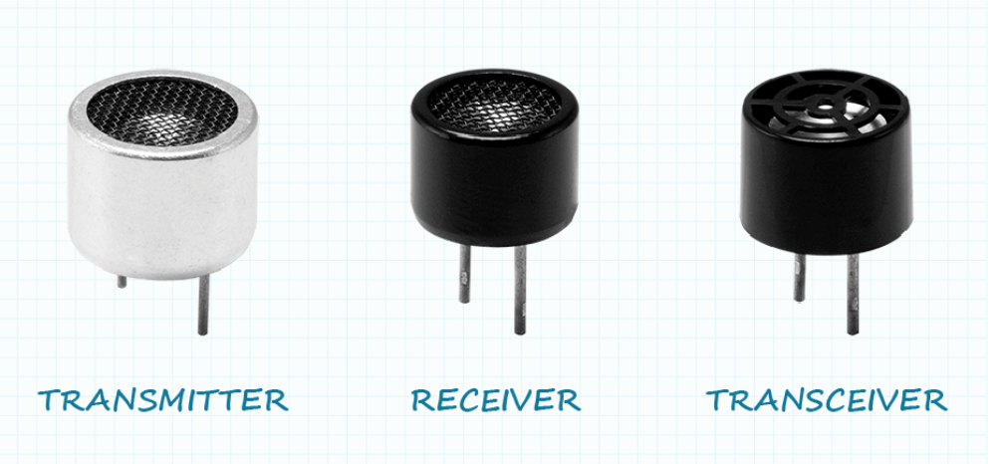Although ultrasonic transmitters, receivers, or transceivers are often purchased separately and assembled with custom circuitry and firmware, they are also sometimes available as a single unit, pre-mounted on a PCB in the standard range finding configuration and a simple logic board.

Fig 4.8 Components of Ultrasonic sensor

**4.3 Signal transmitting**

The ultrasonic system consists of the: • Transducers or ultrasonic sensors • Analog Front End (AFE) to drive the transmitter and condition the received signal • Analog-to-digital converter (ADC) • Additional signal processing capabilities to add intelligence to the measured data The analog front end portion is responsible for driving the transducer, as well as amplifying and filtering the received echo data to make it ready for further processing. Signal processing is either fully done by the control unit in discrete and AFE solutions, or shared between the control unit and the integrated DSP in the ASSP solution with its in-chip intelligence.

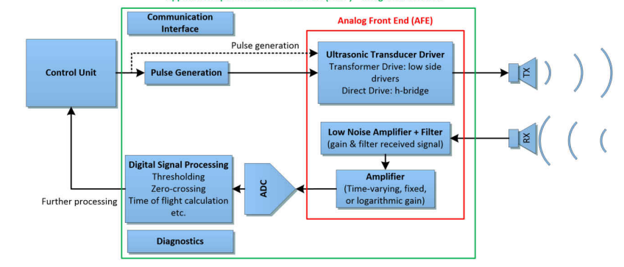transferring a signal from an ultrasonic sensor to a buzzer involves a few key steps that integrate sensing, processing, and actuation components. Firstly, the ultrasonic sensor emits ultrasonic waves from its transmitter. These waves travel through the air and, upon encountering an object, reflect back to the sensor's receiver. The receiver then converts these.

Fig 4.9 Signal transmitter chart

This electrical signal, which contains information about the time it took for the waves to return (time-of-flight), is sent to a microcontroller for processing. The microcontroller interprets the signal to calculate the distance to the object based on the speed of sound in air. If the calculated distance falls below a predefined threshold (indicating that the object is within a certain range), the microcontroller takes action.

Upon determining that the object is close enough, the microcontroller sends a control signal to the buzzer. This control signal can be a simple digital output, like setting a pin high (on) or low (off), to activate or deactivate the buzzer. In more advanced setups, the microcontroller might send a pulse-width modulation (PWM) signal to create different tones or sound patterns. The buzzer then produces an audible alert, signaling the presence of an object within the defined proximity. This system is commonly used in applications such as parking sensors in vehicles, obstacle detection in robotics, and various proximity alert systems.

**Microcontroller Processing**

The microcontroller, a small but powerful computing device, receives the conditioned electrical signal. It performs several crucial tasks:

1. **Time Measurement:** The microcontroller measures the time delay between the emission of the ultrasonic pulse and the reception of the reflected signal. This time-of-flight measurement is critical for calculating distance.
2. **Distance Calculation:** Using the speed of sound (approximately 343 meters per second in air at room temperature), the microcontroller calculates the distance to the object with the formula The division by two accounts for the round-trip journey of the sound wave.
3. **Threshold Comparison:** The microcontroller compares the calculated distance with a predefined threshold value. If the distance is less than the threshold, it decides that the object is within a critical range and triggers an alert.

The buzzer, an electroacoustic transducer, converts the electrical signal from the microcontroller into sound. When activated, it produces an audible alert that indicates the presence of an object within the defined proximity. The nature of the alert (steady tone, beep sequence, etc.) can be customized based on the control signal received from the microcontroller.

**Applications and Considerations**

This integration of ultrasonic sensors and buzzers is widely used in various applications:

* **Automotive Parking Sensors:** To alert drivers of nearby obstacles when parking.
* **Robotics:** For obstacle detection and navigation in autonomous robots.
* **Security Systems:** To detect intruders and trigger alarms.
* **Industrial Automation:** For proximity sensing and object detection on production lines.

Several factors should be considered when designing such systems:

* **Environmental Conditions:** Factors like temperature, humidity, and air pressure can affect the speed of sound and, consequently, the accuracy of distance measurements.
* **Sensor Placement:** Proper placement of the sensor ensures optimal detection range and accuracy.

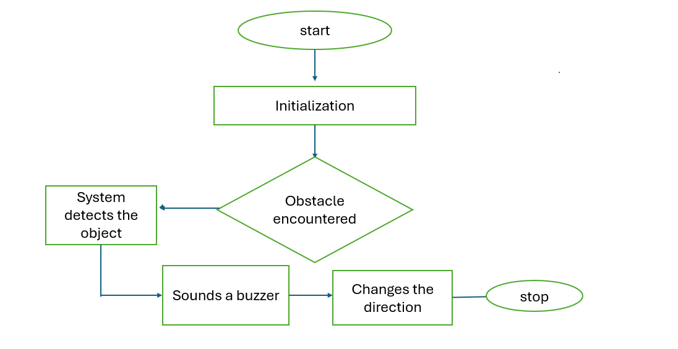**4.4 Flow chart**

The process begins at the **Start** stage, where the system is powered on and ready to initiate the object detection sequence. This initial phase is crucial as it marks the beginning of the operation, ensuring that all systems are prepared to proceed with the subsequent tasks.

Following the start, the system enters the **Initialization** phase. During this stage, the system sets up all necessary components and parameters required for effective object detection. This involves configuring the sensors, setting initial conditions, and performing essential self-checks to ensure that every component is functioning correctly. Proper initialization is vital

As the system runs, it constantly monitors for obstacles. This leads to the **Obstacle Encountered** decision point, where the system evaluates whether an obstacle is present in its path. This evaluation is done through continuous scanning of the environment using various sensor technologies such as infrared, ultrasonic, or laser sensors. These sensors measure distances and detect objects within a certain range, allowing the system to make an informed decision on whether an obstacle has been encountered.

If an obstacle is detected, the system moves to the **System Detects the Object** step. At this point, the detection is confirmed, and the system recognizes the presence of an object. This detection triggers the next step in the process, where the system must respond appropriately to avoid a collision.

To alert nearby individuals or other system components, the system proceeds to **Sounds a Buzzer**. The buzzer acts as an auditory signal, indicating that an obstacle has been detected. This alert is crucial for drawing attention to the situation, especially in environments where immediate human or automated intervention might be necessary.

Following the alert, the system then executes a **Change of Direction**. This step involves recalculating the path or trajectory to avoid the detected obstacle. The system employs algorithms to determine the best alternative direction to move in, ensuring that it can navigate around the obstacle and continue its operation safely. Changing direction is a critical response that helps the system to adapt to its environment and prevent collisions.

Finally, the process reaches the **Stop** stage. This stopping point can serve multiple purposes. It might represent a temporary halt to re-evaluate the surroundings before proceeding or a final stop if the system has completed its task or encountered an obstacle that cannot be bypassed. The stop ensures that the system operates within safe parameters and allows for any necessary reassessments or interventions.

### 5. TESTING AND RESULTS

### 5.1 Introduction to Testing

Testing is a fundamental phase in the development of any technological product, particularly those aimed at assisting visually impaired individuals. The purpose of testing smart glasses for the blind is to ensure the product meets the necessary standards for safety, reliability, and effectiveness. This phase involves rigorous evaluation to identify and fix defects, ensuring that the product delivers accurate, timely, and useful feedback to the user.

Testing these smart glasses involves multiple dimensions, including hardware components like sensors and cameras, software for object detection and user feedback, and the overall user experience. Each component must be tested individually and in combination to ensure the entire system works seamlessly. The primary objectives of testing smart glasses for the visually impaired are to:

1. **Verify Component Functionality:** Ensure each sensor, camera, and feedback mechanism operates correctly.
2. **Validate System Integration:** Confirm that all components work together as intended.
3. **Evaluate Real-World Performance:** Test the glasses in various environmental conditions to ensure reliability.
4. **Identify and Correct Defects:** Detect any issues or bugs and resolve them.
5. **Ensure User Safety and Comfort:** Make sure the glasses are safe to use and comfortable for prolonged periods.

A comprehensive testing strategy involves multiple phases, each focusing on different aspects of the product, from unit tests of individual components to integration and functional testing of the entire system.

### 5.2 Types of Testing

Testing the smart glasses involves several types of testing to ensure thorough evaluation. These include:

**5.2.1 unit testing**

Unit testing is the process of testing individual components or units of the smart glasses in isolation. Each unit, such as the infrared (IR) sensor, ultrasonic sensor, or audio output system, is tested to ensure it functions as intended.

* **Objective:** To verify the correctness of individual components.
* **Method:** Develop test cases for each unit, simulating various conditions and inputs.
* **Tools:** Use testing frameworks that can simulate sensor inputs and measure outputs.

Example: The IR sensor might be tested by exposing it to different objects at various distances and angles to verify its detection accuracy.

#### **5.2.2 Integration Testing**

Integration testing examines how well individual components work together within the system. For smart glasses, this means ensuring that sensors, processors, and feedback mechanisms interact seamlessly.

* **Objective:** To verify that integrated components work together correctly.
* **Method:** Combine units progressively, testing their interactions at each stage.
* **Tools:** Use integration testing tools and frameworks to manage and automate test cases.

Example: The integration of the camera with the object recognition software would be tested to ensure that objects are identified accurately and promptly, and the corresponding audio feedback is provided without delay.

#### **5.2.3 Functional Testing**

Functional testing assesses the complete functionality of the smart glasses, ensuring they meet user requirements and specifications. This type of testing involves evaluating all features and operations under expected usage conditions.

* **Objective:** To validate that the smart glasses fulfill all functional requirements.
* **Method:** Execute comprehensive test cases covering all use scenarios.
* **Tools:** Use functional testing tools and simulate real-world conditions.

Example: Functional tests would involve scenarios like navigating a busy street, detecting obstacles indoors, and operating in various lighting conditions to ensure the system's reliability.

### 5.3 Test Cases

Test cases are essential for ensuring that the smart glasses meet all specified requirements. Here are some examples:

* **Obstacle Detection:**
  + Objective Verify the system can detect obstacles at various distances and angles.
  + Method: Place objects at different distances and angles and measure detection accuracy.
  + Expected Result: The glasses should accurately detect objects within a specified range and angle.
* **Audio Feedback:**
  + Objective Ensure audio feedback is clear and timely.
  + Method: Simulate different obstacle detection scenarios and evaluate the clarity and speed of audio feedback.
  + Expected Result: Audio notifications should be immediate and clear, with no significant delays.
* **Battery Life:**
  + Objective Assess battery performance under continuous use.
  + Method: Operate the glasses continuously and measure battery depletion over time.
  + Expected Result: The battery should last for a specified minimum duration under typical usage conditions.
* **User Interface:**
  + Objective Evaluate the usability of the control interface.
  + Method: Conduct user tests with visually impaired individuals to gather feedback on ease of use.
  + Expected Result: Users should find the interface intuitive and easy to operat

### 5.4 Results and Analysis

The results from testing provide critical insights into the performance and reliability of the smart glasses. Key metrics include:

* **Detection Accuracy:** The percentage of correctly detected objects in various environments.
* **Response Time:** The time taken for the system to respond to detected objects.
* **Battery Life:** The duration the glasses can operate under continuous use.
* **User Feedback:** Qualitative data from users on ease of use and satisfaction.

Analysis involves comparing these metrics against predefined benchmarks and specifications. Any deviations or issues identified during testing are addressed through iterative improvements and retesting.

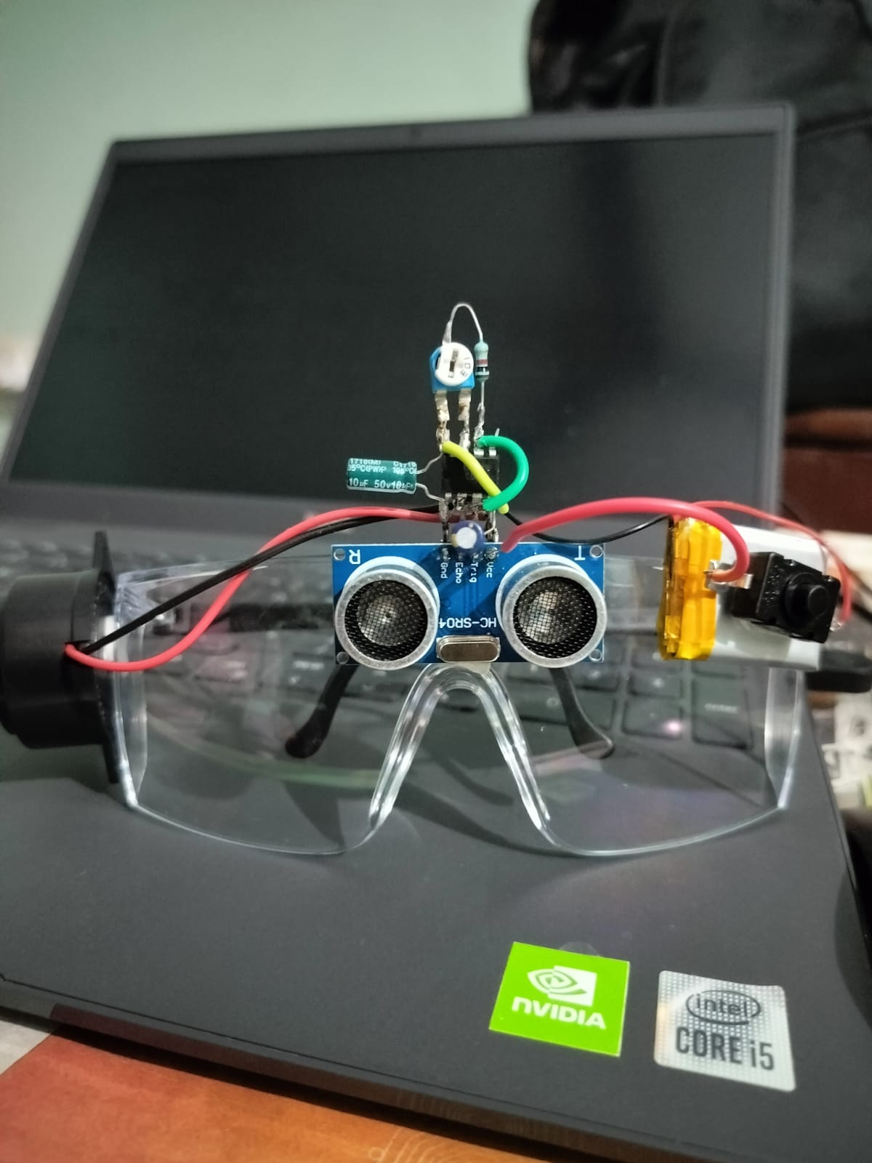

Fig 5.1 output

### CONCLUSION

### 6.1 Conclusion

Smart glasses for the visually impaired represent a significant advancement in assistive technology, providing enhanced mobility and independence. The comprehensive testing process ensures that these devices meet high standards of accuracy, reliability, and usability. By rigorously evaluating each component and the integrated system, developers can identify and address potential issues, resulting in a robust and user-friendly product.

The integration of various sensors, such as IR and ultrasonic sensors, combined with sophisticated software for object recognition and real-time feedback, offers a powerful tool for navigating complex environments. Despite the inherent challenges, such as handling varying environmental conditions and ensuring battery efficiency, the benefits of these smart glasses are substantial.

Technology played a very important role in our life. We use it almost everywhere and every time. The distinct and quick development that we discover each day proof for us that there is no point to give up and struggle with our obstacle in life. Technology offers us a lot of significant solutions to our problems and disapplies. Our role is to use it properly to reach the success level that benefits individual, society and whole country as well

### 6.2 Future Scope

Future developments in smart glasses for the visually impaired could include:

* **Enhanced AI Capabilities:** Leveraging machine learning to improve object recognition and provide more detailed environmental information.
* **Improved User Interfaces:** Developing more intuitive interfaces, possibly incorporating voice commands and haptic feedback.
* **Augmented Reality (AR) Integration:** Providing additional context and information about the surroundings through AR.
* **Advanced Connectivity:** Enabling integration with smartphones and other smart devices for a seamless user experience.
* **Smaller, Lighter Designs:** Further miniaturization of components to make the glasses more comfortable and aesthetically pleasing.
* **Customization Options:** Allowing users to customize the types of feedback and information they receive based on personal preferences and specific needs.

The ongoing advancements in sensor technology, artificial intelligence, and user interface design will continue to enhance the functionality and usability of smart glasses for blind individuals, further empowering them to lead independent and fulfilling lives.

**REFERENCE / BIBLIOGRAPHY**

* The development of low-cost ultrasonic smart glasses for the visually impaired is a significant advancement. According to research published on ResearchGate <https://www.researchgate.net/publication/321288844_Low_cost_ultrasonic_smart_glasses_for_blind>
* Prince Mohammad Bin Fahd University has also explored this technology, highlighting its potential to significantly improve the quality of life for visually impaired users by offering an affordable and effective navigation aid. <https://www.pmu.edu.sa/academics/smart_glasses_for_blind_people>
* Additionally, a YouTube video <https://www.youtube.com/watch?v=R53RfS_3Kvg>

demonstrates the practical application and user experience of these smart glasses, showcasing their real-world benefits. Moreover, the National Blindness and Visual Impairment Survey all over the world.

https://vikaspedia.in/health/health-directory/national-blindness-and-visual-impairment-survey#:~:text=the%20year%202017.-,Results,using%20pinhole

[1]Feng Lan, Guangtao Zhai, Wei Lin “Lightweight smart

glass system with audio aid for visually impaired people”

,TENCON,IEEE,Region 10 Conference, 2015.

[2]ASM Iftekhar Anam, Sahinur Alam, Md Yeasin “A dyadic

conversation aid using google glass for people who are blind

or visually impaired”, Mobile Computing Applications and

Services(MobiCASE),6th International Conference, 2015.

[1]Feng Lan, Guangtao Zhai, Wei Lin “Lightweight smart

glass system with audio aid for visually impaired people”

,TENCON,IEEE,Region 10 Conference, 2015.

[2]ASM Iftekhar Anam, Sahinur Alam, Md Yeasin “A dyadic

conversation aid using google glass for people who are blind

or visually impaired”, Mobile Computing Applications and

Services(MobiCASE),6th International Conference, 2015.

[1]Feng Lan, Guangtao Zhai, Wei Lin “Lightweight smart

glass system with audio aid for visually impaired people”

,TENCON,IEEE,Region 10 Conference, 2015.

[2]ASM Iftekhar Anam, Sahinur Alam, Md Yeasin “A dyadic

conversation aid using google glass for people who are blind

or visually impaired”, Mobile Computing Applications and

Services(MobiCASE),6th International Conference, 2015. [1]Feng Lan, Guangtao Zhai, Wei Lin “Lightweight smart

glass system with audio aid for visually impaired people”

,TENCON,IEEE,Region 10 Conference, 2015.

[2]ASM Iftekhar Anam, Sahinur Alam, Md Yeasin “A dyadic

conversation aid using google glass for people who are blind

or visually impaired”, Mobile Computing Applications and

Services(MobiCASE),6th International Conference, 2015.