JPJ Insight Dashboard
Why this layout and why these colours
Why this layout
The dashboard is split into a Home hub and separate chart pages. This is so one screen does one job, instead of putting every chart on one long page.
- Home shows the headline numbers first (how many vehicles in 2025).
- Gold pills (Home, Mix, Income, States, and so on) open one chart page at a time.
- KPI cards sit above charts so the big numbers are easy to scan.
- Filters stay on the page that needs them (year, state, income band, search).
- Labels use English and Malay (Motorcar / Motokar, Motorcycle / Motosikal).
The four screens
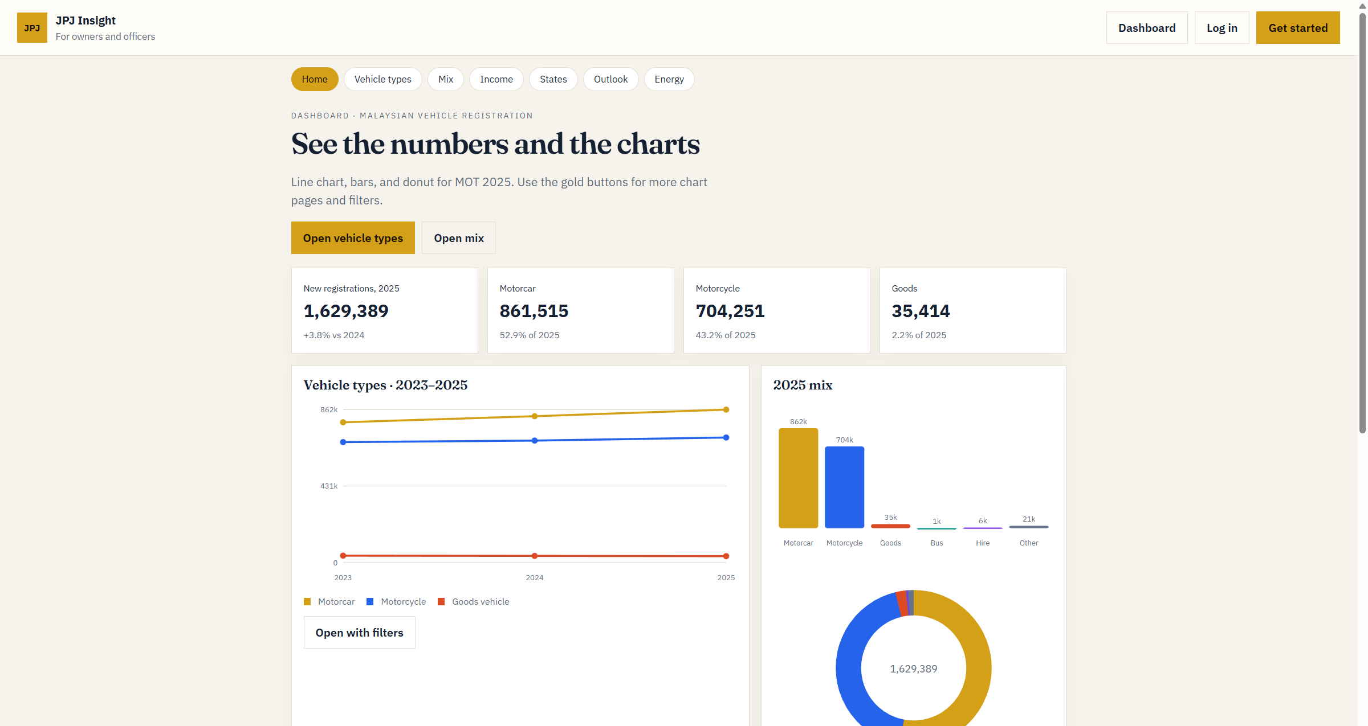
Figure 1. Home hub — KPI cards, 2023–2025 line chart, and 2025 mix.
Home answers “how many this year?” Four cards show 1,629,389 new registrations, motorcar 861,515, motorcycle 704,251, and goods 35,414. The line chart shows the trend from 2023 to 2025. The donut shows the 2025 mix. Gold buttons open other pages, so Home stays simple.
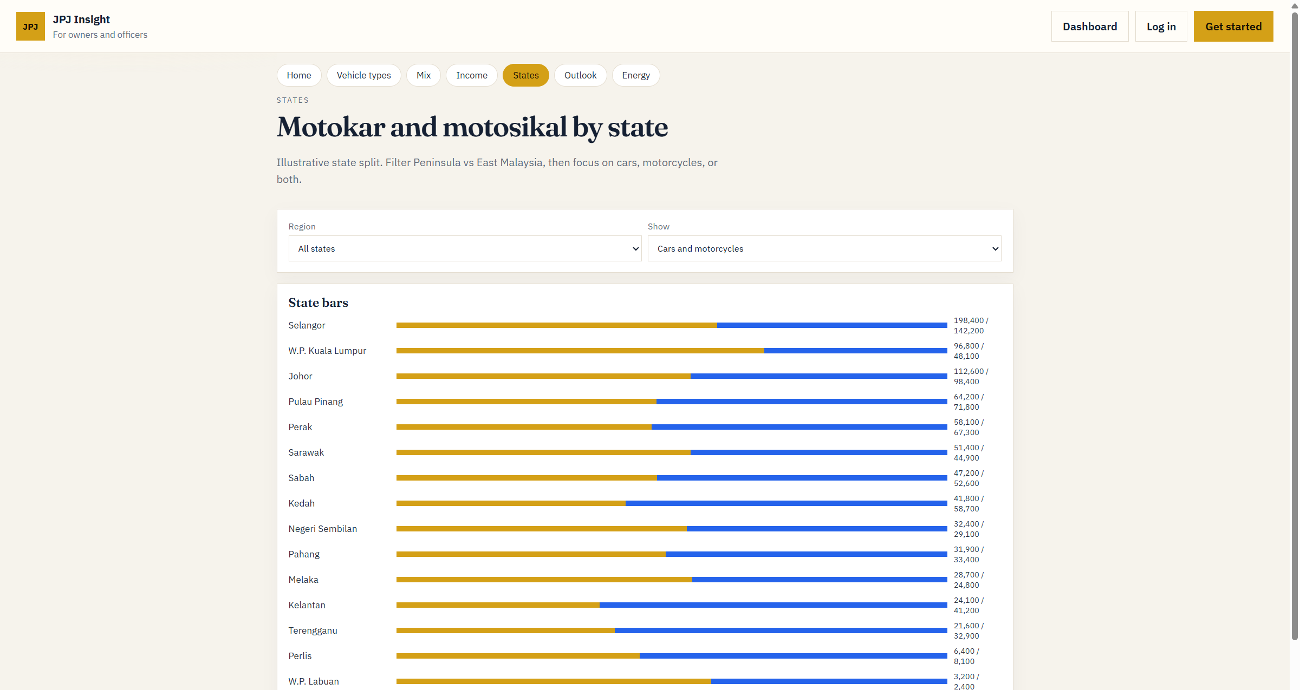
Figure 2. States — Motokar (gold) and motosikal (blue) by state.
This page only compares cars and motorcycles by state. Horizontal bars are used because state names are long. Gold is motokar and blue is motosikal, so the two classes are easy to tell apart. Region and Show filters sit on this page, not on Home.
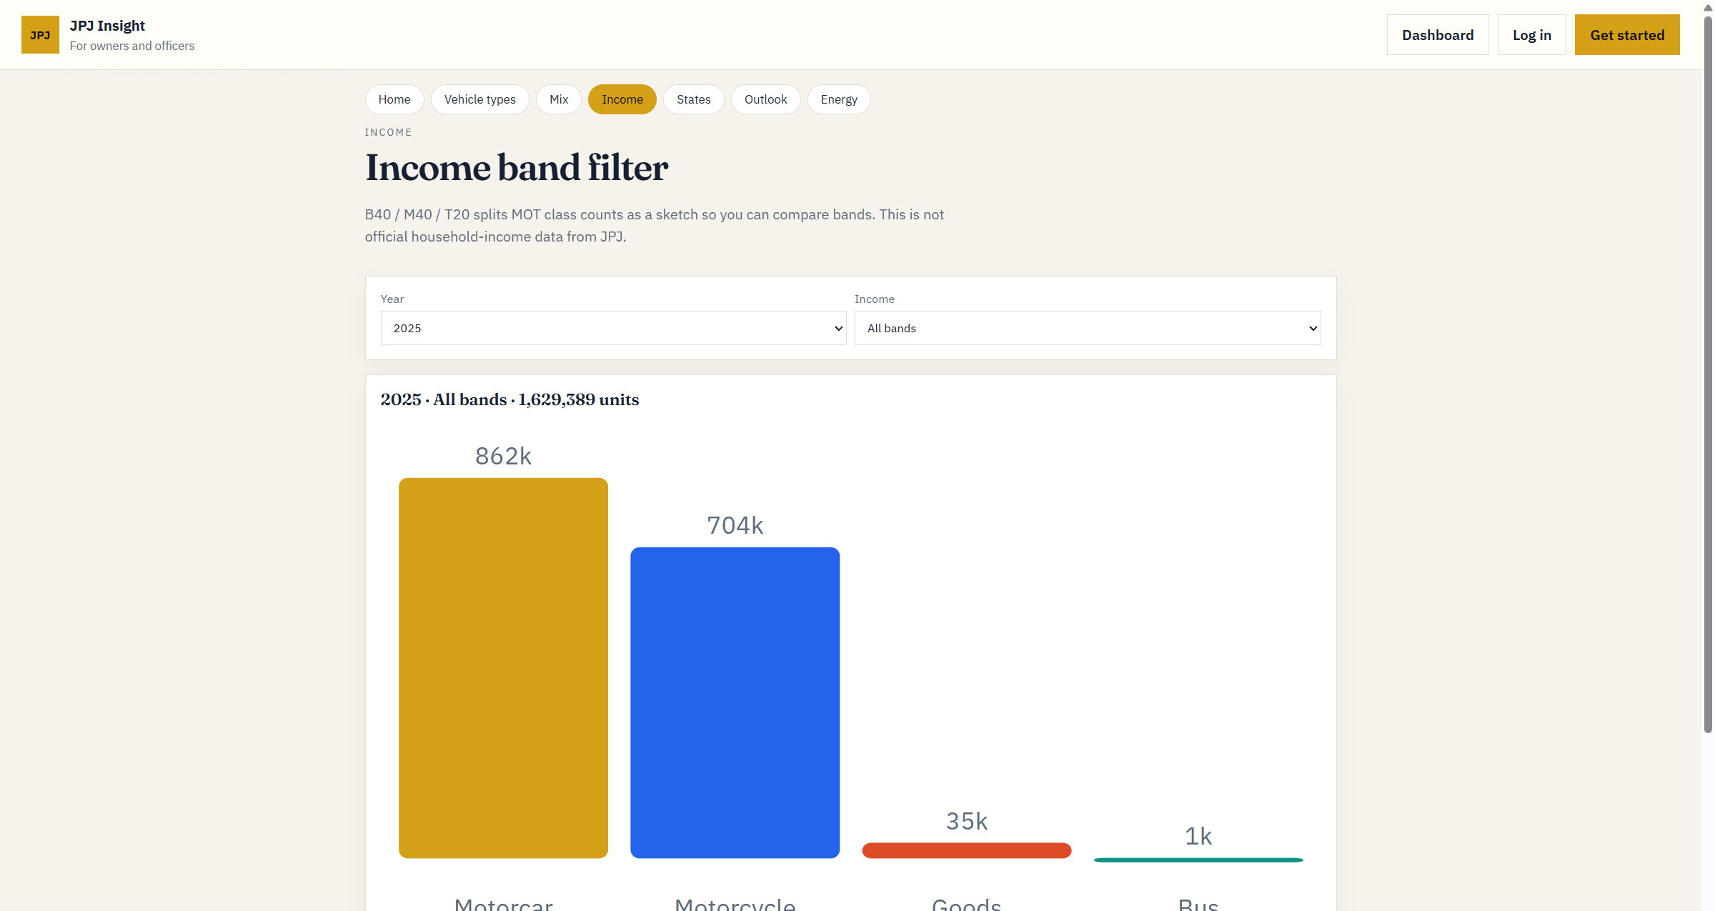
Figure 3. Income — class volume with year and income-band filters.
Vertical bars compare size: motorcar about 862k, motorcycle 704k, goods 35k, bus 1k. Year and income-band dropdowns are on this page. B40 / M40 / T20 is only a sketch for the prototype. It is not official JPJ household-income data.
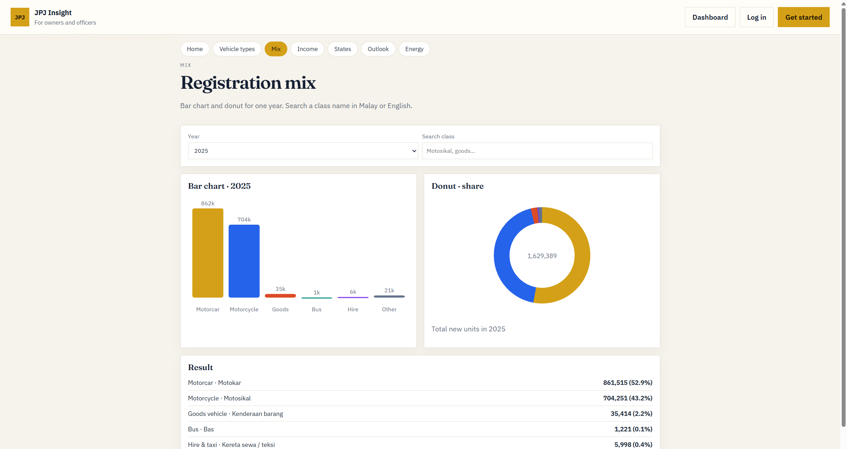
Figure 4. Mix — bar chart, donut, and bilingual result table for 2025.
Mix shows one year’s share in three ways: bars for size, a donut for share, and a table for exact counts. The table lists Motokar 52.9% and Motosikal 43.2%, plus the smaller classes. Users can search a class name in Malay or English.
Why these colours
The first dark navy version was hard to read, so this draft uses a light cream page with dark text. Gold is kept as the accent so buttons and the active page are still easy to see.
- Cream background (#f6f3ec) and white cards — easier to read than dark mode.
- Dark navy text (#152033) — headings and numbers stay sharp.
- Gold (#d4a017) — buttons, the active pill, and the motorcar series (the largest class).
- Blue (#2563eb) — motorcycle series, so the two biggest classes look different.
- Red, teal, purple, and grey — smaller classes (goods, bus, hire, other) so they do not compete with gold and blue.

