FIRST DRAFT · NOT FINAL · STUDENT PROTOTYPE
JPJ Insight Dashboard
First Draft Design Explanation
Why this colour system and why this page design · Malaysian Vehicle Registration prototype
1. Introduction
This report explains the first visual draft of the JPJ Insight public dashboard. JPJ Insight is a COS30049 Computing Technology Innovation Project prototype. It is not an official Jabatan Pengangkutan Jalan (JPJ) product and it is not the final interface. The first draft currently focuses on four screens: Hub, States, Income, and Mix. The live prototype uses a hub plus separate chart pages so users are not forced to scroll one crowded dashboard.
The numbers on screen are based on Ministry of Transport (MOT) 2025 new vehicle registrations. The 2025 total is 1,629,389 units, +3.8% compared with 2024. Motorcar 861,515 (52.9%). Motorcycle 704,251 (43.2%). Goods vehicle 35,414 (2.2%). Bus 1,221 (0.1%). Hire and taxi 5,998 (0.4%). Other 20,990 (1.3%). Recent yearly totals are 2023: 1,533,285; 2024: 1,570,121; 2025: 1,629,389.
2. Design concept — why this layout
The first draft is organised as a hub with gold navigation pills, not as one long page of every chart. Each screen is given one main job so a student, officer, or marker can read the view without hunting.
- Hub first. Home answers “how many vehicles registered this year?” with four KPI cards, then a 2023–2025 line chart and a 2025 mix donut.
- Gold pill navigation. Home, Vehicle types, Mix, Income, States, Outlook, and Energy open one chart page at a time. Dumping every chart onto one page is hard to read on a laptop and worse on a phone.
- KPI cards above charts. Headline counts can be scanned before anyone has to decode a graph. Green is used only for the +3.8% change.
- Filters on the page that needs them. States filters region and cars/motorcycles. Income filters year and B40 / M40 / T20 as a sketch. Mix filters year and class search in Malay or English.
- Bilingual labels. Motorcar / Motokar and Motorcycle / Motosikal are used because the product is for Malaysian users.
- Typography and cards. Serif-like display headings give an editorial, trusted report feel. Sans-serif UI text keeps tables and filters clear. Dark panels group KPIs, charts, and tables.
This is still a first draft. Spacing, chart polish, empty states, and the remaining pages (Vehicle types, Outlook, Energy) will be refined later. The four screens below are the current Canva / live-UI first draft, not the finished product.
3. First-draft screens (figures)
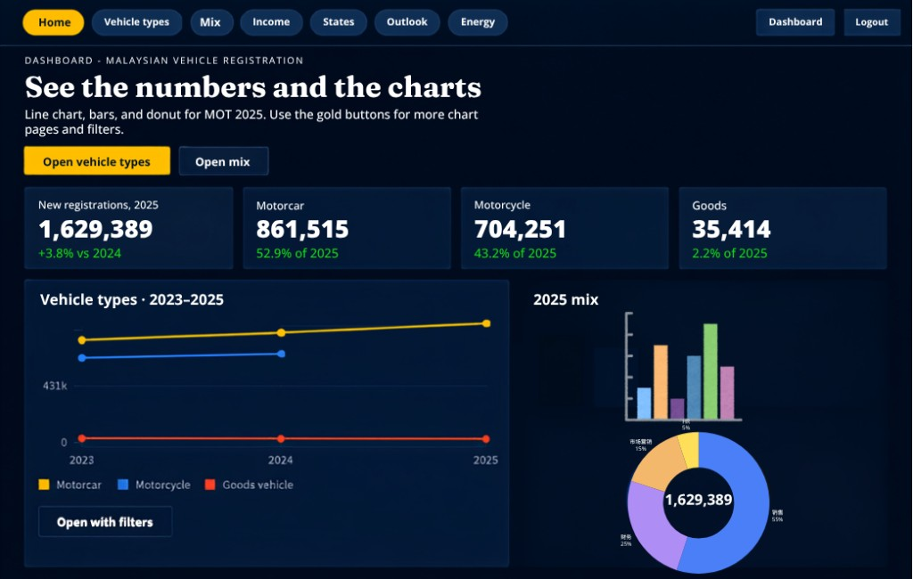
Figure 1. First-draft Hub — headline KPIs, 2023–2025 trend line, and 2025 mix on one landing view.
The Hub is the landing view. The title “See the numbers and the charts” tells the user that this page is for MOT 2025 counts, not a form. Four KPI cards show 1,629,389 new registrations, motorcar 861,515, motorcycle 704,251, and goods 35,414. Gold buttons (“Open vehicle types”, “Open mix”) send the user to a dedicated chart page instead of stacking more widgets here. The line chart keeps time (2023–2025) on the left; the donut keeps 2025 composition on the right. Gold is motorcar, blue is motorcycle, red is goods — the same mapping used on later pages so the colour language stays consistent.
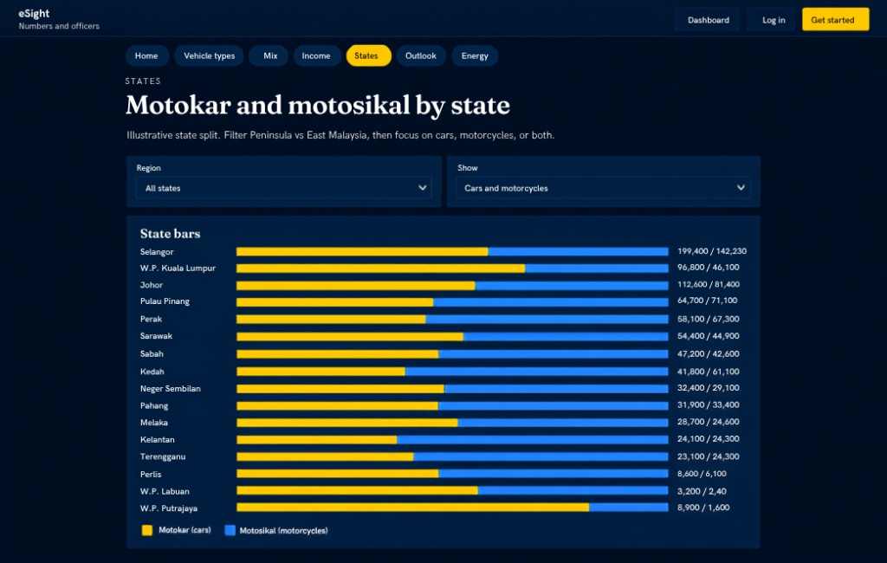
Figure 2. First-draft States page — Motokar and motosikal by state, with region and class filters.
States is a one-job page: compare cars and motorcycles across Malaysia. Horizontal stacked bars are used because state names are long; gold is Motokar (cars) and blue is Motosikal (motorcycles). Selangor leads, then Johor and W.P. Kuala Lumpur. Region and Show filters sit above the chart so Peninsula vs East Malaysia, or cars vs motorcycles, can be narrowed without returning to the Hub. The subtitle states that this split is illustrative for the prototype.
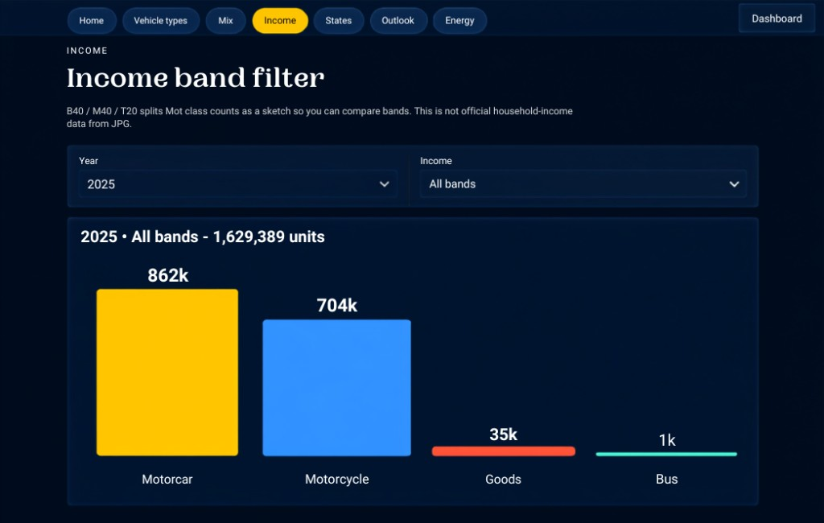
Figure 3. First-draft Income page — class volume with year and income-band filters (prototype sketch).
Income uses vertical bars so class volume is easy to compare: motorcar about 862k, motorcycle 704k, goods 35k, bus 1k. Year and Income dropdowns sit on this page, not on the Hub. The copy on screen says B40 / M40 / T20 splits Mot class counts as a sketch. This is not official household-income data from JPJ. The first draft keeps that disclaimer visible so markers and users are not misled.
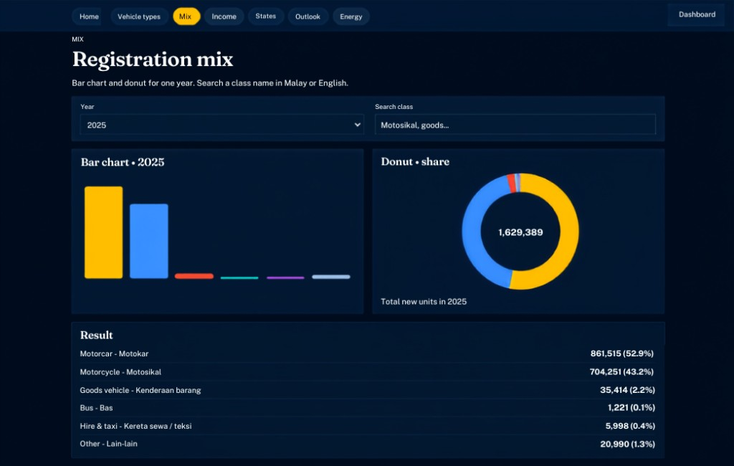
Figure 4. First-draft Mix page — 2025 bar chart, donut share, and bilingual result table.
Mix shows one year’s composition in three ways at once: bars for magnitude, a donut for share, and a result table for exact counts. The table lists Motorcar / Motokar 861,515 (52.9%), Motorcycle / Motosikal 704,251 (43.2%), Goods / Kenderaan barang 35,414 (2.2%), Bus / Bas 1,221 (0.1%), Hire and taxi / Kereta sewa / teksi 5,998 (0.4%), and Other / Lain-lain 20,990 (1.3%). Search accepts a class name in Malay or English. Smaller classes stay visible as thin coloured bars so they are not lost beside motorcar and motorcycle.
4. Colour rationale — why these colours
The first draft uses a dark navy canvas with gold wayfinding. The palette is meant to feel like a government analytics console, cut screen glare, and let the chart series stand out. Gold is also a Malaysian official-adjacent accent without copying a real JPJ crest.
- Navy canvas #07111f, raised #0b1829, panel #102033, hairline #24364d. Dark surfaces reduce glare and make gold, blue, and red series easier to read. Cards sit on #102033 so KPIs and charts read as modules.
- Gold #d4a017. Primary accent for the active nav pill, primary buttons, and the motorcar series (the largest class). Gold is used as wayfinding so the user always knows which page is selected.
- Blue #3d8bfd. Motorcycle series and secondary emphasis. Complementary on navy, so the two biggest classes stay separable at a glance (see Figure 2 gold vs blue bars).
- Smaller-class hues. Goods #e4572e, bus #2ec4b6, hire and taxi #c77dff, other #8b9bb4. These colours are distinct but quieter, so they do not compete with gold and blue.
- Text. Body #d7e0ea, heading ink #f4efe4, muted labels #8ea0b5. Green is reserved only for positive change (+3.8%).
Figure 5. First-draft colour system: navy canvas, gold wayfinding / motorcar, blue motorcycle, then distinct hues for smaller classes.
5. Chart and interaction choices
- Line chart. Time (2023–2025) on the Hub. A line is the right shape for trend, not for share.
- Donut. Composition of one year on Hub and Mix. The 1,629,389 total sits in the hole so the headline number is never far from the mix.
- Horizontal stacked bars. States page. Long names need horizontal labels; stacking gold and blue shows cars vs motorcycles in one row.
- Vertical bars. Income and Mix. Magnitude comparison (862k vs 704k vs 35k) is clearer as column height.
- Filters stay local. The Hub stays a summary. Year, region, income band, and class search live on the page that uses them.
6. Limitations of this first draft
- Not the final UI. These four screens are the first Canva / live draft. Vehicle types, Outlook, and Energy still need the same level of polish.
- Illustrative splits. Income bands are a prototype sketch. The state split is illustrative, not a live JPJ extract.
- Prototype disclaimer. The product must keep a visible note that this is a COS30049 prototype, not an official JPJ website.
- Next draft. Tighten spacing, chart axes, empty and error states, and complete the remaining pages while keeping navy + gold.
7. Conclusion
The first draft uses a dark navy canvas and gold wayfinding so MOT 2025 numbers stay readable, and it splits charts across pages so each screen has one job. Figure 1 leads with KPIs. Figure 2 compares states. Figure 3 compares class volume with an income-band filter. Figure 4 shows 2025 share in Malay and English. These colour and layout choices will be carried into the final draft and refined with feedback. This document describes a first draft only. It is not the finished dashboard and not an official JPJ publication.
End of first-draft design explanation. Figures 1–4 are screenshots of the current JPJ Insight dashboard draft.

