* + 1. page 279(book) 316(pdf)

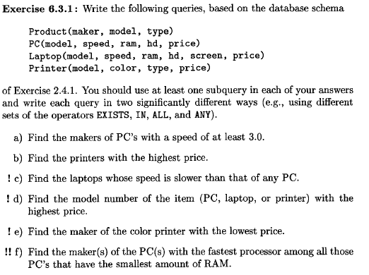

1. B, E

SELECT DISTINCT maker

FROM product

WHERE model = ANY (SELECT model

FROM PC

WHERE speed > 3)

SELECT DISTINCT maker

FROM product

WHERE model IN (SELECT model

FROM PC

WHERE speed > 3)

1. 3003

SELECT model

FROM printer

WHERE price IN (SELECT MAX(price)

FROM printer)

SELECT model

FROM printer

WHERE price >= ALL (SELECT price

FROM printer)

1. allesammen

SELECT model

FROM laptop

WHERE speed < ANY (SELECT speed

FROM pc)

Select model

From laptop

Where speed IN (SELECT laptop.speed

FROM pc, laptop

WHERE laptop.speed < pc.speed)

d)

SELECT a.model

FROM (select model, price from pc union select model, price from laptop union select model, price from printer) AS a

where a.price >= ALL (select price from pc union select price from laptop union select price from printer)

SELECT a.model

FROM (select model, price from pc union select model, price from laptop union select model, price from printer) AS a

where a.price IN (select max(price) from(select price from pc union select price from laptop union select price from printer) as b)

e)

select maker

from product

where model IN (select model from printer where color = TRUE AND price <= ALL (select price from printer))

select maker

from product

where model IN (select model from printer where color = TRUE AND price IN (select min(price) from printer))

f)

select distinct maker

from product, pc

where pc.model = product.model and ram <= all (select ram from pc) and speed >= all (select speed from pc where ram = (select min(ram) from pc))

6.3.2 page 279(book) 316(pfd)

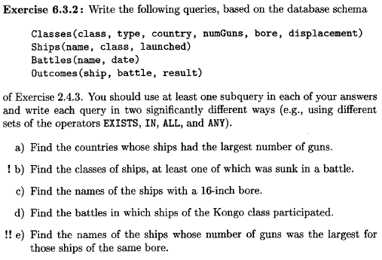

a)

SELECT C.country

FROM Classes C

WHERE numGuns IN (SELECT MAX(numGuns) FROM Classes );

select country

from classes

where numGuns >= ALL (select numGuns from classes)

b)

SELECT DISTINCT C.class

FROM Classes C, Ships S

WHERE C.class = S.class AND

EXISTS (SELECT ship FROM Outcomes O WHERE O.result='sunk' AND O.ship = S.name ) ;

SELECT DISTINCT C.class

FROM Classes C, Ships S

WHERE C.class = S.class AND S.name IN (SELECT ship FROM Outcomes O WHERE O.result='sunk' ) ;

c)

SELECT name

FROM ships

WHERE class IN (SELECT class from classes where bore = 16);

SELECT name

FROM ships

WHERE class = ANY (SELECT class from classes where bore = 16);

d)

SELECT DISTINCT battle

FROM outcomes

WHERE ship = ANY (SELECT name FROM ships WHERE class = 'Kongo');

SELECT DISTINCT battle

FROM outcomes

WHERE ship in (SELECT name FROM ships WHERE class = 'Kongo');

e)

SELECT name

FROM ships, classes AS C1

WHERE ships.class = C1.class AND numGuns = (SELECT MAX(numGuns) FROM classes AS C2 WHERE C1.bore = C2.bore);

5.2.1 page 222(book) 259(pdf)

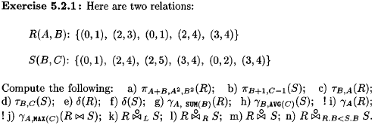

Π=select  
Ϯ=sorter  
ϒ=grouping  
&= udvidet Y  
bowtie= inner join  
bowtie prik = outer join

|  |  |  |
| --- | --- | --- |
| A+B | A2 | B2 |
| 1 | 0 | 1 |
| 5 | 4 | 9 |
| 1 | 0 | 1 |
| 6 | 4 | 16 |
| 7 | 9 | 16 |

|  |  |
| --- | --- |
| B+1 | C-1 |
| 1 | 0 |
| 3 | 3 |
| 3 | 4 |
| 4 | 3 |
| 1 | 1 |
| 4 | 3 |

|  |  |
| --- | --- |
| A | B |
| 0 | 1 |
| 0 | 1 |
| 2 | 3 |
| 2 | 4 |
| 3 | 4 |
|  |  |

|  |  |
| --- | --- |
| B | C |
| 0 | 1 |
| 0 | 2 |
| 2 | 4 |
| 2 | 4 |
| 3 | 4 |
| 3 | 5 |

1. $δ(R)$– duplictate elimination

|  |  |
| --- | --- |
| A | B |
| 0 | 1 |
| 2 | 3 |
| 2 | 4 |
| 3 | 4 |
|  |  |
|  |  |

1. $δ(S)$– duplictate elimination

|  |  |
| --- | --- |
| B | C |
| 0 | 1 |
| 2 | 4 |
| 2 | 5 |
| 3 | 4 |
| 0 | 2 |
|  |  |

1. $γ_{A,SUM\left(B\right)}(R)$ group A sumB

|  |  |
| --- | --- |
| A | SUM(B) |
| 0 | 2 |
| 2 | 7 |
| 3 | 4 |
|  |  |
|  |  |
|  |  |

1. $γ_{B,AVG\left(C\right)}(S)$ Group B avg C

|  |  |
| --- | --- |
| B | AVG(C) |
| 0 | 3/2 |
| 2 | 9/2 |
| 3 | 8/2=4 |

1. $γ_{A}(R)$ group a

|  |  |
| --- | --- |
| A |  |
| 0 |  |
| 2 |  |
| 3 |  |

$γ_{A,MAX\left(C\right)}(R⋈S)$

$R⋈S$ først join R og S på fælles B.

|  |  |  |
| --- | --- | --- |
| A | B | C |
| 2 | 3 | 4 |
| 2 | 3 | 4 |
|  |  |  |

Svar: group på A max(c)

|  |  |
| --- | --- |
| A | MAX(C) |
| 2 | 4 |

1. $R{\left(Outerjoin\right)}_{L}S$– pad højresiden

|  |  |  |
| --- | --- | --- |
| A | B | C |
| 0 | 1 | NULL |
| 2 | 3 | 4 |
| 2 | 3 | 4 |
| 0 | 1 | NULL |
| 2 | 4 | NULL |
| 3 | 4 | NULL |



|  |  |  |
| --- | --- | --- |
| A | B | C |
| NULL | 0 | 1 |
| NULL | 2 | 4 |
| NULL | 2 | 5 |
| 2 | 3 | 4 |
| NULL | 0 | 2 |
| 2 | 3 | 4 |

|  |  |  |
| --- | --- | --- |
| A | B | C |
| 0 | 1 | NULL |
| 2 | 3 | 4 |
| 2 | 3 | 4 |
| 0 | 1 | NULL |
| 2 | 4 | NULL |
| 3 | 4 | NULL |
| NULL | 0 | 1 |
| NULL | 2 | 4 |
| NULL | 2 | 5 |
| NULL | 0 | 2 |

|  |  |  |  |
| --- | --- | --- | --- |
| A | R.B | S.B | C |
| 0 | 1 | 2 | 4 |
| 0 | 1 | 2 | 5 |
| 0 | 1 | 3 | 4 |
| 0 | 1 | 3 | 4 |
| 2 | 3 | NULL | NULL |
| 0 | 1 | 2 | 4 |
| 0 | 1 | 2 | 5 |
| 0 | 1 | 3 | 4 |
| 0 | 1 | 3 | 4 |
| 2 | 4 | NULL | NULL |
| 3 | 4 | NULL | NULL |
| NULL | NULL | 0 | 1 |
| NULL | NULL | 0 | 2 |

6.4.1 page 289(book) 326(pdf)



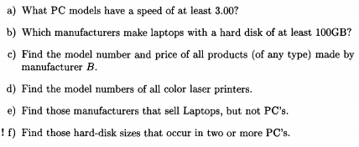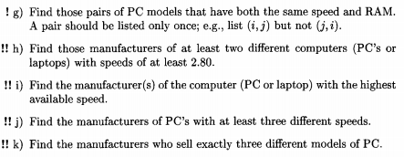

|  |
| --- |
| a) |
|  | select DISTINCT model from pc where pc.speed >= 3.00 |
|  |  |
|  | b) |
|  | select DISTINCT maker  from Product,Laptop |
|  | where Laptop.model=Product.model and |
|  | Laptop.hd>=100 |
|  |  |
|  | C)  SELECT R.model, P.price  FROM Product R, PC P  WHERE R.model = P.model  AND R.maker = 'B'  UNION  SELECT R. model ,  L.price  FROM Product R,  Laptop L  WHERE R. model = L . model  AND R. maker = 'B'  UNION  SELECT R. model, T.price  FROM Product R, Printer T  WHERE R. model = T.model  AND R.maker = 'B' |
| d) | Select distinct model  From product, printer  Where color = TRUE  e)  **SELECT DISTINCT** R.maker **FROM** Product R **WHERE** R.type = 'laptop' **AND** R.maker **NOT IN**(  **SELECT** R.maker  **FROM** Product R  **WHERE** R.type = 'pc'  ); |
|  | f) |
|  | SELECT hd, COUNT(*) as co |
|  | FROM PC |
|  | GROUP BY hd |
|  | HAVING COUNT(*) > 1  g)  select p1.model model1, p2.model model2  from pc p1, pc p2  where p1.speed = p2.speed and p1.ram = p2.ram and p1.model < p2.model |
|  |  |
|  | h) |
|  | select distinct maker |
|  | from product, laptop, pc |
|  | where (product.model = laptop.model OR product.model = pc.model) AND (laptop.speed >= 2.8 OR pc.speed >= 2.8) |
|  | group by product.maker |
|  | having count(product.maker) >= 2 |
|  |  |
|  | i)husk at tilføje distinct |
|  |  |
|  | j) |
|  | select maker  from product,pc  where product.model=pc.model |
|  | group by maker |
|  | having count (distinct speed)>=3 |
|  |  |
|  | k) |
|  | select maker from product,pc where product.model=pc.model |
|  | group by maker |
|  | having count (distinct pc.model) =3 |

6.4.2 page 289(book) 326(pdf)

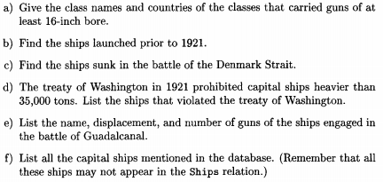

LAV SELV

6.4.6 page 289(book) 326(pdf)

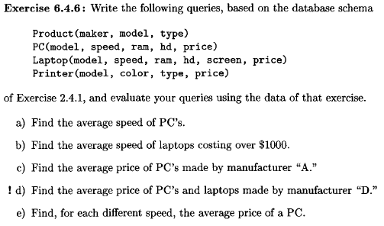

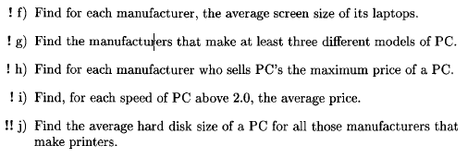

a)

select avg(speed)

from pc

b)

select avg(speed)

from laptops

where price > 1000

c)

select avg(price)

from laptops, products

where maker = ‘A’ AND laptops.model = products.model

d)

select avg(a.price)

from ((select model, price from laptop) union (select model, price from pc)) as a, product

where a.model = product.model AND maker = 'D'

e)

select speed, avg(price)

from pc

group by(speed)

f)

select maker, avg(screen)

from laptop, product

where product.model = laptop.model

group by(maker)

g)

select maker

from product

where type = 'pc'

group by(maker)

having count(maker) >= 3

h)

select maker, max(pc.price)

from product, pc

where product.model = pc.model

group by(maker)

i)

select speed, avg(price), count(speed)

from pc

where speed > 2

group by speed

j)

select product.maker, avg(pc.hd)

from product, pc

where product.model = pc.model AND maker IN (select distinct maker from product where type = 'printer')

group by maker

6.4.7 page 290(book) 327(pdf)

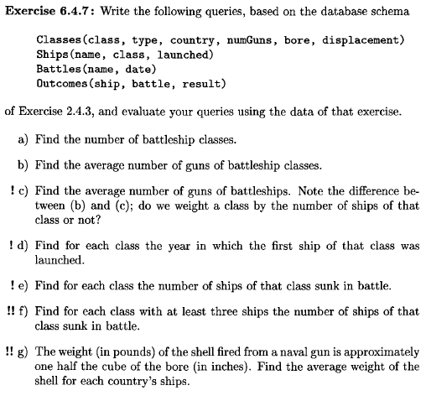

a)

select distinct count(class)

from classes

b)

select avg(numguns)

from classes

c)

select avg(guns)

from classes, ships

where classes.class = ships.class

d)

select class, min(launched)

from ships

group by(class)

e)

select class, count(class)

from ships, outcomes

where result = 'sunk' AND ships.name = outcomes.ship

group by (class)

f)

select a.class, count(a.class)

from (select ships.class as class, outcomes.result as result from outcomes, ships where result = 'sunk' AND ships.name = outcomes.ship) as a

group by(a.class)

having cout(a.class) > 3

g)

select country, (AVG(bore)^3)/2 as weight

from ships, classes

where ships.class = classes.class

group by(country)