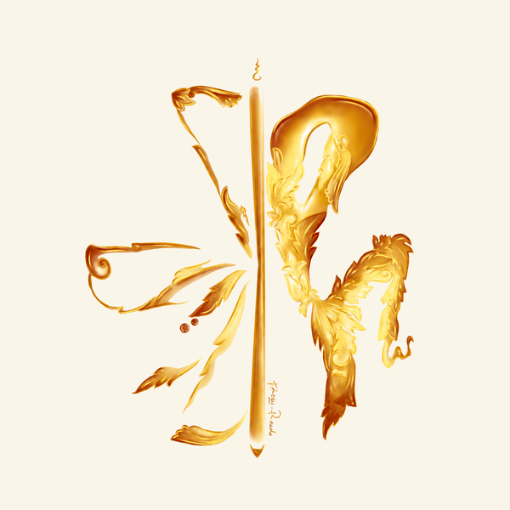
KhozyReads
Khmer Digital Bookstore · khozyreads.com
CANCELLATION & REFUND POLICY
Effective date: 1 October 2026 · Version 1.0

1. Overview
KhozyReads (“we”, “us”, “our”) operates the website https://khozyreads.com, an online bookstore selling digital Khmer novels and stories (“Digital Content”). This Cancellation & Refund Policy explains the terms that apply when you purchase Digital Content from KhozyReads. By completing a payment, you confirm that you have read, understood and agreed to this Policy.

2. Nature of the products
All products sold on KhozyReads are digital goods. Once your payment is confirmed, the purchased book is unlocked immediately in your personal library (“My Library”) and can be read instantly on the website. Because the content is delivered and accessible at once, the product is considered fully delivered at the moment of purchase.

3. All sales are final — no refunds
Due to the digital and instantly-delivered nature of our products, all purchases on KhozyReads are final and non-refundable. We do not offer refunds, returns, exchanges or credits for any purchase, including but not limited to the following situations:
- You change your mind after purchasing or no longer wish to read the book.
- You purchased the wrong title by mistake.
- You have already started or finished reading the book.
- You did not like the story, writing style or content of the book.
- You purchased the same book more than once from the same account.
Please review the book title, synopsis, price and currency carefully before confirming your payment.

4. Cancellation
An order may be cancelled only before payment is made. Once the payment has been successfully completed through ABA PayWay (ABA PAY / KHQR), the order cannot be cancelled and the purchase becomes final in accordance with Section 3.

5. Exceptions
As a gesture of goodwill, we will review refund requests only in the following exceptional cases:
- Duplicate payment: you were charged more than once for the same order due to a technical error.
- Content not delivered: your payment was successfully completed but the book did not appear in your library within 24 hours, and our team is unable to restore access.
Approved exceptions are refunded to the original payment method (ABA account) within 7–14 business days. Refund requests must be submitted within 7 days of the transaction date together with the payment reference (transaction ID / APV code) and your account username.

6. How to contact us
For questions about this Policy or to report a payment issue, please contact us:
- Email: semsokanha15@gmail.com
- Telegram: @callmecutiess
- Phone: +855 99 239 240
- Address: Nokor Krao Village, Kork Chork Commune, Siem Reap City, Siem Reap Province, Cambodia

7. Changes to this Policy
We may update this Policy from time to time. The latest version will always be published on https://khozyreads.com and displayed on the payment page. Continued use of the service after an update constitutes acceptance of the revised Policy.
KhozyReads · Words Are Colors Of The Unspoken Soul.

