**AI/Reference Usage doc:**

**I used Youtube ,Github-Copilot, Chat-GPT, Google, Stackoverflow to complete this project.**

Please find the relevant screenshots of different sources :

Youtube :

I used Youtube to understand concepts which I couldn’t understand through LLM’s

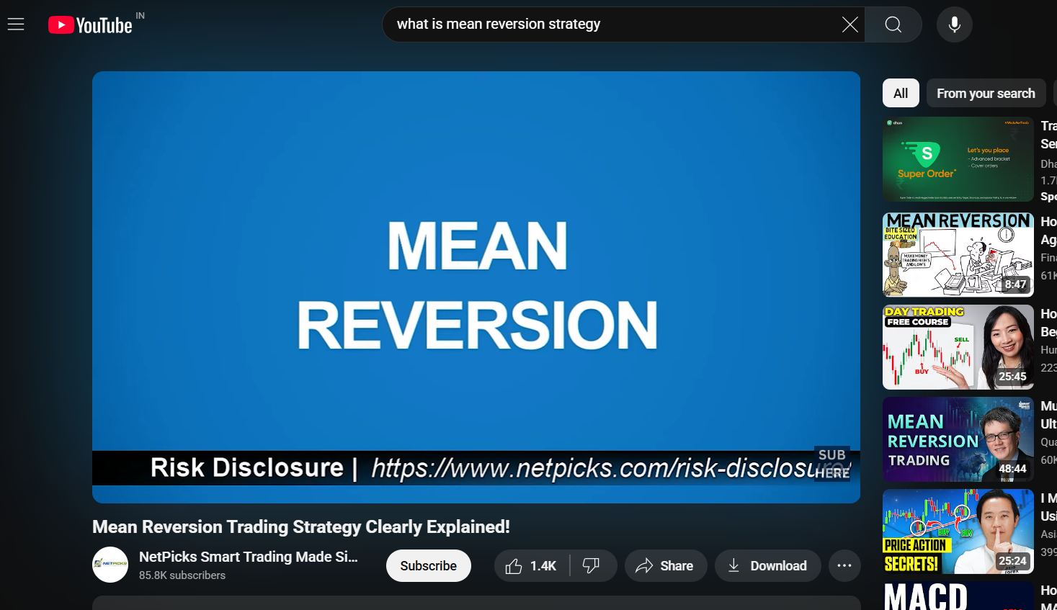

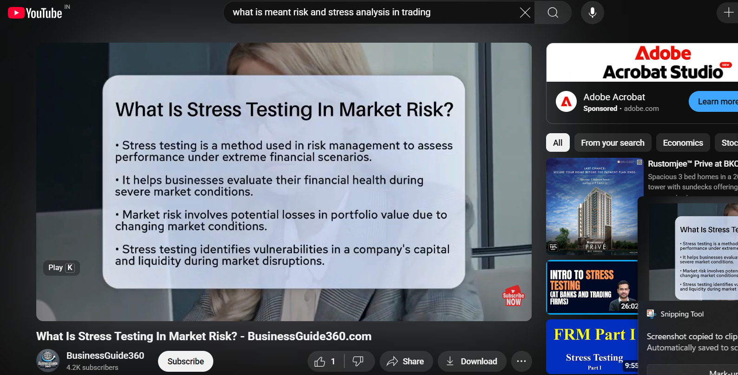

Google:

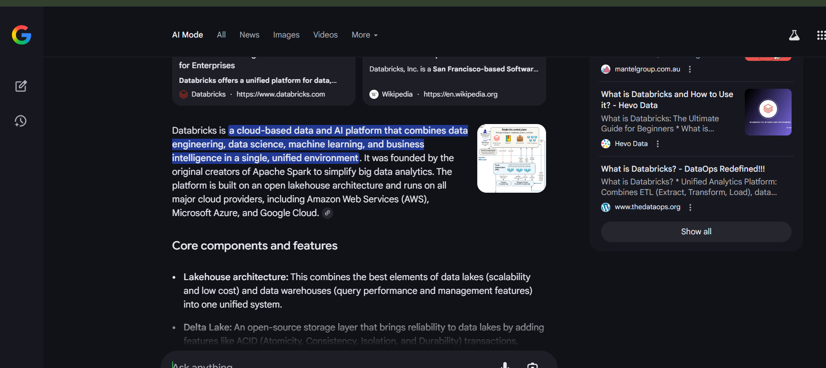

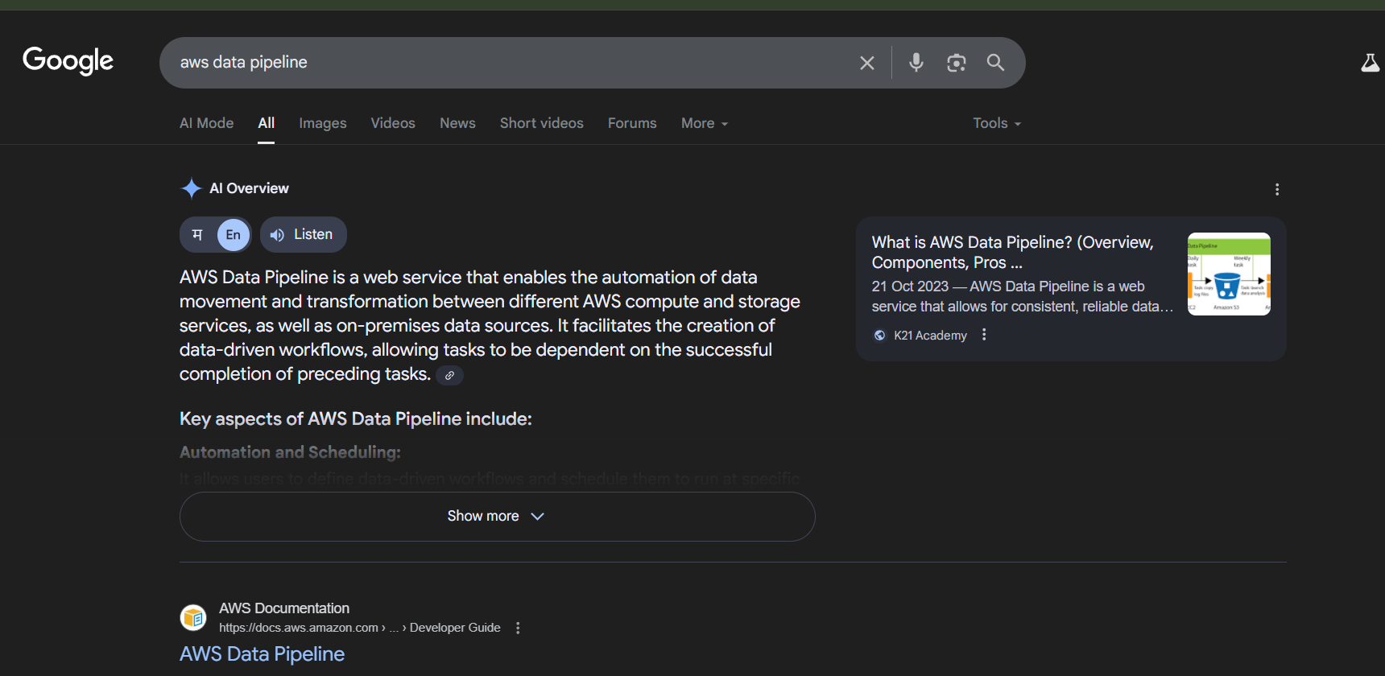

Github Co-pilot:

I used Github Co-pilot extension available in VSCode for code suggestion and error fixing.

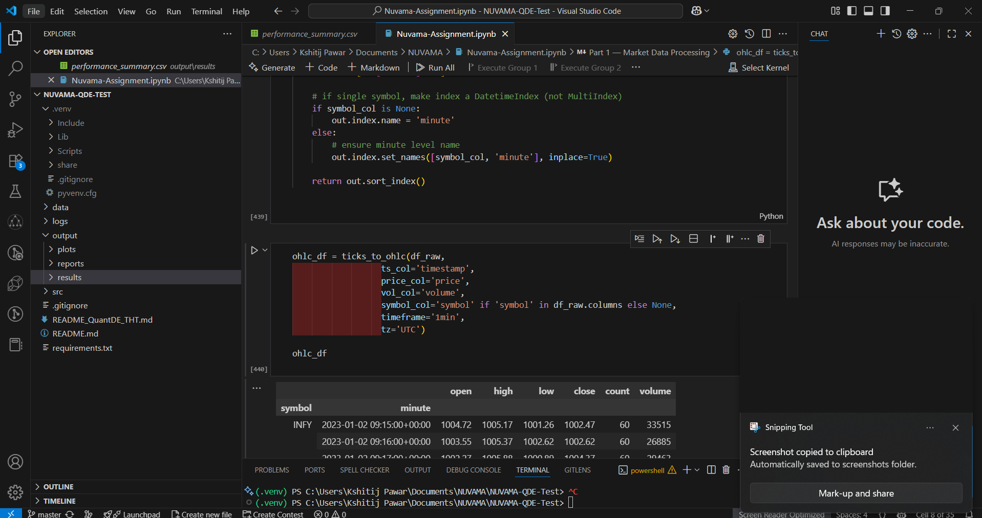

StackOverflow:

I heavely used stack over flow to create an initial prototype i.e. jupyter notebook

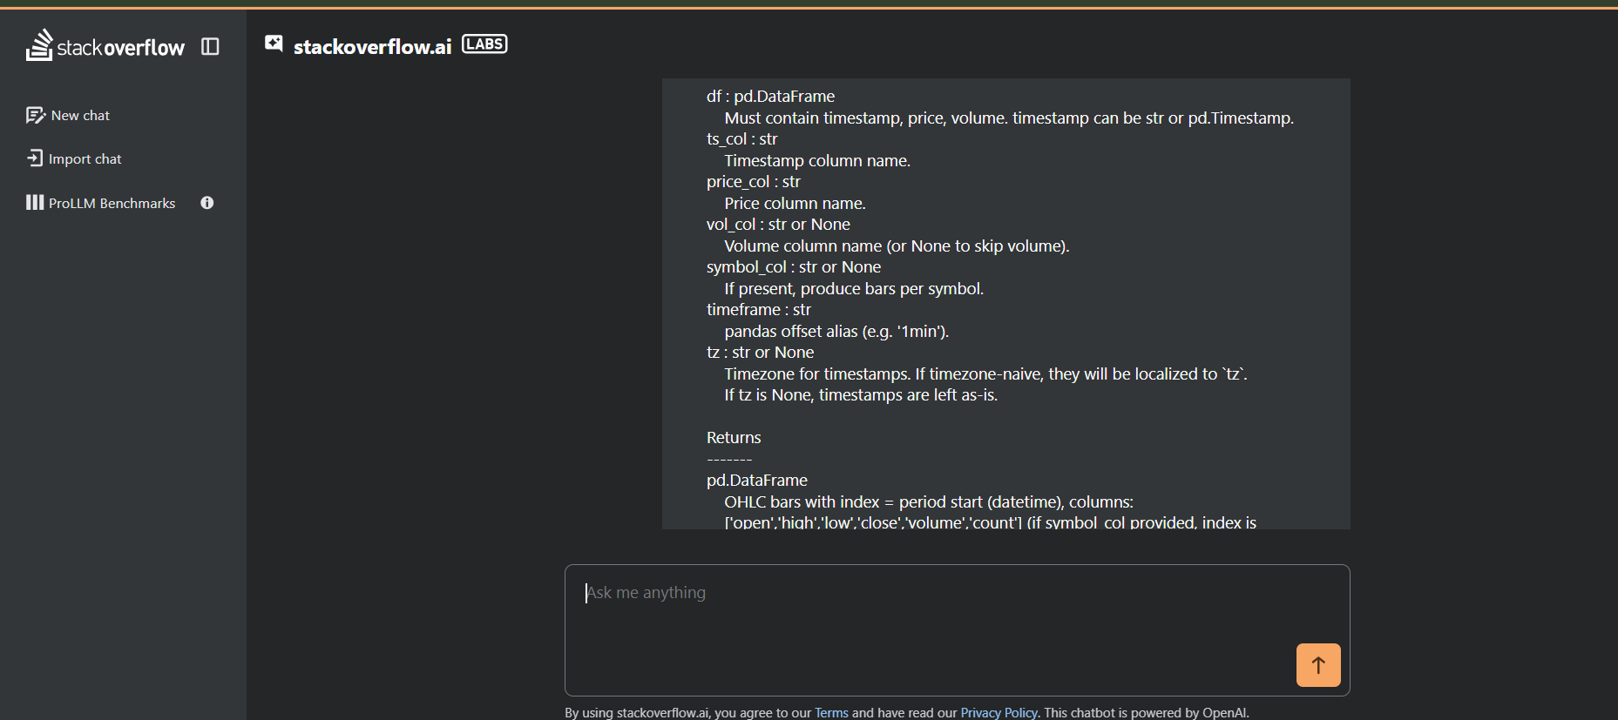

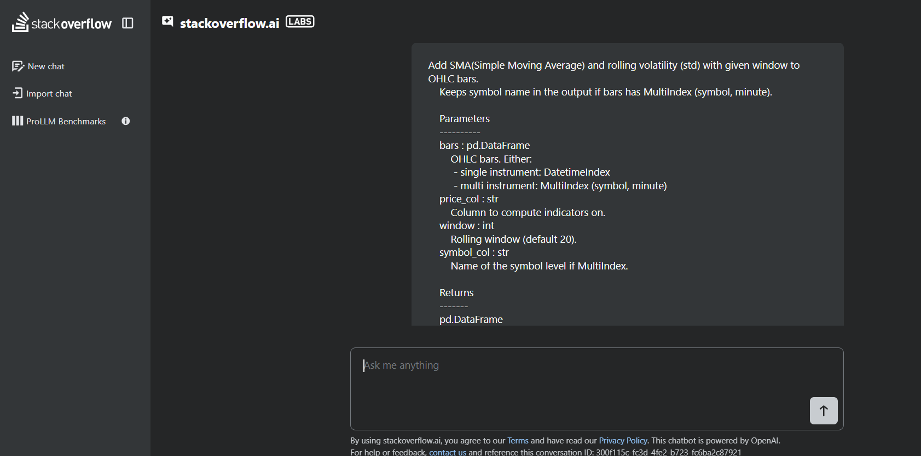

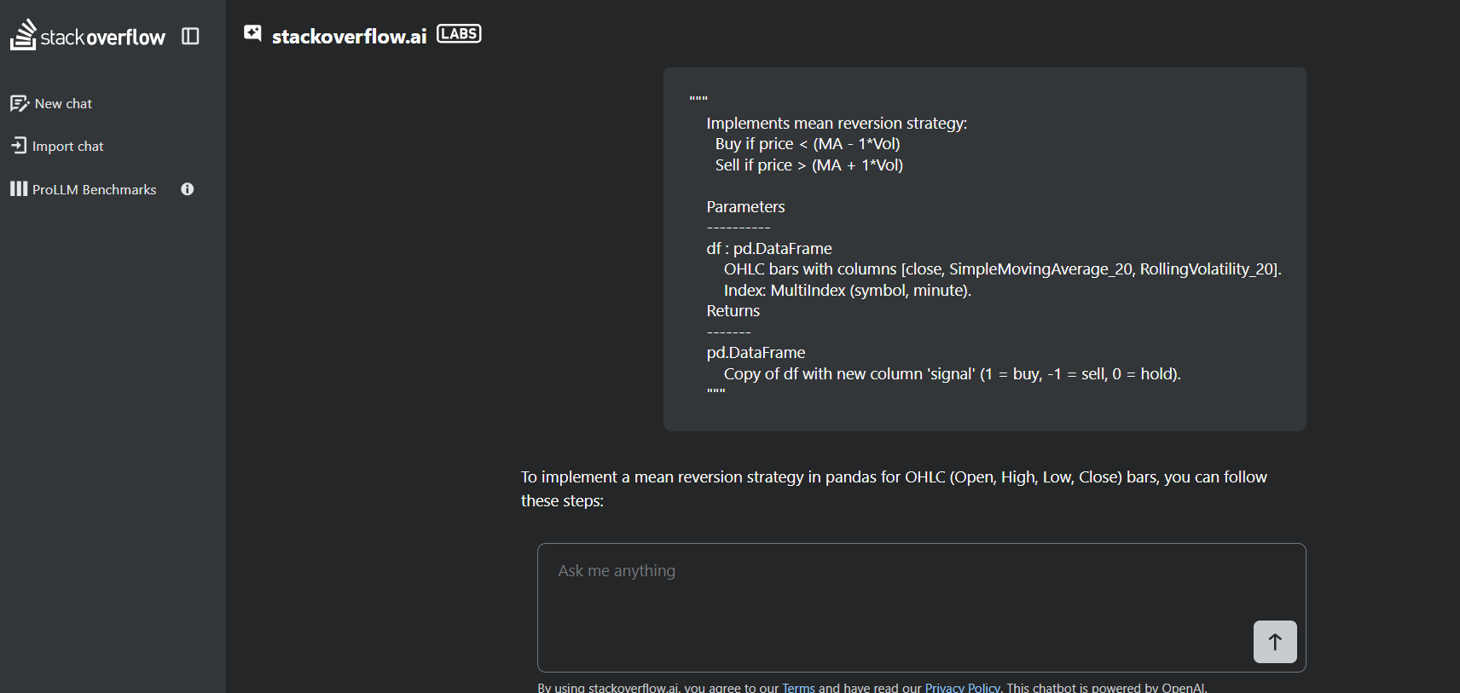

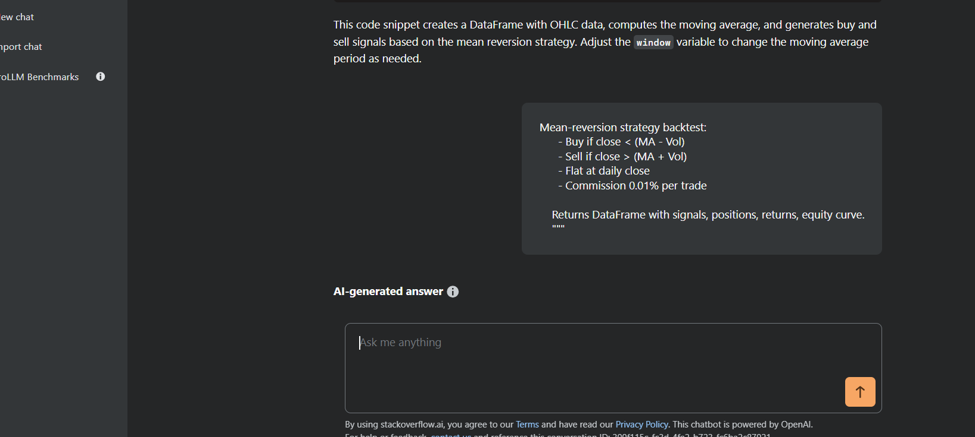

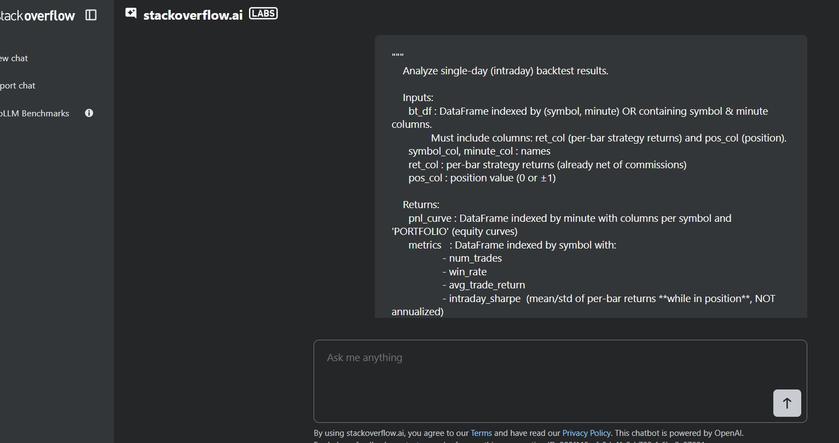

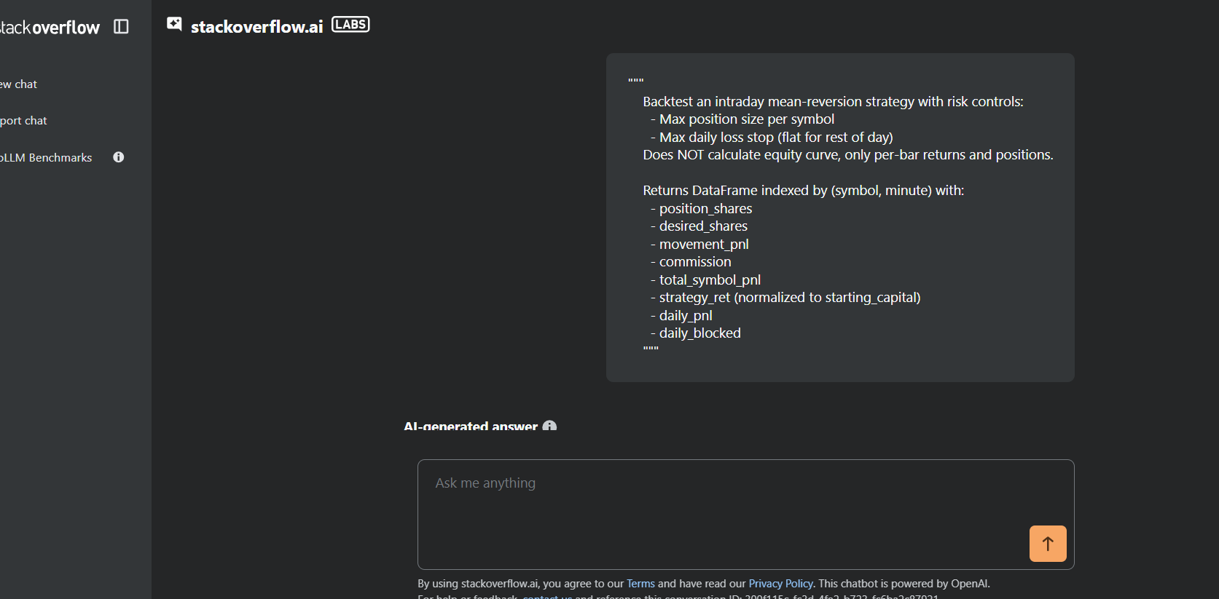

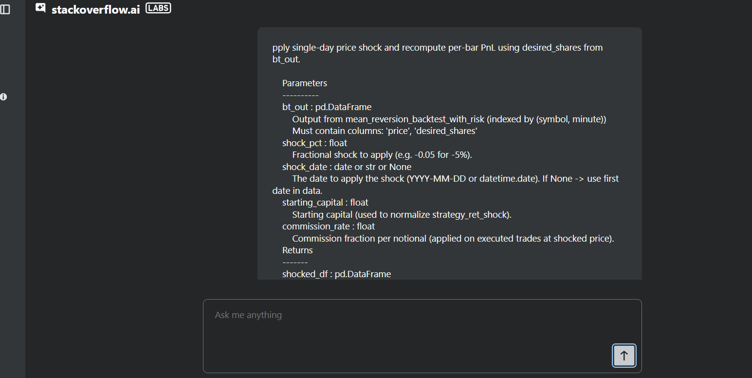

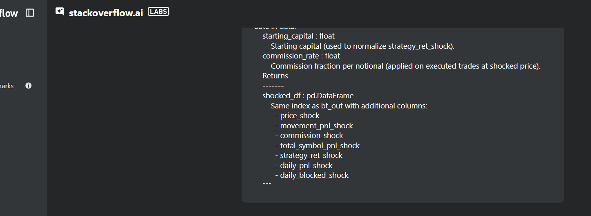

ChatGPT:

I used this to convert the jupyter notebook which I created initially as a prototype to convert into a full fledged project, but it didn’t work. So I had to go step by step.

Chat gpt gave a document with project structure which was not at all practical to implement and it was diverting from the initial requirement of the tasks so I rejected it.

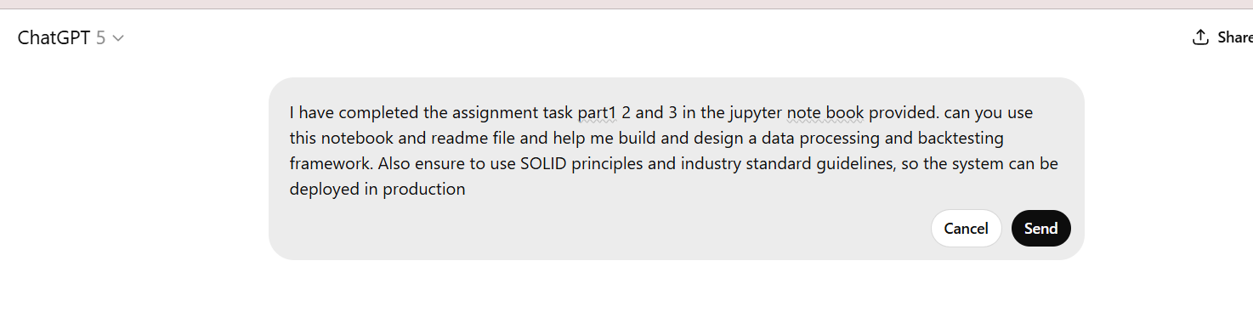

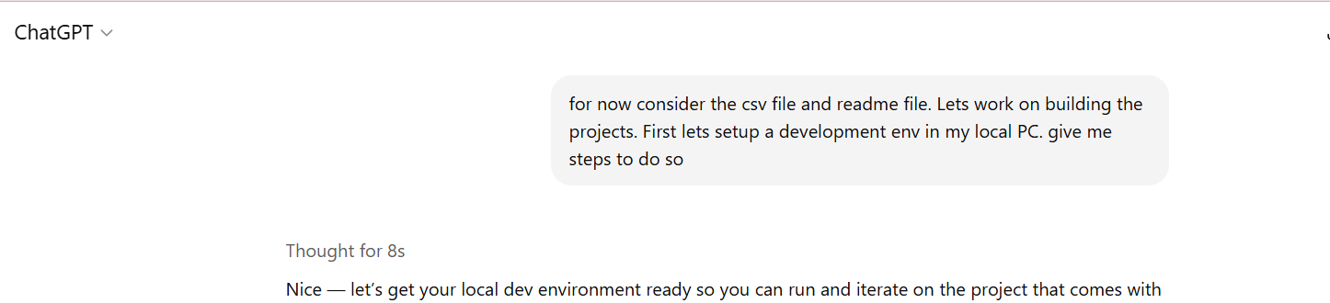

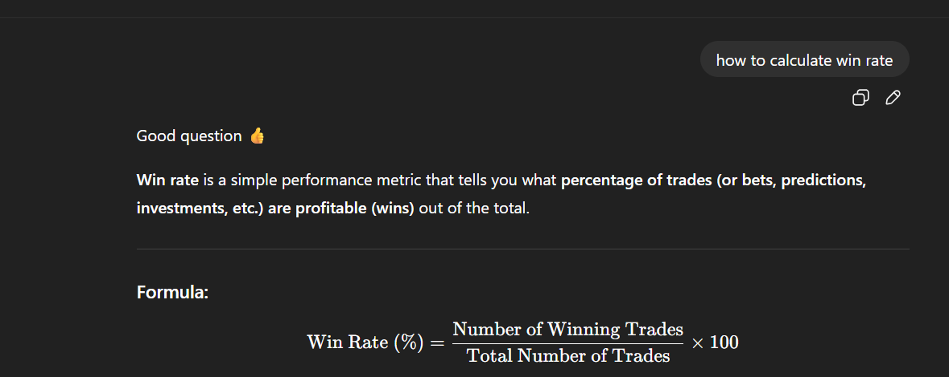

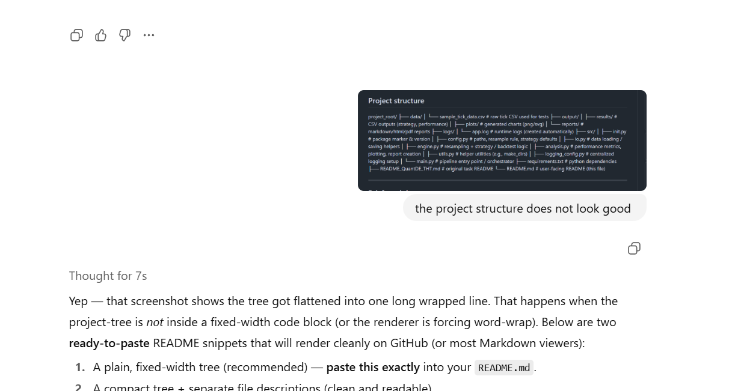

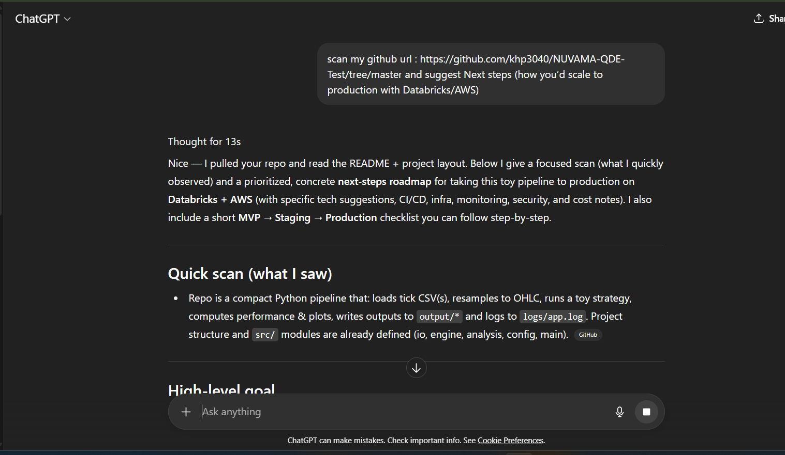

Perplixity:

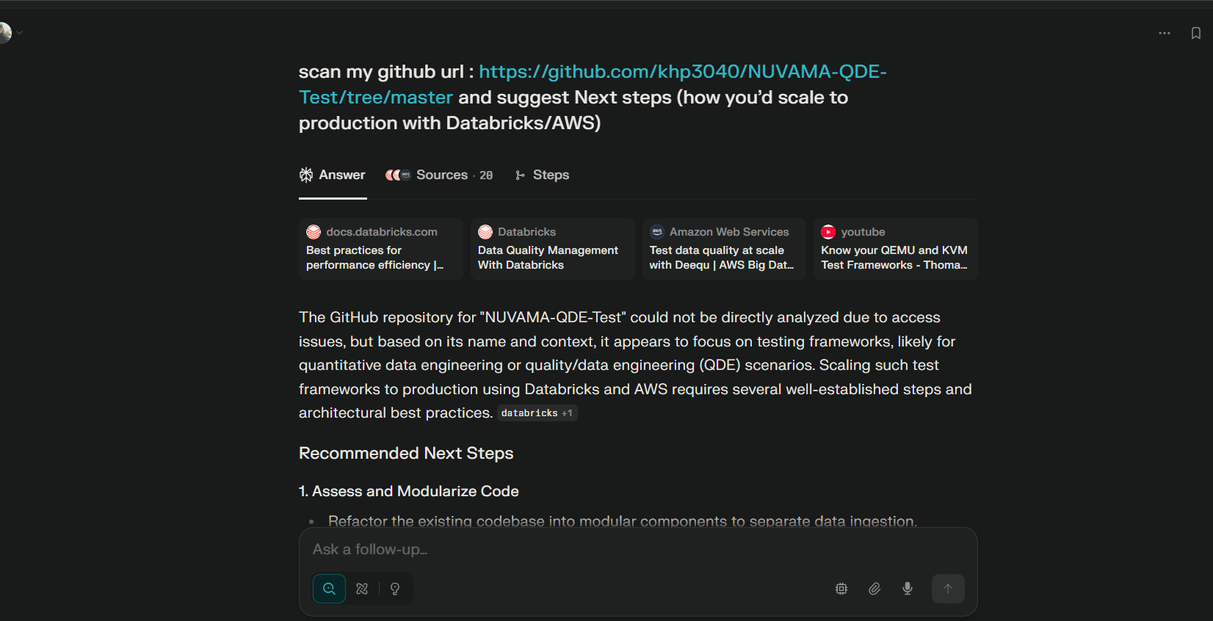

Grok

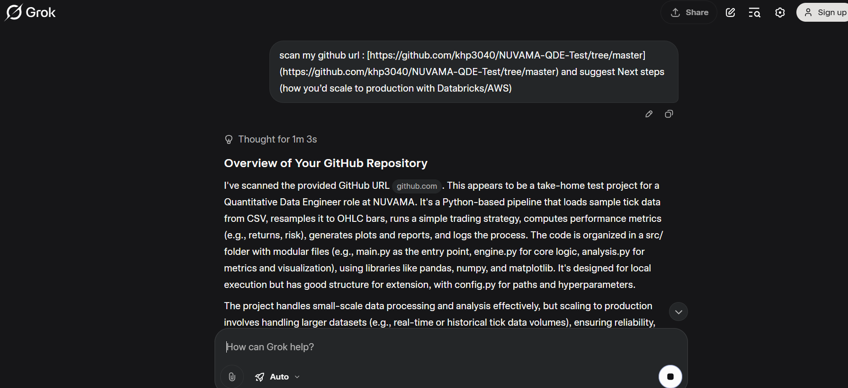

DeepSeek:

