AWS 2

Problem No. 1
Step1: Create an ubuntu instance using EC2
Step 2: Add the following apache starter script in configuration section, advanced details->user data as text

#! /bin/bash
apt-get update
apt-get install -y apache2
cat <<EOF > /var/www/html/index.html
<html><body><h1>Hello World</h1>
<p>This page was created from a simple startup script!</p>
</body></html>
EOF

Step 3: add ssh, http and https rules to security group
Step 4: launch the instance
Step 5: Create Load balancer(Application LB) and target group
Step 6 :Add http port 80 as listener

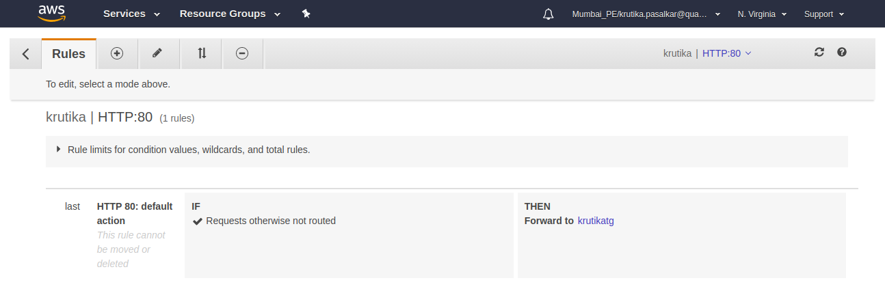
Step 7: Set launch configuration and add new Autoscaling group
Step 8 :Configure the security group rules
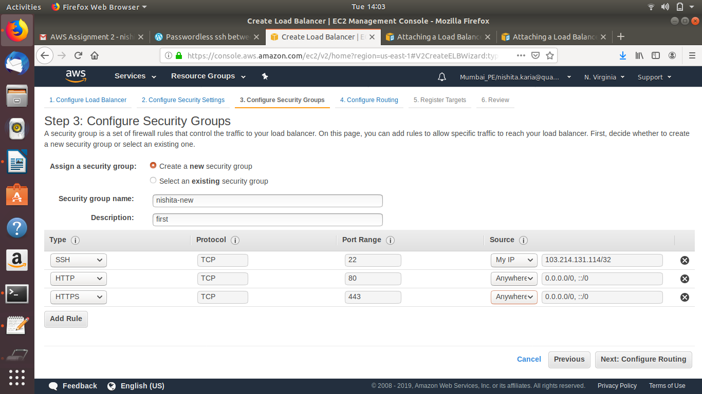

Question 4:

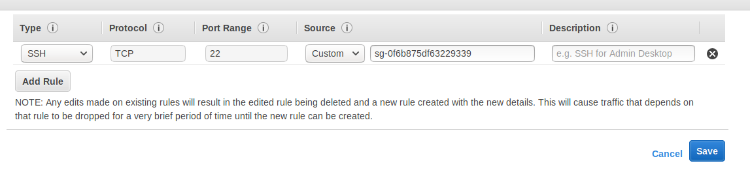
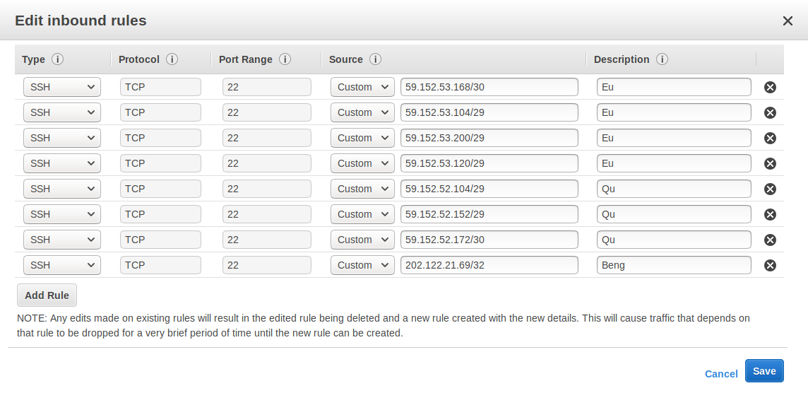

Question No. 5

Step 1.create ec2 instances – they should be in the same subnet and have the same security group
Step 2. Open ports between them – make sure instances can communicate to each other. Use the default security group which has one rule relevant for this case:
Type: All Traffic
Source: Custom – id of the security group
Step 3.Log in to the instance you want to connect from to the other instance
Step 4.ssh-keygen -t rsa -N "" -f /home/ubuntu/.ssh/id_rsa
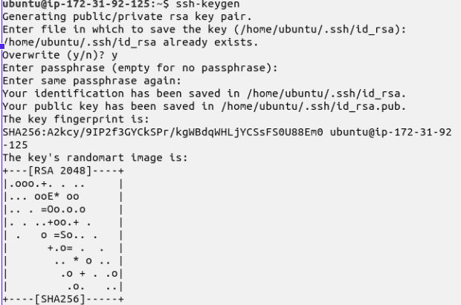
Step 5.Copy your private AWS key as ~/.ssh/my.key (or whatever name you want to use)
Step 6.chmod 600 .ssh/my.key
Step 7.cat ~/.ssh/id_rsa.pub | ssh -i ~/.ssh/my.key ubuntu@10.0.0.X "cat >> ~/.ssh/authorized_keys"
Step 8.ssh 10.0.0.X
