Question 5
1.Create a cloud function
Enter the name
Trigger: Cloud pub/sub
Enter the topic name
Enter the following python code in main.py

from google.cloud import monitoring_v3
import base64
import time
from datetime import datetime
import logging

PROJECT_ID = "pe-training" # Set project id

def cloud_monitoring_report(event, context):
"""
Creates a report of average daily CPU utilization of every instance for each day in the past one week.
:param event: Not used
:param context: Not used
:return: None
"""
client = monitoring_v3.MetricServiceClient()
project_name = client.project_path(PROJECT_ID) # Reports metrics for specific project.
interval = monitoring_v3.types.TimeInterval()
now = time.time()
interval.end_time.seconds = int(now)
interval.end_time.nanos = int(
(now - interval.end_time.seconds) * 10 ** 9) # Find nanoseconds offset.
interval.start_time.seconds = int(now - 604800) # 604800 seconds = 7 days
interval.start_time.nanos = interval.end_time.nanos
aggregation = monitoring_v3.types.Aggregation()
aggregation.alignment_period.seconds = 86400 # 86400 seconds = 1 day
aggregation.per_series_aligner = monitoring_v3.enums.Aggregation.Aligner.ALIGN_MEAN
# Take mean of CPU utilization in one day.

results = client.list_time_series(
project_name,
'metric.type = "compute.googleapis.com/instance/cpu/utilization"',
interval,
monitoring_v3.enums.ListTimeSeriesRequest.TimeSeriesView.FULL,
aggregation)
for result in results:
if len(result.points) >= 5: # Minimum of five days to prevent too much log generation in testing
for point in result.points:
logging.info(point.value.double_value) # CPU Utilization value
logging.info(
datetime.utcfromtimestamp(int(point.interval.start_time.seconds)).strftime('%Y-%m-%d %H:%M:%S'))
logging.info(
datetime.utcfromtimestamp(int(point.interval.end_time.seconds)).strftime('%Y-%m-%d %H:%M:%S'))
# Convert UNIX timestamp to human readable format
logging.info("instance_type={}".format(result.resource.type)) # Type of instance
logging.info("instance_id={}".format(result.resource.labels["instance_id"])) # ID of instance
logging.info("zone={}".format(result.resource.labels["zone"])) # Zone of instance
# TODO: Send Email with this information

Enter the following in requirements.txt

# Function dependencies, for example:
# package>=version
google-cloud-monitoring==0.31.1

Deploy the code and check the logs

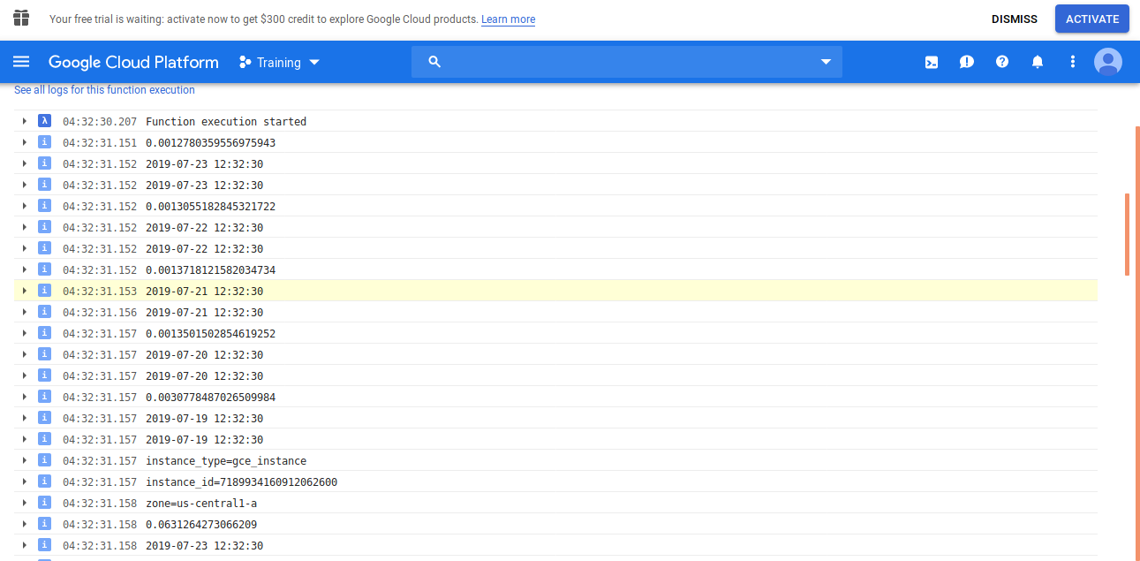

2.Create a scheduler

Create a new job
Add target as pub/sub
Add the topic name
Set the scheduler to 0 9 * * 5 (to trigger every friday)
Click done

