Git

1. created files file1, file2 file3 and added it in git
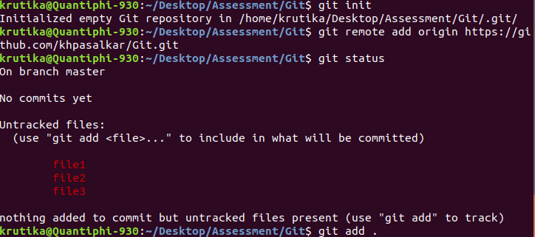
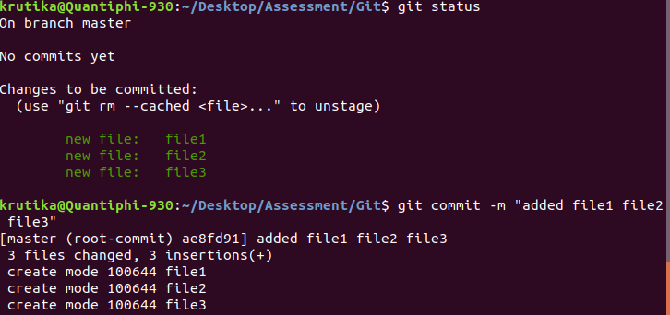

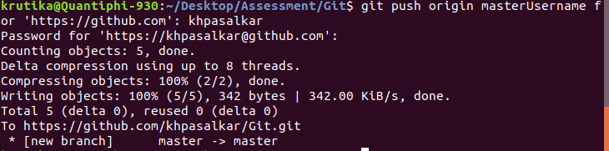

2. cloned git repository, made changes in files and pushed the changes to github

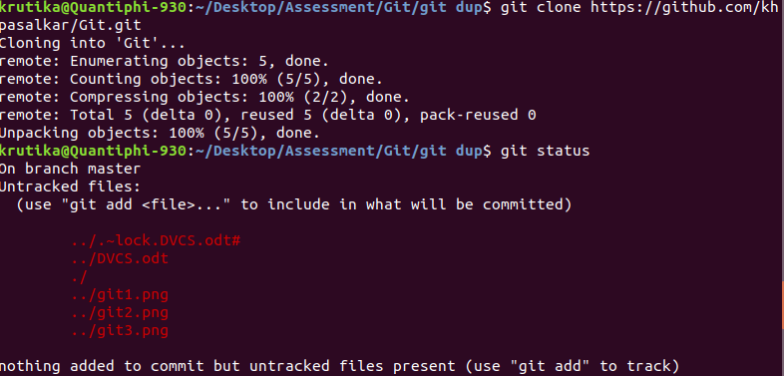
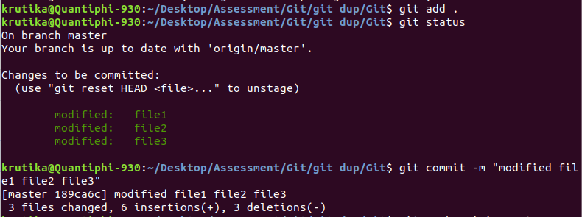
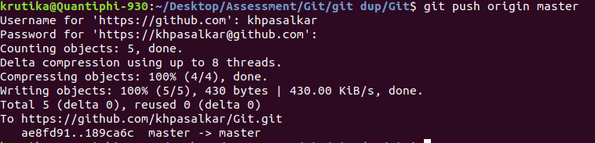
3. file3 has changed in last commit

4. suppose file3 is accidentally added on a DVCS.
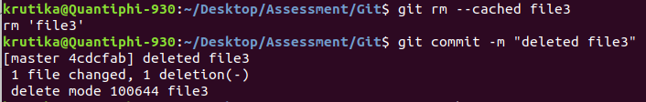
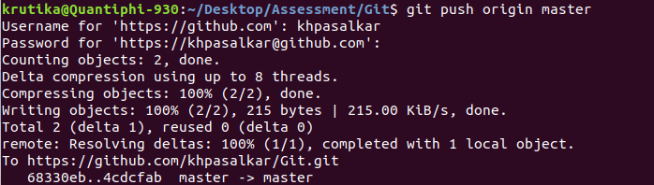
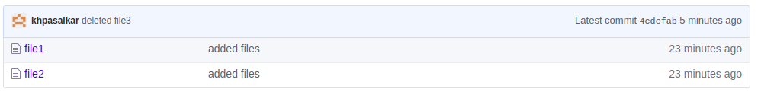

5. suppose file3 was accidently added, hence deleted file3
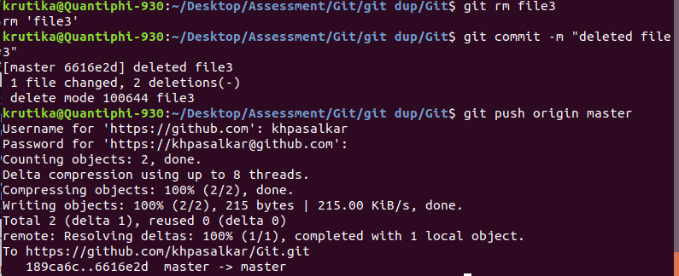

6. merge conflict

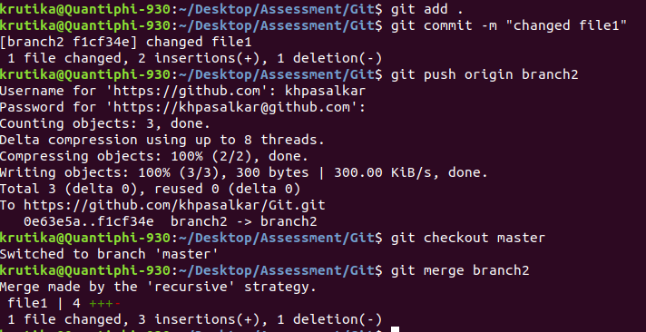
7. cherry-pick

