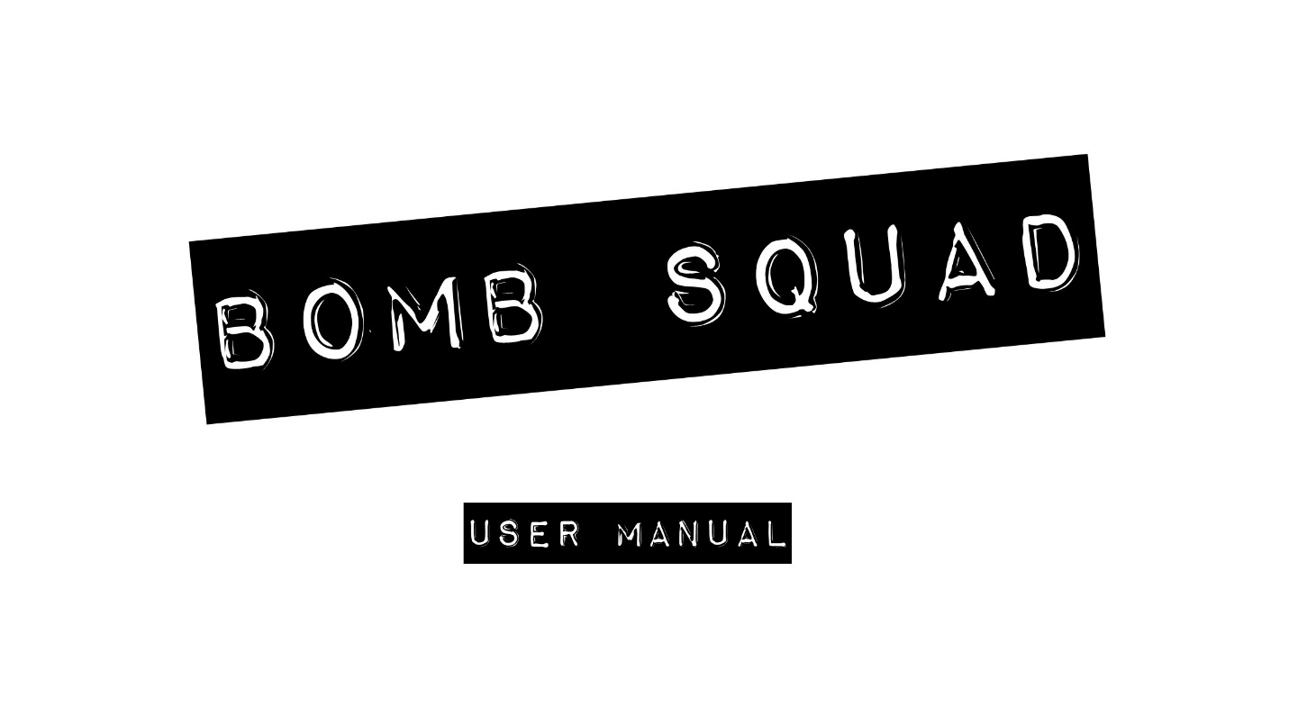

**Bomb Squad Interactive Game Manual**

Bomb Squad is a cooperative game in which the objective is to perform various tasks and solve puzzles on the DE-2 FPGA board with the objective to defuse “the bomb”. The instructions for defusing the bomb will be provided in a game manual. There are two player roles in this game: the technician and the specialist. The technician is the player performing the actions and is not allowed to look at the manual at any time. The specialist is allowed to look at the manual and must verbally communicate with the technician to perform the steps outlined in the manual.

**Login Sequence for the Bomb Squad Game**

The Bomb Squad interactive game is equipped with a credential verifier login sequence designed to authenticate users by entering credentials.

By using the onboard mechanical switches of the FPGA, the bomb squad interactive game can read credentials inputted as an 8 bit binary sequence representation. The operator can use switches SW7 through SW4 to input a binary pattern that represents the operator’s ID and switches SW3 through and SW0 to input the password. The switches positions are shown below:

|  |  |  |  |  |  |  |  |
| --- | --- | --- | --- | --- | --- | --- | --- |
| On | On | On | On | On | On | On | On |
| Off | Off | Off | Off | Off | Off | Off | Off |

SW7 SW6 SW5 SW4 SW3 SW2 SW1 SW0

MSB LSB

**Input Credentials**

To input credentials, the user just need to move the mechanical switches to their on or off position following the binary sequence for their id and password, then press the submit button and wait for the LCD to show a message informing if the credentials verification failed or succeeded.

To input your credentials follow the next steps:

* Look for your credentials in the Bomb Squad interactive game manual
* Move the switches to the on or off position whenever there is a binary 1 or binary 0 in the credentials respectively
* Press the submit button KEY[1]
* Wait for a verification message in the LCD

The bomb squad interactive game comes preloaded with 4 user profiles. To play in each profile, the user needs to input their respective credentials. The preloaded user profiles and their respective credentials are shown below

Table 1 preloaded user credentials

|  |  |  |
| --- | --- | --- |
|  | ID | PASSWORD |
| Katherine Perez | 1100 | 1100 |
| Sergio Silva | 0011 | 0011 |
| Daniel Lopez | 1101 | 0001 |
| Rafael Campos | 0100 | 1110 |

The game begins when the verification process succeeds and the seven segment display timer start the countdown for “explosion”.

**Playing with the Bomb Squad Game**

The Bomb Squad interactive game is a cooperative game for up to two players. Player one is denoted as the operator (technician) of the bomb and player two will be in charge of the game manual. The game manual contains a log of all the possible puzzles in the game and the instructions about how to solve them.

Once the timer start counting down, the game starts and four seven segment displays in the board will show random patterns, at this point the operator has to describe the pattern shown by the seven segment displays to player two. Player two has to search in the manual log for instructions to solve the puzzle. The instructions are input codes patterns that the operator has to enter to clear a Stage. In order to diffuse the bomb, the players need to clear a total of 3 stages without making any mistake. When the bomb is diffused, the LCD will show the message “bomb deactivated” and the game will start again in the next difficulty level. The bomb squad game has a total of 10 difficulty levels and each will set a smaller time window to diffuse the bomb. If the operator makes a mistake, input the wrong diffusing code or the time runs out, the LCD will show the message “bomb detonated” and the game will be over. After a game over, the players need to press the reset button to restart the game.

In order for the operator to input the diffusing codes, the Bomb Squad game has two onboard push buttons designated as the “rotate” button and the “verify” button. The rotate button will change position of the cursor in a seven segment display. The verify button sends a signal to the Bomb Squad game controller to check if the position entered is correct. If the entered position is correct, the game transitions the operator to control to the next seven segment display. If the entered position is incorrect, the game is over.

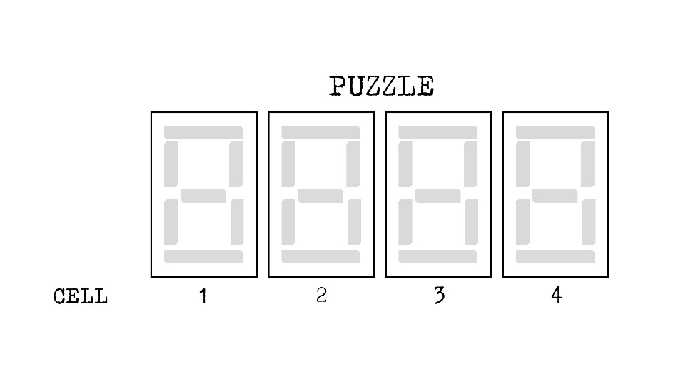**Patterns**

* A pattern will quickly appear and disappear. Enter the correct sequence on the display.
* Press the verify button to move to the next cell.
* Entering the incorrect sequence will result in an explosion.

**Stage 1:**

If cell 2 displays: Enter:

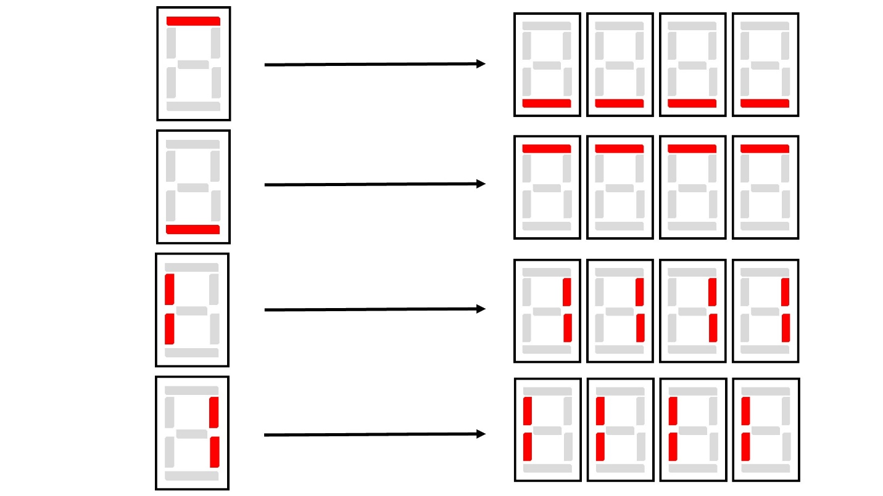

**Stage 2:**

If cell 4 displays:

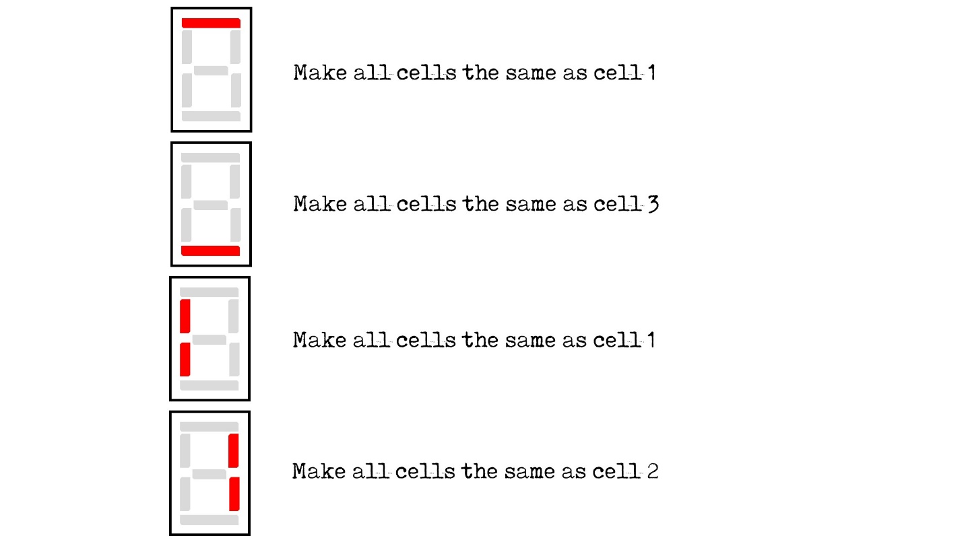

**Stage 3:**

If cell 1 displays:

