

**Login Sequence for the Bomb Squad Game**

The Bomb Squad interactive game was equipped with a login verifier sequence designed to identify the user by the input of credentials.

By using the onboard mechanical switches of the FPGA, the bomb squad interactive game can read credentials inputted as an 8 bit sequence representation. The operator can use switches SW7 through SW4 to input a binary pattern that represents the operator’s ID and switches SW3 through and SW0 to input the password. The switch formation is shown below:

|  |  |  |  |  |  |  |  |
| --- | --- | --- | --- | --- | --- | --- | --- |
| On | On | On | On | On | On | On | On |
| Off | Off | Off | Off | Off | Off | Off | Off |

SW7 SW6 SW5 SW4 SW3 SW2 SW1 SW0

MSB LSB

**Input Credentials**

To input credentials, users just need to flip the mechanical switches to their on or off positons following the binary sequence for their id and password, then press the submit button and wait for the LCD to show a message informing if the credentials verification failed or succeeded.

To input your credentials follow the next steps:

1. Look for your credentials in the Bomb Squad interactive game manual
2. Move the switches to the on or off position whenever there is a binary 1 or binary 0 in the credentials respectively
3. Press the submit button KEY[1]
4. Wait for a verification message in the LCD

The bomb squad interactive game comes preloaded with 4 user profiles. To play in each profile, the user needs to input their respective credentials. The preloaded user profiles and their respective credentials are shown below

Table 1 preloaded user credentials

|  |  |  |
| --- | --- | --- |
|  | ID | PASSWORD |
| Katherine Perez | 1100 | 1100 |
| Sergio Silva | 0011 | 0011 |
| Daniel Lopez | 1101 | 0001 |
| Rafael Campos | 0100 | 1110 |

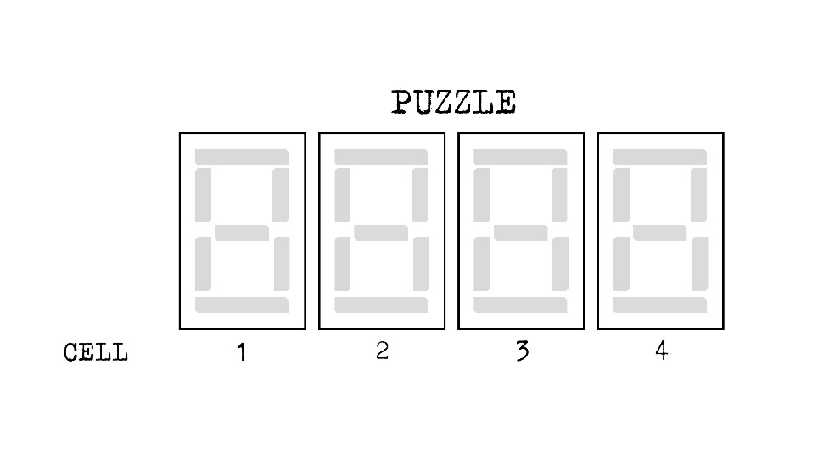**Patterns**

* A pattern will quickly appear and disappear. Enter the correct sequence on the display.
* Press the verify button to move to the next cell.
* Entering the incorrect sequence will result in an explosion.

**Stage 1:**

If cell 2 displays: Enter:

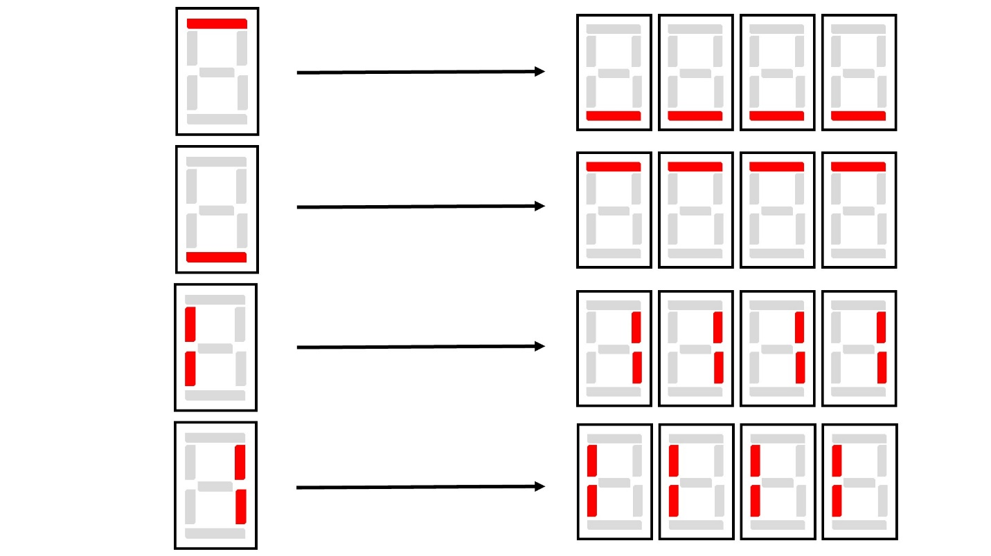

**Stage 2:**

If cell 4 displays:

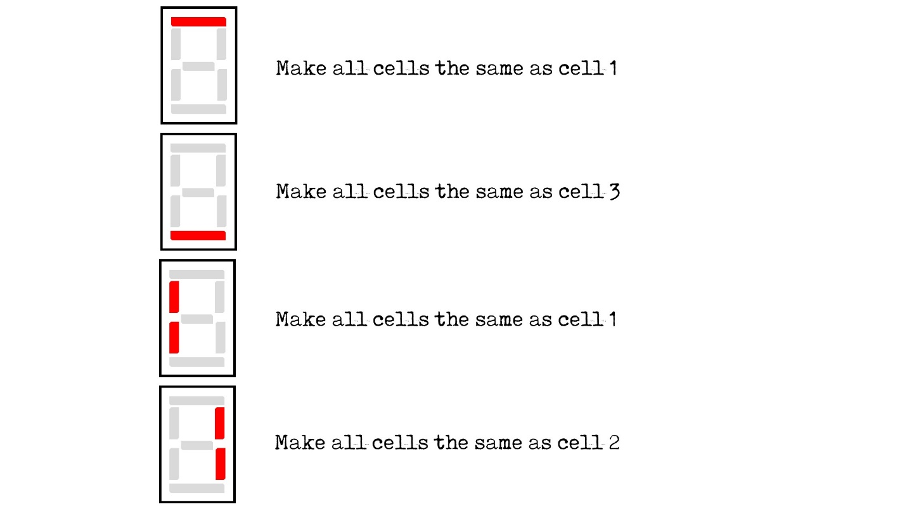

**Stage 3:**

If cell 1 displays:

