**HOSTEL MANAGEMENT SYSTEM**



**Submitted By:  
MUHAMMAD REHAN: 52036  
 Session: 2020-2024**

**MUHAMMAD UMAIR: 52075  
 Session: 2020-2024**

**ALI HASSAN: 52022**

**Session: 2020-2024**

**Supervised By:   
DR. MUHAMMAD ALI SHAH**

**Institute of Computing and Information Technology**

**Gomal University, Dera Ismail Khan**

**APPROVAL CERTIFICATE**

This certifies that Muhammad Rehan, Muhammad Umair, and Ali Hassan Baloch have successfully completed their Final Year Project (FYP) at the Department of Computing & Software Engineering, Gomal University, Dera Ismail Khan. The Project Report submitted by them is hereby approved in partial fulfillment of the requirements for the degree of Bachelor of Science in Software Engineering (BSSE).

### Supervisor

Dr. Ali Shah

Gomal Unversity, Dera Ismail Khan

### Externals

Dr. Muhammad Ali Shah

Gomal Unversity, Dera Ismail Khan

Dr. Syeda Rabail Zahra

Gomal Unversity, Dera Ismail Khan

### Director DCSE

Dr. Husain Ahmad Marwat

Gomal Unversity, Dera Ismail Khan

**ACKNOWLEDGEMENT**

I would like to express my sincere gratitude to all those who have contributed to the successful completion of this project.

First and foremost, I extend my deepest appreciation to my supervisor, **DR.MUHAMMAD ALI SHAH**, for their invaluable guidance, unwavering support, and insightful feedback throughout the development of this project. Their expertise and encouragement have been instrumental in shaping the direction and scope of this research.

I am also grateful to the faculty members of the Department of ICIT at Gomal University, Dera Ismail Khan, for their academic mentorship and encouragement during my undergraduate studies. Their dedication to fostering a stimulating learning environment has played a pivotal role in my academic and professional growth.

I extend my heartfelt thanks to my classmates and friends for their camaraderie, encouragement, and moral support throughout the course of this project. Their constructive feedback and collaborative spirit have been invaluable in overcoming challenges and achieving milestones.

I am deeply indebted to my family for their unwavering love, encouragement, and sacrifices. Their unconditional support and belief in my abilities have been a constant source of motivation and inspiration.

Last but not least, I would like to express my gratitude to all the developers, researchers, and authors whose work has laid the foundation for this project. Their innovative ideas, groundbreaking research, and open-source contributions have been instrumental in shaping the landscape of technology and academia.

In conclusion, I am immensely grateful to everyone who has contributed to this project in one way or another. Your support and encouragement have been indispensable, and I am truly appreciative of the opportunity to undertake this endeavor.

**Muhammad Rehan**

**Muhammad Umair**

**Ali Hassan Baloch**

# **Index of content**

**Chapter#1 Project In Brief** **01**

* 1. : Objective and Goals
  2. : Tools Used

**Chapter# 2 Why PHP** **02**

**Chapter#3 The Existing System** **04**

* 1. **:** Disadvantages of Manual system
  2. **:** The Proposed system

**3.3:** Advantages

**Chapter#4 Introduction To Hostel Management System (HMS)** **06**

**4.1:** Purpose

**4.2:** Objectives

**4.3:** Scope Of Objectives

**4.4:** Overview Of Project

**Chapter#5 Overall Description** **07**

**5.1:** System Requirements

**5.2:** Technology Used

**Chapter#6 User Requirement Definition** **09**

**6.1:** Less Human Error

**6.2:** Reduction Of Manual Labor Strain

**6.3:** High Security

**Chapter#7 System Requirement Specifications** **11**

**7.1:** Functional System Requirements

**7.2:** Non**-**Functional System Requirements

**Chapter#8 Hardware Requirements** -------------------------------------------------------**13**

**ABSTRACT**

In an era where digital transformation is reshaping traditional systems, the need for modernizing hostel management practices has become paramount. The Hostel Management System project addresses this necessity by introducing a comprehensive solution that streamlines hostel operations through automation and digitization.

Gone are the days of cumbersome manual processes and paperwork. With this system, hostel administrators can bid farewell to time-consuming tasks such as manual record-keeping, room allocation, and fee management. By leveraging the power of technology, the project aims to revolutionize the way hostels are managed, ushering in an era of efficiency, accuracy, and convenience.

The project's significance lies in its ability to overcome the limitations of traditional hostel management methods. By embracing digital tools and online platforms, the system ensures transparency, accessibility, and data integrity. It empowers both hostel administrators and residents with user-friendly interfaces and real-time access to information, thereby enhancing overall operational efficiency and service quality.

In essence, the Hostel Management System project marks a departure from outdated practices and heralds a new era of hostel management characterized by innovation, effectiveness, and adaptability to the evolving needs of educational institutions. It is not merely a technological upgrade but a transformative journey towards modernity and excellence in hostel administration.

**METHADOLOGY**

The development of the Hostel Management System using PHP follows a structured approach aimed at ensuring the project's success and meeting the specified requirements. The methodology encompasses the following phases:

1. **Requirements Analysis:**

* The project begins with a comprehensive analysis of the requirements gathered from stakeholders, including students, hostel managers, and administrators.
* Detailed discussions and interviews are conducted to understand the functional and non-functional requirements of the system, such as user roles, features, security, and performance expectations.

1. **Planning and Design:**

* Based on the gathered requirements, the project team creates a detailed project plan outlining the scope, timeline, resources, and deliverables.
* Architectural and database designs are developed to define the system's structure, including the database schema, user interfaces, and system components.
* Wireframes and prototypes may be created to visualize the user interface and gather feedback from stakeholders before proceeding with development.

1. **Development:**

* The development phase involves the implementation of the system according to the defined designs and specifications.
* Using PHP as the primary programming language, developers write code to create the various modules, functionalities, and components of the Hostel Management System.
* Development follows best practices and coding standards to ensure code quality, maintainability, and scalability.

1. **Testing and Quality Assurance:**

* Rigorous testing is conducted throughout the development process to identify and address defects, bugs, and inconsistencies in the system.
* Unit testing, integration testing, and system testing are performed to verify the functionality, performance, and reliability of the system.

Quality assurance measures are implemented to ensure that the system meets the defined requirements and adheres to industry standards and best practices.

1. **Deployment and Implementation:**

* Once development and testing are complete, the Hostel Management System is deployed to the production environment.
* The deployment process involves installing and configuring the system on the server, setting up databases, and performing any necessary data migrations.
* Training sessions may be conducted for end-users, including students, hostel managers, and administrators, to familiarize them with the system and its features.

1. **Maintenance and Support:**

* Following deployment, ongoing maintenance and support are provided to address any issues, bugs, or enhancements that arise post-launch.
* Regular updates and patches may be released to improve system performance, address security vulnerabilities, and introduce new features based on user feedback and evolving requirements**.**

**PROJECT IN BRIEF**

**Project Title**: **Hostel Management System.**

**Objective:**

The objective of the Hostel Management System project is to develop a comprehensive web-based application that facilitates efficient management of hostel operations. The system aims to automate various processes involved in hostel management, including student registration, room allocation, fee management, and maintenance of records. By providing a user-friendly interface and robust functionalities, the system seeks to enhance the overall efficiency, transparency, and convenience of hostel administration.

**Undertaken By:**

Muhammad Rehan, Muhammad Umair, Ali Hassan

**Supervised By:**

Dr. Muhammad Ali Shah, Lecturer ICIT, Gomal University, Dera Ismail Khan

**Starting Date:** 02-02-2024

**Ending Date:** 22-05-2024

**Tools Used:**

* **HTML**
* **CSS**
* **Bootstrap**
* **Javascript**
* **PHP**

**WHY PHP**

1. **MVC Architecture**: PHP, particularly when used with frameworks like Laravel, follows the MVC architecture, facilitating organized code structuring and separation of concerns. This makes it easier to manage and scale PHP projects, including POS systems, by keeping the business logic separate from the presentation layer.
2. **Database Interaction:** PHP provides robust database interaction capabilities, allowing seamless integration with databases such as MySQL or PostgreSQL. This is essential for POS systems, where efficient handling of transaction data and inventory management is critical.
3. **Security Features:** PHP offers a range of security features, including built-in functions for handling user input validation, preventing SQL injection, and implementing secure authentication mechanisms. These features are crucial for ensuring the security of sensitive transaction data in a POS system.
4. **Rapid Development:** PHP, with its vast ecosystem of libraries and frameworks, enables rapid development of POS systems. Frameworks like Laravel provide pre-built components and tools for common functionalities, speeding up the development process and reducing time to market.
5. **Scalability:** PHP is highly scalable, allowing POS systems to accommodate growing business needs, such as increased transaction volume or additional features. With proper architecture and design patterns, PHP-based POS systems can easily scale to handle larger operations.
6. **Flexibility:** PHP offers flexibility in terms of deployment options, allowing POS systems to be deployed on various platforms, including shared hosting, virtual private servers, or cloud platforms. This flexibility makes PHP suitable for businesses of all sizes and budget.
7. **Community Support:** PHP has a large and active community of developers and contributors who continuously improve the language and its ecosystem. This community support ensures that PHP-based POS systems remain up-to-date with the latest security patches, performance improvements, and feature enhancements.
8. **Cost-Effectiveness:** PHP is open-source and free to use, making it a cost-effective choice for developing POS systems, especially for small and medium-sized businesses. The low barrier to entry and availability of free resources contribute to the affordability of PHP-based solutions.
9. **Compatibility:** PHP is compatible with various operating systems, web servers, and databases, providing developers with the flexibility to choose the technology stack that best suits their project requirements. This compatibility ensures smooth integration with existing infrastructure and technologies.
10. **Performance Optimization**: PHP offers numerous performance optimization techniques, such as opcode caching, database query optimization, and code profiling. These optimization techniques help improve the performance and responsiveness of PHP-based POS systems, ensuring a smooth user experience even under heavy load.

# **The Existing System**

Before developing a computerized system, we analyze the existing manual system to identify its flaws and inadequacies. This step is crucial because it enables us to create a new system that is free from the shortcomings of the current one.

# **Disadvantages of Manual system**

Certainly, here is a concise list of the disadvantages of manual sales systems:

* + Time-consuming operations leading to slower customer service.
  + Increased risk of human error in transactions and record-keeping.
  + Limited capacity for data analysis making strategic decisions challenging.
  + Difficulties scaling operations as business grows.
  + Inefficient inventory management often results in overstocking or stockouts.
  + Lack of integration with other business systems like accounting or CRM.
  + Higher security risks due to physical storage of sensitive information.
  + Compliance challenges with financial regulations and tax laws.

# **The Proposed system**

A computerized Point of Sale (POS) system can effectively resolve the issues inherent in the existing manual sales processes. Due to the numerous limitations of manual transaction and record-keeping methods, computerizing the POS system leads to a faster, more efficient, and user-friendly solution. This advancement not only streamlines daily business operations but also enhances accuracy and improves the overall customer experience.

# **Advantages**

* + **Increased Efficiency:** Automates and speeds up sales transactions.
  + **Accurate Record-Keeping:** Reduces human errors in transaction logging.
  + **Enhanced Inventory Management:** Provides real-time inventory updates and alerts.
  + **Comprehensive Reporting:** Generates detailed sales and inventory reports.
  + **Improved Customer Management:** Maintains detailed customer profiles.
  + **Employee Management:** Monitors employee performance and schedules.
  + **Multi-Location Management**: Coordinates operations across multiple locations.
  + **Reduced Costs:** Cuts down on excess inventory and operational inefficiencies.
  + **Increased Payment Capabilities:** Supports various payment methods.
  + **Enhanced Security:** Protects against theft and ensures data privacy.
  + **Scalability:** Adapts to growth, accommodating new products and locations.
  + **Better Customer Experience:** Provides faster and more reliable service.

1. **Introduction**

# **Purpose:**

The Software Requirements Specification (SRS) will provide a detailed description of requirements for the Hostel Management System (HMS). This SRS will be helpful for complete understanding what is to be expected from the newly introduced system which is to be constructed. The clear understanding of the system and its functionality will allow for the correct software to be developed for the end user and will be used for the development of the future stages of the project.This SRS will provide the foundation of the project. From this SRS, the Hostel Management System can be designed, constructed and finally tested.

The Project team will use the SRS to fully understand the expectations of the HMS to construct the appropriate software. The hostel end users will be able to use the SRS as a “test” to see if the constructing team will be constructing the system to their expectations.

**Objectives:**

* + - To deal with Hostel Management System in an easy and an efficient manner.
    - Create strong and secrete database that allow for any connection in a secret way, to prevent any outside or inside attacks.

**Scope Of The Project:**

* + - Hostel Management System is designed for Hostel (like schools, Universities).
    - There will be predefined criteria for the Reservation to the hostels.

He/She checks the attested application forms of the students obtained from the internet and verify it with the student database.

* + - If the students are found eligible then they are allotted to the hostel Room.

**Overview Of Project:**

Hostel Room Allocation System is a web application which aims at computerization of current procedure of allocating hostel rooms. Currently the process involves students filling up the forms and submitting them in respective hostel offices which involves a lot of paperwork, hence less efficient.

1. **Overall Description:**

**System Requirements**

The Web Application has two main parts:

1. Hostel Administrators

This section of the web application is dedicated to hostel administrators, providing them with comprehensive tools for managing hostel operations efficiently. Administrators can oversee student admissions, room allocations, and facility maintenance, ensuring smooth functioning of the hostel.

1. Students

The student interface offers a user-friendly platform for hostel residents to access essential services and information. Students can submit accommodation applications, view room assignments, and communicate with hostel authorities, enhancing their overall hostel experience and convenience.

The student can select among the allocated hostel to a specified batch and the Hostel Administrator can assign the room number in the specific hostel that the student has selected upon the availability.

**Technology Used**

The Hostel Management System project utilized several programming languages and technologies to develop a comprehensive web application. The languages used include:

1. HTML (Hyper-Text Markup Language): Used for creating the structure and content of web pages, including forms, text, images, and links.
2. CSS (Cascading Style Sheets): Employed for styling and formatting the appearance of web pages, including layout, colors, fonts, and spacing.
3. JavaScript: Utilized for adding interactivity and dynamic behavior to web pages, such as form validation, event handling, and user interface enhancements.
4. PHP (Hypertext Preprocessor): Employed as a server-side scripting language for processing data, interacting with databases, and generating dynamic content on web pages.
5. SQL (Structured Query Language): Used for managing and manipulating data within the MySQL database, including querying, inserting, updating, and deleting records.
6. MySQL: Employed as the relational database management system (RDBMS) for storing and organizing data related to hostel management, such as student information, room allocations, and application statuses.

These languages and technologies collectively contribute to the functionality, usability, and reliability of the Hostel Management System, enabling seamless management of hostel-related operations and enhancing the user experience for administrators and students alike.

1. **User Requirements Definition :**

The user requirement definition for the hostel management system encompasses several key aspects aimed at enhancing user experience and system functionality. Firstly, it emphasizes the need for a user-friendly interface that simplifies navigation and facilitates efficient task execution for users with varying levels of technical proficiency. Secondly, it underscores the importance of comprehensive reporting functionality, enabling users to access detailed reports, analytics, and insights to support data-driven decision-making and performance evaluation.

**Less Human Error**

In order to enhance the efficiency of hostel management, the system should minimize human errors by automating repetitive tasks such as room allocation, fee management, and student information updates. This will ensure accuracy in data entry and processing, leading to improved decision-making and operational effectiveness.

**Reduction of Manual Labor Strain:**

The system should alleviate the physical and mental strain associated with manual hostel management tasks such as record-keeping, room allocation, and student registration. By automating these processes, administrators and staff members can focus on more strategic aspects of hostel management, leading to increased productivity and job satisfaction.

**High Security:**

Security is paramount in hostel management systems to safeguard sensitive student information, financial transactions, and administrative operations. The system should incorporate robust authentication mechanisms, access controls, and data encryption protocols to prevent unauthorized access, data breaches, and cyber threats. Additionally, regular security audits and updates should be conducted to maintain the integrity and confidentiality of the system.

1. **System Requirement Specification**

**Functional System Requirements**:

This section gives a functional requirement that applicable to the HMS. These are sub modules in this phase.

* + - Administrator module.
    - User Module
    - Application Module

### **Administrator module:**

The Administrator can :

1. Allot different students to the different hostels.
2. Vacate the students from the hostels.
3. Edit the details of the students & modify the student records.

### **User module:**

1. Can submit the application form
2. Can view the notice board
3. Can submit the vacating form.

### **Application module:**

This section provides a form to the students which can be filled by them, and a copy of the filled page can be taken in the printed form. This is later submitted to the Hostel authorities can be verified by them before allotting them to the respective hostels Rooms.

### **Non-Functional System Requirements:**

### **Performance Requirements:**

Some Performance requirements identified is listed below:

* + - 1. The database shall be able to accommodate around thousand records to store.
      2. The software shall support use of multiple users at a time.

### **Safety Requirements:**

The database may get crashed at any certain time due to virus or operating system failure. Therefore, it is required to take the database Backup.

### **Security Requirements:**

Some of the factors that are identified to protect the software from accidental or malicious access, use, modification, destruction, or disclosure are described below. Keep specific log or history data sets

* + - 1. Assign certain functions to different modules
      2. Restrict communications between some areas of the program
      3. Check data integrity for critical variables
      4. Later version of the software will incorporate encryption
      5. techniques in the user/license authentication process.

# **Hardware Requirements**

* Processor: Pentium or greater
* RAM: 512MB
* Hard Disk: Depends on how much data is stored in DATABASE (min 1GB)
* Keyboard
* Monitor

**Login Page**

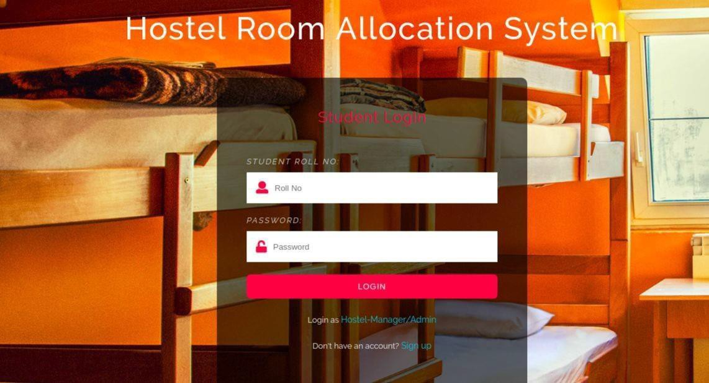

**Details:**

The login page appears to be part of a hostel room allocation system.

* It restricts access to the hostel room allocation system to authorized users.
* It collects student roll number and passwords to verify the user's identity.
* It grants access to the system only if the username and password match an authorized user in the database.
* It displays an error message if the username or password is incorrect.
* The login page serves as the initial point of entry into the hostel room allocation system, ensuring secure access for authorized users.
* Apart from collecting student roll numbers and passwords for user authentication, it may also incorporate additional security measures such as captcha verification or two-factor authentication to enhance data protection.
* Furthermore, the page could feature a password recovery option, allowing users to reset forgotten passwords through a verified email or mobile number.
* Additionally, it may implement session management techniques to control user sessions and prevent unauthorized access due to session hijacking or timeout issues.
* Moreover, the login page might include functionality for user role management, enabling administrators to assign different access levels and permissions based on user roles within the system.

**Sign Up Page**

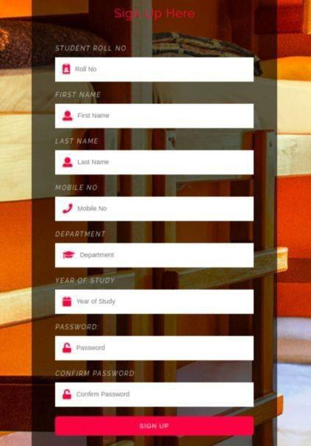

**Details:**

* + Students who are not a part of the portal can register themselves here.
  + Hostel Manager cannot sign up, he/she can only login. Hostel manager

can only be created by Admin!

* + All the necessary error conditions are checked. (like if a user with the entered roll number already exists).
  + The signup page facilitates registration for students who are not yet part of the portal, allowing them to create accounts and access hostel management features.
  + It enforces restrictions preventing hostel managers from signing up directly; instead, hostel manager accounts can only be created by administrators to maintain control over managerial access.
  + The signup process incorporates thorough error handling to validate user inputs and ensure data integrity, including checks for duplicate roll numbers to prevent account duplication.
  + Additionally, it may feature form validation to verify the correctness of user-provided information, such as ensuring valid email formats and enforcing password strength requirements.

**Hostels Page**

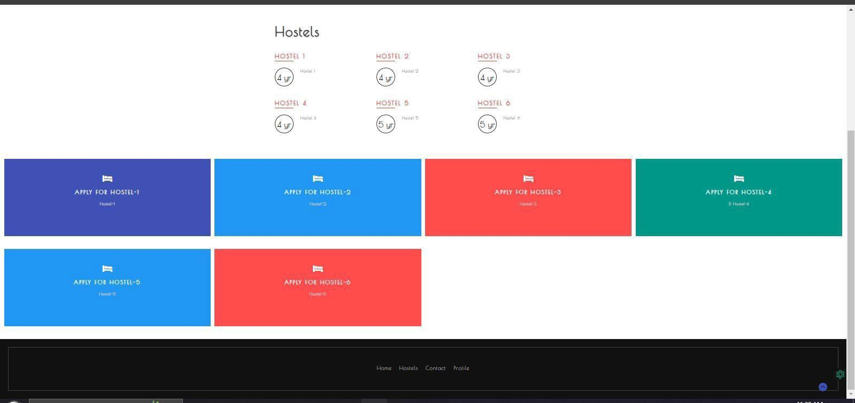

**Details:**

* Functionality: Briefly explain what users can do on this page, such as apply for different hostels.
* Target users: Specify who this page is designed for, such as students.
* You can choose which type of hostel you want to apply.
* Users can explore various hostel options available within the system.
* They can view detailed information about each hostel, including facilities, room types, and occupancy rates.
* Students can submit their room applications directly through the platform.
* The system allows for easy customization of preferences, such as selecting preferred hostel locations and room types.
* Hostel managers have access to oversee the allocation process and manage room availability.
* Applicants can track the status of their applications and receive notifications regarding room allocations.
* The platform ensures a user-friendly experience, guiding applicants through the application process smoothly.
* Hostel administrators can manage hostel listings, update information, and monitor application submissions.

**Application Form**

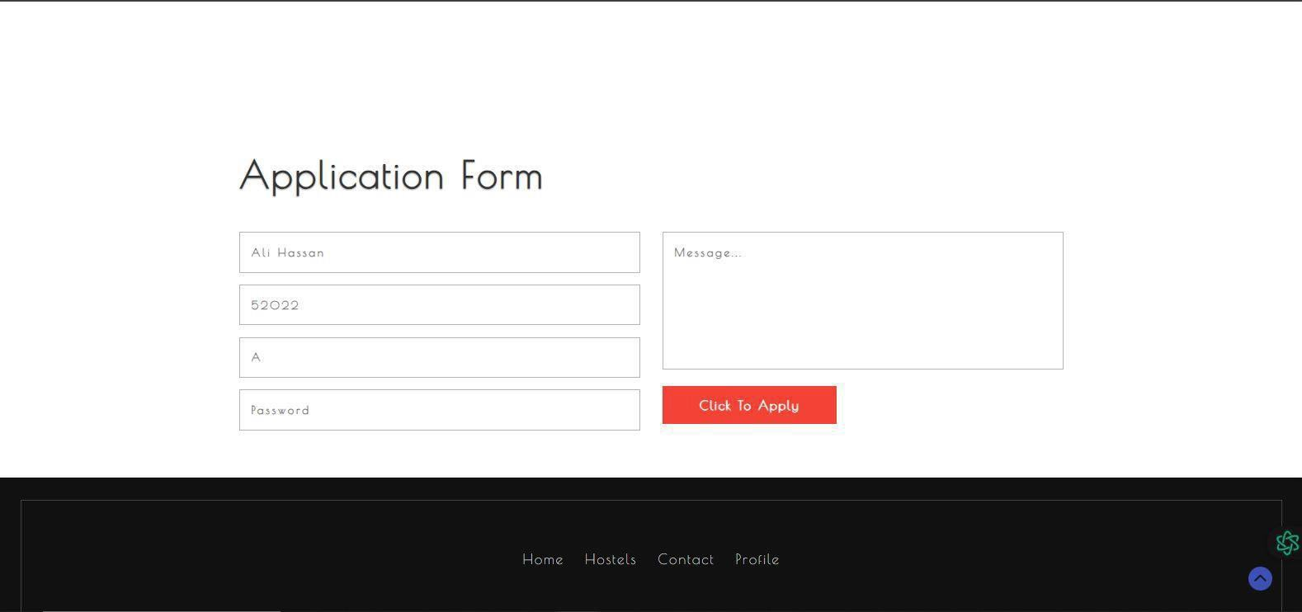

**Details:**

* Student Should enter password to confirm
* If the student is already allocated room, he won’t be allowed to submit any application forms.
* Fill the form and click the option click to apply to submit the application.
* Students must confirm their application by entering their password for security purposes.
* Once a student is allocated a room, the system prevents them from submitting additional application forms.
* Applicants need to fill out the application form provided and then click the "Apply" option to submit their application.
* The application form captures essential information required for hostel allocation, ensuring all necessary details are provided.
* Upon submission, the system processes the application and notifies the student of the status of their application.
* Any errors or missing information in the application form are highlighted to the student for correction before submission.
* The application form interface is user-friendly, guiding students through each step of the application process seamlessly.
* Hostel administrators can access and review submitted application forms, facilitating efficient allocation decisions.

**Contact Form**

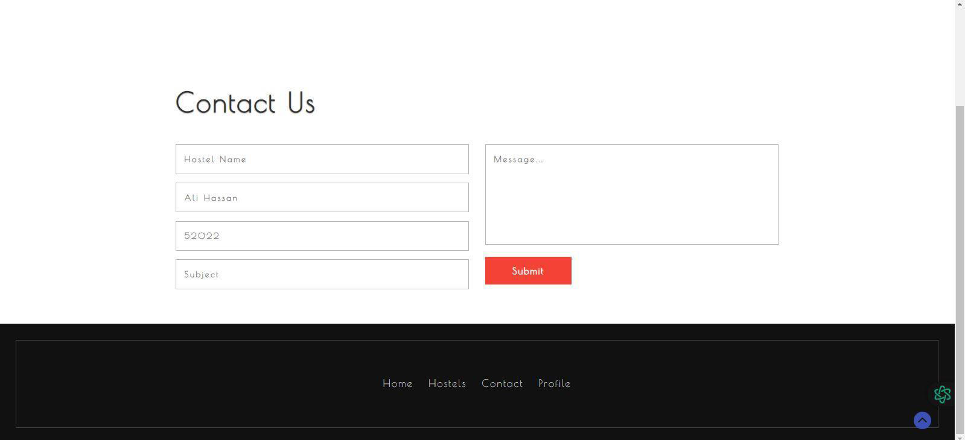

**Details:**

* + Student can send messages to hostel manager by filling up this form and

clicking on the submit.

* + If you have any problem about rooms or changing the hostle you can also contact with the hostel manager.
  + The hostel manager will reply you soon. Than you
  + Students can use the contact form to send messages directly to the hostel manager by filling out the required fields and clicking the "Submit" button.
  + In case of any issues regarding rooms or requests for hostel changes, students can utilize this form to communicate with the hostel manager efficiently.
  + Once a message is submitted through the contact form, the hostel manager will promptly review and respond to the student's inquiry or request.
  + The contact form serves as a convenient communication channel between students and hostel management, facilitating effective dialogue and problem resolution.
  + Students can expect timely responses from the hostel manager upon submitting their messages through the contact form.
  + The contact form interface is user-friendly, ensuring that students can easily navigate and utilize the form to communicate their concerns or inquiries.

**Profile**

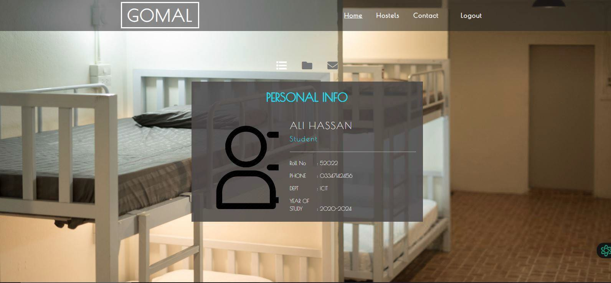

**Details:**

* This the profile of student where the student can see his all details.
* Here are profile where the student can access all of his information.
* The profile page provides students with comprehensive access to their personal information, academic details, and hostel-related records.
* Students can view and manage all aspects of their profile, including contact information, room allocation status, and application history.
* Along with basic details, students can also access additional features such as updating personal information or modifying application preferences.
* The profile page serves as a centralized hub for students to monitor and track their hostel-related activities, ensuring transparency and convenience.
* Students can review their room allocation status, application submissions, and any pending requests directly from their profile page.
* The profile interface is designed for ease of use, allowing students to navigate effortlessly and access relevant information with minimal effort.
* Any changes made to the profile information are instantly reflected, ensuring that students have access to the most up-to-date records at all times.

**Admin Login Page**

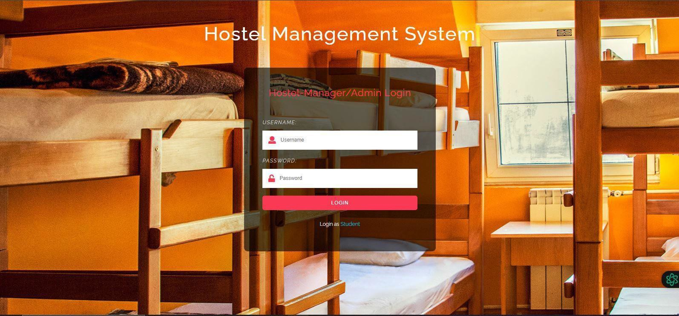

**Details:**

* This is the Hostel manager and Admin login page.
* On this page the admin can make all the hostel’s manager, if the admin could not make the manager profile than hostel manager could not access the website data.
* Manager can access all the student applications and approved the submitted application.
* The login page serves as the gateway for hostel managers and administrators to access the system's administrative features.
* Administrators have exclusive privileges to create and manage hostel manager profiles, ensuring control over user access and permissions.
* Hostel managers are granted access to student applications, allowing them to review and approve submitted requests efficiently.
* Hostel managers can oversee the allocation process, manage room assignments, and address any hostel-related inquiries or issues.
* The login page implements robust security measures to authenticate users and safeguard sensitive data from unauthorized access.
* Administrators have the authority to revoke access or modify permissions for hostel managers as needed, maintaining system integrity and security.

**Hostel Manager Home Page**

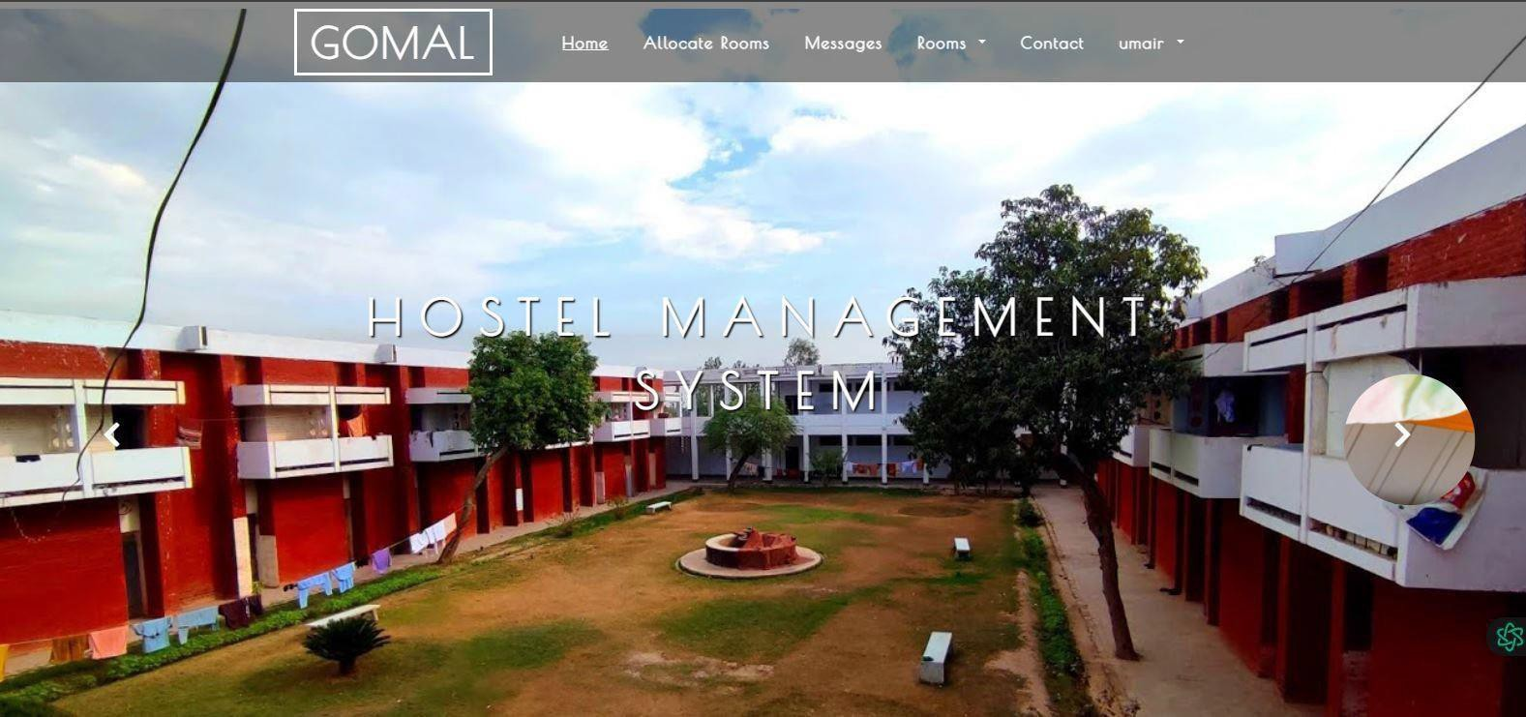

**Details:**

* This the hostel manager home page.
* The hostel manager can access all the details of hostel and also can see the submitted application and approve and disapprove the application of students.
* The Hostel manager can allow the rooms to students and Admin can see the approval of manager.
* The hostel manager's home page serves as the central hub for managing hostel operations and student applications.
* Hostel managers have comprehensive access to hostel details, including occupancy rates, room availability, and student applications.
* Managers can review submitted applications, evaluate student requests, and make decisions to approve or reject hostel accommodation requests.
* Hostel managers have the authority to allocate rooms to students based on availability and eligibility criteria established by the administration.
* Administrators can oversee the approval process conducted by hostel managers, ensuring transparency and accountability in room allocations.
* The home page provides hostel managers with intuitive navigation and tools to streamline administrative tasks, facilitating efficient hostel management operations.

**Allocated Rooms**

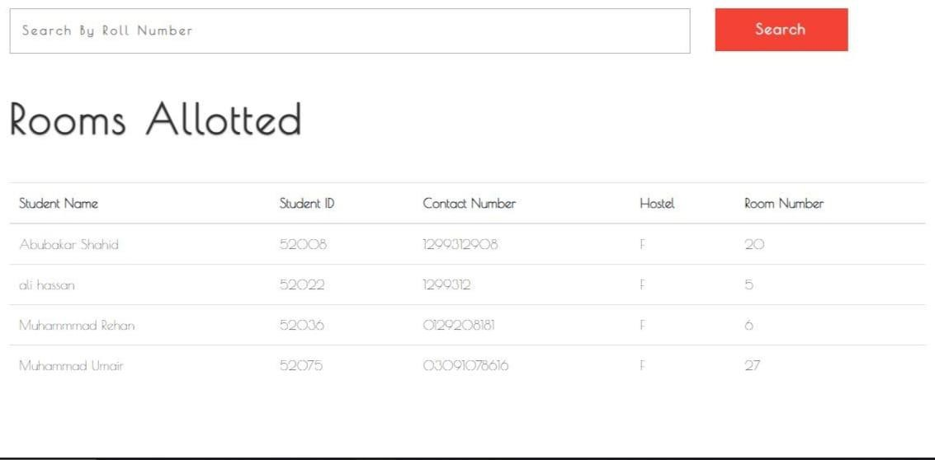

**Details:**

* The allocated rooms page where the manager can see the details of rooms and details of students which room allowed to each student.
* On this page the manager can decide the upcoming admission in empty rooms and tell to admin the following room is empty and remaining rooms are full.
* The allocated rooms page provides hostel managers with a comprehensive overview of room allocations and student details.
* Managers can access detailed information about each allocated room, including room numbers, occupancy status, and student names.
* Hostel managers can efficiently manage room allocations by reviewing which rooms are currently occupied and which are available for future admissions.
* This page facilitates decision-making regarding upcoming admissions by allowing managers to identify empty rooms and communicate this information to administrators.
* Managers can initiate discussions with the administration regarding room availability, enabling proactive planning for future student accommodations.
* The interface offers intuitive tools for updating room allocation statuses, facilitating seamless coordination between hostel managers and administrative staff.
* Managers can monitor occupancy rates, track room

**Empty Rooms**

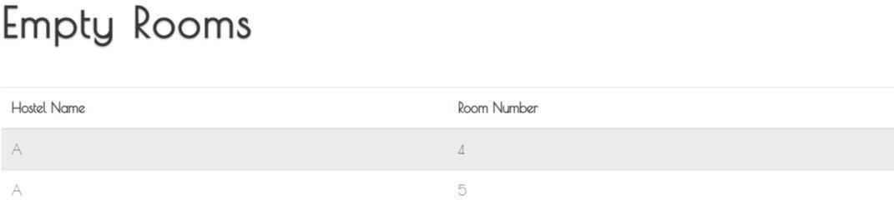

**Details:**

* Here are the full details of empty room.
* If rooms are empty than the manager can decide to give admission to new students.
* The details of empty rooms page present comprehensive information about all vacant rooms within the hostel.
* Hostel managers can access detailed listings of empty rooms, including room numbers, floor locations, and any associated amenities.
* This page enables managers to make informed decisions regarding the allocation of vacant rooms to new students.
* Managers can review the availability of empty rooms and initiate the admission process for incoming students based on current vacancies.
* The interface provides real-time updates on room availability, allowing managers to efficiently manage admissions and occupancy levels.
* Hostel managers can prioritize the allocation of empty rooms based on factors such as student preferences, room configurations, and hostel policies.
* This page facilitates proactive planning for room allocations, ensuring optimal utilization of hostel resources and minimizing vacancy rates.
* Managers can maintain accurate records of empty rooms and track admissions through the details of empty rooms page, enhancing overall hostel management efficiency.

**Vacate Rooms**

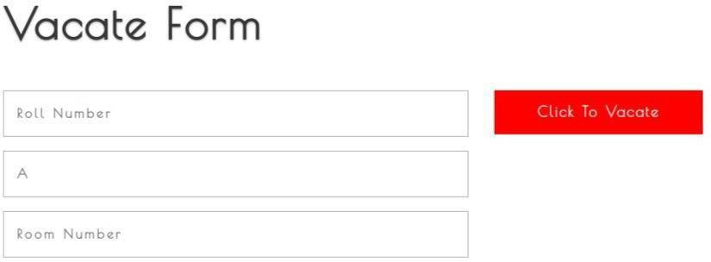

**Details:**

* The Vacate rooms where the students can apply for hostel rooms.
* Students can submit his application to the admin and hostel
* manager can access these application of student.
* And if the student is eligible than allot them the hostel’s room.
* The vacate rooms form serves as a platform for students to apply for hostel accommodations.
* Students can submit their room allocation requests through this form, providing necessary details and preferences.
* Hostel managers and administrators have access to these applications, enabling them to review and process student requests efficiently.
* Eligible students receive hostel room allocations based on the availability of rooms and their application status.
* The vacate rooms form streamlines the room allocation process, ensuring transparency and accountability in hostel management.
* Hostel managers can assess student applications and allocate rooms according to established criteria and policies

**Application Page**

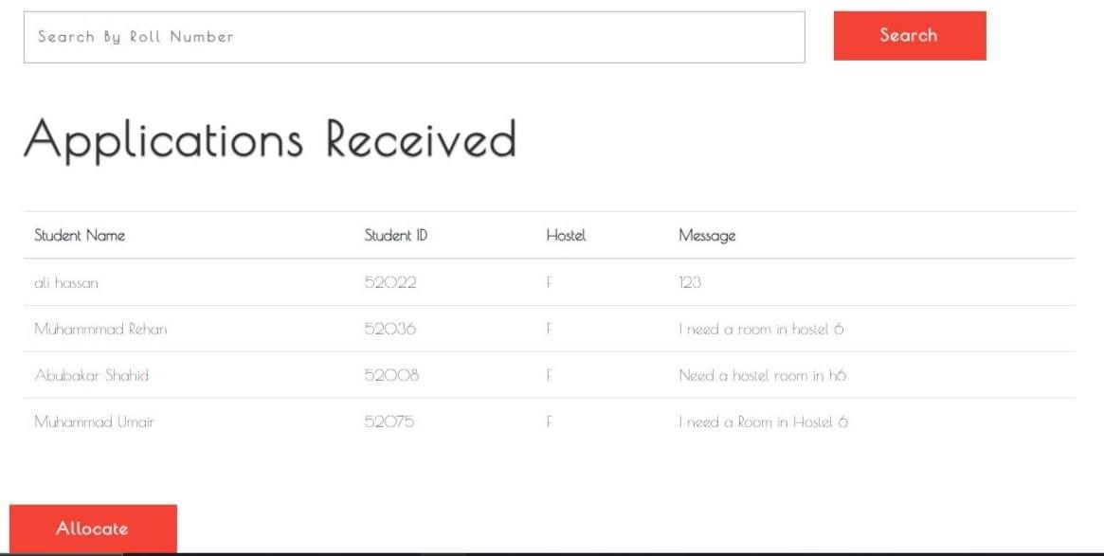

**Details:**

* Here are the details of submitted application of students.
* The manager can see the application of students.
* Moreover, the manager can decide the acceptation of application and rejection of application.
* The application received page displays detailed information regarding the applications submitted by students for hostel accommodations.
* Hostel managers have access to view all the applications received from students, including their personal details and room preferences.
* Hostel managers can review each application thoroughly and make decisions regarding the acceptance or rejection of applications based on established criteria.
* This page enables hostel managers to manage the influx of student applications effectively, ensuring timely responses and appropriate room allocations.
* Managers can use the application received page to track the status of each application, streamline decision-making processes, and maintain transparency in room allocation procedures.

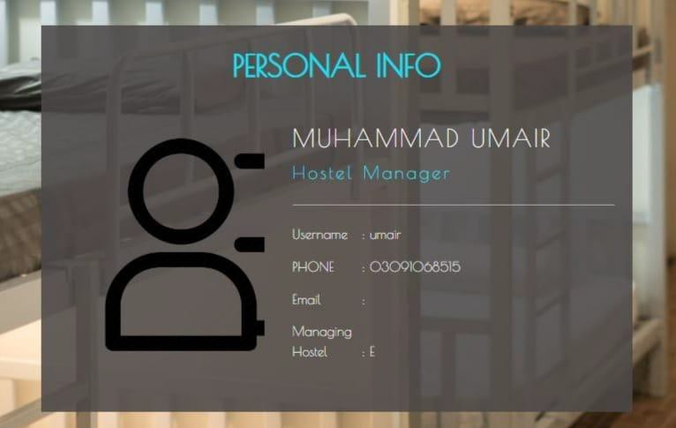**Hostel Manager Profile Page**

**Details:**

* This is the profile page for hostel managers, providing access to comprehensive details and administrative functions.
* Hostel managers can utilize this page to oversee various aspects of hostel management, including student allocations, room assignments, and application processing.
* The profile page offers hostel managers insights into student accommodation statuses, application histories, and communication records.
* Hostel managers can efficiently manage room allocations, track student requests, and maintain updated records through the profile interface.
* In addition to viewing student details, hostel managers can update room assignments, approve applications, and communicate with students as needed.
* The profile page serves as a central dashboard for hostel managers to monitor hostel occupancy, review application statuses, and address any operational issues promptly.
* Hostel managers have access to administrative tools and functionalities within their profile, enabling them to streamline hostel operations and ensure efficient management practices.

**Admin Home Page**



**Appoint Hostel Manager**

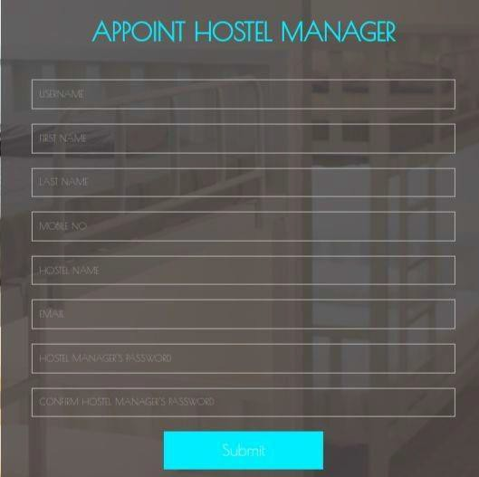

**Details:**

* Here the admin can appoint the manager for each hostel.
* The admin can give access to the manager of to see the profile of students and make decision to allow or reject to student’s application.
* If admin want to delete the manager profile than manager would not be able to access the website.
* This is the section where the admin appoints managers for each hostel, assigning specific responsibilities and access privileges.
* Admins have the authority to grant managers access to student profiles and empower them to make decisions regarding application approvals or rejections.
* If necessary, admins can revoke manager access or delete manager profiles, thereby restricting their ability to interact with the website's functionalities.
* The process of appointing hostel managers involves assigning managerial roles, defining access permissions, and ensuring effective communication channels between administrators and managers.
* Admins play a crucial role in overseeing hostel management operations, including the selection and supervision of appointed managers.

**Remove Hostel Manager**

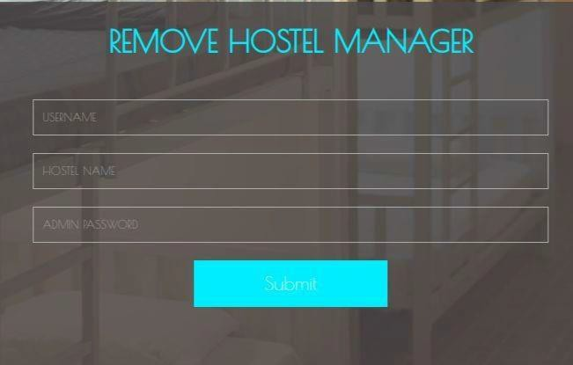

**Details:**

* Here the admin can remove the manager of hostel.
* When the manager was removed than he/she could not access the website.
* Moreover, the admin have complete access to remove or add the manager.
* This section enables admins to remove hostel managers from their assigned roles, terminating their access and privileges within the system.
* Once a manager is removed, their access to the website and its functionalities is immediately revoked, ensuring compliance with administrative decisions.
* Admins have full control over the process of removing hostel managers, exercising authority to manage personnel changes and maintain organizational integrity.
* The removal of hostel managers is conducted with precision and accountability, aligning with established protocols and administrative guidelines.
* Admins may choose to remove managers due to various reasons, including organizational restructuring, performance issues, or personnel changes.
* Removing hostel managers requires careful consideration of potential impacts on hostel operations and coordination with relevant stakeholders.

**Students Page**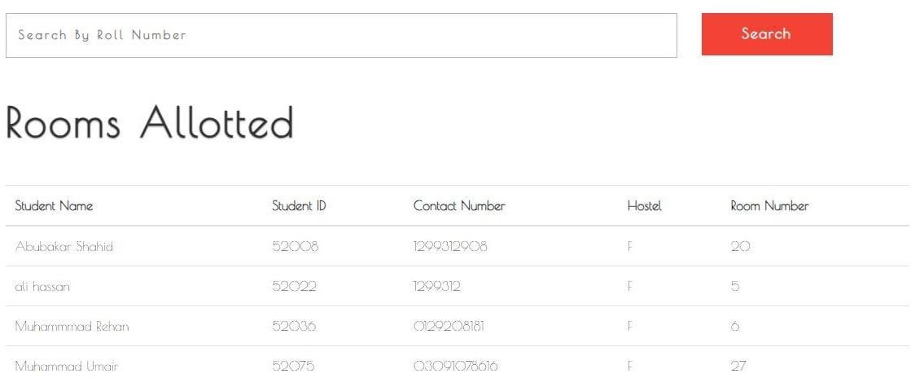

**Details:**

* This is the admin accessible page of students details.
* The admin can see all the details of students and access to students.
* And on the upper of page admin can search the student via roll number.
* This section serves as an administrative dashboard for accessing and managing student details within the system.
* Admins have comprehensive visibility into all student records and information, facilitating effective oversight and administrative tasks.
* The page features a search functionality that enables admins to quickly locate specific students by their roll numbers, streamlining the information retrieval process.
* Admins can utilize the search feature to efficiently navigate through large volumes of student data, enhancing productivity and workflow management.
* Access to student details empowers admins to perform various administrative functions, such as updating records, managing applications, and responding to inquiries.
* The admin-accessible page provides a centralized platform for administering student-related tasks and maintaining accurate records.

**Admin Profile Page**

**Details:**

* This section serves as an administrative dashboard for administrators, providing comprehensive access to hostel-related details and administrative functions.
* Admins can utilize this page to oversee various aspects of hostel management, including student allocations, room assignments, and application processing.
* The profile page offers admins insights into hostel occupancy statuses, application histories, and communication records, facilitating efficient administrative tasks.
* Admins can efficiently manage room allocations, track student requests, and maintain updated records through the profile interface.
* In addition to viewing student details, admins can update room assignments, approve applications, and communicate with students as needed.
* The profile page serves as a central dashboard for admins to monitor hostel occupancy, review application statuses, and address any operational issues promptly.
* Admins have access to administrative tools and functionalities within their profile, enabling them to streamline hostel operations and ensure efficient management practices.

