AIRBNB NEW YORK CITY
FINAL DATA ANALYSIS PROJECT
VOLTIX Internship Program · Data Analysis Track · Task 12

1. Project Overview
This project analyzes the supplied Airbnb New York City listings dataset to characterize listing supply, advertised nightly prices, room types, review activity, and geographic distribution. The workflow includes profiling, cleaning, exploratory analysis, visualizations, an interactive HTML dashboard, and evidence-based recommendations.
Scope constraint: only the user-provided AB_NYC_2019.csv was used as analytical data. The project does not join external datasets. Findings describe the dataset snapshot and should not be interpreted as current market conditions.

2. Dataset Information
Original dataset: AB_NYC_2019.csv. Original dimensions: 48,895 rows × 16 columns. After exact-duplicate removal: 48,895 rows × 22 columns in the prepared analysis file (additional derived fields are included).
Main columns: id (listing identifier), name (listing title), host_id and host_name (host identifiers/names), neighbourhood_group and neighbourhood (geographic group and neighbourhood), latitude and longitude (coordinates), room_type (listing category), price (advertised price per night in USD), minimum_nights (minimum stay), number_of_reviews (review count), last_review (date of most recent recorded review), reviews_per_month (recorded monthly review rate), calculated_host_listings_count (host listing count), and availability_365 (days available in a year).
Key questions: What room types and boroughs dominate supply? How do nightly prices differ by area and room type? How skewed is price? Are prices associated with review counts, minimum nights, or availability? Where are listings spatially concentrated?

3. Data Cleaning & Preparation
Exact duplicate rows detected in the original file: 0; removed: 0. Text fields were trimmed and blank-like strings normalized to missing values. Numeric fields were coerced to numeric types and last_review to datetime. Original source fields were retained. Added derived fields include has_reviews, reviews_per_month_filled, price_band, minimum_nights_band, price_outlier_iqr, and zero_price_flag.
Missing values in the original file are documented in analysis/missing_values_original.csv. Price outliers were flagged using the IQR upper fence ($334.00) rather than removed automatically. There are 2,972 rows above this fence and 11 zero-price rows. Zero prices should be validated before price-sensitive business decisions.
No imputation was applied to the original reviews_per_month column; a separate derived field replaces its missing values with zero for a limited descriptive feature. This avoids overwriting the source data but should not be mistaken for proof that those listings received no reviews.

4. Exploratory Data Analysis
The largest borough by listing count is Manhattan (21,661 listings). The highest median advertised price among boroughs is in Manhattan ($150); the lowest is in Bronx ($65).
The most common room type is Entire home/apt (25,409 listings). Median listing price is $106; the median among positive-price listings is $106. The mean price ($152.72) should be interpreted carefully because high-price outliers can pull it upward.
Pearson correlation between price and number_of_reviews: -0.048; price and minimum_nights: 0.043; price and availability_365: 0.082. These are descriptive linear associations, not causal effects. The dataset has no explicit guest-rating column, so rating-price relationships cannot be directly tested.

Listings by room type
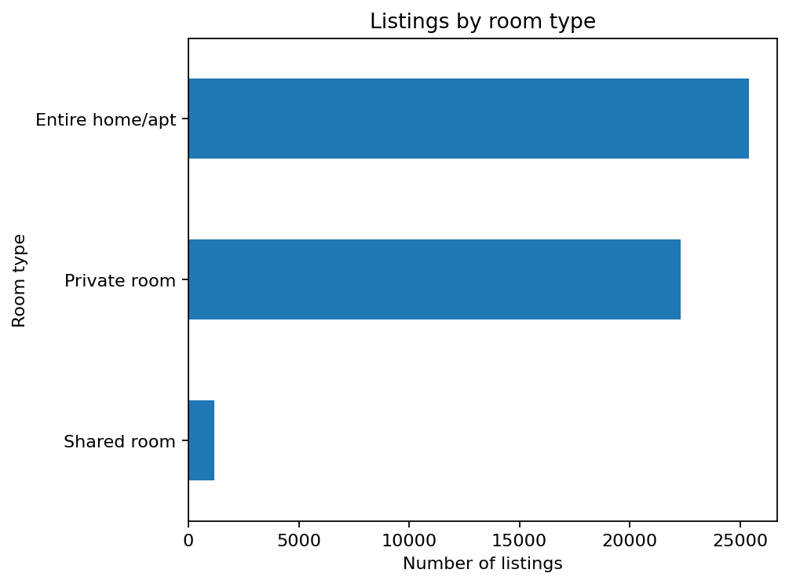
Listing supply is compared across the room categories.

Listings by borough
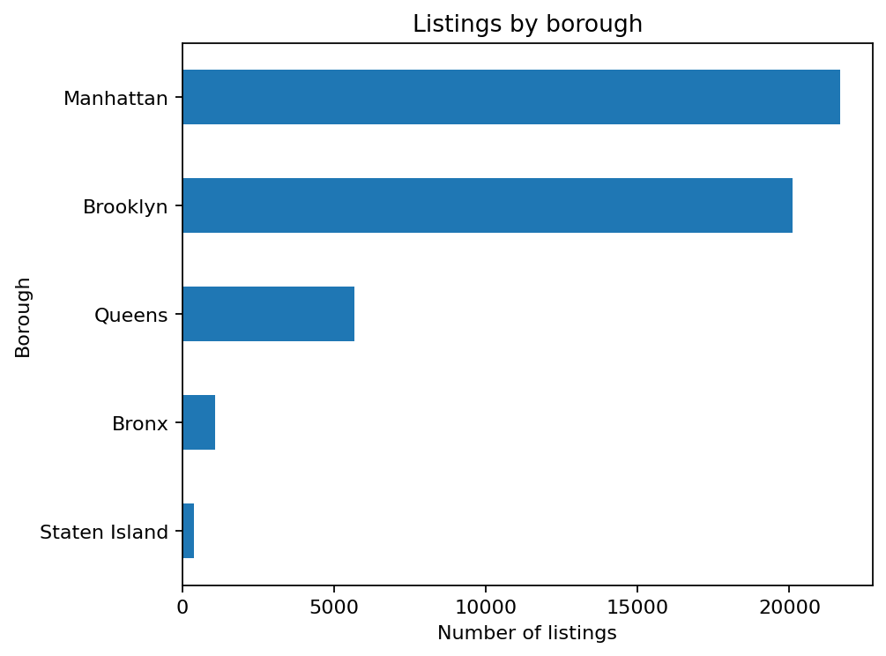
Listing counts reveal the geographic concentration of supply.

Price distribution by borough
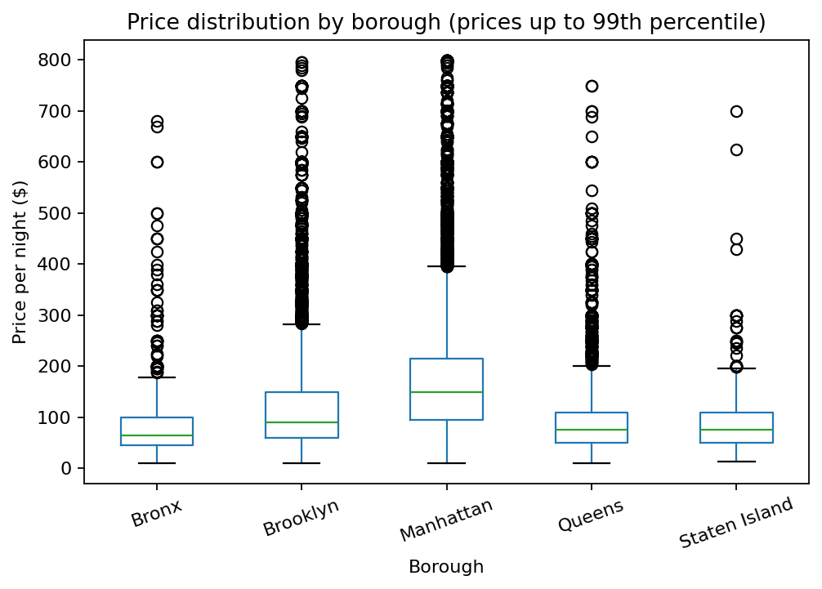
Box plots compare price distributions while excluding the top 1% of prices for readability; source data remains intact.

Price and review count
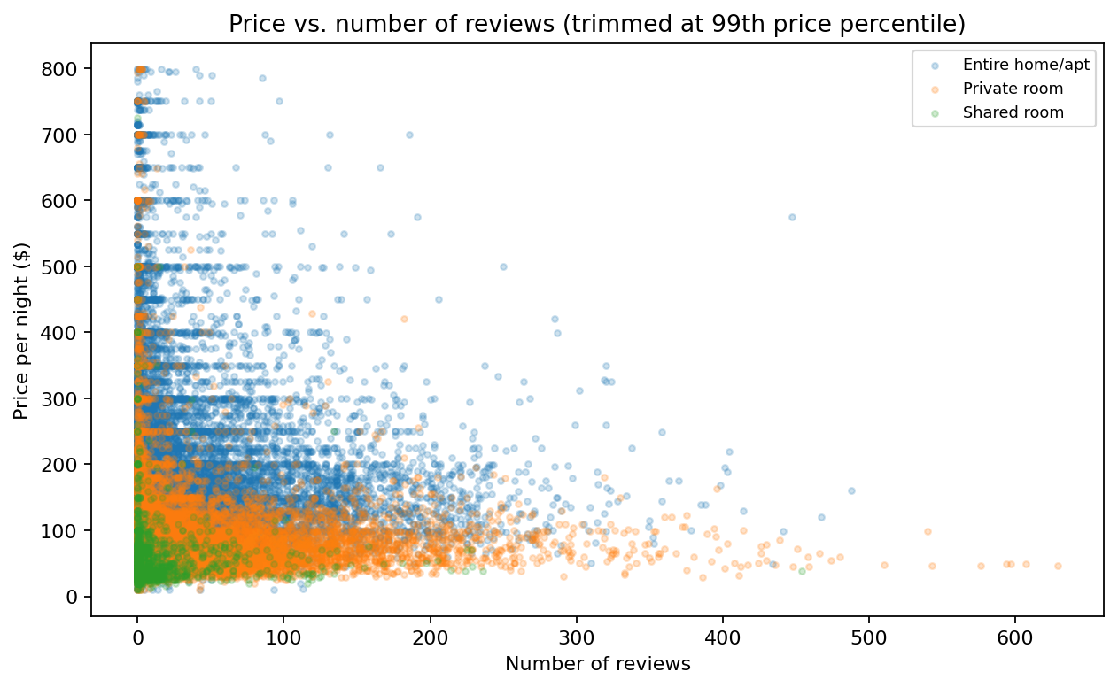
The scatter plot explores association between advertised price and review count.

Nightly price distribution
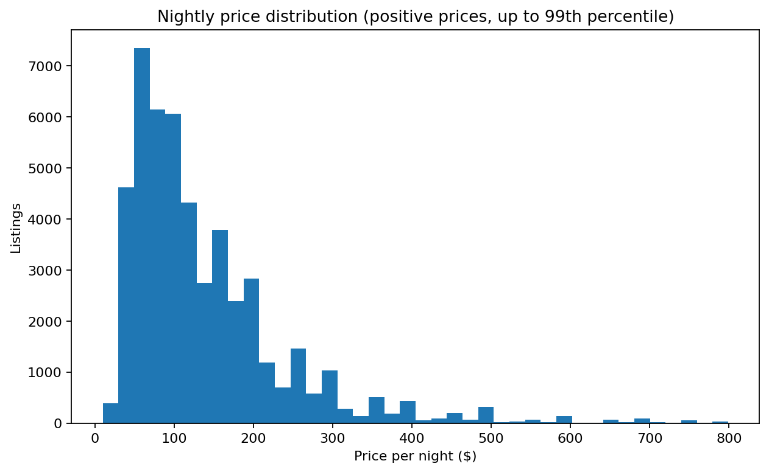
The histogram shows the skew of positive nightly prices up to the 99th percentile.

Geographic distribution
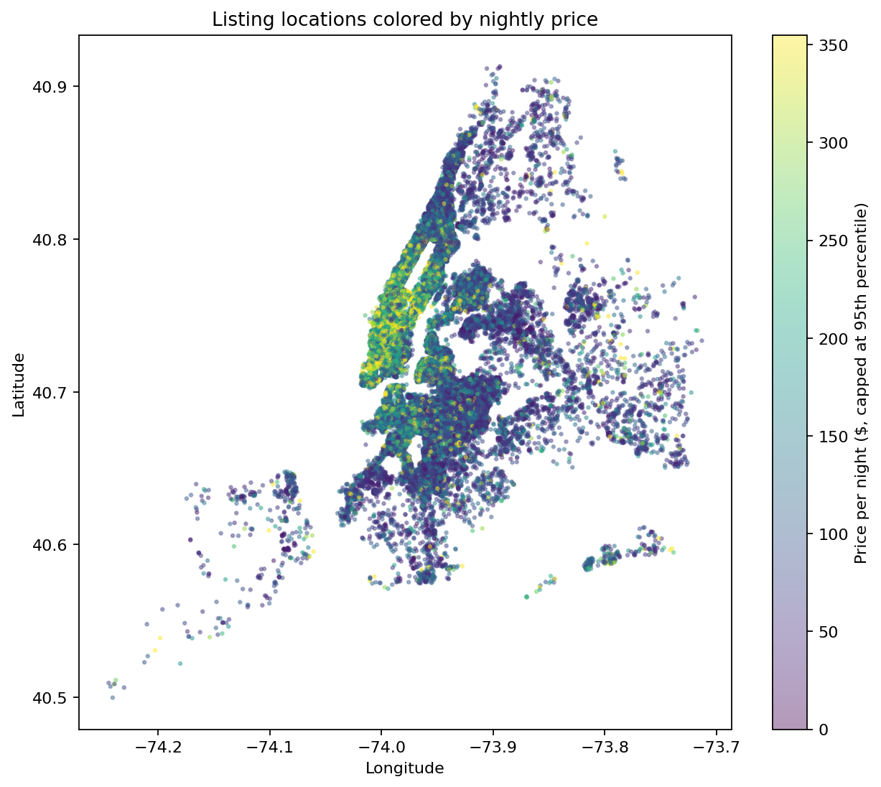
Coordinates from the supplied dataset are used without external map data.

5. Dashboard
The interactive dashboard is delivered as dashboard/Airbnb_NYC_Interactive_Dashboard.html. It includes KPI cards and interactive Plotly charts for room type, borough activity, borough price distributions, and listing coordinates. Charts support hover, zoom, pan, and image export. The dashboard does not implement cross-filtering between charts; use the notebook or exported summaries for deeper filtering.

6. Business Insights & Recommendations

Supply concentration: Manhattan has the largest number of listings.
Interpretation: This borough is the largest observed supply pool in the dataset. High supply may also imply stronger competition.
Recommendation: Hosts and analysts should compare pricing and review activity within neighbourhoods, not rely only on city-wide averages.

Price differs geographically: median prices range from $65 in Bronx to $150 in Manhattan.
Interpretation: Location is associated with meaningful price differences in this snapshot, but property and host characteristics may also explain them.
Recommendation: Use neighbourhood-level medians and room-type comparisons as a starting benchmark; avoid assuming borough alone causes price differences.

Room-type mix: Entire home/apt is the most frequent category.
Interpretation: The dominant category shapes the competitive environment and likely warrants its own benchmark.
Recommendation: Segment dashboards and pricing comparisons by room type to avoid comparing unlike listings.

Price has a skew/outlier issue: 2,972 listings exceed the IQR upper fence and 11 have zero listed price.
Interpretation: Mean price alone can misrepresent a typical listing; unusual and zero values need review.
Recommendation: Report median and percentile ranges alongside means; inspect flagged rows before using prices operationally.

Price/review correlation is -0.048.
Interpretation: The linear relationship is not sufficient to claim expensive listings get more or fewer reviews; review counts depend on many factors and exposure time.
Recommendation: Use review counts as an engagement proxy only, and investigate within comparable neighbourhood/room-type segments.

Data limitation: no guest-rating score or realized booking revenue is present.
Interpretation: The requested rating-price and profitability questions cannot be directly answered from this file.
Recommendation: Do not label review count as rating, revenue, occupancy, or profit. Collect these fields in a future authorized data collection if permitted by the project owner.

7. Limitations
The data is a 2019 snapshot and may not represent today's New York City market. It lacks bookings, realized revenue, occupancy, guest ratings, property amenities, and time series of all price changes. Correlation is not causation. The map-like geographic scatter uses latitude/longitude only; no external boundary file was used.

8. Conclusion
The project demonstrates a reproducible analysis workflow from data profiling and preparation to exploratory charts, summary exports, an interactive dashboard, and actionable recommendations. The most reliable conclusions concern listing composition, descriptive price differences, data quality, and observed associations. Decisions should use medians, segmented comparisons, and explicit data-quality checks, while respecting the dataset's historical and feature limitations.

Appendix: Deliverable index
- data/airbnb_nyc_cleaned.csv — prepared analysis dataset
- data/AB_NYC_2019_original.csv — unchanged copy of the supplied source
- notebooks/Airbnb_NYC_Analysis.ipynb — rerunnable notebook
- dashboard/Airbnb_NYC_Interactive_Dashboard.html — interactive dashboard
- analysis/Airbnb_NYC_Analysis_Summaries.xlsx — summary workbook
- analysis/*.csv and key_metrics.json — reusable analytical outputs
- visualizations/*.png — report-ready charts
- README.md — run instructions and project structure

