Project : Project 5, Monitoring Kubernetes clusters with AI (Cloud Services and Systems, HES-SO Master)
Group : 13
Students : Nicolas Favre, Malik Fleury, Khalil El Ajeri
Git URL (if applicable) : https://github.com/khronozz/k8s-observability (public copy of the main branch; original on the HEFR GitLab, internal visibility: https://gitlab.forge.hefr.ch/nicolas.favre1/k8s-observability)
Link to a video : https://drive.switch.ch/index.php/s/SjsMTYzJge9NKPA (Switch Drive, narrated in French, 9 min)
Architecture
A monitoring assistant answers questions about a Kubernetes cluster in natural language: the engineer asks in Open WebUI, the assistant queries Mimir (metrics) and Loki (logs) with the help of the LLM, then answers and lists the tools it called. The figure shows the version deployed on AWS.
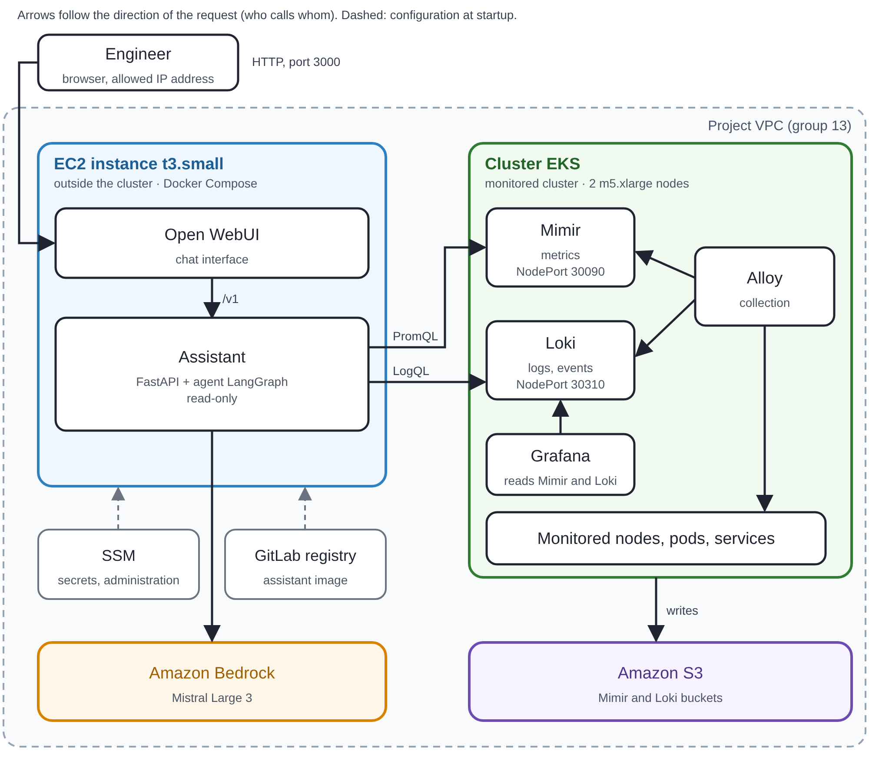
Figure: AWS deployment (us-east-1). The assistant runs on an EC2 instance, outside the EKS cluster it monitors.
Component | Role
Open WebUI | Chat interface where the engineer asks questions in French. It calls the assistant through an OpenAI-compatible API (/v1).
Assistant | FastAPI + LangGraph agent: turns the question into PromQL/LogQL calls (tools), summarises the result and lists the tools called with their arguments. Read-only; refuses off-topic requests.
LLM | Amazon Bedrock, Mistral Large 3 (public model).
Alloy | Collects metrics and logs from nodes and pods (k8s-monitoring) and sends them to Mimir and Loki.
Mimir / Loki | Mimir stores metrics (PromQL), Loki stores logs (LogQL). Both write their data to S3.
Grafana | Dashboards and Explore on Mimir and Loki; used to replay the assistant's queries and check them.
Amazon S3 | 6 buckets for Mimir blocks and Loki chunks.
How a question travels
The engineer types a question in Open WebUI, which passes it to our assistant (Open WebUI sees it as an ordinary OpenAI-style model). The assistant asks the LLM what to look up; the LLM picks tools (a PromQL query on Mimir, a LogQL search in Loki, or a pod description) and the assistant runs them. The LLM then writes the answer, and the assistant adds the list of tools it called with their exact arguments, so anyone can replay the queries in Grafana.
Deployment
1. Kubernetes cluster: Amazon EKS (g13-p5-eks, 2 m5.xlarge nodes). Alloy, Mimir, Loki and Grafana are installed with Helm through OpenTofu (about 40 pods).
2. Storage: 6 Amazon S3 buckets, used by Mimir and Loki.
3. Assistant and Open WebUI: 2 Docker Compose containers on a single EC2 t3.small instance, outside the cluster. The assistant image comes from the HEFR GitLab registry; secrets are in AWS SSM Parameter Store; administration goes through SSM, with no SSH key.
4. LLM: Amazon Bedrock (Mistral Large 3), reached through the instance's IAM role, limited to this model by the policy in our OpenTofu code.
5. Network: no load balancer and no TLS. Open WebUI (HTTP, port 3000) accepts only IP addresses authorised beforehand (added by hand with make aws-allow-ip), so nobody else can reach it; the assistant reads Mimir and Loki on ports 30090 and 30310 of one node, opened only to the host's security group (no authentication).
6. Automation and cost: OpenTofu and scripts. make aws-up deploys the infrastructure, the stack and the host (19 min 12 s on 27 Oct); make aws-down destroys everything; make aws-audit lists our project's resources to check that nothing is left. Nodes and control plane: about $0.48/h (estimated from AWS list prices).
Tasks
Tasks | Outcome | Students involved
Observability stack and assistant on a laptop (Kind) | Mimir, Loki, Alloy, Grafana, Open WebUI and assistant; smoke test 6 out of 6 | Nicolas, Malik, Khalil
Deployment on SWITCHengines (20 Oct) | 2 VMs and k3s with OpenTofu, S3, stack deployed in 12 min 35 s, smoke test 6 out of 6, then deleted | Khalil
Laptop test setup (Kind) with the LLM on Bedrock (25 Oct) | LLM_PROVIDER=bedrock variable, secret script, adapted smoke test | Malik
Deployment on AWS (27 Oct), after the professor's feedback | EKS, EC2 host, Bedrock, S3; deployment, destroy and audit scripts | Nicolas
Assistant, tests and improvement plan | Assistant 0.5.x; 15 test scenarios on AWS (27-28 Oct); plan of 15 fixes | Nicolas
Documents | Architecture v1 to v4 (with requirements), guide, test plan, demo script | Nicolas, Malik, Khalil
Demonstration video | Video in French of the assistant running on AWS | Malik
Results of the tests
15 scenarios on AWS (details in docs/tests/plan-de-tests.md in the repository), 27-28 October, a handful of trials each, judged by hand against kubectl or direct queries. These numbers show what happened, not general reliability.
Scenario | What we saw
Cluster health | Node and pod counts correct in 5 trials out of 6. The first trial said "0 pods" because the model invented a metric; fixed afterwards.
Incident on a pod | Right pod, restart count and error message. Some durations were misread, and the logs of a pod that crashes in a loop were only partly collected.
Root-cause question | We asked the assistant for the cause of an error we had set up on purpose (a pod that cannot reach a database). Right cause in 7 valid trials out of 7; facts and guesses cleanly separated in 3, only partly in 4.
Node and service | Node state right in 4 trials out of 6, usually with one wrong or unchecked claim. Asked about a service, it described a pod instead.
Refusals and safety | Off-topic questions: 20 refused out of 20. Requests to delete or restart something: 3 out of 3 refused. Requests for secrets: 2 out of 2 refused. An instruction hidden in logs was not obeyed (2 out of 2). A joke mixed with a real question was answered without an explicit refusal of the joke.
Failures | With Mimir's query-frontend deleted, the assistant said Mimir was unreachable and invented no number; the pod was back in about 55 s. Restarting the assistant took about 2 s and the open conversation kept working. We also gave the assistant a wrong model ID on purpose: for a while it could not reach the LLM and showed the raw AWS error; once the ID was corrected, everything worked again.
Why these choices
Choice | Why | Alternatives set aside
AWS (EKS, S3, EC2) | On 22 Oct the professor told us the group has an AWS space with credits. EKS is AWS's managed Kubernetes and S3 its native object store. | Switch Cloud (managed Kubernetes), dropped: our course account only gave access to SWITCHengines (VMs), where we tested k3s.
Alloy, Mimir, Loki, Grafana; LangChain, FastAPI | Required by the project statement, so we studied no alternative. | None studied.
OpenTofu and Helm, one module for the laptop test setup (Kind) and the cloud | The professor asks for automation. One module stops the laptop test setup and the cloud from drifting apart: only the cluster and S3 change. A full AWS deployment takes 19 min 12 s. | None documented.
Bedrock (Mistral Large 3) on AWS, Ollama (qwen3:8b) in our laptop tests | The professor asked for a public model: small models tested on a laptop were unconvincing. Mistral Large 3 costs $0.50 in and $1.50 out per million tokens (list price, 22 Oct). On a laptop nothing leaves the machine, but the CPU gives only 9 to 12 tokens per second. | A self-hosted LLM in the cloud, ruled out by the professor.
Assistant built with FastAPI and one LangGraph agent | FastAPI exposes the assistant as one service that Open WebUI can call. One agent keeps control of the queries sent to Mimir and Loki, and the checks are in our Python code, so we can test without the LLM. When the model invented queries or wrong units, we moved that judgment into Python. | None documented.
Assistant on an EC2 t3.small, outside the cluster | The professor asked us to keep the tools that measure the cluster apart from the AI tools that read the measurements. An EC2 virtual machine is easy to create and delete with a script and is billed by the hour. Memory is tight: 489 of 1909 MiB free when idle. | ECS Fargate, Lambda, the group's Mac.
Administration with SSM, secrets in Parameter Store | AWS Systems Manager (SSM) lets us run commands on the instance without opening port 22 or keeping a private key. Secrets sit in SSM Parameter Store, not in the instance's startup data, where its description would show them. | An SSH key pair.
Read-only assistant that shows its tools | Safer: it only sends GET requests to Mimir and Loki, with no kubectl and no write right. A checkable answer beats a fluent one we cannot check: one query from the footer, replayed in Grafana, gave the same pod (262.3 vs 264.4 MiB, 14 min apart). Not a guarantee: some answers still held wrong claims. | None documented.
2 m5.xlarge nodes for EKS | Upper bound taken from the Kind install (7 to 8 GiB at most). m5 rather than t3 for a predictable cost (about $0.05/h more). Real consumption was not measured. | t3 nodes.
Open problems and next steps
1. Open problems: no tool for alerts (Mimir's ruler and Alertmanager are empty), it can read an empty result as "nothing there", and Mimir and Loki are not monitored themselves. Our improvement plan (docs/plan-amelioration.md in the repository) lists 15 fixes; none is done yet.
2. Cost and end of project: the cluster is billed while it exists. It is destroyed once the documents are final (make aws-down, then make aws-audit); the video is the record.
Remarks. All three students used AI tools.

