**Project Report**

**on**

**CHEMPY**



**Submitted By**

Kaustubh Sethi

Vinaayak Srivastava

Class: XII D

**Under the Guidance of**

Ms. Angel Panesar

Department of Computer Science

Sardar Patel Vidyalaya

Lodhi Estate, New Delhi 110003

**CERTIFICATE**

This is to certify that Kaustubh Sethi and Vinaayak Srivastava Of Class XII D have prepared the report on the Project entitled “CHEMPY”. The report is the result of their efforts & endeavors. The report is found worthy of acceptance as final project report for the subject Computer Science of Class XII. They have prepared the report under my guidance.

Ms. Angel Panesar

Department of Computer Science

Sardar Patel Vidyalaya

Lodhi Estate, New Delhi 110003

**DECLARATION**

We hereby declare that the project work entitled “CHEMPY”, submitted to Department of Computer Science, Sardar Patel Vidyalaya, Lodhi Estate, New Delhi 110003 is prepared by us. The project work is result of our personal efforts.

Vinaayak Srivastava

Kausutbh Sethi

Class: XII D

**ACKNOWLEDGEMENT**

We would like to express our special thanks and gratitude to our Computer Science teacher “Ms. Angel Panesar” for her able guidance and support in completing our Project. We are deeply indebted to her for providing us timely advise not only for this project but throughout the year. Her faith and guidance has helped us achieve our full potential.

We would also like to extend our gratitude to the Principal Ma’am “Ms. Anuradha Joshi” for providing us with all the facility that was required,

Vinaayak Srivastava

Kaustubh Sethi

Class: XII D

**CONTENTS**

|  |  |  |
| --- | --- | --- |
| S. No. | Topic | Page No. |
| 1. | LIBRARIES USED | 6 |
| 2. | WORKING DESCRIPTION | 7-9 |
| 3. | PROJECT CODE | 10-18 |
| 4. | OUTPUT SCREENS | 19-21 |
| 5. | CONCLUSION | 22 |
| 6. | BIBLIOGRAPHY | 23 |

**LIBRARIES USED**

1. Tkinter
2. Mysql comnnector
3. Turtle
4. Chempy
5. PIL
6. cv2

**WORKING DESCRIPTION**

* We began our project by making the table of elements in MySQL. For this we used excel and MySQL workbench to connect with MySQL and import data into the database of MySQL as making a long table in MySQL by writing queries could have been tiresome and a very lengthy process.
* We used mysql-connector library for connecting with mysql, then took input from user and used fetchone( )for fetching result. Then we printed the relevant information in the tkinter window itself using labels and buttons.
* For printing electronic configuration in a user-friendly way, we used split method of strings and converted the superscript of string stored in sql table.
* Since we know that atomic number is from 1-118, incase user entered any value out of range, we showed error window.
* The table contains atomic number, electronic configuration, symbol, group number, atomic mass, electronegativity.
* After making the table in MySQL, we made the main interface for our program.
* We used tkinter to take input of atomic number and stationary state of an element by making a Entry and a button to click after input was complete by Button()
* We used mathematical formulae for calculating energy and radius of such a shell. Then we printed it with Label( ), pack( ) and Button( ) method.
* The main menu window of the program is made by tkinter library in which we used function ‘title’ which gives a title to the tkinter window and takes the argument as a string.
* PIL is a library from which ImageTk and image function help us in adding a picture in the tkinter window by giving the path or name of the file. A menu widget was added for GUI and to make it user friendly.
* This was created by first defining a menubar in which we cascaded headings of menu by add_cascade function and added command which had the heading to direct us to the functions we programmed by add_command function which has 2 argument label name and command in which we give a function which was to import file according to the name and used add_separator to add line between the headings.
* We similarly used a menu widget for Cations and Anions which contain names of ion according to their respective group name. To display reactions we used cv2 that is opencv python library in which we used imread which took path of the file or name and imshow function which took name of image and path read by imread function.
* We used tkinter to take input of atomic number of an element by making a Entry and a button to click after input was complete by Button() which had an argument that was command in which we can give a function which would trigger our my sql and python connection and from our table in which we stored information regarding all atomic numbers.
* We used turtle library to show Orbitals , Geometry and Shape.
* First we defined a turtle object, then we used write () function to write heading on a specific location by goto() function which takes turtle pointer to a point on x and y axis.
* To avoid unnecessary drawing we used penup() which stops the pen to draw and used pendown() as and when required , color() was used to change the color of the pointer, forward() was used to draw the pointer forward and to turn at an angle used left() and right() which took an angle in degree as argument.
* To fill color we used begin_fill() and end_fill() , the color could be change by color() , the begin_fill() and end_fil() was called at beginning and ending respectively between which would be code of a closed shape object.
* To make the pointer draw fast we used speed(0) which at 0 worked fastest. At the end to hide the pointer we used hideturtle()

**PROJECT CODE**

**Main code:**

CHEMPY.py

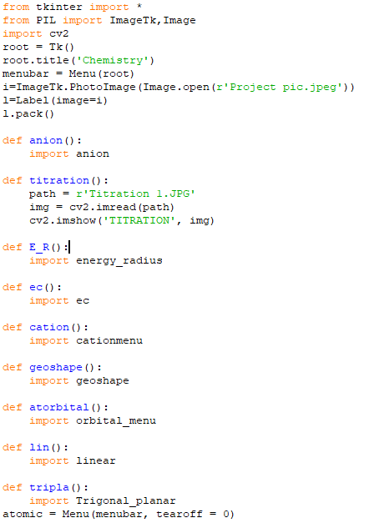

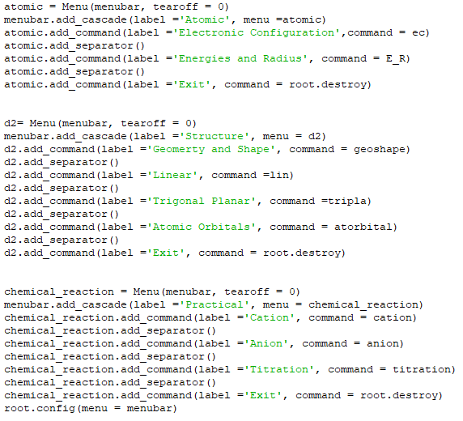

**Imported files:**

anion.py

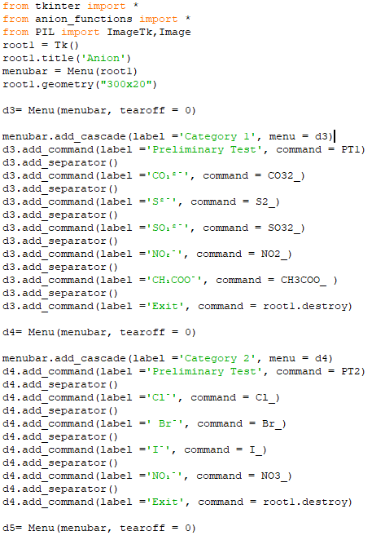

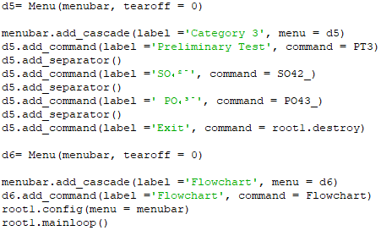

anion_functions.py

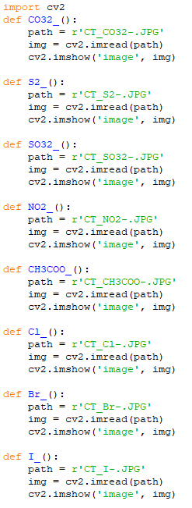

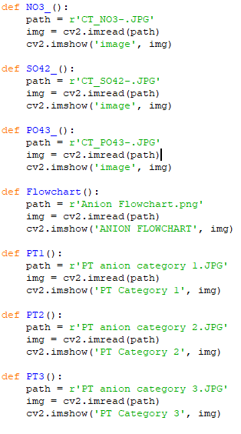

cationmenu.py

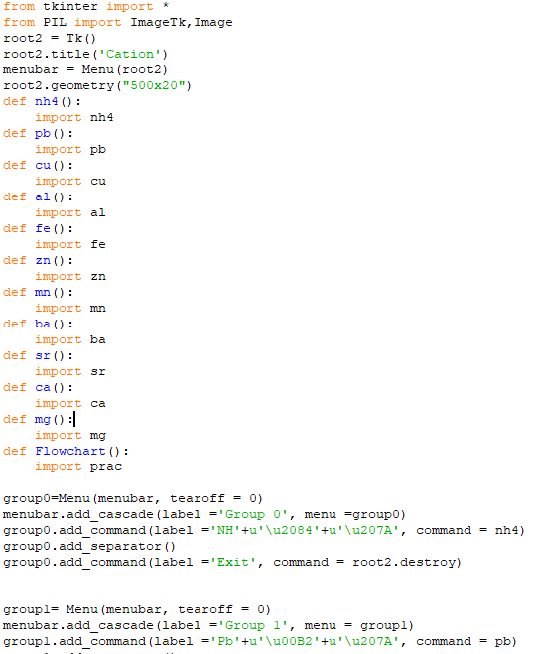 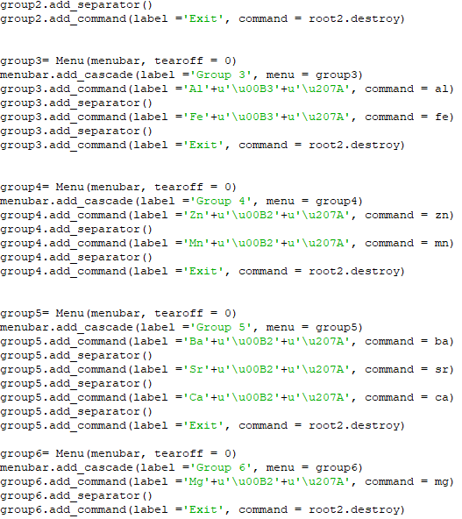 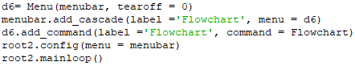

energy_radius.py

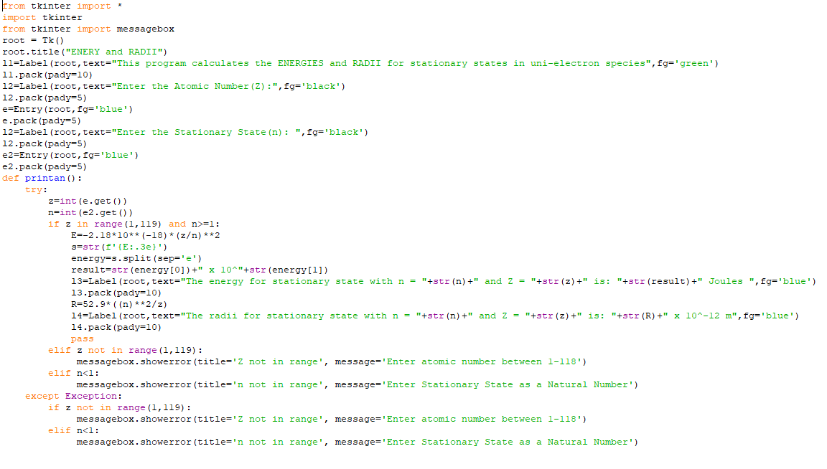



orbital_menu.py

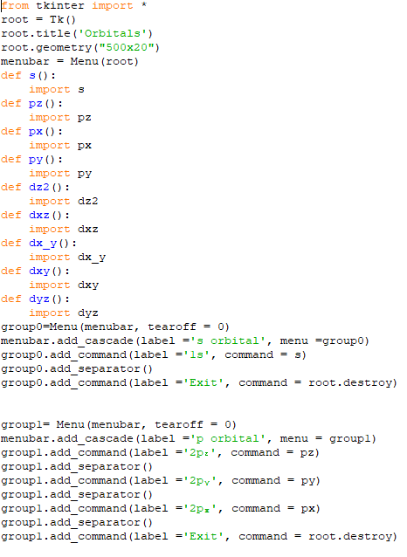

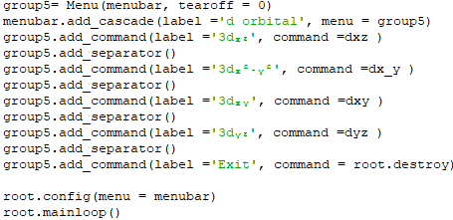

geoshape.py

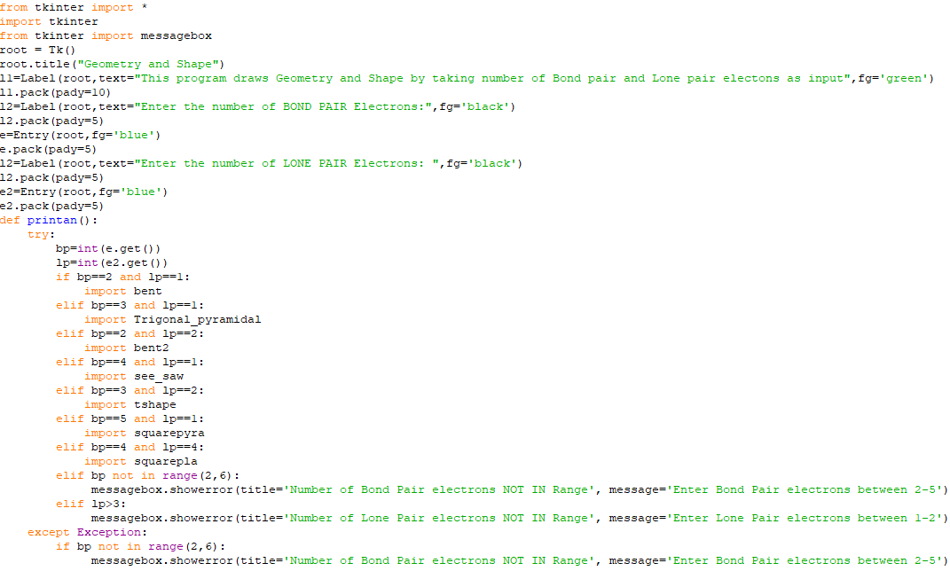



ec.py

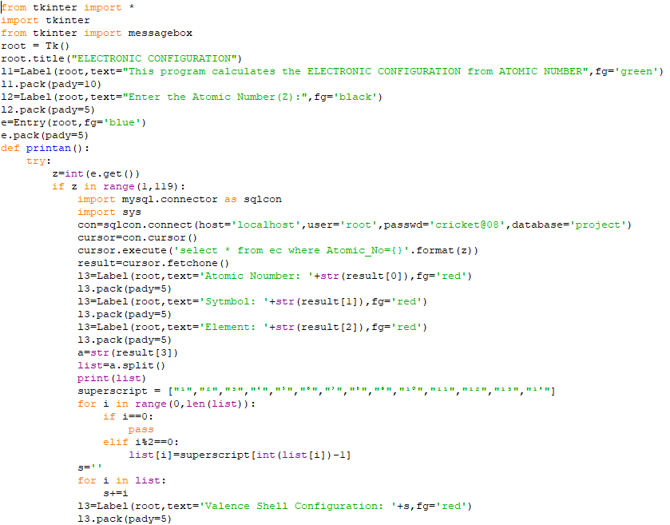

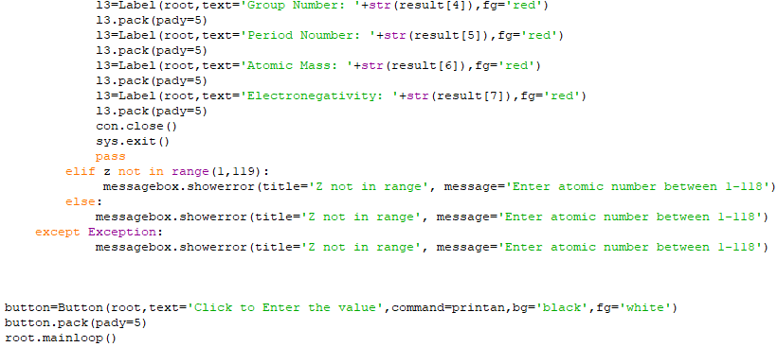

px.py

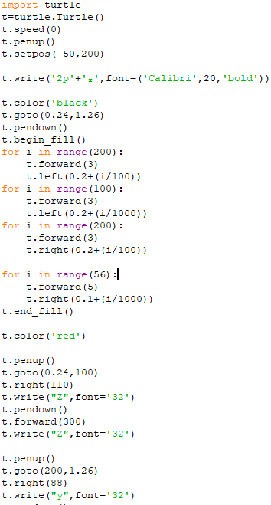

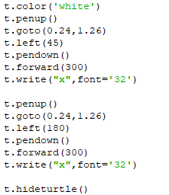

py.py

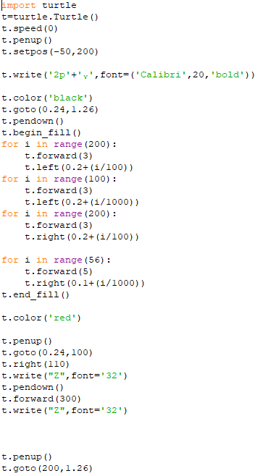

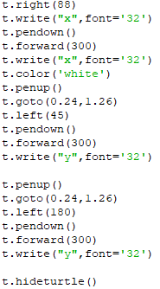

pz.py

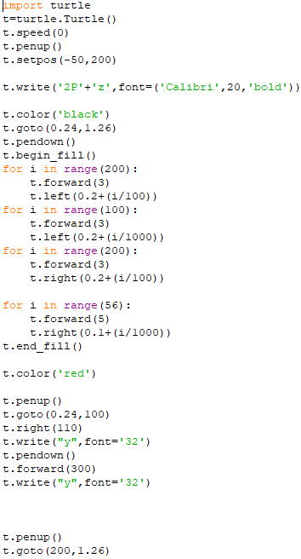

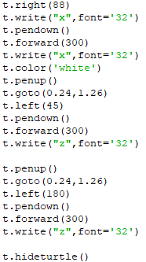

dx_y.py

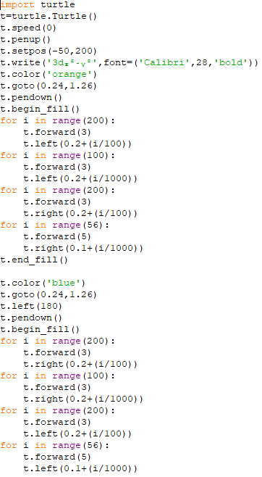

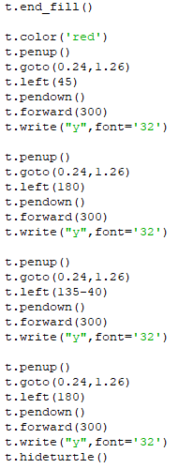

dxy.py

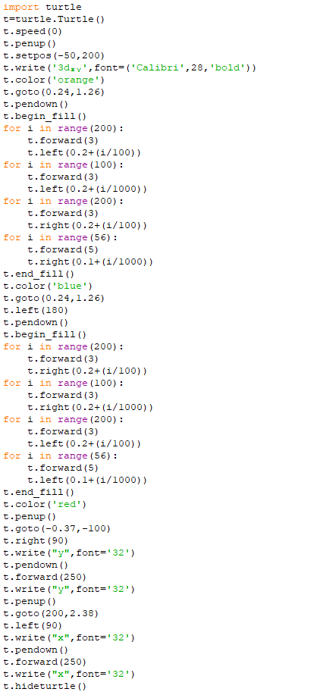

dxz.py

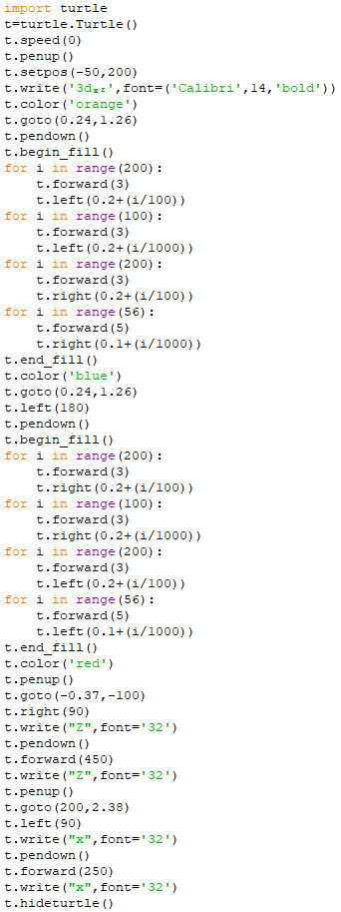

dyz.py

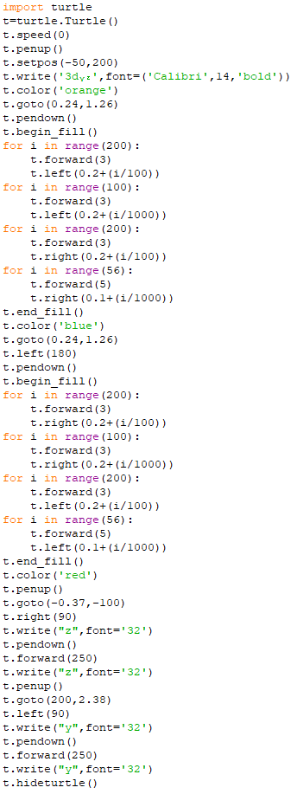

bent.py

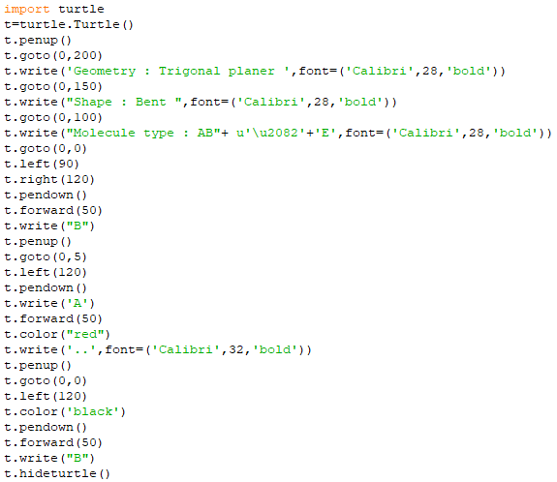

bent2.py

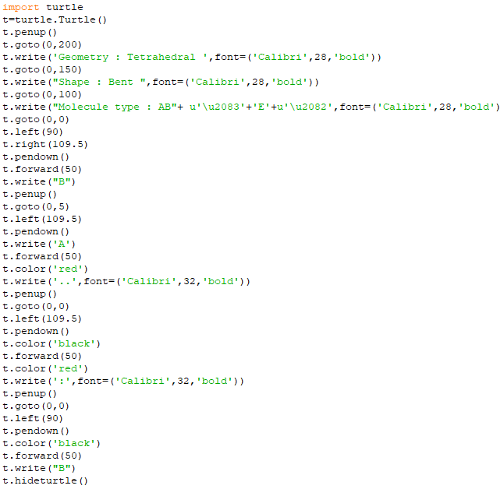

See_saw.py

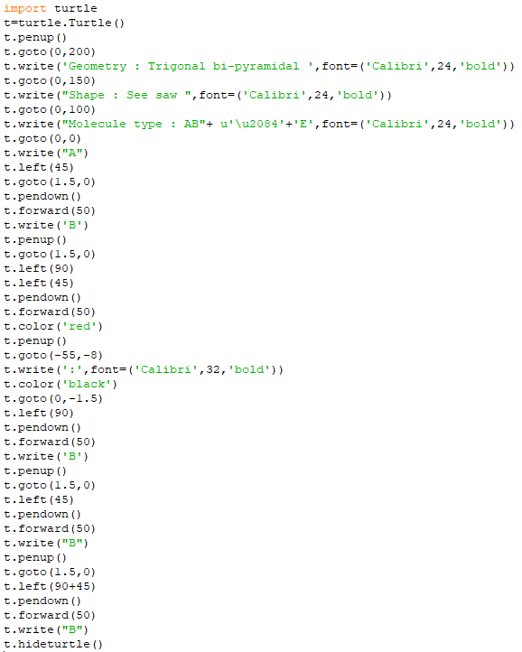

squarepla.py

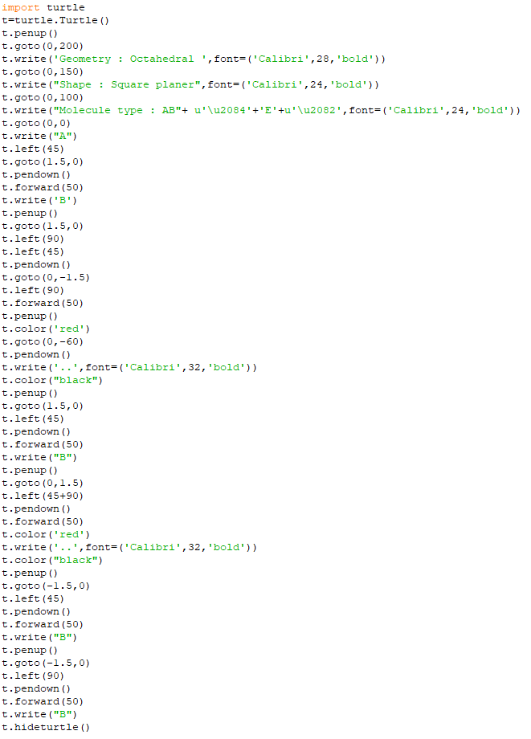

squarepyra.py

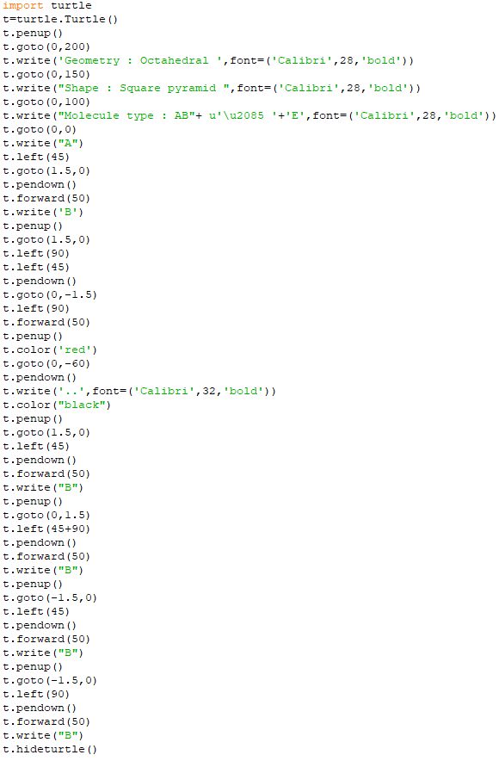

Trigonal_pyramidal.py

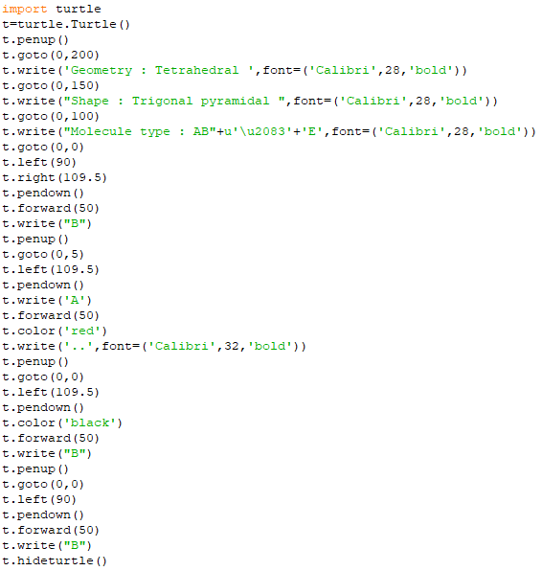

tshape.py

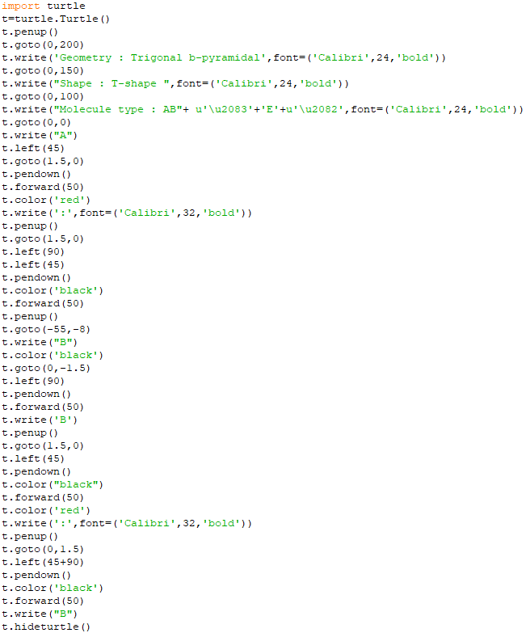

linear.py

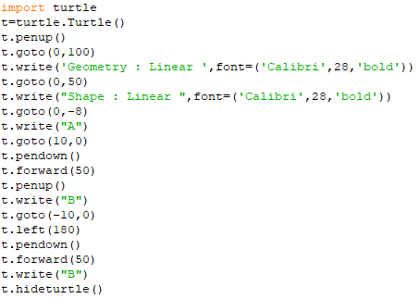

Trigonal_planar.py

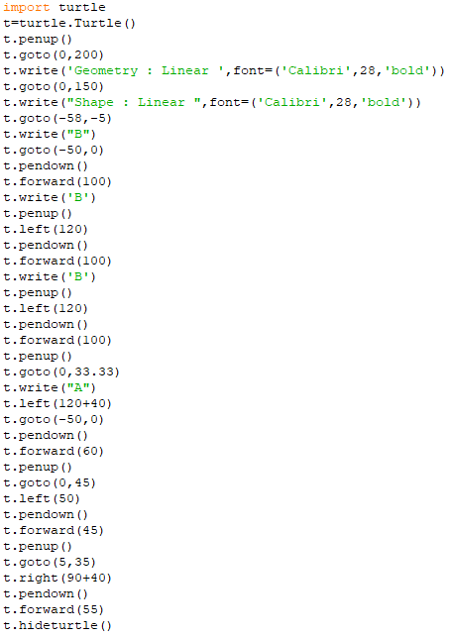

s.py

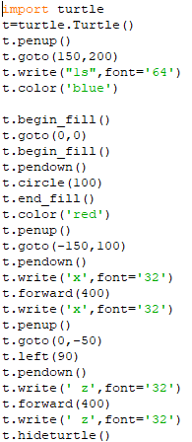

nh4.py



pb.py

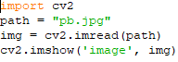

cu.py

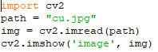

al.py

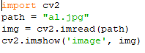

fe.py



zn.py

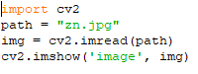

mn.py

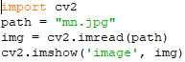

ba.py

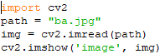

sr.py

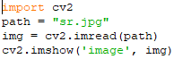

ca.py

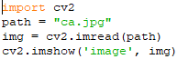

mg.py

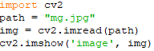

prac.py



**OUTPUT SCREENS**

**Main Interface:**

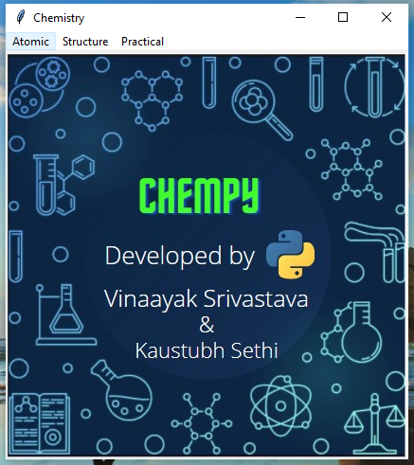 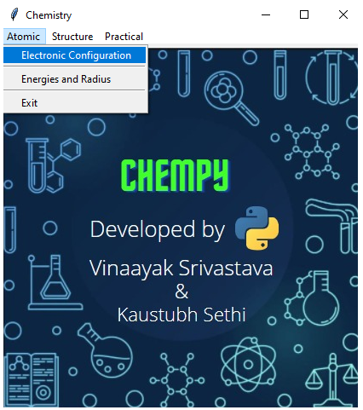

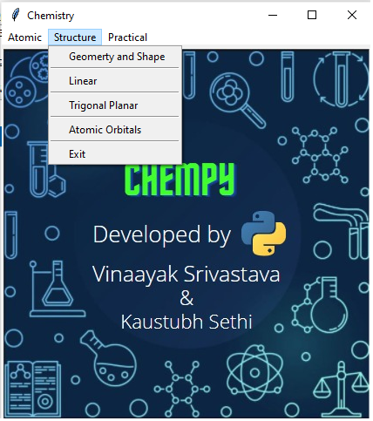 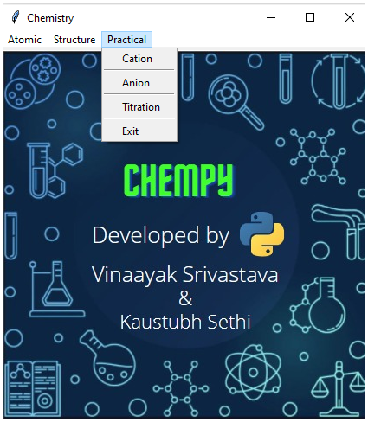

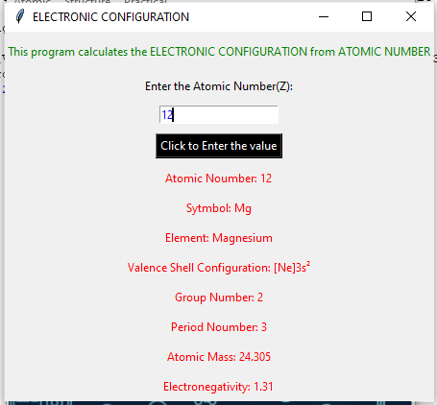 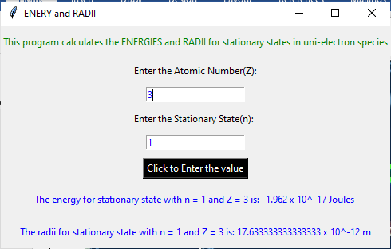

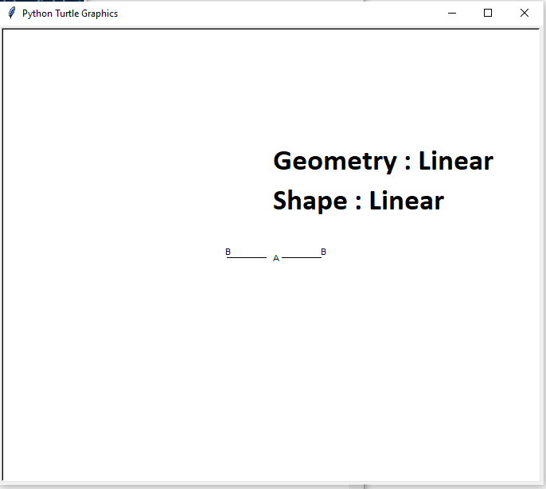 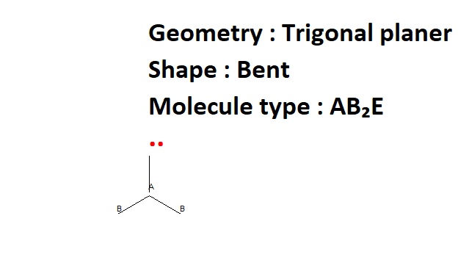

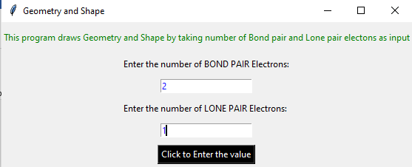 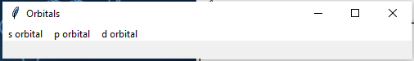

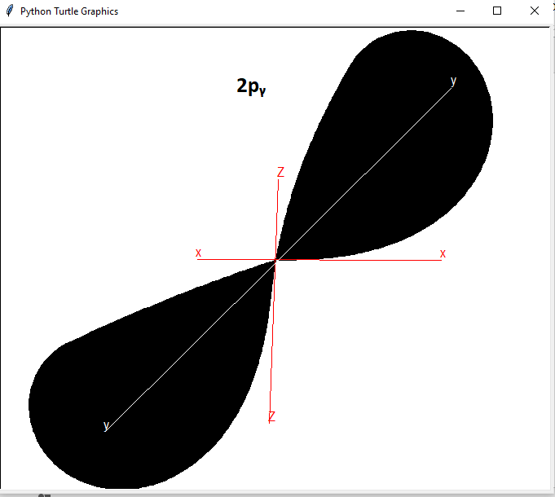 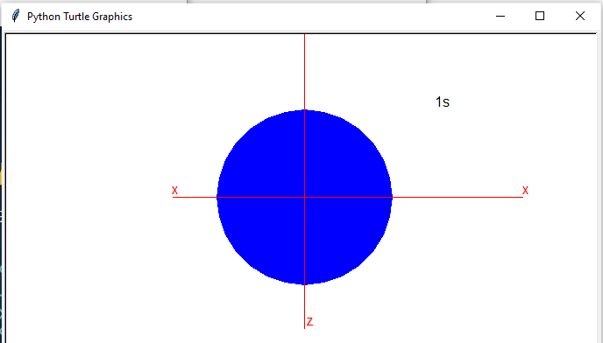

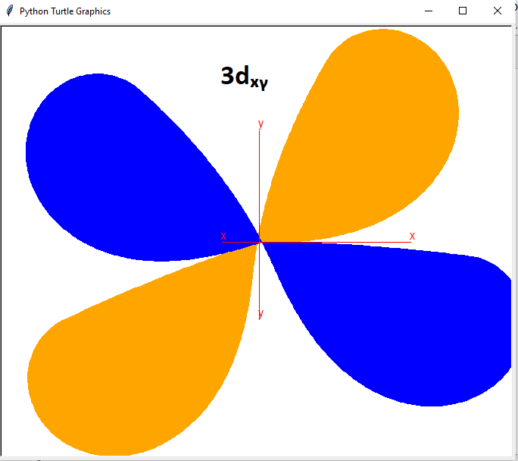

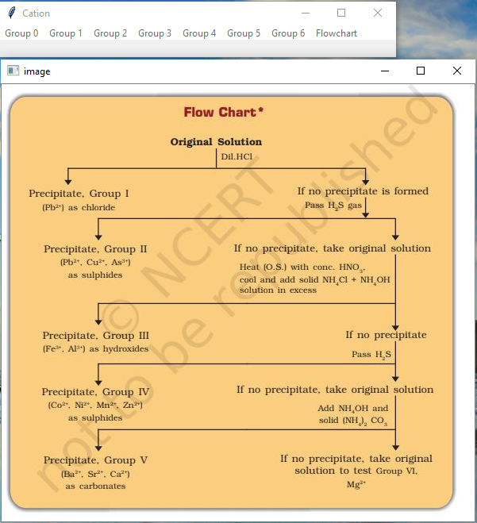

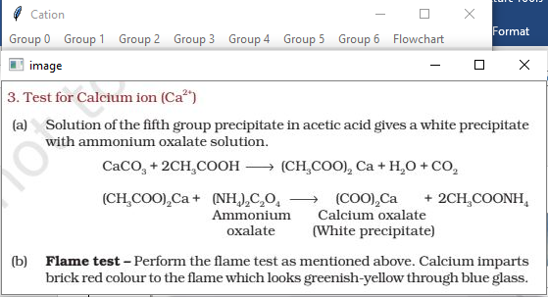

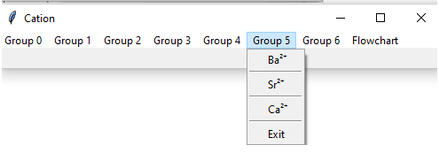 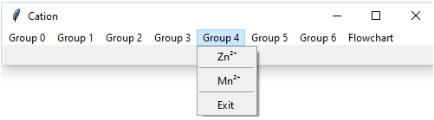

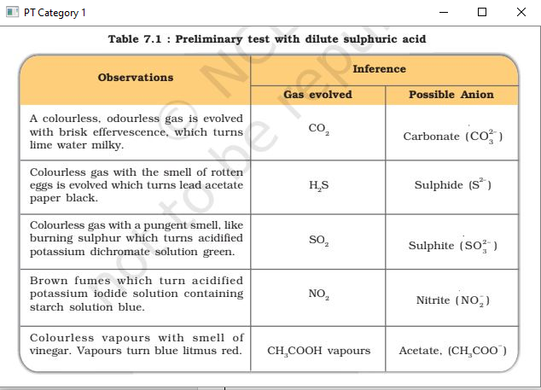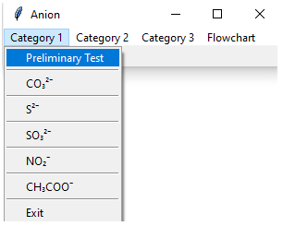

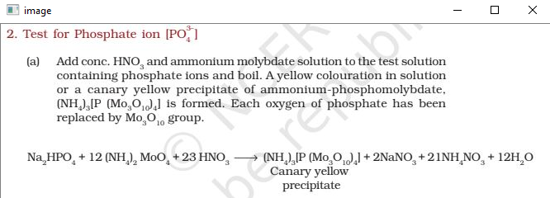 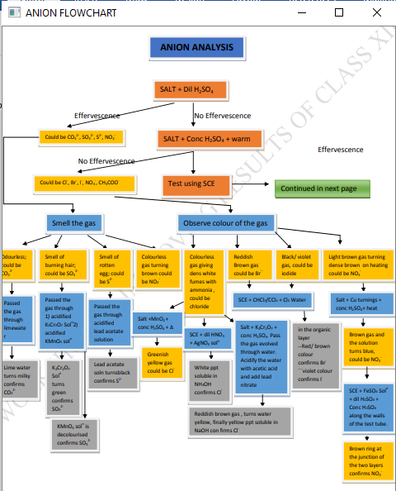 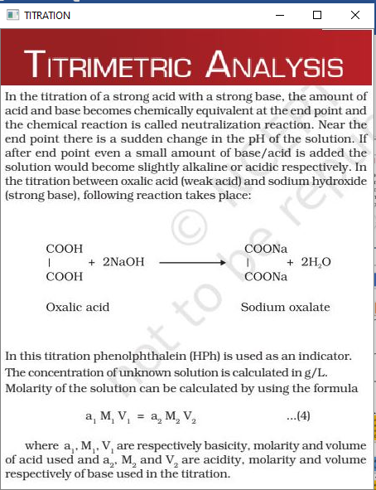

**CONCLUSION**

Chemistry is part of day to day life, but its concepts are not so easy to understand. Hence with the help of our project the user will be able to learn new concepts of chemistry in an interactive way rather than reading from the book. Thereby making the process of learning more visual based and interesting.

* This project aims at exploring various areas of Chemistry and understand them better with Python, its libraries and MySQL.
* One of the key features of our project is that it helps us in studying chemistry by giving relevant information about every element in the periodic table.
* We have made visualization easier by drawing and printing atomic orbitals, shape and geometry of compounds.
* We added a function to help us in calculating Energy and radius of various shells.
* Our program also helps in practicals for detecting anions and cations in a compound, in acid base titration by showing all the reactions and method to detect them.
* It’s a great program for beginners to learn chemistry.
* This program can further be updated by adding more atomic orbitals, geometry and shape combinations and new practical experiments.

**BIBLIOGRAPHY**

1. Sumita Arora, *Computer Science with Python*, 2020
2. https://docs.python.org/3/library/turtle.html
3. Allen B. Downey ,Think Python: How to Think Like a Computer 2016
4. https://docs.python.org/3/library/tkinter.html
5. https://pythonprogramming.net/loading-images-python-opencv-tutorial/
6. <https://pypi.org/project/chempy/>
7. Salt analysis pdf ncert lab manual
8. Titration pdf ncert lab manual
9. <https://www.tutorialspoint.com/python/python_gui_programming.htm>
10. <https://www.geeksforgeeks.org/introduction-to-chempy-in-python/>
11. <https://www.youtube.com/watch?v=NoTM8JciWaQ>