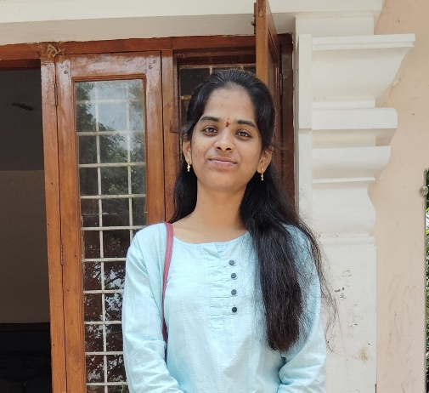
JULURU ROOPIKA
CONTACT : +91 9182357635
EMAIL : roopikajuluru4@gmail.com
GITHUB :
LINKEDIN:

OBJECTIVE:
Focused computer science undergrad student highly organized, self-motivated and working hard towards my goals, trying to find a challenging position to enhance my skills.

EDUCATION:
KESHAV MEMORIAL INSTITUTE OF TECHNOLOGY (2023-2027)

B.E Computer Science Engineering – CGPA:8.71
SRI CHAITANYA JUNIOR KALASALA (2021-2023)

Intermediate (TSBIE) – Percentage – 98.0
SHINE HIGH SCHOOL (2021)

High School 10th (SSC) – GPA: 10
SKILLS:
- Programming Languages:
- C (Proficient)
- PYTHON (Competence)
- JAVA (Competence)
- Database:
- MySQL (Proficient)
- Framework & Scripting Languages:
- HTML (Expert)
- CSS (Expert)
- JAVASCRIPT (Expert)
- NODE.JS (Proficient)
      - Other Technical Languages:
    - MACHINE LEARNING

PROJECTS:
- CULINARY QUEST (An interactive recipe application)
            - Scope of Culinary Quest
                - An interactive recipe app for discovering, saving, and personalizing recipes with meal planning, shopping lists, and guided cooking.
            - Technology Stack
1. Frontend: React.js, Redux, Tailwind CSS
2. Backend: Node.js, Express, REST APIs
3. Database: MongoDB
4. Auth: JWT
5. Deployment: AWS or Firebase

CERTIFICATIONS:
      - Web Development Masterclass (UDEMY)

HOBBIES:
    - Learning latest technological updates
    - Listening to Music
    - Watching Movies
    - Playing Badminton
INTERESTS:
    - Machine learning
    - Artificial Intelligence
    - Networking
PERSONAL PROFILE:
    - Date of Birth – 04/10/2006
    - Nationality - Indian
    - Languages – Telugu, English , Hindi

Roopika.

