Large-Scale Psychometric Evaluation of an Open Psychometric

50-Item Big Five Model-Based Personality Measure, 2016-2018
Emma Hughes; Sarvar Khamidov
GPH-GU 2225 – Final Project
Psychometric Measurement and Analysis in Public Health Research and Practice
Department of Biostatistics, School of Global Public Health, New York University
December 17, 2025

Introduction & Aims
Personality traits provide insight into patterns of behavior, offering helpful context for understanding individuals’ differences in communication, perception, and coping styles.⁸ Understanding these characteristics can also support adequate self-reflection of long-term behavioral coping tendencies.⁸ Prior research has demonstrated associations between specific personality traits and various outcomes, including behavior, cognitive function, and overall health.⁵ For example, low conscientiousness has been associated with poorer health outcomes; and high extraversion with an increased likelihood of substance use engagement.⁵
With the rise of the Myers-Briggs Type Inventory (MBTI) in professional settings during the 1980s and its subsequent popularity in personal and social contexts throughout the 1990s-2010s, public attention toward personality classification has increased substantially.^{7,21} However, the MBTI has faced much criticism, particularly for its use in high-stakes environments (i.e. the workplace).⁷ The critiques highlight its reliance on dichotomous preference scores and failure to support construct validity, including weak results of factor analysis. These limitations underscore the importance of normalizing the use of evidence-based personality measures with strong reliability and validity, especially in contexts where decisions have meaningful consequences. In contrast to the MBTI, the Big Five model represents a well-established framework that meets these psychometric standards.
Also known as the Five-Factor Model, the Big Five conceptualizes personality along five continuous dimensions: 1) Openness; 2) Conscientness; 3) Extroversion; 4) Agreeableness; and 5) Neuroticism–commonly referred to as “OCEAN.”^{10,15} Rather than categorizing individuals strictly, this method places each individual on a spectrum of trait dimensions.
Extensive reliability and validity studies have been completed for Big Five measures, however, often studies on samples of only a few thousand participants and may be somewhat homogenous. In contrast, this study leverages a substantially larger international sample of over one million, increasing the precision of reliability and validity estimates and provides greater statistical power to capture true variance of the five theoretically independent personality constructs.

Aim
This study assesses the reliability and validity of a 50-item “Big-Five Personality Test” composed of established items from IPIP and utilizing responses from over one million international respondents.²⁰ Analyses include:
- Internal consistency assessed via Cronbach’s alpha;
- Construct and convergent validity evaluated through parallel and factor analysis; and
- Divergent validity examined using pairwise Pearson correlations at the factor-level.

Hypotheses
- Internal consistency is hypothesized to be strong with Cronbach’s alpha (ɑ) above 0.70;
- Parallel and factor analysis maintain evidence of five-factor model; and
- Strong divergent validity shown through pairwise correlations that produce weak relationships between factors, as theoretically expected.

Instrument Description
The development of the Big Five is rooted in lexical theory, from the early work of Sir Francis Galton (1884).²³ Galton hypothesized a systematic taxonomy of traits could be derived as personality traits and differences in people can be described by language in single words. Building on this work, Gordon Allport and Henry Odbert (1936) compiled a list of 4,504 adjectives they believed were innate, observable personality traits.³ In 1943, Raymond Cattell reduced this list to 171 terms by eliminating synonyms and followed to identify sixteen personality factors using factor analysis based on item responses from knowledgeable acquaintances.⁹ With continued refinement by multiple psychologists and psychometricians over subsequent decades, the five-factor model was eventually published by Paul Costa Jr & Robert McCrae in 1992 and became widely accepted in modern psychology.¹¹
Given that the Big Five is a framework rather than a specific measure, this study utilized the 50-item “Big-Five Personality Test” by Open-Source Psychometrics Project (OSPP).²¹ This scale 10 descriptive statements per category of personality trait based on OCEAN, 50 items total, respondents are asked to rate the statement in regard to themselves. The response options remain constant throughout the survey and are based on a 5-point likert system response set ranging from “Disagree” to “Agree”. Some items are reverse-coded which is discussed in the methods section. Individuals independently found and chose to complete the online survey.
This measure follows the 50-item questionnaire guidelines of the International Personality Item Pool (IPIP).² In regards to content validity, the IPIP is an open-source collection of over 3,000 items and 250 scales rooted in lexical theory and the five-factor mode. It was originally developed through grant-funded research and is now maintained publicly. This collection began as a project by Wim K. B. Hofstee at the University of Groningen in the Netherlands, who believed respondents rating short behavioral phrases would be more likely to capture complex nuances in personality rather than individuals simply identifying with just an adjective as previous studies of lexical theory and the Big Five have focused on.^{18,19} The first IPIP items were collected and developed through various projects by Hofstee and his colleagues, all based on the Big Five model. The project became international when it was translated into American-English by American Lewis R. Goldberg and German by Alois Angleitner, only items with adequate translations were retained. The item collection continued to grow as it gained increasing international attention in the 1990s which spurred implementation of open-source access.
Prior studies have assessed the reliability and validity of this measure across diverse samples and multiple languages to support the scale’s internal consistency, test-retest reliability, and construct validity. English-language versions, as well as Greek and Amharic translations, have successfully replicated the five-factor framework through exploratory and confirmatory factor analyses with strong reliability measures of Cronbach’s alpha above 0.8.^{4,15,24}

Sample & Methods
Data was obtained from Open Psychometrics, an online platform that provides access to psychological instruments.¹ The original dataset includes 1,015,342 complete international responses to the 50-item Big Five personality questionnaire from 2016-2018.⁶ Participation was voluntary, anonymous, and uncompensated as individuals accessed the instrument on their own and consented prior to completion. Because this was online and open-access, participants represent a self-selected convenience sample.
When running initial analysis with the full dataset we encountered a substantial wait time for calculations. In compromise, a simple random sample of 100,000 observations were selected from the original dataset to improve computational expense and efficiency while attempting to preserve the distributional characteristics and benefits of a large sample size. Other than the specific 50 items, additional variables included metadata like timestamps, user screensize, time spent on certain pages, exact location and country but were not used in this analysis. Also, there were in total 18 items reverse-coded. To ensure all items measure the same direction all were rescored by the “New_score = 6 - Original_Score” formula.
One of the main strengths of this dataset is sample size which provides statistical power to psychometrics analyses. It allows for stable estimation reliability coefficients, factor loadings and item parameters. The large number of respondents from all over the world increases variability in item responses. However, the dataset relies on a non-probability, self-selected sample of online respondents which limits the generalizability to the broader population and introduces selection bias. Participants who choose to complete the questionnaire may differ from non-participants in motivation and personality traits. As a result, and after looking into the distribution of participants’ countries (Table 1), there’s overrepresentation of individuals from Western backgrounds. The absence of controlled testing conditions may introduce response biases such as inattentive responding or social desirability, despite basic data quality screening. While these limitations constrain external validity and prevalence estimation, they do not substantially undermine the dataset’s utility for psychometric evaluation, as analyses primarily focus on internal measurement properties rather than population-level inference.

Reliability & Validity Analyses

Reliability
Unstandardized Cronbach’s alpha values were calculated for each personality domain.¹² The ten items within each domain were analyzed to assess internal consistency. These results allow for evaluation of interitem relationships, helping to ensure that each group of items was measuring the same underlying construct while avoiding redundancy. Cronbach’s alpha above 0.9 indicates potential item redundancy, this should be avoided to reduce potential random error.

Construct/Convergent Validity
To evaluate the construct validity and examine the underlying factor structure of the Big Five personality questionnaire an exploratory factor analysis was conducted.
Factors were extracted using principal axis factoring (PAF), since this method focuses on shared variance.²⁵ The number of factors to retain was determined using parallel analysis, supplemented by inspection of the scree plot and evaluation of eigenvalues. Parallel analysis compared observed eigenvalues with those generated from random data, and factors were retained when observed eigenvalues exceeded corresponding random eigenvalues.
To enhance interpretability of the factor solution, an orthogonal rotation was applied.¹⁴ Orthogonal rotation was chosen because the Big Five personality traits were assumed to be not correlated. Rotated factor loadings were examined to evaluate item factor relationships, with loadings of .40 or greater considered meaningful. Items weak factor loadings were noted and examined for their impact on the scale.

Divergent Validity
In order to assess and confirm weak correlations between theoretically distinct traits, total scores were created for each domain by summing the ten respective items. Pairwise Pearson correlations were then computed at the trait level between extraversion, agreeableness, conscientiousness, neuroticism, and openness.²⁶ Correlation coefficients of approximately 0.30 or lower were interpreted as sufficiently weak, providing evidence of divergent validity between constructs.
NOTE: All analyses were completed in Stata, Version 18;²⁷ `paran` package was utilized to conduct Horn’s parallel analysis.¹³

Results & Interpretation

Reliability
All five traits demonstrated good to strong internal consistency with unstandardized alpha coefficients ranging from 0.79 to 0.89 (Table 2). Extraversion showed the highest reliability, followed by Emotional Stability, Agreeableness and Conscientiousness. Openness to experience demonstrated lowest internal consistency with alpha = 0.79. These values indicate that the items capture the same underlying construct within each trait without being so highly related as to suggest redundancy.

Construct/Convergent Validity
The initial unrotated solution showed that the first six factors had eigenvalues greater than 1 (6.68, 4.44, 3.34, 2.93, 2.20, 1.37) while the rest of them were below 1 (Table 3). An eigenvalue greater than 1 in data analysis means that a derived factor or component explains more variance than a single original variable. The first six accounted for approximately 102% of the common variance (cumulative proportion = 1.095). However, the theorized 5 factors accounted for 95% of the variance. We also looked at exploratory factor analysis using principal axis factoring with orthogonal rotation. The first 5 factors accounted for the majority of variance (around 88%).
We also calculated the factor loadings which are statistical values that show the strength and direction of a variable’s relationship with the factor. The results show that almost all of the items were matching with its intended category of traits. Factor 1, extraversion items’ factor loadings were generally exceeding 0.6. Factor 2 was characterized by high loadings from Emotional stability items, most of them above 0.4 and one question around 0.32. Factor 3 was defined by Agreeableness, the loadings were generally moderate to strong, supporting the identification of category as a distinct personality dimension. Also, factor 4 and 5 were dominated by Conscientiousness and Openness to Experience factor items. Loadings graphs show clear separation of each factor item compared to other factors (Figure 1).
Horn’s parallel analysis was conducted using 1,000 iterations and the 95th percentile criterion to determine the number of components to retain.¹⁹ Adjusted eigenvalues were compared against the criterion value of 1.0. As it can be seen in the scree plot (Figure 2), the results indicated that the first seven components had adjusted eigenvalues greater than 1.0 (Component 1 = 7.18, Component 2 = 4.93, Component 3 = 3.92, Component 4 = 3.48, Component 5 = 2.75, Component 6 = 1.96, Component 7 = 1.28). The adjusted eigenvalue for the eighth component fell below the retention threshold.
Although parallel analysis suggested a seven-factor solution, theoretical expectations and prior research strongly support a five-factor structure for personality. The additional factors beyond the fifth likely reflect minor facets, method effects, or residual variance rather than substantively distinct personality dimensions. Given the large sample size, even small sources of variance may appear as statistically distinguishable factors.
Divergent Validity
All correlations between the total trait-level scores were relatively low, providing support for divergent validity (Table 4). This pattern indicates that the domains represent related but distinct constructs rather than overlapping dimensions of personality. Extraversion showed small correlations with agreeableness (r = 0.32) and openness (r = 0.18), and near-zero correlations with the remaining traits, suggesting limited shared variance with other domains. Conscientiousness demonstrated weak associations with agreeableness (r = 0.19) and openness (r = 0.13), consistent with theoretical expectations of partial relatedness. Emotional stability exhibited minimal correlations with the other domains, with r values ranging from -0.20 to 0.00, further supporting the independence of this construct within the five-factor framework.

Conclusion & Utility
Overall, the findings support the Big Five personality test as a reliable and valid measure in this sample. All five traits showed good to strong internal consistency. The factor analysis results mostly reproduced the expected five factor structure, with item loading primarily on their intended traits (>0.4) supporting the construct and convergent validity. Although eigenvalues and parallel analysis suggested more than five factors, these extra components are likely due to minor facets influenced by a large sample rather than extra personality domain. Also, low inter-trait correlations supported divergent validity indicating that each scale captures a theoretically distinct personality trait rather than redundant constructs.
There were several strengths within the psychometric evaluation of Big Five personality data. Even though the large sample size is a major strength because it increases precision and stability of estimates, it may have also contributed to detecting small sources of variance in the factor analyses that are not necessarily meaningful. At the same time, the results should be interpreted with important limitations in mind. Because the data are self-reported, responses may be affected by social desirability, response styles, or inattentive responding. In addition, if the sample is not fully representative of the broader target population, generalizability of the findings may be limited. More broadly, despite coherence and societal acceptance, the development of the Big Five model was shaped by a narrow group of psychologists and samples.⁹ This raises concerns regarding cultural and demographic limitations.
Future research should further strengthen evidence of reliability, external validity, and criterion validity. This could include test-retest analyses to assess score stability over time, as well as country-level psychometric analyses. Although the sample was international, its large size may have obscured meaningful cross-cultural variation in item functioning and trait expression. While the Big Five is widely regarded as the gold standard of personality measurement, criterion validity can be further evaluated by comparing relevant domains with other established instruments that assess theoretically related constructs. For example, neuroticism scores could be examined in relation to measures of perceived stress, such as the Perceived Stress Scale.¹⁰

Appendix I: Tables & Figures
Table 1. Top 5 total number of respondents by countries
Country | Count
USA | 546,403
Germany | 66,596
Canada | 61,849
Australia | 50,030
Philippines | 19,847
Table 2. Internal Consistency Reliability (Cronbach’s alpha) for the Big Five Personality Domains
Personality Domain | Cronbach’s alpha (α)
OPN | 0.7945
CSN | 0.8067
EXT | 0.8865
AGR | 0.8244
EST | 0.8637

Table 3. Principle components: Eigenvalues
Factor | Eigenvalue | Difference | Proportion | Cumulative
Factor1 | 6.68313 | 2.24428 | 0.3251 | 0.3251
Factor2 | 4.43885 | 1.10204 | 0.2159 | 0.5410
Factor3 | 3.33681 | 0.40723 | 0.1623 | 0.7034
Factor4 | 2.92958 | 0.73432 | 0.1425 | 0.8459
Factor5 | 2.19526 | 0.82057 | 0.1068 | 0.9527
Factor6 | 1.37470 | 0.66051 | 0.0669 | 1.0195
Factor7 | 0.71419 | 0.23335 | 0.0347 | 1.0543
Factor8 | 0.48083 | 0.17066 | 0.0234 | 1.0777
Factor9 | 0.31018 | 0.02462 | 0.0151 | 1.0928
Factor10 | 0.28555 | 0.01089 | 0.0139 | 1.1067

Figure 1. Factor Loadings
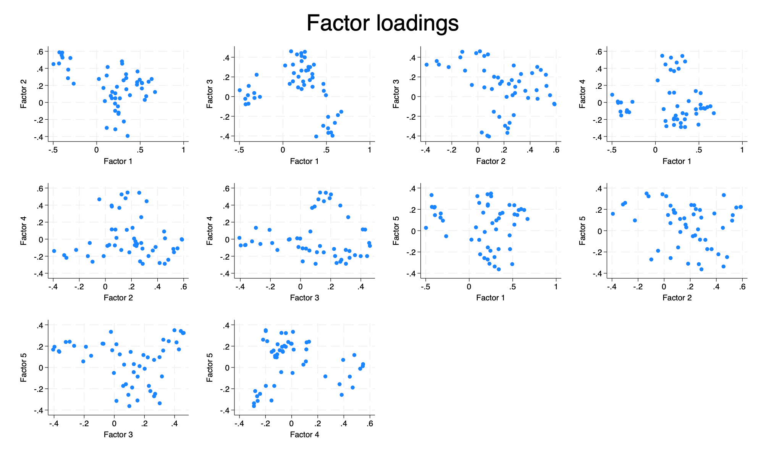
Figure 2. ​​Scree Plot of Eigenvalues from Exploratory Factor Analysis
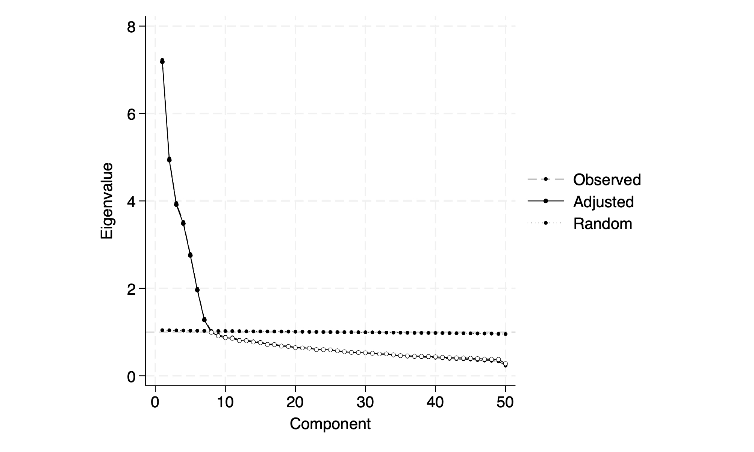
Table 4. Correlation Matrix of Trait-Level Total (T) Scores Assessing Divergent Validity
 | EXT_T | AGR_T | CSN_T | EST_T | OPN_T
EXT_T | 1
AGR_T | 0.3179 | 1
CSN_T | 0.0876 | 0.1857 | 1
EST_T | -0.1954 | 0.0014 | -0.1813 | 1
OPN_T | 0.1753 | 0.1809 | 0.1258 | -0.0196 | 1

Appendix II: References
- About the Open-Source Psychometrics Project. (n.d.). Retrieved December 16, 2025, from https://openpsychometrics.org/about/
- Administering IPIP Measures, with a 50-item Sample Questionnaire. (n.d.). Retrieved December 8, 2025, from https://ipip.ori.org/New_IPIP-50-item-scale.htm
- Allport, G. W., & Odbert, H. S. (1936). Trait-names: A psycho-lexical study. Psychological Monographs, 47(1), i–171. https://doi.org/10.1037/h0093360
- Amente, T., & Zeleke, S. (2024). Validation of the Big Five Personality Scale for Ethiopian university students: Exploring the psychometric properties of the Amharic version. Cogent Psychology, 11(1), 2379153. https://doi.org/10.1080/23311908.2024.2379153
- Atherton, O. E., Robins, R. W., Rentfrow, P. J., & Lamb, M. E. (2014). Personality Correlates of Risky Health Outcomes: Findings from a Large Internet Study. Journal of Research in Personality, 50, 56–60. https://doi.org/10.1016/j.jrp.2014.03.002
- Big Five Personality Test (Kaggle). (n.d.). Retrieved December 8, 2025, from https://www.kaggle.com/datasets/tunguz/big-five-personality-test
- Boyle, G. J. (1995). Myers-Briggs Type Indicator (MBTI): Some psychometric limitations. Humanities & Social Sciences Papers, 30. https://doi.org/10.1111/j.1742-9544.1995.tb01750.x
- Brewer, L., & Brewer, L. (n.d.). General Psychology: General Psychology: Required Reading Required Reading.
- Cattell, H. E. P., & Mead, A. D. (2008). The Sixteen Personality Factor Questionnaire (16PF). In G. Boyle, G. Matthews, & D. Saklofske, The SAGE Handbook of Personality Theory and Assessment: Volume 2—Personality Measurement and Testing (pp. 135–159). SAGE Publications Ltd. https://doi.org/10.4135/9781849200479.n7
- Cohen, S., Kamarck, T., & Mermelstein, R. (1983). A global measure of perceived stress. Journal of Health and Social Behavior, 24(4), 385–396. https://doi.org/10.2307/2136404
- Costa, P., & McCrae, R. R. (1999). A five-factor theory of personality. The Five-Factor Model of Personality: Theoretical Perspectives, 2, 51–87.
- Cronbach, L. J. (1951). Coefficient alpha and the internal structure of tests. Psychometrika, 16(3), 297–334. https://doi.org/10.1007/BF02310555
- Dinno, A. (2009). Implementing Horn’s parallel analysis for principal component analysis and factor analysis. Stata Journal, 9(2), 291–298.
- Driskell, J., Goodwin, G., Salas, E., & O’Shea, P. (2006). What Makes a Good Team Player? Personality and Team Effectiveness. Group Dynamics: Theory, Research, and Practice, 10, 249–271. https://doi.org/10.1037/1089-2699.10.4.249
- Gkatsa, T., & Papageorgiou, M. (2025). PERSONALITY TRAITS OF STUDENTS FROM DIFFERENT UNIVERSITY FACULTIES. European Journal of Education Studies, 12(1). https://doi.org/10.46827/ejes.v12i1.5785
- Goldberg, L. R. (1992). The development of markers for the Big-Five factor structure. Psychological Assessment, 4(1), 26–42. https://doi.org/10.1037/1040-3590.4.1.26
- Graham, E. K., Rutsohn, J. P., Turiano, N. A., Bendayan, R., Batterham, P. J., Gerstorf, D., Katz, M. J., Reynolds, C. A., Sharp, E. S., Yoneda, T. B., Bastarache, E. D., Elleman, L. G., Zelinski, E. M., Johansson, B., Kuh, D., Barnes, L. L., Bennett, D. A., Deeg, D. J. H., Lipton, R. B., … Mroczek, D. K. (2017). Personality Predicts Mortality Risk: An Integrative Data Analysis of 15 International Longitudinal Studies. Journal of Research in Personality, 70, 174–186. https://doi.org/10.1016/j.jrp.2017.07.005
- Hendriks, J., Hofstee, W., & Raad, B. (2002). The Five-Factor Personality Inventory: Assessing the Big Five by means of brief and concrete statements [ch. 4] (pp. 79–108).
- History of the IPIP. (n.d.). Retrieved December 16, 2025, from https://ipip.ori.org/HistoryOfTheIPIP.htm
- Horn, J. L. (1965). A Rationale and Test for the Number of Factors in Factor Analysis. Psychometrika, 30(2), 179–185. https://doi.org/10.1007/BF02289447
- International Personality Item Pool. (n.d.). Big Five Personality Test. Open-Source Psychometrics Project. https://openpsychometrics.org/tests/IPIP-BFFM/
- Jung, C. G. H. (2014). Collected Works of C.G. Jung, Volume 6: Psychological Types: (R. F. C. Hull, Ed.). Princeton University Press. https://doi.org/10.1515/9781400850860
- Kabigting, F. (2021). The Discovery and Evolution of the Big Five of Personality Traits: A Historical Review. https://doi.org/10.13140/RG.2.2.13907.40480
- Kadri, F. (2022). Reinventing personality from a Volterra nonlinear model of motivation. Acta Europeana Systemica, 11(1), 41–58. https://doi.org/10.14428/aes.v11i1.63013
- Nunnally, J. C., & Bernstein, I. H. (20). Psychometric theory (3. ed., [Nachdr.]). McGraw-Hill.
- Pearson Correlation—An overview | ScienceDirect Topics. (n.d.). Retrieved December 16, 2025, from https://www.sciencedirect.com/topics/mathematics/pearson-correlation
- Stata, Version 18 (Version 18). (2025). [Computer software]. StataCorp.

Appendix III: Stata Code
use "big5_rev.dta"

***Reduce sample size from 1,000,000 to 100,000***

set seed 33333

sample 100000, count
*`count` selects specifically 100,000 observations*

save "big5_rev100k.dta"

use "big5_rev100k.dta"

order ///
EXT1 EXT2_R EXT3 EXT4_R EXT5 EXT6_R EXT7 EXT8_R EXT9 EXT10_R ///
AGR1_R AGR2 AGR3_R AGR4 AGR5_R AGR6 AGR7_R AGR8 AGR9 AGR10 ///
CSN1 CSN2_R CSN3 CSN4_R CSN5 CSN6_R CSN7 CSN8_R CSN9 CSN10 ///
EST1 EST2_R EST3 EST4_R EST5 EST6 EST7 EST8 EST9 EST10 ///
OPN1 OPN2_R OPN3 OPN4_R OPN5 OPN6_R OPN7 OPN8 OPN9 OPN10
* `_R` identifies reverse-coded items *

// CRONBACH'S ALPHA
display "=== EXT — Unstandardized Cronbach's Alpha ==="
alpha EXT1 EXT2_R EXT3 EXT4_R EXT5 EXT6_R EXT7 EXT8_R EXT9 EXT10_R, asis

display "=== AGR — Unstandardized Cronbach's Alpha ==="
alpha AGR1_R AGR2 AGR3_R AGR4 AGR5_R AGR6 AGR7_R AGR8 AGR9 AGR10, asis

display "=== CSN — Unstandardized Cronbach's Alpha ==="
alpha CSN1 CSN2_R CSN3 CSN4_R CSN5 CSN6_R CSN7 CSN8_R CSN9 CSN10, asis

display "=== EST — Unstandardized Cronbach's Alpha ==="
alpha EST1 EST2_R EST3 EST4_R EST5 EST6 EST7 EST8 EST9 EST10, asis

display "=== OPN — Unstandardized Cronbach's Alpha ==="
alpha OPN1 OPN2_R OPN3 OPN4_R OPN5 OPN6_R OPN7 OPN8 OPN9 OPN10, asis

// DIVERGENT VALIDITY
*create new variables for total scores within trait groups*
egen EXT_T = rowtotal(EXT1 EXT2_R EXT3 EXT4_R EXT5 EXT6_R EXT7 EXT8_R EXT9 EXT10_R)
egen AGR_T = rowtotal(AGR1_R AGR2 AGR3_R AGR4 AGR5_R AGR6 AGR7_R AGR8 AGR9 AGR10)
egen CSN_T = rowtotal(CSN1 CSN2_R CSN3 CSN4_R CSN5 CSN6_R CSN7 CSN8_R CSN9 CSN10)
egen EST_T = rowtotal(EST1 EST2_R EST3 EST4_R EST5 EST6 EST7 EST8 EST9 EST10)
egen OPN_T = rowtotal(OPN1 OPN2_R OPN3 OPN4_R OPN5 OPN6_R OPN7 OPN8 OPN9 OPN10)

*correlation matrix of each personality domain total score*
correlate EXT_T AGR_T CSN_T EST_T OPN_T

// PARALLEL ANALYSIS
paran EXT1 EXT3 EXT5 EXT7 EXT9 EST1 EST3 EST5 EST6 EST7 EST8 EST9 EST10 AGR2 AGR4 AGR6 AGR8 AGR9 AGR10 CSN1 CSN3 CSN5 CSN7 CSN9 CSN10 OPN1 OPN3 OPN5 OPN7 OPN8 OPN9 OPN10 EXT2_R EXT4_R EXT6_R EXT8_R EXT10_R EST2_R EST4_R AGR1_R AGR3_R AGR5_R AGR7_R CSN2_R CSN4_R CSN6_R CSN8_R OPN2_R OPN4_R OPN6_R, iter(1000) centile(95) graph seed(1)

// EIGENVALUES AND FACTOR LOADINGS
factor EXT1 EXT3 EXT5 EXT7 EXT9 EST1 EST3 EST5 EST6 EST7 EST8 EST9 EST10 AGR2 AGR4 AGR6 AGR8 AGR9 AGR10 CSN1 CSN3 CSN5 CSN7 CSN9 CSN10 OPN1 OPN3 OPN5 OPN7 OPN8 OPN9 OPN10 EXT2_R EXT4_R EXT6_R EXT8_R EXT10_R EST2_R EST4_R AGR1_R AGR3_R AGR5_R AGR7_R CSN2_R CSN4_R CSN6_R CSN8_R OPN2_R OPN4_R OPN6_R, factors(10)

// ROTATION: rotate orthoganally and get eigenvalues and factor loadings
rotate, factors(10)

// VISUAL: loading plot with labels
loadingplot, factors(5) combined maxlength(3) mlabsize(tiny) msize(vtiny)

// VISUAL: loading plot without labels
loadingplot, factors(5) combined mlabel("")

// VISUAL: screeplot
screeplot, yline(1)

