The Interaction Effect Between Antihypertensive Medication and Depressive Symptoms on Uncontrolled Hypertension Using Regression Survey Analysis and Random Forest Tree Approach
Sarvar Khamidov, Shuxin Tang, Linqing Zheng

Abstract
1 in 5 individuals with hypertension have their blood pressure uncontrolled, and 70 percent of those failed to control their blood pressure using medications. Depression has shown to be a potential risk factor for uncontrolled hypertension investigating the moderator effect of antihypertensive use on the association between depression and uncontrolled hypertension may guide blood pressure control. A total of 39,467 individuals from NHANES data were used to investigate this association through multivariable logistic regression and Random Forest models. Adjusted logistic regression model showed that among individuals who used antihypertensive medication, depression score was associated with an increase in 0.04 odds (95% CI: 0.02, 0.06) of having uncontrolled hypertension. The GLM and Random Forest models exhibited high sensitivity (>98%) but low specificity (~9%), indicating strong detection of uncontrolled hypertension but poor differentiation of negative cases. Logistic regression had a slightly higher AUC (0.79) than RF (0.78), suggesting better discriminative ability. Future studies should investigate bias and other mapping areas.

Keywords
Depression, uncontrolled hypertension, antihypertensive medication use

Introduction
Hypertension is one of the leading risk factors for cardiovascular disease and attributes to 1 in 8 cardiovascular deaths in the U.S (Martin et al., 2024). Nearly half of the adults in the U.S. have hypertension, and only 1 in 5 of those have their blood pressure controlled (Fryar et al., 2024). Additionally, 70 percent of the individuals with uncontrolled hypertension failed to control their blood pressure using medications (Richardson et al., 2024). Therefore, identifying risk factors associated with uncontrolled hypertension after antihypertensive medication use is important to prevent the development of cardiovascular disease.
One potential risk factor that contributes to uncontrolled hypertension after medications use is depression. Research has shown that depression increases the risk of developing uncontrolled hypertension due its effect on elevating the sympathetic tone and cortisol production and (Rubio-Guerra et al., 2013; Wang et al., 2021; Sırlıer Emir et al., 2023). In addition to the direct effect of depression on hypertension, depression may influence patient’s adherence to antihypertensive drugs, leading to poor blood pressure control (Grenard et al., 2011). Given the high prevalence of uncontrolled hypertension with antihypertensive medication use and the potential interaction effect between antihypertensive medication and depressive symptoms, understanding how antihypertensive medication influence the association between depression and uncontrolled hypertension could guide blood pressure control.
In this study, we investigated the moderator effect of antihypertensive medication use on the association between depression and uncontrolled hypertension using a nationwide survey data in the U.S. We hypothesized that greater depressive symptoms will be associated with uncontrolled hypertension with antihypertensive medication use.
Methods
Data source
NHANES is one of the biggest openly available cross-sectional survey data which consists of health and nutritional condition of adults and children of United States population from interviews and physical examinations. NHANES data are collected in a nationally representative manner using a complex, multistage probability sampling design, making it a valuable national-level data source (CDC, 2025).
Analytic sample
In this cross-sectional study we used a total of 39,467 individuals from NHANES data retrieved from cardioStatsUSA and NHANES Patient Health Questionnaire conducted between 2005 and 2020 (Jaeger et al., 2023). Patients with missing data on questions regarding depression and blood pressure measurements were excluded from our study sample.
Assessment of depression and uncontrolled hypertension
The depression for our study was diagnosed based on DSM-5 diagnostic criteria using the Patient Health Questionnaire (PHQ-9) from the NHANES Patient Health Questionnaire, with a score of 10 indicating the diagnosis (Maurer, Raymond and Davis, 2018). To assess the severity of depression symptoms, depression score was operationalized as a continuous variable, reflecting the number of depressive symptoms that participant reported. Uncontrolled hypertension was defined as study participant who had systolic blood pressure ≥140 mmHg or diastolic blood pressure ≥90 mmHg from the cardioStatsUSA dataset (Jaeger et al., 2023).
Covariates
We identified potential confounding variables from previous literature on the determinants of depression and ion such as gender, age, race, smoking status, usage of antihypertensive medications, BMI and a history of cardiovascular diseases (CVD) (Wang et al., 2021; Schaare et al., 2023). Age was divided into four groups:18-44, 45-64, 65-74, and 75 or more. Race was categorized classified as non-Hispanic White, non-Hispanic Black, non-Hispanic Asian, Hispanic, and other. Smoking status was categorized as never smoked, former smoker, and current smoker. BMI was grouped into four categories: less than 25, 25 to < 30, 30 to < 35, and 35 or more). Gender, use of antihypertensive medications, and history of CVD (coronary heart disease, myocardial infarction, stroke or heart failure) were coded as binary variables.
Statistical analysis
We examined the baseline characteristics of our study participants and reported the unweighted frequency and weighted percentage in Table 1. We used adjusted multivariable logistic regression model with an interaction term between depression score and antihypertensive medication to assess the moderator effect of antihypertensive medication use on the association between depression score and uncontrolled hypertension (Table 2). Random forest model using Gini Impurity scores was used to make the comparison to the logistic regression that we modeled. The numeric values labels indicate the actual importance values for each feature variable (Figure 2). To ensure nationally representative estimates, all statistical analyses were performed using the survey weights. A flow chart of data cleaning and statistical analysis steps were shown in Figure 1.
Results
Descriptive statistics
The study sample included 39,467 individuals who participated in NHANES data from 2005-2020. Among participated individuals, 48.8% were self-identified as men and 51.2% as women. Most of the study participants were 18 to 44 years old, non-Hispanic White, did not use antihypertensive medication, with no depression, never smoked, BMI between 25 to 30, and did not have a history of cardiovascular disease (Table 1).
Multivariable statistics
Our adjusted multivariable results, shown in table 2, suggested that non-Hispanic Black [aOR: 0.61(95% CI: 0.53, 0.70)], non-Hispanic Asian [aOR: 0.25(95% CI: 0.11, 0.39)], Hispanic [aOR: 0.16 (95% CI: 0.06, 0.25)], current smoker [aOR: 0.17 (95% CI: 0.06, 0.28)], having hypertension awareness [aOR: 1.46 (95% CI: 1.33, 1.59)], and BMI greater than 35 [aOR: 0.32(95% CI: 0.20, 0.45)] were positively associated with uncontrolled hypertension. Additionally, depression score [aOR: -0.02 (95% CI: -0.04, -0.01)], antihypertensive medication use [aOR: -0.70 (95% CI: -0.85, -0.54)], and having a history of CVD [aOR: -0.14 (95% CI: -0.25, -0.02)] were negatively associated with uncontrolled hypertension. Individuals who used antihypertensive medication, depression score was associated with an increase in 0.04 odds (95% CI: 0.02, 0.06) of having uncontrolled hypertension, while controlling for potential confounding variables. The random forest model achieved a slightly higher accuracy (82.11%) compared to the logistic regression model (81.95%), indicating a marginally improved overall classification performance. However, the logistic regression model outperformed the random forest model in terms of AUC (0.7907 vs. 0.7817), suggesting better discrimination ability between uncontrolled and controlled hypertension cases. Both models exhibited high sensitivity, with the logistic regression model achieving 98.04% and the random forest model achieving 98.42%, indicating that both models were effective in identifying cases of uncontrolled hypertension.
Discussion
Our results are consistent with our hypothesis such that individuals using antihypertensive medications with elevated depressive symptoms (PHQ-9 ≥10) faced a higher probability of uncontrolled hypertension compared to non-depressed medicated patients. These results are aligned with biological evidence that anxiety, depression, and cardiovascular dysregulation are actively associated with uncontrolled hypertension (Grippo & Johnson, 2009).
However, both models showed low specificity (logistic regression: 9.14%; random forest: 8.29%), meaning they struggled to correctly classify negative cases (controlled hypertension), likely due to class imbalance in the dataset. Both logistic regression (area under the curve [AUC] = 0.790) and random forest (AUC = 0.781) models demonstrated comparable accuracy (~82%), though logistic regression slightly outperformed the machine learning approach, is because the linear relationships between key predictors. Future research is needed to investigate the bias in our models.
In conclusion, our research has shown that individuals who are taking antihypertensive medication have depressive symptoms that are positively associated with uncontrolled hypertension. More research is needed to examine the association with models that have higher specificity.
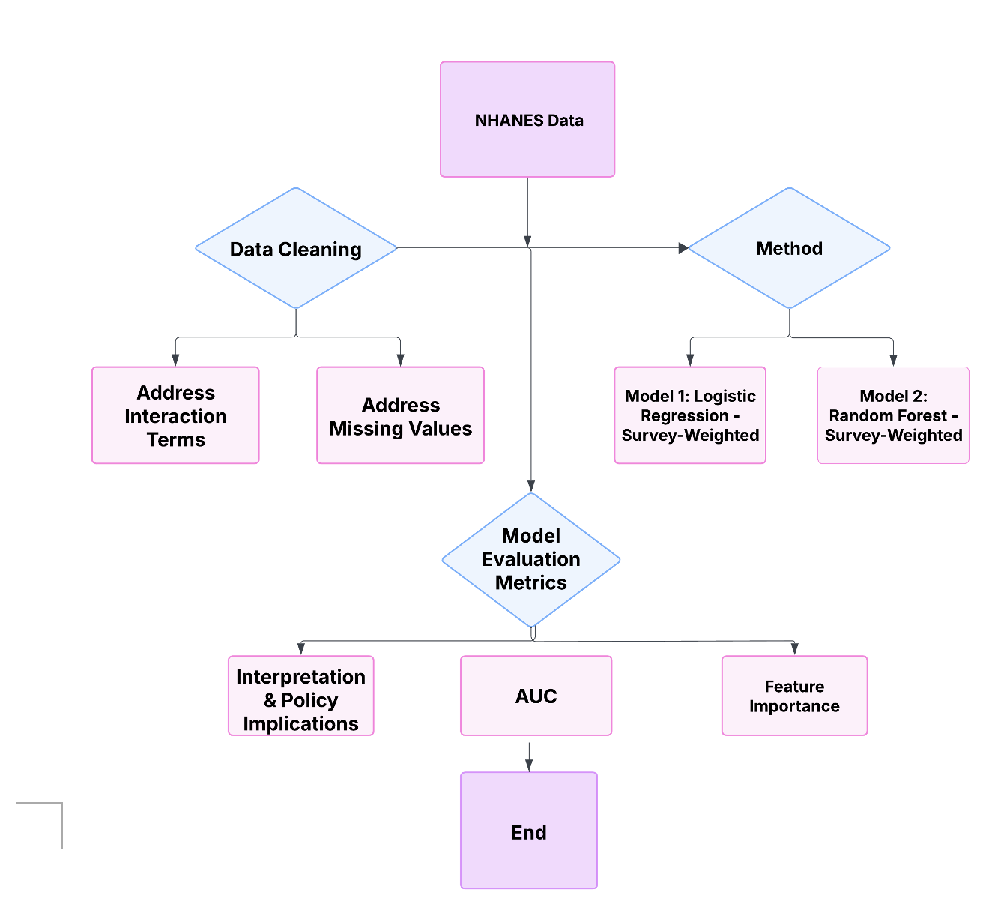
Figure 1. A flowchart of data cleaning and statistical analysis used in this study
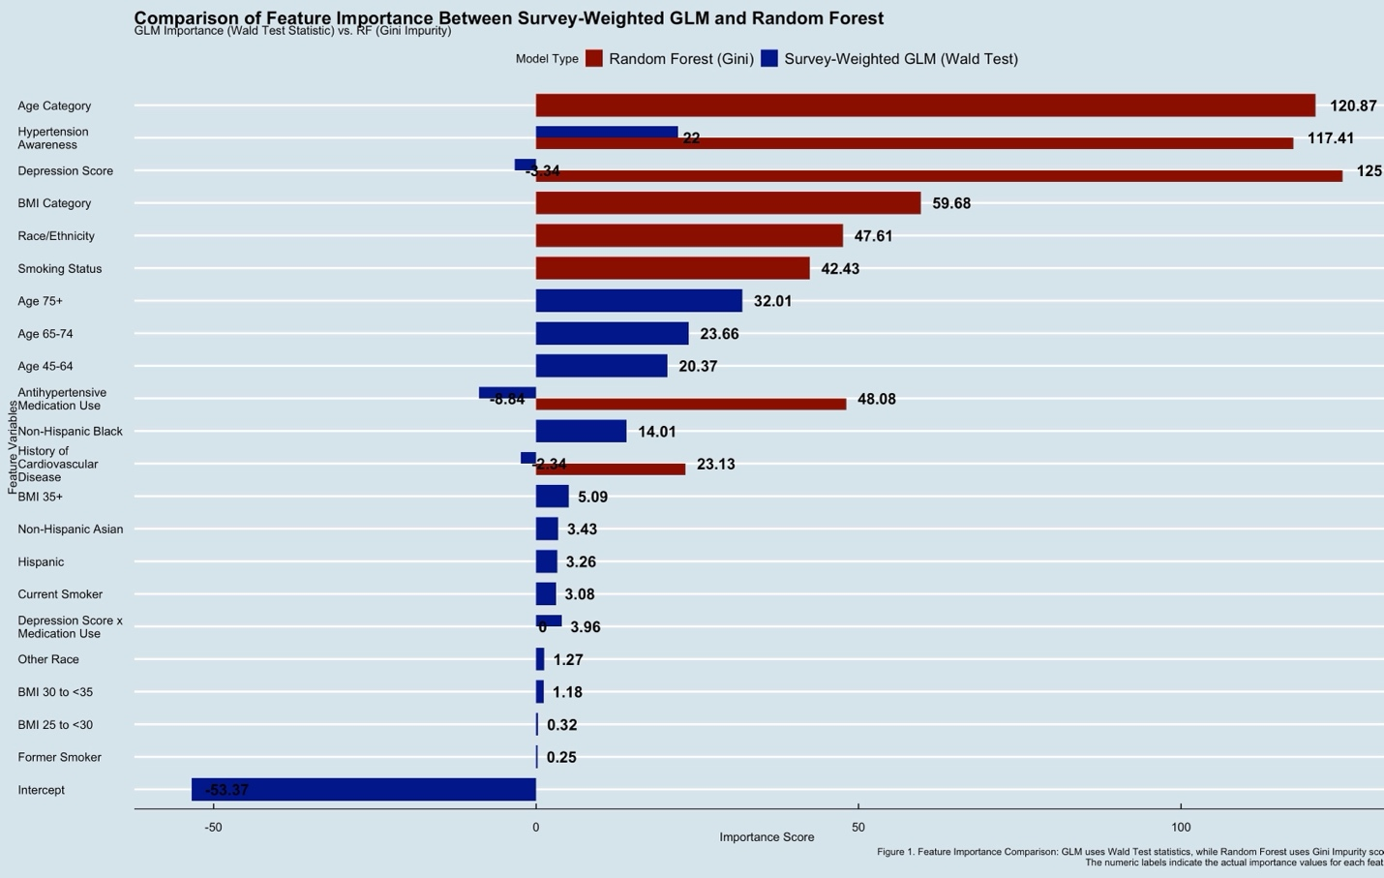Figure 2. GLM comparison with Random Forest with Feature Importance

Table 1. Baseline characteristics among study participants by hypertension status
Baseline characteristic | Unweighted N (Weighted %) | 95% CI of weighted %
Gender
Men | 19,405 (48.8%) | 48.2%, 49.5%
Women | 20,062 (51.2%) | 50.5%, 51.8%
Age Category
18 to 44 | 17,806 (47.2%) | 46.5%, 47.9%
45 to 64 | 12,767 (34.8%) | 34.1%, 35.4%
65 to 74 | 5,075 (10.8%) | 10.4%, 11.2%
75+ | 3,819 (7.2%) | 6.93%, 7.47%
Race
Non-Hispanic White | 16,322 (67.6%) | 67.1%, 68.1%
Non-Hispanic Black | 8,931 (11.2%) | 10.9%, 11.4%
Non-Hispanic Asian | 2,654 (3.0%) | 2.84%, 3.08%
Hispanic | 9,976 (14.1%) | 13.8%, 14.4%
Other | 1,584 (4.2%) | 3.99%, 4.51%
Antihypertensive medication use
No | 29,015 (77.0%) | 76.5%, 77.6%
Yes | 10,385 (23.0%) | 22.4%, 23.5%
Depression
0 | 35,991 (92.3%) | 92.0%, 92.6%
1 | 3,476 (7.7%) | 7.37%, 8.04%
Smoking
Never | 21,360 (55.2%) | 54.6%, 55.9%
Former | 9,090 (24.8%) | 24.2%, 25.4%
Current | 7,672 (20.0%) | 19.5%, 20.5%
BMI
<25 | 11,542 (30.7%) | 30.1%, 31.3%
25 to <30 | 12,492 (32.5%) | 31.9%, 33.1%
30 to <35 | 7,921 (20.2%) | 19.7%, 20.7%
35+ | 6,788 (16.6%) | 16.2%, 17.1%
History of CHD, MI, stroke or HF
No | 35,657 (92.2%) | 91.9%, 92.5%
Yes | 3,810 (7.8%) | 7.46%, 8.11%

Table 2. Adjusted logistic regression model for assessing moderator effect on antihypertensive medication on depression score and uncontrolled hypertension using 2005-2020 NHANES Data

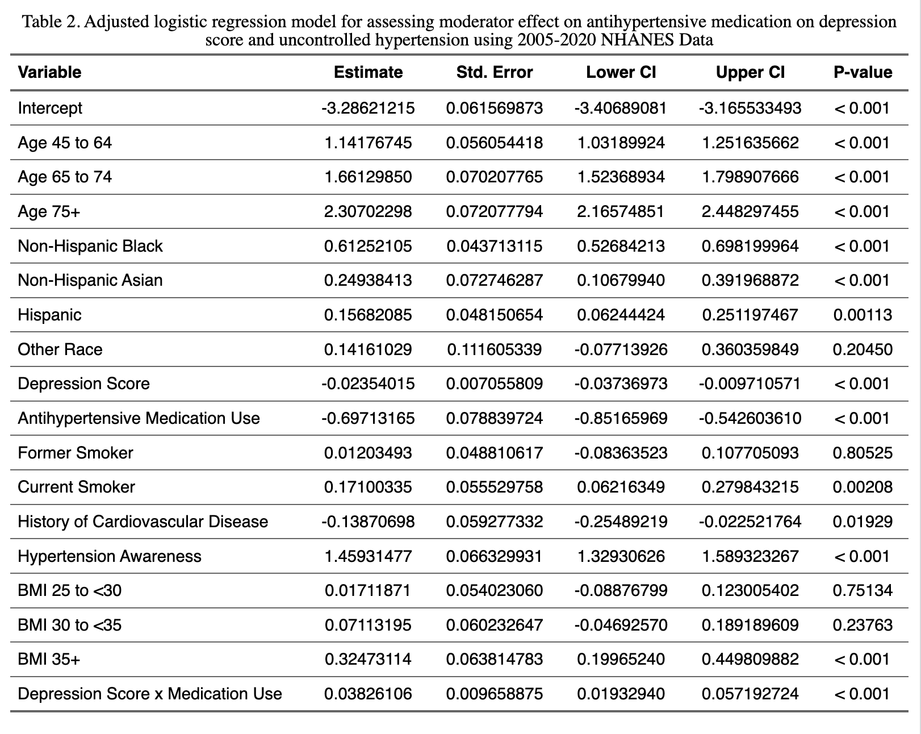

Reference
CDC. (2025) NHANES Survey Methods and Analytic Guidelines. URL https://wwwn.cdc.gov/nchs/nhanes/analyticguidelines.aspx [accessed 17 February 2025]
Dworkin, B.R., Filewich, R.J., Miller, N.E., Craigmyle, N. and Pickering, T.G. (1979) Baroreceptor activation reduces reactivity to noxious stimulation: implications for hypertension. Science (New York, N.Y.), 205, 1299–1301.
Fang, J., Zhang, Z. and Greenlund, K.J. (2022) Association of depressive symptoms and hypertension prevalence, awareness, treatment and control among US adults. Journal of hypertension, 40, 1658–1665.
Fryar, C., Kit, B., Carroll, M. and Afful, J. (2024) Hypertension prevalence, awareness, treatment, and control among adults age 18 and older: United States, August 2021–August 2023. NCHS Data Brief, no 511. Hyattsville, MD: National Center for Health Statistics.
Grenard, J.L., Munjas, B.A., Adams, J.L., Suttorp, M., Maglione, M., McGlynn, E.A., et al. (2011) Depression and Medication Adherence in the Treatment of Chronic Diseases in the United States: A Meta-Analysis. Journal of General Internal Medicine, 26, 1175–1182.
Herrmann-Lingen, C., Meyer, T., Bosbach, A., Chavanon, M.-L., Hassoun, L., Edelmann, F., et al. (2018) Cross-Sectional and Longitudinal Associations of Systolic Blood Pressure With Quality of Life and Depressive Mood in Older Adults With Cardiovascular Risk Factors: Results From the Observational DIAST-CHF Study. Biopsychosocial Science and Medicine, 80, 468.
Jaeger, B.C., Chen, L., Foti, K., Hardy, S.T., Bress, A.P., Kane, S.P., et al. (2023) Hypertension Statistics for US Adults: An Open-Source Web Application for Analysis and Visualization of National Health and Nutrition Examination Survey Data. Hypertension, 80, 1311–1320.
Martin, S.S., Aday, A.W., Almarzooq, Z.I., Anderson, C.A.M., Arora, P., Avery, C.L., et al. (2024) 2024 Heart Disease and Stroke Statistics: A Report of US and Global Data From the American Heart Association. Circulation, 149, e347–e913.
Maurer, D.M., Raymond, T.J. and Davis, B.N. (2018) Depression: Screening and Diagnosis. American Family Physician, 98, 508–515.
Richardson, L.C., Vaughan, A.S., Wright, J.S. and Coronado, F. (2024) Examining the Hypertension Control Cascade in Adults With Uncontrolled Hypertension in the US. JAMA Network Open, 7, e2431997.
Rubio-Guerra, A.F., Rodriguez-Lopez, L., Vargas-Ayala, G., Huerta-Ramirez, S., Serna, D.C. and Lozano-Nuevo, J.J. (2013) Depression increases the risk for uncontrolled hypertension. Experimental & Clinical Cardiology, 18, 10–12.
Schaare, H.L., Blöchl, M., Kumral, D., Uhlig, M., Lemcke, L., Valk, S.L., et al. (2023) Associations between mental health, blood pressure and the development of hypertension. Nature Communications, 14, 1953.
Sırlıer Emir, B., Yıldız, S., Kazgan Kılıçaslan, A., Kılıçarslan, G., Kurt, O., Korkmaz, S., et al. (2023) Evaluation of Arterial Stiffness in Depression Patients. Alpha Psychiatry, 24, 193–199.
Wang, L., Li, N., Heizhati, M., Li, M., Yang, Z., Wang, Z., et al. (2021) Association of Depression with Uncontrolled Hypertension in Primary Care Setting: A Cross-Sectional Study in Less-Developed Northwest China. International Journal of Hypertension, 2021, 6652228.

