Bigdata for Planon

Recently requirements for the storage and processing of large volumes of data have been issued. This document is a discussion of a proof of concept for a solution of this challenge.

Use case
The use case at hand is a set of 1000 energy meters producing a reading every 5 minutes. Data must be kept for 6 years. It must be possible to query the results with performance comparable to the ‘normal’ Planon functionality.

Design choices
The data model chosen is a star model common in data warehouse / data mart environments. This design differs significantly from the usual OLTP (On Line Transaction Processing) like modeling that Planon has used exclusively so far. Apart from this only techniques are used that are used in the Planon database already. So no advanced features that are only available in separately licenses.
Hardware used is deliberately modest in order to prove the point that acceptable performance can be explained by the design instead of advanced hardware.

Data model
The next image is an ERD of the concept:
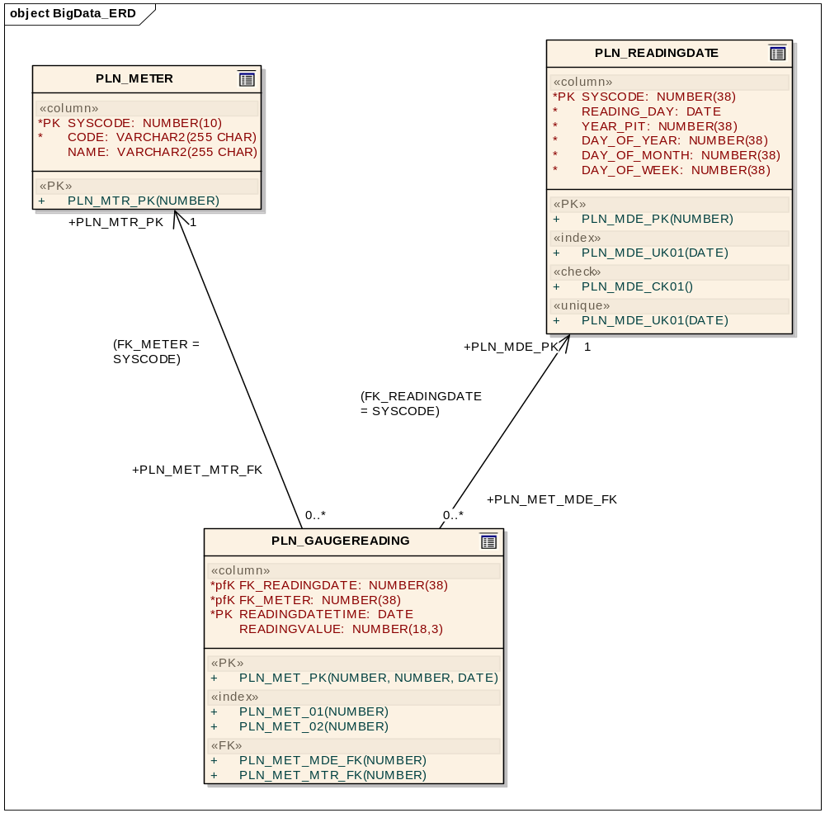

In this model a number of notable design features are implemented. Apart from that a notable feature is the volume of the data involved.

The PoC on Oracle has 1000 meters over a period of time ranging from 01-01-2007 till 23-01-2013. This results in data volumes (in number of records) of:
PLN_METER : 1000
PLN_READINGDATE : 2215
PLN_GAUGEREADING : 637920000

As is quite obvious it is the table PLN_GAUGEREADING that has a volume of data in it that is way beyond anything usual in Planon. An order table of tree million in Planon is big and gives challenges enough to maintain a workable environment. PLN_GAUGEREADING is 200 times bigger in terms of record numbers. Therefore we need to make some clear design decisions in order to prevent things from grinding to a halt.
Model decisions
Selections on the big / huge PLN_GAUGEREADING fact table are done trough one or both of the other two tables, in this model known as the dimension tables. Making selections directly on the fact table without involvement of any dimension tables makes no sense. They will result in poor performance and queries like this should be interpreted as a symptom of the fact that a dimension is missing from the model.
Here we come to one of the fundamental differences of this data warehouse star model as opposed to the usual OLTP model: a star model is not intended to support as many as possible different queries of unpredictable nature. A requirement of a new query involving new dimensions can very well result into a model change. E.g. in the addition of a new dimension.
Redundancy is another aspect demonstrated in this model. The table PLN_GAUGEREADING does contain a column describing the exact timestamp of the reading. This should in an OLTP model be enough to make selections even if these selections should be aggregated e.g. to the level of one day. In this model though there is a dimension table created where the dimension of date of the reading is extensively summarized. In an OLTP model the very existence of this table could only be defended as a de-normalization for performance purposes. In a star model a de-normalized dimension is a valid design decision.
Technical decisions
First of all the record definition of PLN_GAUGEREADING is deliberately kept small:
FK_READINGDATE Integer Not Null, -- 19 bytes
FK_METER Integer Not Null, -- 19 bytes
READINGDATETIME DATE Not NULL, -- 7 Bytes
READINGVALUE NUMBER(18, 3) NULL -- 10 Bytes
A record PLN_GAUGEREADING is 55 bytes in size on Oracle and 37 bytes in MsSql. As database platforms conduct reads block wise (8 kilobytes at a time is standard on MsSql and quite common in Oracle) it does matter how many records do fit in a database block. Keeping individual records small makes fit more of them in one block resulting in reading more records in a single I/O action and allowing more records to be cached once read.
This does imply that adding fields to the record definition is not free in terms of performance. This includes free fields.
Apart from this it is important to have data stored physically in the tables in a logically sorted way. E.g. sorted by one of the dimensions. So if a query is executed along one of the dimensions related data is stored physically close together improving the chance that one I/O will read many relevant records.
If a table or index on the table gets fragmented it will be a matter of regular maintenance to rebuild the table or index in order to restore the compact physical storage. This might be long running operations that should be scheduled as inherent maintenance on tables like this.
Functional consequences
Implementing this approach has consequences on the functional level. These include:
- Delay in the time dimension. In an OLTP environment modifications on data by transactions can be selected back immediately by other users. A BigData environment is updated at scheduled intervals with aggregated data. So it will take time for data modifications to become available.
- Loss of Flexibility. BigData is fixed on maintaining performance in high volume environments. The model therefore is adapted to the types of queries to expect. Hence the dimension tables. Requests for new dimensions might result in a redesign of the model.
- Availability. An OLTP environment is normally available 24/7. Scheduled downtime for maintenance is kept to a minimum and all functionality is available at all times. A BigData environment will be down regularly for maintenance, e.g. for loading new data into the system.
- Response times. An OLTP system is supposed to respond in seconds. A BigData report conducting in dept analysis of large data sets can take a long time. Also in a concurrent environment an OLTP setup is supposed to handle many requests at the same time while BigData might involve sequential scheduling.

Performance tests
Some example selections are executed. These are listed here including response times. This to give an idea of response times to be expected. Comparison between results on both is not possible due to the significant difference in hardware applied.

Oracle
The Oracle use case is conducted on a 5 year old developers PC running Centos linux and Oracle 11.2 as database platform.
Data volumes (in number of records) of:
PLN_METER : 1000
PLN_READINGDATE : 2215
PLN_GAUGEREADING : 637920000

Use case #1 is selecting the average gauge reading value of one day of all meters. Dimension therefore is a reading day.
Query:
Select avg(fact.READINGVALUE)
From PLN_READINGDATE d Inner join PLN_GAUGEREADING fact on (fact.FK_READINGDATE = d.SYSCODE And d.READING_DAY = To_Date('01-9-2011', 'dd-mm-yyyy'))

Response time first execute is 23.248 seconds. Subsequent executes, where the selected data is cached by the database, execute in less than 0.1 second elapsed time.
Use case #2 is selecting the average gauge reading value of one day of a specific meter. Dimensions here are both day and meter.
Query:
Select avg(fact.READINGVALUE)
From PLN_READINGDATE d Inner join PLN_GAUGEREADING fact on (fact.FK_READINGDATE = d.SYSCODE And d.READING_DAY = To_Date('21-7-2007', 'dd-mm-yyyy'))
Inner join PLN_METER m on (fact.FK_METER = m.SYSCODE And m.CODE = 'METER_123')
Response time first execute is 0.17 second. Subsequent executes are finished in terms of 0.003 seconds.

Conclusion here is that when specifying search queries with specific dimensions clearly defined it is possible to query a large data set of 600 million records with very good performance on Oracle.

MsSql
The MsSql case is build on a virtual machine hosting MsSql 2008.
Data volumes (in number of records) of:
PLN_METER : 1000
PLN_READINGDATE : 2206
PLN_GAUGEREADING : 635087000

Use case #1 is selecting the average gauge reading value of one day of all meters. Dimension therefore is a reading day.
Query:
Select avg(fact.READINGVALUE)
From PLN_READINGDATE d Inner join PLN_GAUGEREADING fact on (fact.FK_READINGDATE = d.SYSCODE And d.READING_DAY = Convert(datetime, '21-7-2007', 105))

Response time first execute is well within one second. Subsequent executes, where the selected data is cached by the database, execute in likewise times..
Use case #2 is selecting the average gauge reading value of one day of a specific meter. Dimensions here are both day and meter.
Query:
Select avg(fact.READINGVALUE)
From PLN_READINGDATE d Inner join PLN_GAUGEREADING fact on (fact.FK_READINGDATE = d.SYSCODE And d.READING_DAY = Convert(datetime, '24-9-2011', 105))
Inner join PLN_METER m on (fact.FK_METER = m.SYSCODE And m.CODE = 'METER_123')
Response time first execute is again off scale 0.00 second. Subsequent executes are finished just as quick.
Conclusion here is that when specifying search queries with specific dimensions clearly defined it is possible to query a large data set of 600 million records with very good performance on MsSql.

