Beyond Story Points in AI-Assisted Delivery: An Evidence Map and Simulation Framework for Role-Constrained Human Capacity
Anonymous submission
Abstract.
AI-assisted programming can shorten some implementation activities without proportionally shortening software delivery. Work can instead accumulate in requirements clarification, architecture, review, security, testing, integration, release, and acceptance, where finite specialist capacity and evidence obligations constrain flow. Conventional single-value planning estimates do not represent those role-specific queues or whether required release evidence is ready. This paper develops a role-constrained verified delivery model through a targeted, access-constrained evidence map and a design-science process. The artifact represents pre-commitment demand drivers, role-by-stage human service demand, effective role capacity, evidence-readiness states, dependencies, queues, and bounded rework. A developmental discrete-event simulation compares Story-Point, HIE-compatible, simple role-load, proposed, and diagnostic-oracle forecasts across declared synthetic worlds. The evidence map included 791 study families, 2,343 source-located findings, and 769 quantitative findings. No family met all five predeclared overlap dimensions for the same pre-commitment planning use. Across 11 developmental scenarios, the proposed and HIE-compatible models each had the lowest descriptive Brier score in four, simple role load in two, and Story Points in one. No deployable comparator was uniformly best. The evaluation is mechanism evidence rather than human or organizational validation. The contribution is therefore a falsifiable planning representation and a prospective validation agenda, not a universal replacement for Story Points. No substantively duplicative framework was identified within the predeclared open sources and citation network through the stated cutoff and approved resource cap; this is not an exhaustive-literature claim.
Keywords: AI-assisted software engineering; Agile estimation; software effort estimation; human oversight; software delivery; queueing; evidence readiness; discrete-event simulation

1 Introduction
Generating code is only one activity in converting an idea into accepted, operable software. A work item must also be understood, bounded, designed, integrated, reviewed, tested, secured, released, and accepted. AI assistance can change the duration and volume of implementation work, but it does not remove the need for accountable decisions or trustworthy evidence. When implementation accelerates faster than review, test, security, architecture, or acceptance capacity, the constraint moves rather than disappears.
This distinction matters for planning. Story Points are normally used as team-relative estimates of work-item size, complexity, or uncertainty and are interpreted through a team's historical throughput. They are not a universal measure of hours, and this paper does not assume that they measured coding time alone. Their limitation for the present problem is representational: one scalar does not expose which role must act, when that role is required, how long work may wait, which evidence is missing, or whether faster implementation increases downstream arrival pressure. Reviews and replications of Agile effort estimation show an extensive scalar-estimation literature while also reporting continuing limits in estimator transfer and predictive differentiation [1,2].
Recent LLM-aware estimation, human-oversight, developer-experience, review, testing, lifecycle, and delivery-orchestration research already addresses important parts of this problem [3–10]. The proposed work therefore cannot defensibly claim the first AI-era effort model, the first human-in-the-loop framework, or the first lifecycle gate process. The narrower question is whether a pre-commitment, role-by-stage resource-and-flow representation can make cross-functional delivery constraints and evidence readiness inspectable without collapsing them into another universal score.
We address that question with three linked contributions:
- a targeted open evidence map that separates peer-reviewed studies,
preprints, secondary studies, practitioner evidence, and foundational references;
- a design-science artifact that represents demand, effective capacity,
queues, readiness, dependencies, and rework at role-stage resolution; and
- a reproducible developmental simulation that tests internal behavior,
counterexamples, and conditions under which simpler models remain adequate.
The evaluation deliberately permits null and adverse findings. Synthetic results can establish whether mechanisms are internally coherent and whether a proposed representation behaves differently under specified conditions. They cannot establish that the representation measures human cognition, predicts a real organization, causes quality improvements, or outperforms existing planning practice in the field.

1.1 Research questions
- RQ1 — Evidence: How does accessible scholarly and practitioner evidence
characterize human work redistribution, review, assurance, coordination, and estimation in AI-assisted software delivery?
- RQ2 — Artifact: Which pre-commitment constructs and state variables are
necessary to represent role-constrained, evidence-ready delivery without treating psychological workload as an interchangeable proxy for time or capacity?
- RQ3 — Mechanisms: Under which declared synthetic conditions do explicit
role-stage demand, queues, dependencies, readiness, and rework alter verified completion forecasts relative to simpler comparators?
- RQ4 — Boundaries: When does the proposed detail add no material value,
become unstable, or impose unjustified estimation overhead?

2 Related-work positioning

2.1 Agile estimation and Story Points
Agile effort-estimation research spans expert judgment, analogy, machine learning, deep learning, and hybrid methods across several Agile variants [1]. A replication of learned Story Point estimation found that semantic similarity alone did not adequately distinguish stories by assigned points and called for additional techniques and features [2]. These findings do not show that Story Points are invalid or that they measured coding time alone. They support the narrower representational concern: the mapped scalar estimators do not explicitly expose role-stage queues and evidence readiness for the forecast target studied here.

2.2 LLM-aware effort and human oversight
HIE and its conceptual predecessor explicitly model LLM context, interaction/transformation, validation, and human oversight [3,4]. The empirical HIE report involved 22 developers and reports improved explained variance relative to its Story Point baseline, while the predecessor is explicitly conceptual [3,4]. The present artifact treats this line as a foundation and comparator. Its candidate distinction is the information cutoff and forecast unit: ex-ante role-stage demand and constrained delivery flow rather than realized prompt or correction activity.

2.3 Review, testing, security, and lifecycle assurance
The evidence map shows that review and quality outcomes are common, but direct prospective estimates of human effort and elapsed time are much less common. For example, a study of AI-supported test-case development reports increased interaction time alongside quality and idle-time changes [9], while a study of AI-generated pull-request descriptions reports a reduction in review time but also documents construct-validity limits [10]. These findings are activity- and context-specific; neither licenses a proportional end-to-end acceleration assumption. We therefore keep active review time, elapsed queue time, evidence obligations, defect outcomes, and subjective workload distinct.

2.4 Productivity, flow, and gate frameworks
Lifecycle and approval-gate frameworks constrain the novelty claim: gates, traceability, human approval, agentic cost, and delivery orchestration are not new [5–7]. Agile V provides a compliance-ready lifecycle and evidence-gate workflow but is supported by a bounded single case [5]. ACEM estimates agentic cost and human-in-the-loop intensity under an explicitly sequential pipeline [6]. A longitudinal delivery study examines human-AI orchestration across three modernization programs [7]. The proposed contribution is therefore narrowly the combined pre-commitment role-stage demand, touch-versus-queue, capacity/readiness/dependency, and verified-completion forecast target.

3 Research method

3.1 Overall design
The study follows a design-science sequence: characterize the problem and prior artifacts; define objectives and construct boundaries; design an inspectable planning representation; demonstrate it in a discrete-event prototype; and evaluate internal behavior, sensitivity, and failure conditions. Evaluation is split into an evidence map and developmental simulation. Neither component is presented as a field validation study.

3.2 Targeted open evidence map
The review uses a predeclared, non-Cartesian allocation of focused search families to OpenAlex, Semantic Scholar Academic Graph, and arXiv. Crossref is used for DOI and bibliographic verification rather than broad absence evidence. Six subscription sources are recorded as inaccessible coverage limitations. The protocol prohibits claims of exhaustive retrieval across all literature.
Search families cover estimation predecessors, code-review demand, testing and QA, security assurance, lifecycle/team delivery, exact duplication terms, and foundational comparisons. Two bounded integrative searches test terminology and cross-family coverage. Each declared query must pass source-specific syntax, sentinel, pagination, completeness, deterministic precision-appraisal, raw archive, and checksum controls before freeze.
After accountable-author approval and protocol freeze, 18 accepted searches were rerun into a new systematic corpus. Records were normalized and deduplicated by DOI, arXiv identifier, title, authors, and year; related preprint and peer-reviewed reports are consolidated into study families without losing report provenance. Two isolated agents screen an identical checksummed packet, followed by a separate adjudication pass. Agreement is reported as agent concordance, not human inter-rater reliability. Included reports undergo lawful full-text retrieval, design-appropriate appraisal, exact-locator extraction, and recursive backward and forward citation chasing to the prespecified stopping rule or prospective resource cap. The accountable author confirmed all ten material claims and their supporting locators at D17.
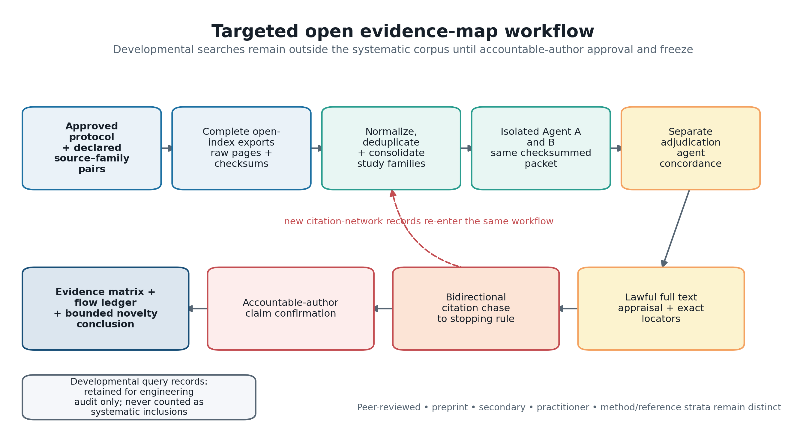
Figure 1. Targeted open evidence-map workflow. Developmental query records remain outside the systematic corpus until protocol approval and freeze.

3.3 Artifact-development logic
Constructs were separated by unit and time. Active human service requirement is not elapsed time; queue delay is not touch time; effective capacity is not headcount; evidence readiness is not confidence; and subjective or cognitive workload is not inferred from hours. Candidate inputs must be observable at the commitment cutoff t0. Realized prompt counts, code churn, review comments, test failures, rework, and post-commitment evidence are prohibited from prospective predictors because they leak outcomes or process realization.
Figure 2 summarizes the hypothesized ordering used to structure the Route B mechanisms. Its arrows are not estimated causal effects.
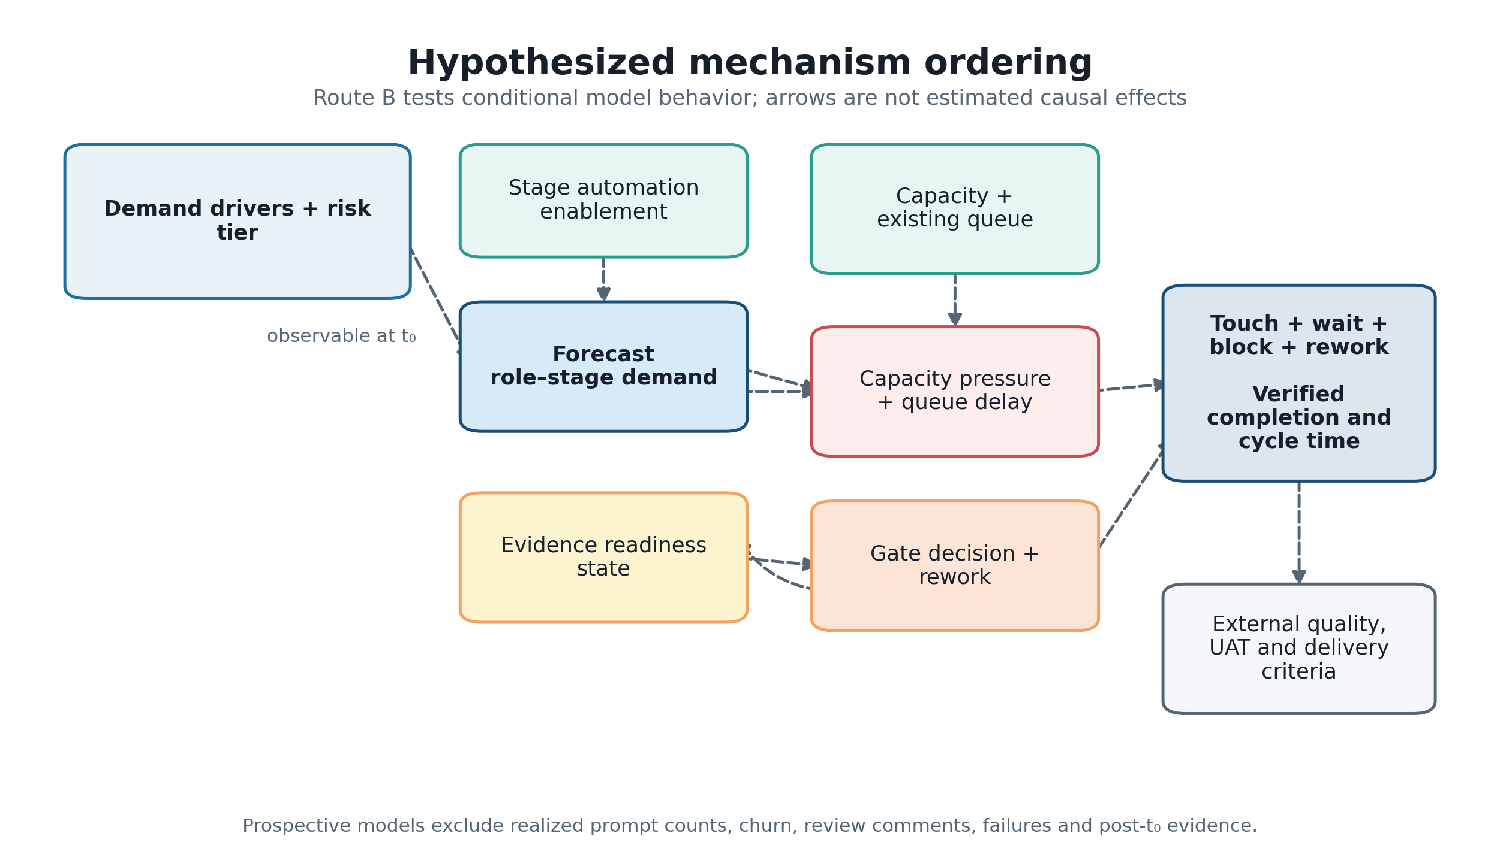
Figure 2. Hypothesized mechanism ordering and prospective information boundary.

4 Role-constrained verified delivery framework

4.1 Decision unit and prediction target
Figure 3 shows how the input profile, delivery-system mechanisms, and auditable outputs remain distinct.
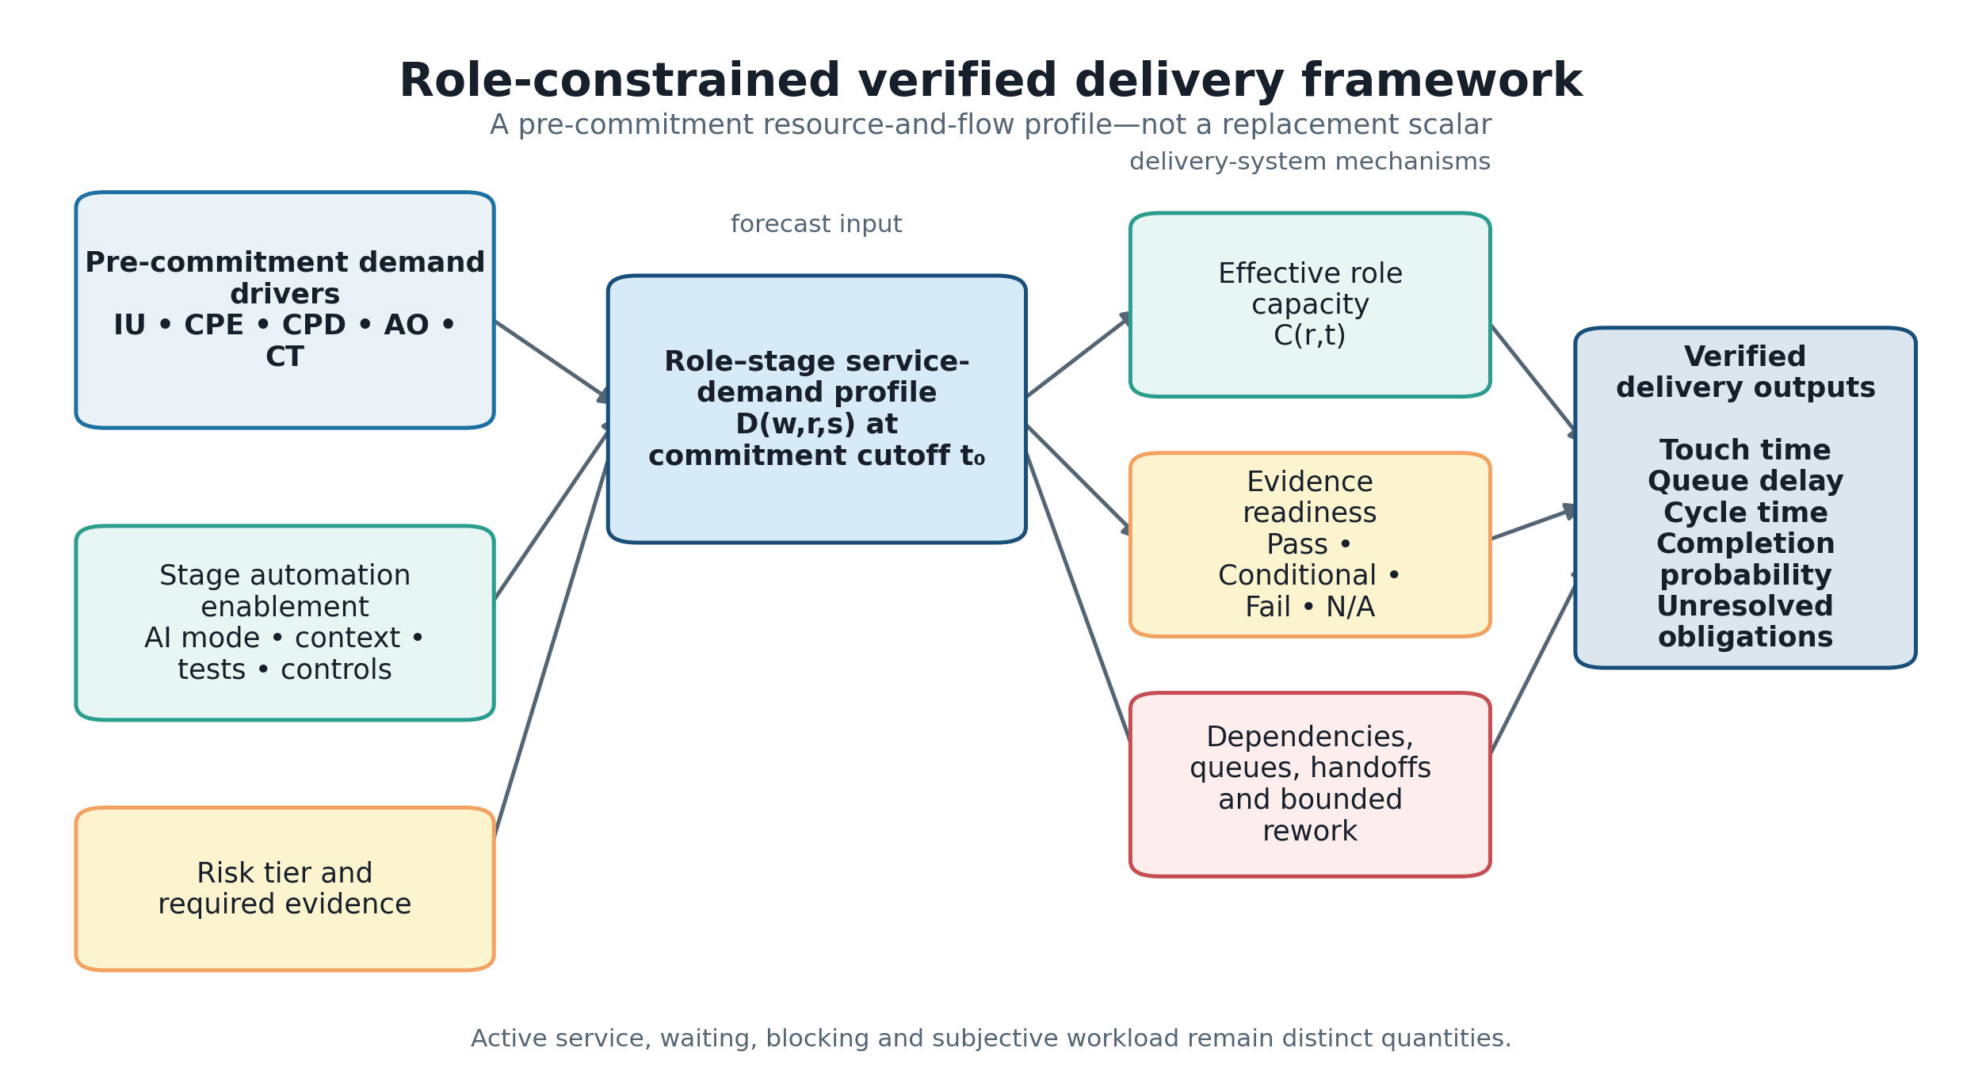
Figure 3. Role-constrained verified delivery framework.
The unit is a work item moving through lifecycle stages within a planning interval. The decision is whether a proposed portfolio can satisfy its defined release or acceptance evidence by the deadline under finite cross-functional capacity. The principal output is a distribution of verified items per horizon and a probability of verified completion for each item. The artifact is not intended for individual ranking, surveillance, compensation, or autonomous approval.

4.2 Pre-commitment demand drivers
Five formative drivers describe conditions expected to shape service demand:
- Intent Uncertainty (IU): unresolved rules, scope, decisions, acceptance
examples, and domain interpretation;
- Change Propagation Exposure (CPE): affected boundaries, interfaces, data,
dependencies, non-functional requirements, and rollback complexity;
- Context Provisioning Deficit (CPD): required trustworthy information that
is absent, stale, inaccessible, unapproved, or difficult to retrieve;
- Assurance Obligation (AO): evidence required by risk and policy across
review, test, security, compliance, operations, and acceptance; and
- Coordination Topology (CT): roles, teams, handoffs, decisions,
dependencies, and synchronization constraints.
These inputs form a profile, not a reflective psychological scale. They must not be summed into a Fibonacci-like total, and internal-consistency statistics such as Cronbach's alpha would not establish their validity.

4.3 Role-stage demand, capacity, and queues
For work item w, role pool r, and lifecycle stage s, define the ex-ante role-stage human service-demand distribution at t0 as
D(w,r,s) = distribution of active human service required at t0.
For role r in planning interval t, offered load and effective capacity are
L(r,t)=Σw,sE[D(w,r,s)], U(r,t)=L(r,t) / C(r,t),
where C(r,t) is schedulable role time after declared absence and non-project obligations. U(r,t) is utilization pressure, not an individual-performance measure. Queue delay W_q(w,r,s) begins when the item is ready for role-stage service and ends when service starts. Touch, queue, blocking, calendar pause, and rework time remain separately auditable.

4.4 Evidence readiness and transitions
Risk-scaled gates use Pass, Conditional, Fail, or Not Applicable, with required evidence identifiers, freshness and validity state, accountable role, decision rationale, and permitted transition. A mandatory failure cannot be averaged away. Conditional advancement carries an explicit residual-risk record. Failed evidence can trigger a declared bounded rework route; evidence invalidated by a change must be regenerated before a later gate can rely on it.

4.5 Stage automation enablement
Automation enablement is represented separately by stage and may include AI mode, trustworthy context, tool/domain experience, executable tests, traceability, and policy controls. It is a moderator, not a universal productivity multiplier, and is not mechanically subtracted from human demand.

4.6 Framework outputs and use
The output remains a role-stage profile plus uncertainty, not one replacement point score. It includes active service, queues, cycle time, rework, readiness, constrained roles, completion probability, and sensitivity to assumptions. A delivery lead can use the profile to ask whether commitment should change, whether a specialist pool is binding, which evidence obligation is unresolved, and which assumption most affects the forecast. Those are proposed uses, not validated organizational benefits.
The initial lifecycle representation spans intent through business acceptance and retains an accountable role pool at each stage (Figure 4).
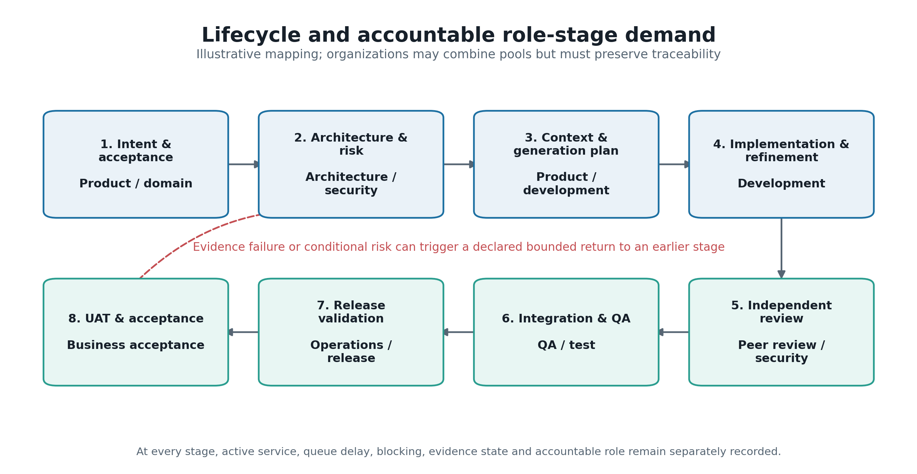
Figure 4. Illustrative lifecycle and accountable role-stage demand.

5 Developmental simulation

5.1 Purpose and architecture
The discrete-event simulation is a design-science demonstration of the artifact's mechanics. Work items request service from finite role pools, wait in explicit FIFO queues, traverse finish-to-start dependencies, encounter evidence gates, and may enter bounded rework. Executable calendars and blackouts constrain capacity. Immutable event, service, gate, queue, outcome, and manifest records support reconciliation.
The architecture separates: (1) a truth-generating scenario; (2) a prospective comparator layer restricted to information available at t0; and (3) an evaluation layer. This prevents realized events from leaking into forecasts.
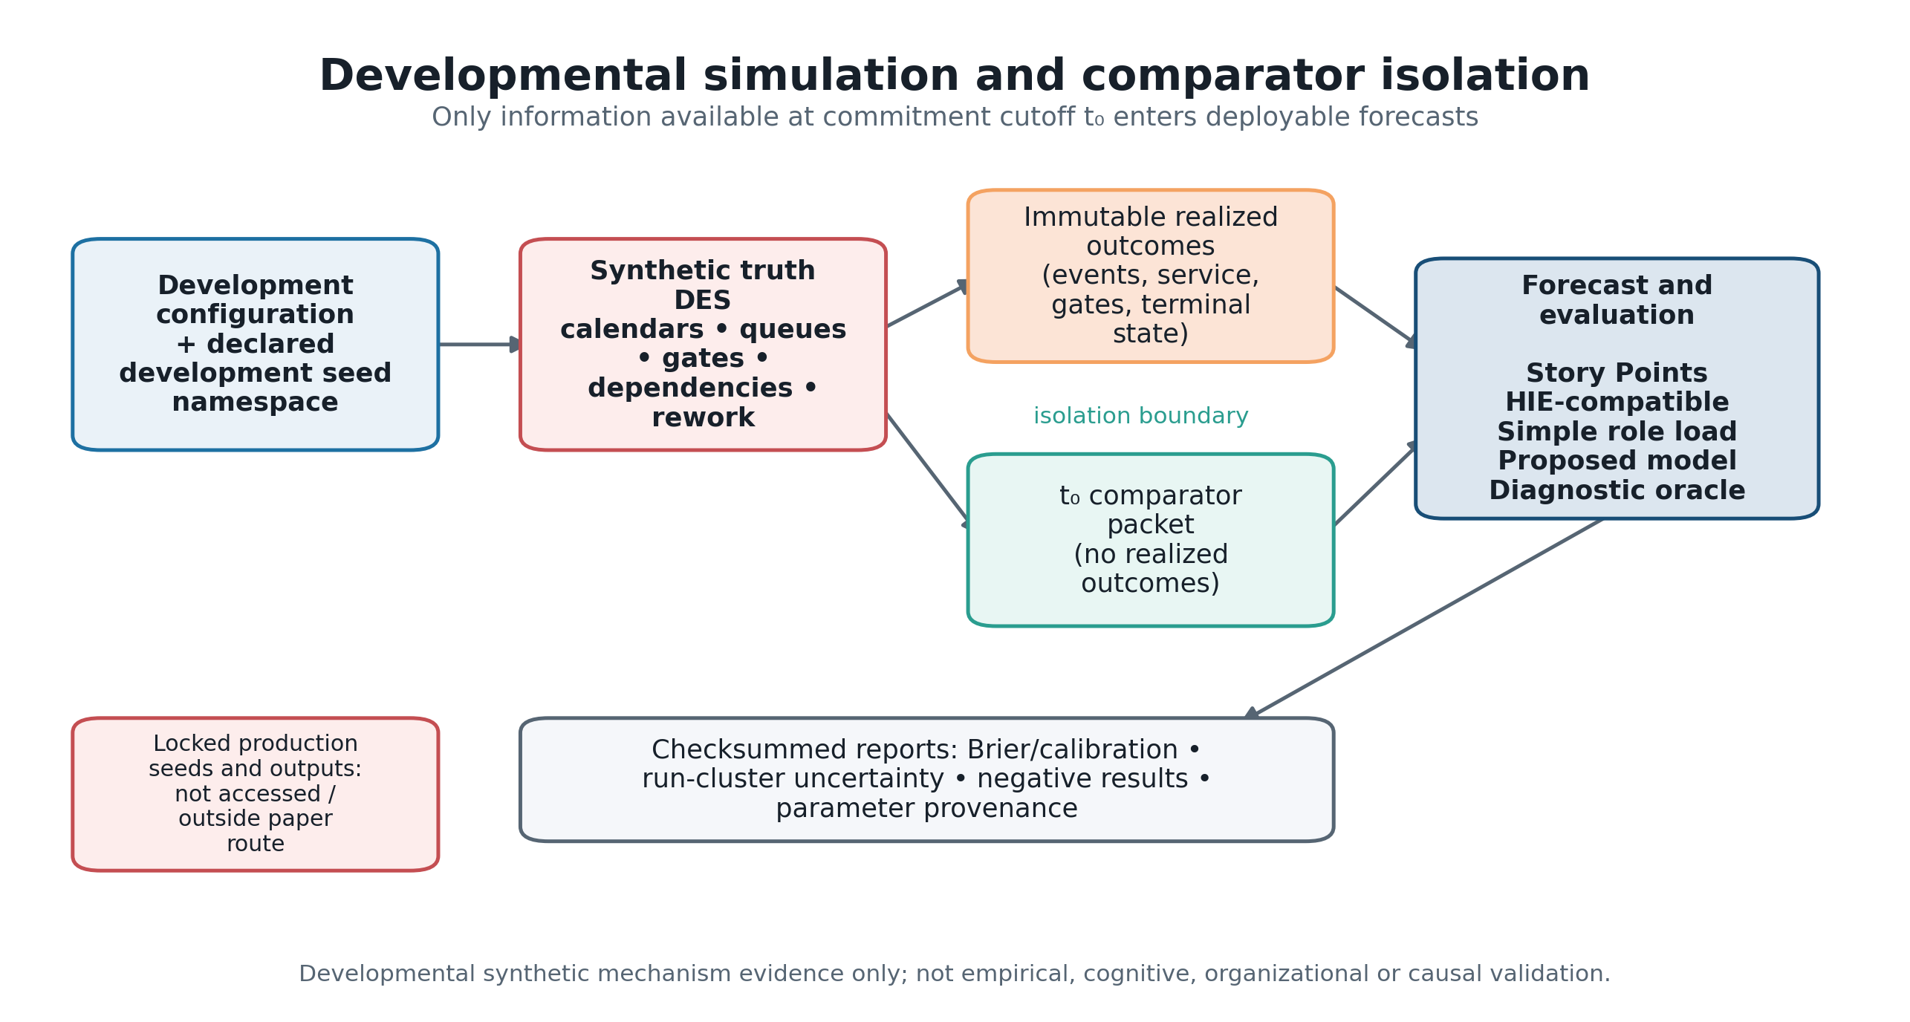
Figure 5. Developmental simulation, comparator isolation, and reporting boundary.

5.2 Comparators
Five comparator families receive the same eligible pre-commitment information:
- an organizational Story-Point-style baseline;
- an ex-ante HIE-compatible task-demand model;
- a simple role-load ratio;
- the proposed role-stage/readiness forecast; and
- a diagnostic oracle that may use scenario truth and is never deployable.
Comparators are evaluated across worlds deliberately favorable to different representations, including Story-Point-sufficient, HIE-compatible, role-bottleneck, readiness/rework, mixed, and misspecified conditions. The design therefore allows a simpler comparator to win.

5.3 Outcomes and verification
The primary forecast target is completion within the declared planning horizon under an explicit terminal-state mapping. Evaluation includes Brier and log loss, calibration, paired contrasts, cycle and queue errors, bottleneck identification, over/undercommitment, and Monte Carlo uncertainty where available. Verification includes deterministic toy cases, time and entity conservation, mandatory-failure tests, calendar and dependency fixtures, evidence-production/invalidation/regeneration tests, queue-area reconciliation, fixed-seed regression, and mechanism ablations.

5.4 Developmental status
All current runs are developmental synthetic evidence. Parameter records are classified by provenance; illustrative values are permitted for mechanism exploration but cannot be described as empirical estimates. The checked-in prototype seed set is not a sealed production evaluation. Production lock is outside the minimum paper route.

6 Results

6.1 Evidence-map results
The systematic-search stream contained 5,879 record occurrences. After 1,917 duplicate occurrences were removed, 3,962 reports representing 3,930 study families entered title/abstract screening. Screening excluded 1,854 families; 2,076 reports were sought, 472 were unavailable, 1,604 were assessed in full, and 1,034 were excluded, leaving 570 included families.
The first citation round contained 6,097 candidate occurrences, consolidated to 6,017 families after 80 duplicate occurrences were removed. Screening excluded 5,000; 1,017 reports were sought; 680 were unavailable; 337 were assessed; and 212 were included. A recovery supplement added 54 occurrences, consolidated to 33 families; 11 reports were sought, nine were assessed, and all nine were included. The accountable author approved a prospective resource cap before recursively chasing the 221 newly included citation families.
The reconciled map contains 791 unique included study families and 2,343 exact-locator findings, including 769 quantitative findings. Appraisal bands were 95 high, 397 moderate, and 299 low/contextual; the bands control narrative weight rather than eligibility. Evidence concentrated in implementation/refinement (746 families), integration (633), context/prompt (614), security/compliance (611), requirements (582), testing (575), and code review (516). Only 134 families covered manual QA/UAT, demonstrating an evidence distribution rather than a measure of relative importance.
Across 3,955 family-by-dimension overlap judgments, 19 were met, 235 partial, and 3,701 not met. Thirty-four families had the same planning use, but none met all five dimensions for that use. Accordingly, no substantively duplicative framework was identified within the predeclared open scholarly indexes, repositories, and citation networks searched through the stated cutoff and reported resource cap. Subscription-database inaccessibility, unavailable lawful full texts, unresolved public-API failures, and the approved cap bound that conclusion; it is not an absolute claim about the absence of prior work.

6.2 Developmental simulation results
The reconciled pipeline contains 11 scenarios with 24 replications each (264 runs). Two independent current-code executions were byte-identical. Manifest 0.2.0-development binds the four result tables to configuration SHA-256 6b2fd67b…db48b and implementation SHA-256 61625c62…21e4; the full values and retired predecessor hashes are preserved in the reproducibility audit. All results use developmental seeds and illustrative inputs.
Table 1 reports the descriptive lowest-Brier deployable comparator by scenario. The proposed model and the HIE-compatible model each lead four scenarios, simple role load leads two, and Story Points leads the no-rework edge case. The winner count is not a statistical ranking: the scenarios differ in number of items and were used during development.
Scenario | Items | Lowest-Brier deployable model | Brier score
Baseline bottleneck | 288 | Proposed model | 0.120608
Baseline HIE | 288 | HIE-compatible | 0.105476
Baseline Story Point | 288 | HIE-compatible | 0.145997
No-rework edge | 288 | Story Points | 0.001022
Severe-queue edge | 1,152 | Simple role load | 0.161438
High load | 864 | Simple role load | 0.249521
Low load | 144 | HIE-compatible | 0.110432
Low service-recovery fixture | 288 | Proposed model | 0.151579
High service-recovery fixture | 288 | Proposed model | 0.142288
High review capacity | 576 | HIE-compatible | 0.287817
Low review capacity | 576 | Proposed model | 0.220344

The reporting pipeline resampled complete runs 5,000 times. Figure 6 shows the paired Brier-score difference from Story Points for the other deployable models. In the severe-queue scenario, simple role load and the proposed model both improve materially on the scalar baseline in the synthetic system; simple role load remains slightly better. In the baseline-bottleneck scenario, the proposed model's difference from Story Points is small (−0.00392) and its run-cluster 95% interval (−0.00821 to 0.00006) includes zero. These contrasting cases illustrate why a single development-world winner cannot support a general superiority claim.
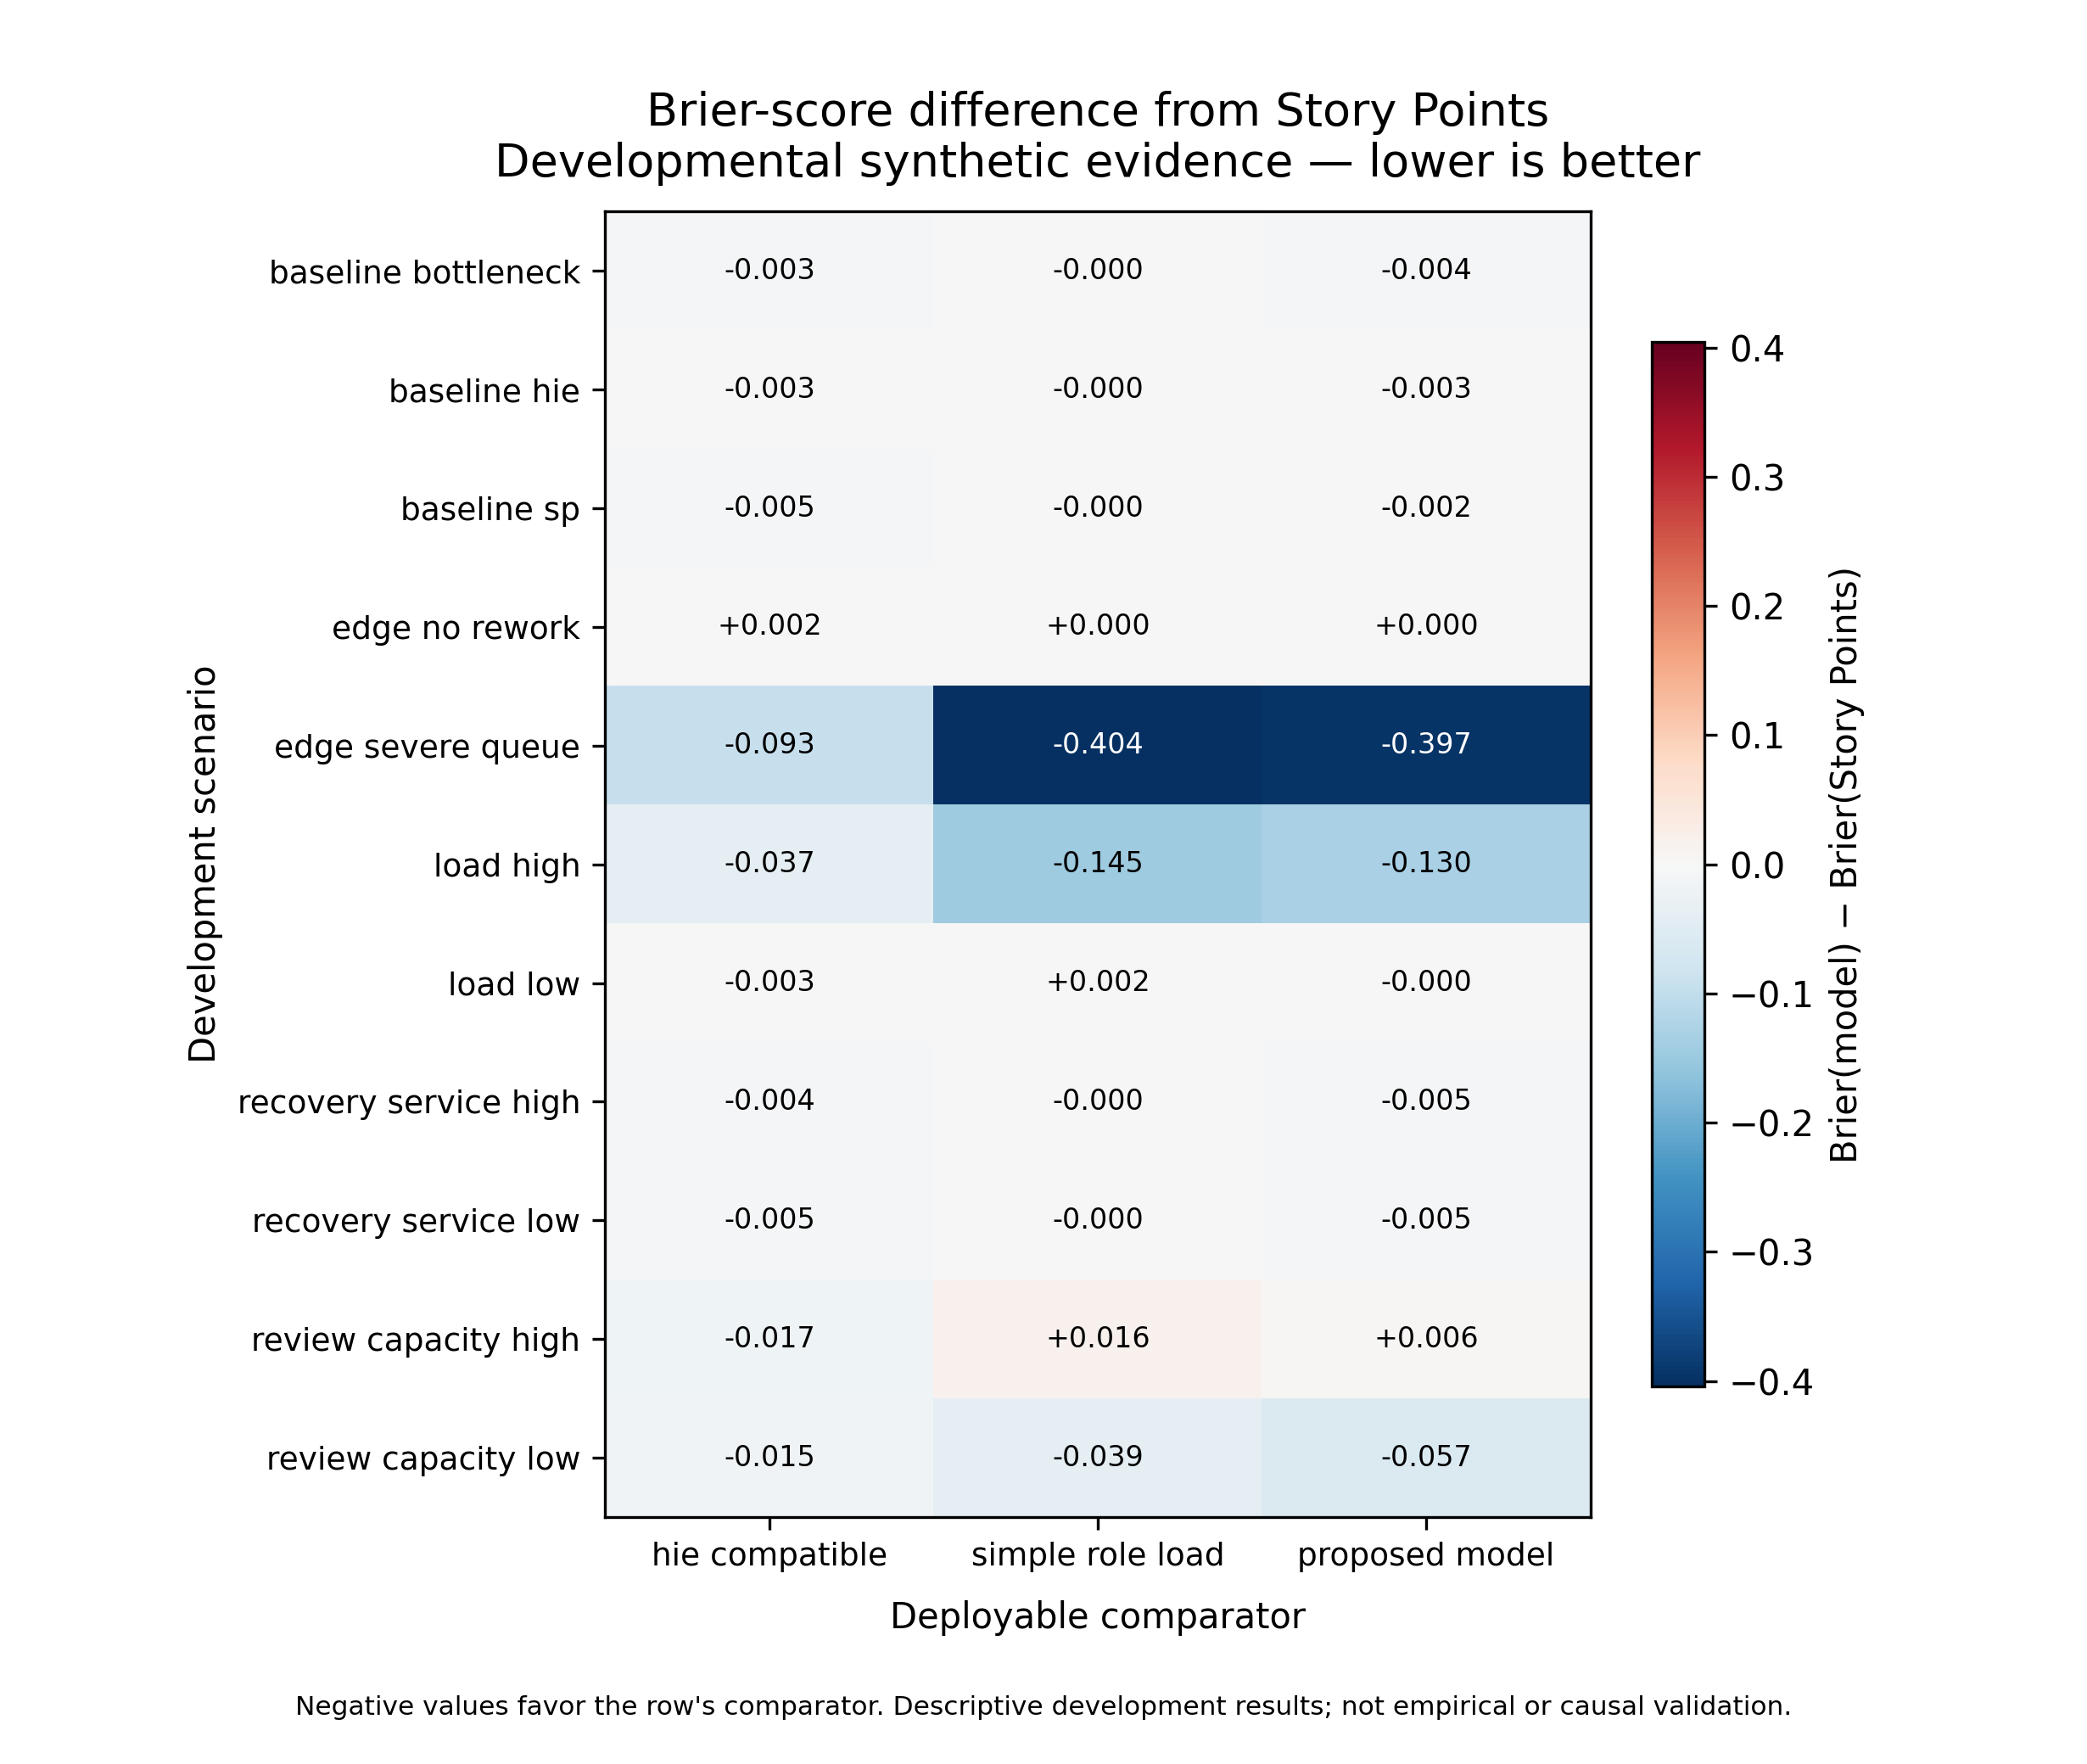
Figure 6. Brier-score differences from Story Points across developmental synthetic scenarios. Negative values favor the named comparator; values are not empirical or causal estimates.
The service-multiplier recovery fixtures returned 0.785693 for target 0.75 (absolute error 0.035693) and 1.825802 for target 1.75 (absolute error 0.075802). They verify a development diagnostic, not the recoverability of organizational parameters. Earlier reported errors from a stale output snapshot were retired during reconciliation.
Four mechanism removals—queues, readiness, dependencies, and multi-role structure—were executed across three development worlds with 24 paired replications per world. The 576 run records and 12 effect rows reproduce byte-for-byte. Their numerical deltas are not interpreted as isolated causal effects: changing event paths changes pseudorandom draw consumption, and multi-role removal also changes resource topology. Readiness removal is null in these illustrative worlds because evidence state is not a binding differentiator. The ablations therefore demonstrate executable mechanism boundaries and expose a future keyed-random-stream requirement.
All active calibration and comparator inputs remain Class I illustrative values. Literature records motivate directional mechanisms but do not supply a compatible numerical transformation for role-stage time, capacity, arrivals, gate outcomes, or rework. The detailed parameter-use table is included in the supplementary artifact set.

7 Discussion

7.1 From estimation totals to delivery constraints
The central proposal is not to rename effort as attention or to replace one scalar with another. It is to align the planning representation with the decision: whether a cross-functional portfolio can produce its required evidence by a deadline. Role-stage demand makes the location of service requirements visible; capacity and queues expose flow constraints; readiness states expose transition obligations. Whether this additional structure is worth eliciting remains an empirical question.

7.2 Implications for Agile planning
Story Points can remain useful where team composition, role demand, quality obligations, and work mix are stable enough that history absorbs those effects. The proposed model is most plausibly relevant when scarce specialist roles, high coordination, uneven automation, explicit risk gates, or downstream assurance dominate. A practical adoption sequence should therefore begin in shadow mode and compare incremental information and overhead rather than mandating a replacement scale.

7.3 Failure conditions
The artifact should be simplified or rejected when a role-load ratio performs equivalently, readiness does not predict transitions, conclusions reverse under small plausible perturbations, the input profile cannot be rated reliably, or measurement overhead approaches the decision benefit. Mixed and negative synthetic results are part of the evaluation, not exceptions to omit.

7.4 Organizational-use guidance
Organizations should introduce the artifact as a planning aid in shadow mode, not as a replacement mandate. First define the release evidence required for each risk tier and the accountable role pools. Next estimate role-stage demand as distributions, record schedulable capacity and existing queues, and keep waiting separate from active service. Compare the resulting completion forecast with current Story Point and simple role-load practice at the same information cutoff. Adoption should proceed only if calibration, bottleneck information, and decision value improve enough to justify elicitation overhead. Ratings should remain at work-item and role-pool level, with explicit anti-surveillance and anti-Goodhart controls.

8 Threats to validity and limitations

8.1 Evidence coverage
The evidence map uses open indexes and lawful open versions. Scopus, Web of Science, IEEE Xplore, ACM Digital Library, SpringerLink, and ScienceDirect are not available as authenticated systematic-search sources. Open-index field semantics and coverage differ, English-access rules may exclude relevant work, and fast-moving preprints may later change status. The review therefore cannot claim exhaustive coverage.

8.2 AI-assisted review
Two isolated agents and a separate adjudicator improve procedural separation but do not constitute independent human reviewers. Agent concordance may be affected by shared model lineage and training data. Exact-locator extraction, checksums, disagreement records, and accountable-author citation confirmation reduce but do not eliminate screening and synthesis error.

8.3 Construct validity
Role-stage service demand is a proposed resource quantity, not observed human attention or cognitive load. The formative drivers have not undergone expert content validation, inter-rater reliability, usability, or incremental-validity testing. Ordinal anchors cannot be converted to hours without genuine calibration data.

8.4 Simulation validity
The simulation verifies software behavior under declared inputs. Illustrative parameters, simplified organizations, selected mechanisms, and synthetic truth limit external validity. Scenario comparison cannot establish real causal effects, forecast calibration, organizational value, or fairness. A model can perform well when its own assumptions generate the data; diverse and misspecified worlds mitigate but do not remove that circularity.

8.5 Temporal and organizational validity
AI tools, policies, codebases, and team practices change rapidly. Any later empirical model will require temporal validation, tool/version reporting, team/project holdouts, and recalibration. Raw Story Points cannot be pooled across teams without respecting their local meaning.

9 Ethics and responsible use
The proposed artifact operates at work-item and role-pool level. It must not be used for individual surveillance, ranking, compensation, or automated denial of professional judgment. Future organizational studies should minimize measurement burden, protect work-log privacy, use minimum reporting cell sizes, control access, document retention, and monitor gaming and disparate effects. Security, compliance, release, and acceptance decisions remain accountable human responsibilities.

10 Future Route A validation
A prospective shadow-mode study should record normal Story Points, an ex-ante HIE-compatible baseline, and the role-stage profile independently at t0 before the proposed model affects commitments. Multi-role touch observations and workflow timestamps should keep active service and waiting separate. Outcomes should include completion, cycle time, queue delay, rework, UAT rejection, and prespecified quality windows. Evaluation should use temporal and leave-team/project-out validation, calibration and proper scoring rules, and measurement-error audits. Only after predictive and usability evidence should a randomized or stepped-wedge planning rollout test whether using the artifact changes delivery outcomes.

11 Conclusion
AI-assisted implementation changes the planning problem without eliminating it. Faster artifact generation can coexist with finite review, assurance, coordination, and acceptance capacity. This paper proposes an inspectable role-stage, capacity, queue, and evidence-readiness representation and evaluates its mechanics through an open evidence map and developmental simulation. The evidence map identified adjacent estimators, gate systems, cost models, and delivery frameworks, but no complete duplicate within the bounded search. The simulation also showed that added detail is not uniformly beneficial: simpler comparators won several declared worlds. VDCM should therefore be judged as a falsifiable planning artifact and validation agenda, not as a validated cognitive metric or a universal replacement for Story Points.

Declarations

AI-assistance disclosure
AI systems assisted with query engineering, record processing, screening preparation, code generation, testing, adversarial audit, and draft language. The accountable human author retains responsibility for the protocol, source verification, analysis decisions, claims, authorship, conflicts, research ethics, and submitted text. AI systems are not authors. The disclosure follows Springer Nature's requirement for transparent declaration of substantive generative-AI assistance and accountable human verification.

Data and code availability
The intended release package includes non-confidential protocol, query, evidence-ledger, simulation-code, configuration, manifest, and derived result artifacts where licensing and double-blind review permit. No restricted organizational data are used in Route B.

Competing interests, funding, and author contributions
Competing-interest, funding, and author-contribution declarations are withheld from the anonymous review version and will be supplied in the identified-author package before G06 approval.

References
1. Fernández-Diego, M., Mendez, E.R., González-Ladrón-de-Guevara, F., Abrahão, S., Insfrán, E.: An update on effort estimation in Agile software development: A systematic literature review. IEEE Access 8 (2020). https://doi.org/10.1109/ACCESS.2020.3021664
2. Tawosi, V., Moussa, R., Sarro, F.: Agile effort estimation: Have we solved the problem yet? Insights from a replication study. IEEE Trans. Softw. Eng. (2022). https://doi.org/10.1109/TSE.2022.3228739
3. Alaswad, F., Poovammal, E., Ramana, K., Surya Narayana, G., Khan, A.A., Faheem, M.: Hybrid intelligence effort for software effort estimation in LLM-assisted development. Discover Computing (2026). https://doi.org/10.1007/s10791-026-10331-6
4. Alaswad, F., Poovammal, E., Aljaddouh, B.: Toward LLM-aware software effort estimation: A conceptual framework. Frontiers in Artificial Intelligence (2026). https://doi.org/10.3389/frai.2026.1772418
5. Koch, C., Wellbrock, J.A.: Agile V: A compliance-ready framework for AI-augmented engineering—from concept to audit-ready delivery. arXiv preprint (2026). https://doi.org/10.48550/arXiv.2602.20684
6. El-Ramly, M.: ACEM: A cost estimation model for agentic software engineering. arXiv preprint (2026). https://doi.org/10.48550/arXiv.2608.02582
7. Armesto, M., Kolb, C.: Orchestrating human-AI software delivery: A retrospective longitudinal field study of three software modernization programs. arXiv preprint (2026). https://doi.org/10.48550/arXiv.2603.20028
8. Tomaz, R., Guenes, P., Araújo, A.A., Baldassarre, M.T., Kalinowski, M.: Impacts of generative AI on Agile teams' productivity: A multi-case longitudinal study. arXiv preprint (2026). https://doi.org/10.48550/arXiv.2602.13766
9. Shi, B.J., Kristensson, P.O.: Preemptive, buffered or guided? Empirical studies on human-AI interaction strategies for software test case development. University of Cambridge Apollo Repository (2026). https://doi.org/10.17863/CAM.131425
10. Xiao, T., Hata, H., Treude, C., Matsumoto, K.: Generative AI for pull request descriptions: Adoption, impact, and developer interventions. Proc. ACM Softw. Eng. (2024). https://doi.org/10.1145/3643773

