Advanced Apex Project–2

P4 - ANN Based Customer Response Prediction
Student Name | Roll Number
Shaik Khaja Nayab Rasool | 2025EM1100102

ANN-based customer response prediction framework using UCI Bank Marketing dataset to predict term-deposit subscriptions, to improve campaign targeting, reduce marketing costs, and maximize conversion by identifying high-potential customers before initiating campaigns.

1. Problem Understanding & Objective
a. Problem Statement: Banking industry continually strives to optimize marketing strategies, for term deposits but direct marketing campaigns face several challenges such as Low Conversion Rates, Wasted Resources, Lack of Targeted Approach.
b. Objective: Develop robust predictive model to accurately identify prospective customers subscription to term deposit by Improving Marketing, Enhancing Customer Acquisition by gaining Actionable Insights.

2. Data Inspection & Preparation
- Dataset Selection: Selected bank_additional_full.csv containing 41,188 records & 21 attributes from UCI https://archive.ics.uci.edu/dataset/222/bank+marketing.
- Data Quality: No missing values; treated 'unknown' entries as implicit missing values.
- Data Cleaning: Removed 12 duplicate records & optimized categorical data types.
- Data Transformation: Encoded binary & nominal categorical features, applied RobustScaler to numerical attributes.
- Feature Preparation: Transformed pdays into previous-contact indicator & removed duration to eliminate data leakage.
- Class Balancing: Applied SMOTE on training dataset to address class imbalance.
- Target Variable: y, Has client subscribed to term deposit? (binary: yes, no)

3. Exploratory Data Analysis (EDA)
- Class Distribution: EDA revealed significant class imbalance, with only ~11% of customers subscribing.
- Customer Segments: Students, retirees & customers contacted via cellular channels showed higher subscription rates.
- Feature Relationships: euribor3m, nr.employed, and emp.var.rate exhibited strong correlations with customer response.
- Campaign Insights: Previous successful campaigns, fewer contact attempts, and specific seasonal periods significantly increased subscription likelihood.

4. Feature Engineering
- Feature Engineering: Created interaction features age_education_interaction and campaign_previous_interaction.
- Domain Features: Engineered behaviour-driven features to capture customer characteristics.
- Feature Optimization: Applied feature scaling & engineered indicators to improve model representation.
- Model Robustness: Prevented multicollinearity and eliminated potential data leakage.

5. Multiple Model Construction
- Baseline Model: Established Logistic Regression as the baseline classifier.
- Advanced Models: Evaluated Random Forest, XGBoost & ANN (ReLU, ELU, and SELU architectures).
- Performance Comparison: Ensemble models consistently outperformed the linear baseline.
- Deep Learning: The optimized ANN achieved competitive predictive performance and class discrimination.
6. Hyperparameter Tuning
- Hyperparameter Tuning: GridSearchCV & Randomized Search using 5-fold cross-validation.
- Model Optimization: Tuned Logistic Regression regularization, Random Forest tree depth and estimators, and XGBoost learning rate, depth, and subsampling.
- Validation Strategy: Used cross-validation for robust & unbiased model selection.
- Class Imbalance: Integrated imbalance handling techniques for tuning pipeline.

6. Model Comparison & Evaluation
- Evaluation Metrics: Assessed models using Accuracy, Precision, Recall, F1-score, ROC-AUC, PR Curve, KS Statistic, Lift, and Calibration.
- Logistic Regression: Achieved highest Recall, effectively identifying positive cases.
- Random Forest & XGBoost: Random Forest delivered strong Precision, while XGBoost provided most balanced overall performance among classical models.
- Best Model: The tuned Random Forest achieved highest F1-score, whereas ANN remained competitive in ROC-AUC.
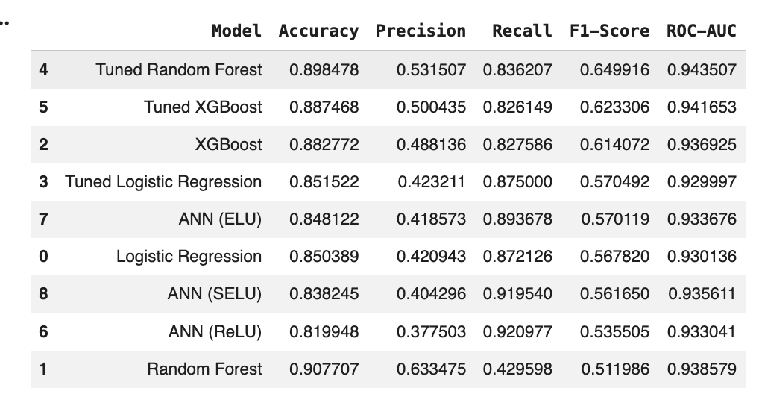

- Top Performer: Tuned Random Forest provided best operational balance with an F1-Score of 0.65 and highest ROC-AUC (0.94), making it ideal for efficient, targeted marketing.
- Maximum Sensitivity: ANN (ReLU) architecture achieved highest Recall (92%), serving as primary tool for broad market capture where missing lead is costly.
- Baseline Performance: All optimized models significantly outperformed Logistic Regression baseline, proving value of non-linear feature synthesis.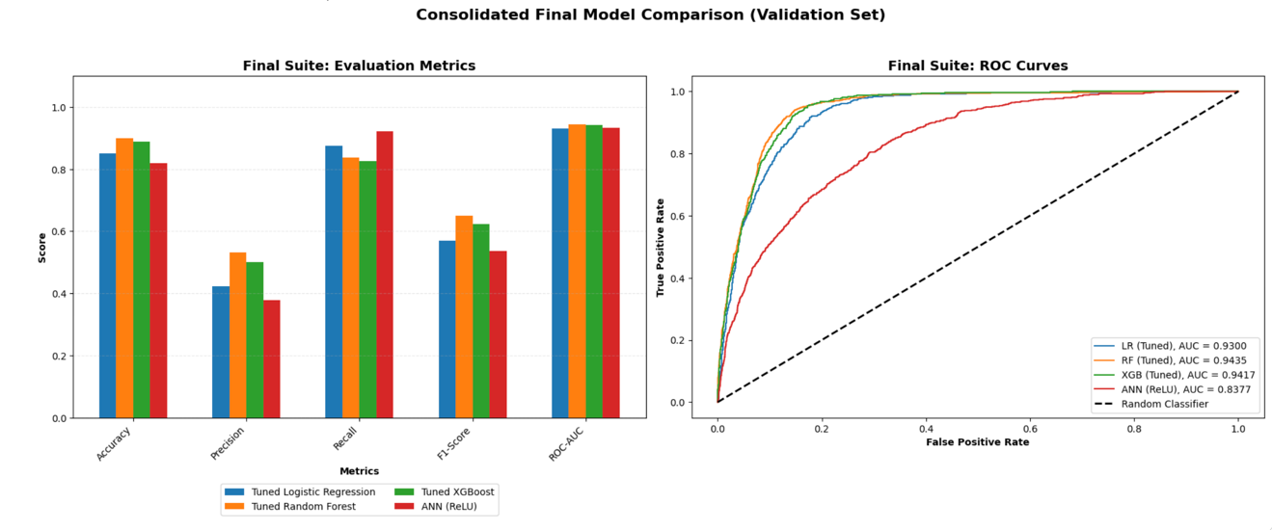

Recommendations

- Primary Recommendation (Efficiency): Deploy Tuned Random Forest model for standard marketing operations as its high precision ensures that bank's human resources are utilized on the most likely converts, maximizing the ROI per call.
- Secondary Recommendation (Outreach): Deploy ANN (ReLU) model during aggressive growth phases or seasonal high-opportunity periods (e.g., March or September), as 92% recall ensures that bank maximizes its market share by capturing nearly all potential revenue opportunities.
- Technical Safeguard: Implement Optimal Threshold (0.60 for XGBoost/RF models to maintain desired balance between operational volume and conversion rate.

7. Overfitting / Generalization
- Learning Behaviour: Training & validation curves demonstrated stable convergence after tuning.
- Overfitting Control: Applied cross-validation, regularization, SMOTE within pipelines & probability calibration to reduce overfitting.
- Generalization: Final model exhibits strong & consistent performance on unseen test data.

8. Interpretation & Insights
- Model Interpretation: Feature importance & SHAP analysis consistently identified nr.employed, euribor3m, emp.var.rate, previous campaign outcome & customer contact history as most influential predictors.
- Business Insights: Lift analysis showed targeting highest-ranked customer segments can significantly improve campaign efficiency over untargeted marketing.

9. Reproducibility & Documentation
- Reproducibility: Implemented a fully reproducible workflow covering preprocessing, EDA, feature engineering, modelling, hyperparameter tuning, diagnostics, ANN experimentation, model persistence, and inference.
- Documentation: Maintained clear, structured, and well-documented execution steps throughout the notebook.
- Tools & Technologies: Leveraged Python, Pandas, Scikit-learn, XGBoost, TensorFlow, SHAP, and Matplotlib for end-to-end model development and evaluation.
This work transforms raw customer data into actionable intelligence through rigorous analysis, robust modelling, and responsible validation. The resulting framework is accurate, interpretable, reproducible, and capable of enabling data-driven marketing decisions with confidence.

