BUDT703_0501_06

Read Me File

Nisarg Patel, Kai-Hsiang Lin, Parth Nanwani, and Snigdha Madiraju

**Brand Name**: CP HotSpots

The data was extracted from 3 of the largest online restaurant review sites:

* Yelp
* Google/Google Reviews
* TripAdvisor

The data was collected from 3 review websites by researching restaurants in the College Park, Maryland area. Only one additional filter that included vegan/vegetarian options was applied to retrieve the data. In addition, for each restaurant, we used the first 5 reviews that appeared in the review section as our data.

For customer data, if the customer did not have a name but rather a user id, we used the id as the first name and left the last name as NULL.

**Project Testing Methodology:**

For our project below files are to be run in the said order. To answer the business transactions we have created the views and have printed the results.

1. ‘Project_0501_06_DDL_CREATE_DROP_TABLE.sql’ is the first file that needs to be run.

In that file, first drop all the tables if they exist.

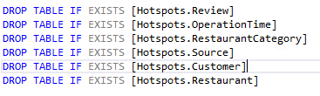

Once, all the drop statements run successfully, you’ll get the below message.

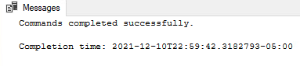

The next part in the file contains creating all the tables one after another. All the tables need to be created in the below order only, otherwise it’ll lead to an error due forigen key constraints.

1. Create the Restaurant table

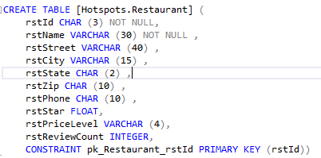

Once the restaurant table is created, you’ll get the below message

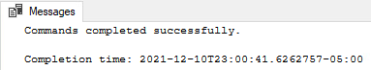

1. Create the Customer table

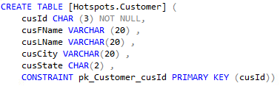

Once the customer table is created, you’ll get the below message

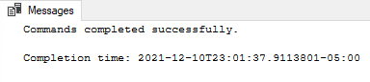

1. Create the Source table

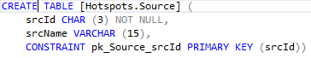

Once the source table is created, you’ll get the below message

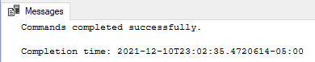

1. Create the RestaurantCategory table

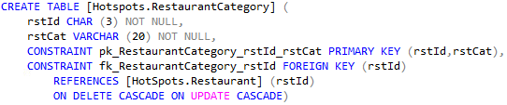

Once the RestaurantCategory table is created, you’ll get the below message

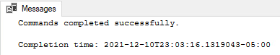

1. Create the OperationTime table

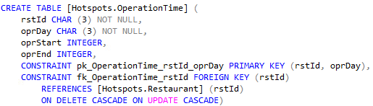

Once the OperationTime table is created, you’ll get the below message

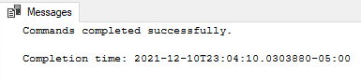

1. Create the Review table

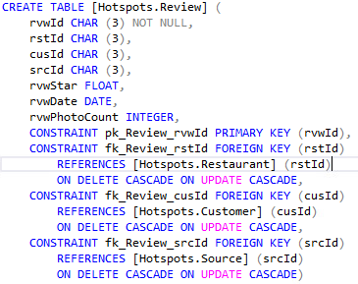

Once the Review table is created, you’ll get the below message

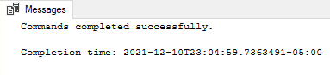

B) ‘Project_0501_06_DDL_INSERT_TABLE.sql’ is the second file that contains all the insert queries. The insert queries should be executed in the same order because of the foreign key constraints.

1. The first queries contains details about the restaurant table

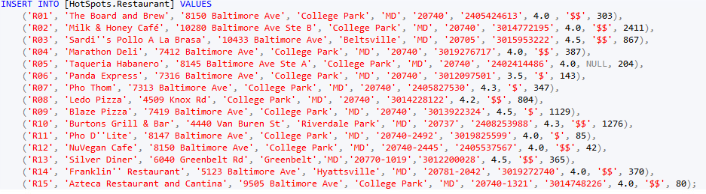

After inserting the values below message will appear

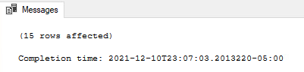

1. Below insert queries contain only a part queries of table customer

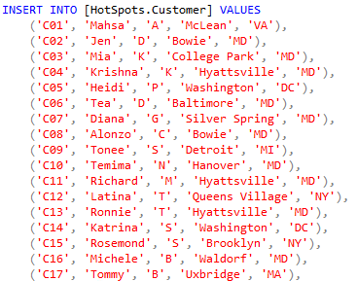

After inserting the values below message will appear

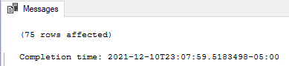

1. Next query contains details about the source table

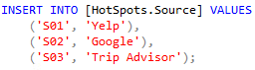

After inserting the values below message will appear

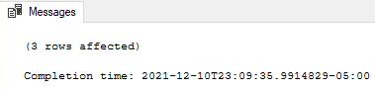

1. Below insert queries contain only a part queries of table RestaurantCategory

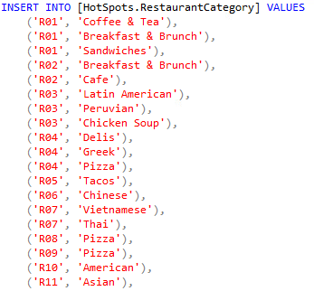

After inserting the values below message will appear

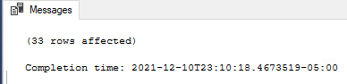

1. Below insert queries contain only a part queries of table OperationTime

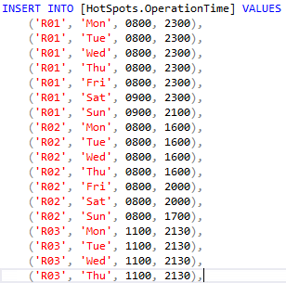

After inserting the values below message will appear

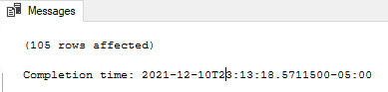

1. Below insert queries contain only a part queries of table Review

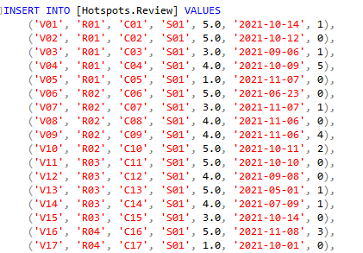

After inserting the values below message will appear

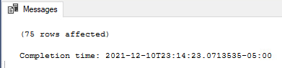

**C) The last file to be executed is ‘Project_0501_06_DML.sql’ . It contains all the answers to the business transactions and select statements to view all the tables.**

* **Execute the below table queries one after the other, to view all the data in the tables**

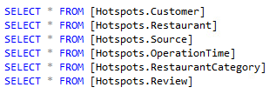

**After running the select statement of the Customer table below output can be seen.**

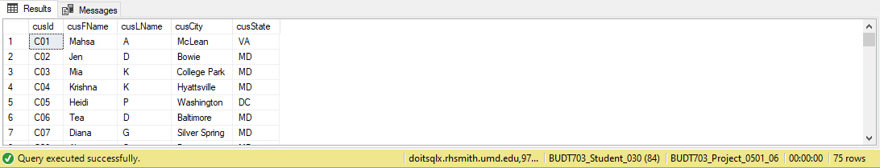

**After running the select statement of the Restaurant table below output can be seen.**

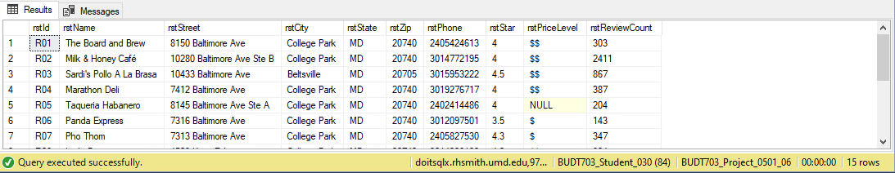

**After running the select statement of the Source table below output can be seen.**

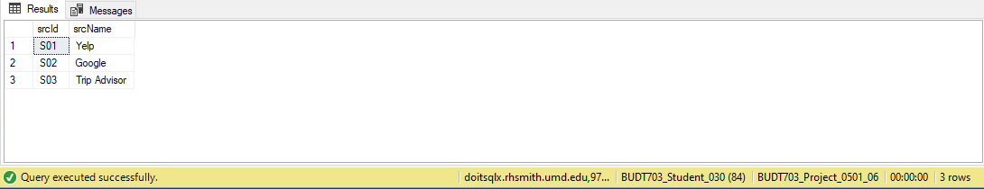

**After running the select statement of the OperationTime table below output can be seen.**

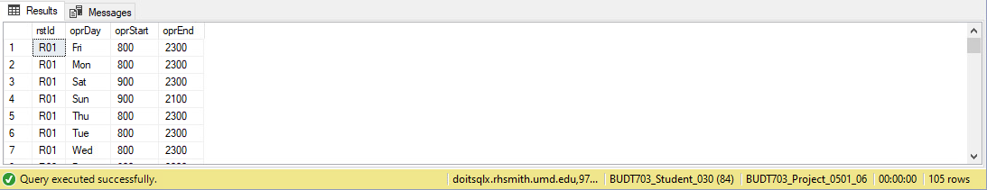

**After running select statements of the RestaurantCategory table below output can be seen.**

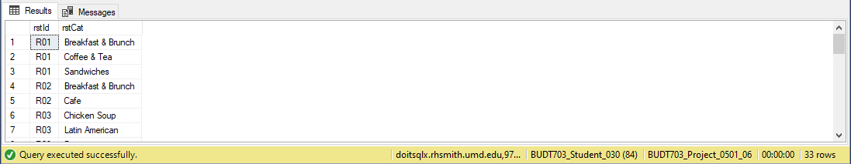

**After running the select statement of the Review table below output can be seen.**

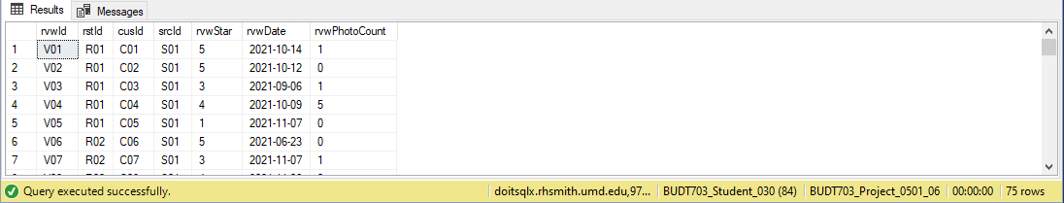

* **The next step is to drop all the views for business transactions if they exist, before creating them again.**

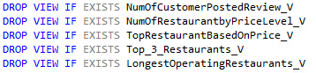

**Once all the statements are executed below message will be displayed.**

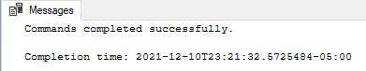

* **Next step is creating the view to answer the business transactions and using a select statement to view the result.**

**Question 1**: Which city has the most number of customers that posted a review?

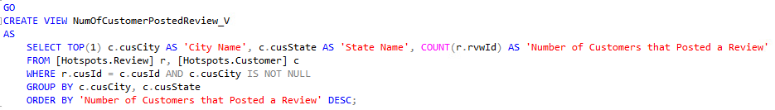

**After the view is created below message will appear**

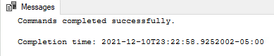

**To view the answers of the view statement below query is executed.**



**Result of the business transaction using view table**



Interpretation

* We can see that among all customers, seven are coming from Washington, DC. We conclude that most of the customers of these restaurants are local customers. Therefore, we would like to suggest potential business owners to utilize social media, conduct email marketing campaigns and get involved in local community events to target and attract local customers.

**Question 2**: What PriceLevel is the most popular among all restaurants?

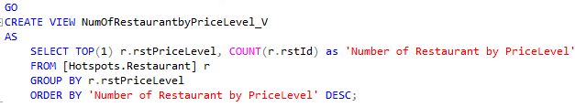

**After the view is created below message will appear**

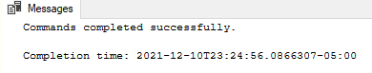

**To view the answers of the view statement below query is executed.**



**Result of the business transaction using view table**



Interpretation

* Among 15 restaurants in our database, PriceLevel “$$” is the most popular PriceLevel. “$$” indicates that the price is moderate. This may be because these restaurants are located near campus, and most of the customers are students. Therefore, we suggest possible restaurant owners that in order to attract customers and maximize profits, they should not set the price for their foods too high.

**Question 3**: Which restaurant, across all PriceLevel, has the highest rating?

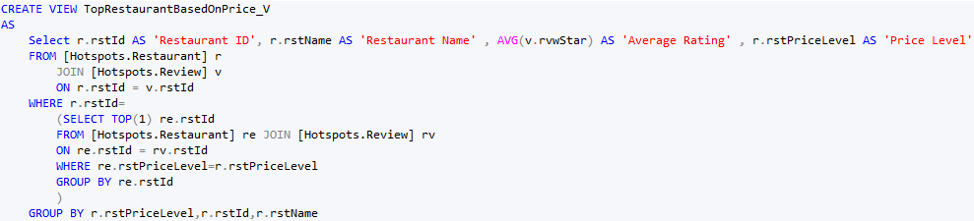

**After the view is created below message will appear**

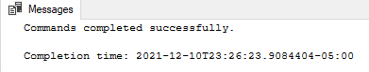

**To view the answers of the view statement below query is executed.**



**Result of the business transaction using view table**

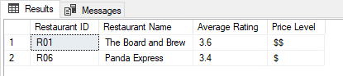

Interpretation

* The above query helps to identify the best restaurant in each price level. The ‘$’ price level restaurant usually contains fast food restaurants while ‘$$’ price level contains restaurants that are fine dine restaurants. This would help customers to pick the restaurant based on their preference and what is the occasion. If they want to grab a quick bite from the best restaurant they will go to Panda express, but if they are celebrating something they can go to ‘The Board and Brew’.

**Question 4:** Which are the names of the top 3 restaurants without considering their PriceLevel?

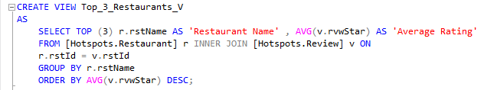

**After the view is created below message will appear**

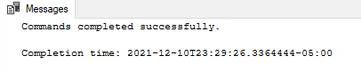

**To view the answers of the view statement below query is executed.**



**Result of the business transaction using view table**

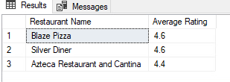

Interpretation

* This business transaction will help customers to pick the best restaurant in the college park. As we can see, the top restaurants are fast food chains because the College park population has the majority of students, hence they like to go to places that are cheap and offer quick services like Blaze Pizza and Silver Diner.

**Question 5**: Which restaurant has the highest opening hours?

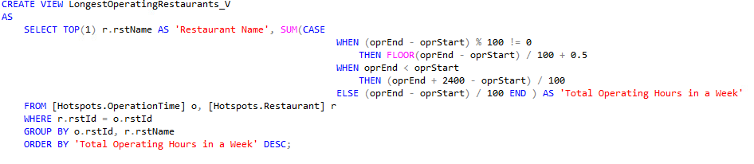

**After the view is created below message will appear**

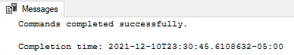

**To view the answers of the view statement below query is executed.**



**Result of the business transaction using view table**

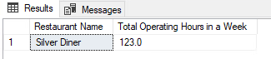

Interpretation

* The average closing time for restaurants in College Park is around 08:00 PM. This makes customers postpone or alter their dinner plans. The above query helps to identify the restaurants with the most number of Operating Hours in a week. This would help customers to pick the restaurant based on their appropriate time. If they want to spend some quality time with friends and family for a late dinner night they can certainly visit Silver Diner, seeing its longer operating hours.

**References**

* <https://www.yelp.com/>
* <https://www.google.com/>
* <https://www.tripadvisor.com/>