Why settle for an average summer job when you can do something that changes girls’ lives.


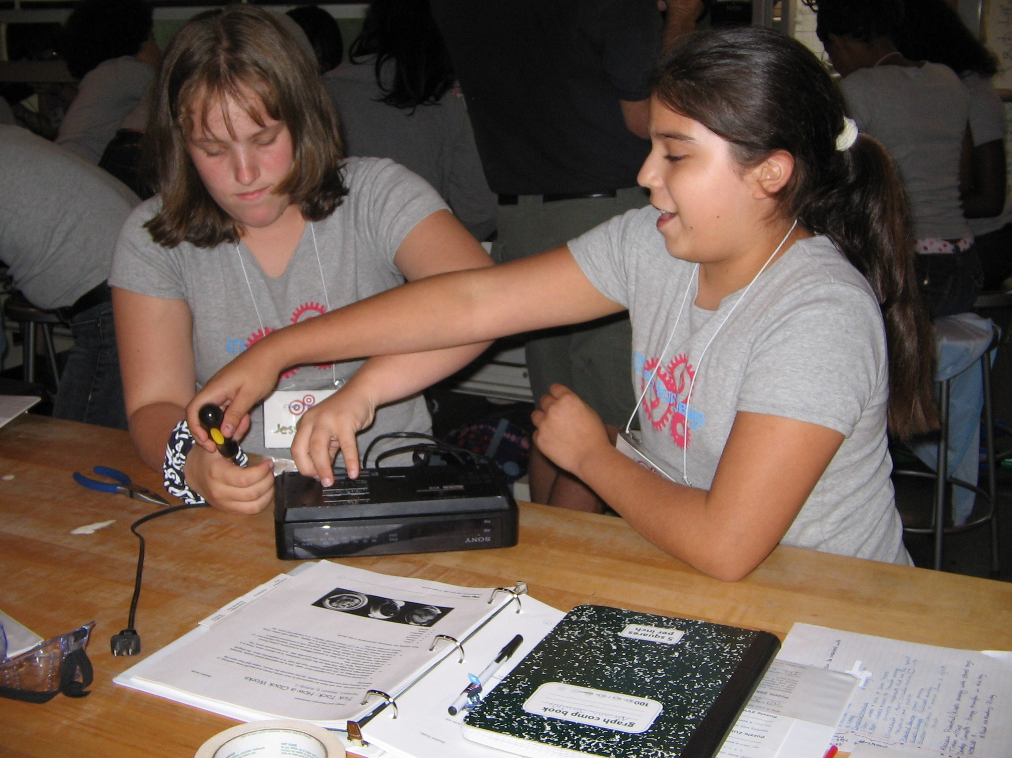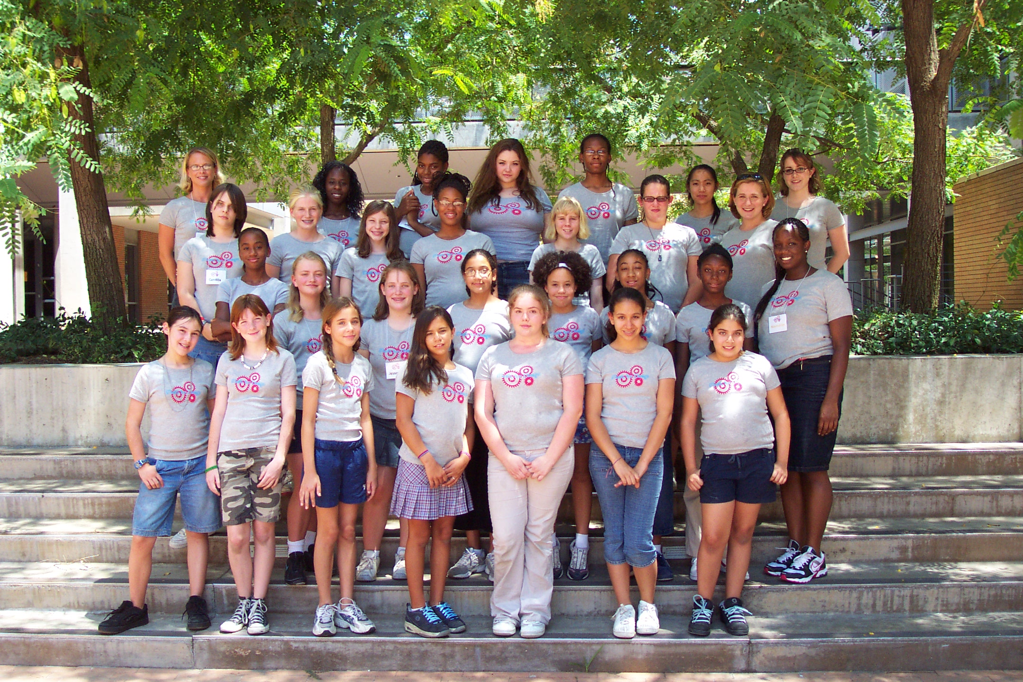

Join us as a teacher for Minds for Design & Engineer IT! Girls
unique day and resident camps for girls ages 11 to 17.

Girl Scouts of San Gorgonio Council in collaboration with Bourns College of Engineering is providing girls with an opportunity to see how fun engineering, math, and science can be through hands-on, inquiry based activities and experiments
at special camp sessions this summer.

Minds For Design Engineer IT Girls
July 13-24, 2009 August 2-7, 2009
(no program on weekends)
Teach for one session or both sessions
The Details



Location: All program sessions take place on the campus of the University of California, Riverside at the Bourns College of Engineering.
Hours: Teaching time is from 8 a.m. to 5 p.m. each day. Teachers set their own preparation
schedules.

Salary: Salary for Engineer IT Girls one-week resident camp including prep time and training is
is $1,250 per instructor. Salary for Minds for Design two-week day camp including prep time and training is $2,500 per instructor.

Training: All teachers will be fully trained in the program curriculum and will work collaboratively with experienced Girl Scout staff to implement the program.

Transportation: No transportation is provided, except for field trips.

Qualifications: You do not need to be a teacher to apply. We are looking for candidates with excellent leadership skills who have strong interest and experience in working with youth. Background in engineering, science, or math preferred.

How to Apply: Return the enclosed application and three reference forms by June 1st, 2009 to:
Girl Scouts of San Gorgonio Council
Attn: Jennifer Spencer
1751 Plum Lane, Redlands, CA 92374
Fax: 909-307-6526
Questions? Call (800) 400-4475 ext. 252 or e-mail jspencer@gssgc.org



Instructions:
Please type or print clearly
Return to:
GSSGC
Attn: Jennifer Spencer
1751 Plum Lane
Redlands, CA 92374
Girl Scouts of San Gorgonio Council

Minds for Design/Engineer IT Girls
Teacher Application

Personal Information:
Name |  |  | Date of Application
Present Address | Street | City |  | State | Zip |  | Telephone Number
 |  |  |  |  |  |  | ( )
Permanent Address | Street | City |  | State | Zip |  | Email Address
Present Occupation or Year in School |  | How did you learn about these positions?

Experience as a Counselor in Training, resident camp volunteer, or camp staff member:
Have you ever worked at a Resident Camp? If yes, please list below.
Name of Camp | Organization | Address (Street, City, State, Zip) | Phone# |  | Supervisor | Position | Dates
 |  |  | Day
 |  |  | Eve
 |  |  | Day
 |  |  | Eve

Training and Skills:
Courses taken in training or leadership | Agency | Location | Dates

Other Training and Experience | Certification Date | Other Training and Experience | Certification Date
First Aider  Standard Community |  | Licensed Driver State:

Education:
Name of schools (High School, College, Graduate School) | Highest Grade Completed | Degree or Credits

Activities: Briefly summarize community, school or any volunteer experience that will enable you to carry out the responsibilities of the job you are seeking. Also list experience in working with children, the purpose of the experience, your role and the results. You may attach additional page, if necessary.

Employment Experience:
List most recent experience first. Include all experience for the past 5 years. Attach extra pages as needed.
Employer’s Name and Address | Position/Major Responsibilities | Dates Employed
 |  | From |  | To
 | Reason for Leaving | Supervisor’s Name
Employer’s Name and Address | Position/Major Responsibilities | Dates Employed
 |  | From |  | To
 | Reason for Leaving | Supervisor’s Name

References:
List three persons NOT related to you who can judge your qualifications for this position. If you have previous experience as a camp staff member, one reference should be from a camp director or camp administrator.
Name | Address (Street, City, State, Zip) | Phone# |  | Position/Title
 |  | Day
 |  | Eve.
 |  | Day
 |  | Eve.
 |  | Day
 |  | Eve.

I hereby authorize Girl Scouts of San Gorgonio Council to contact all my educational references and the personal and employment references listed. I further authorize these references to release all information to Girl Scouts of San Gorgonio Council that pertains
to the position I am applying for. Answer yes or no.
Present Employer | Yes | Present Employer after accepting position | Yes
Present Employer | No | Present Employer after accepting position | No
Previous Employers | Yes
Previous Employers | No

Do you know of any reason why you would not be able to perform the essential functions of the job position for which you are applying, with or without reasonable accommodation?

Yes No
Please Describe:

Do you have a legal right to work in the United States? Yes No

Have you ever been convicted of a crime (other than traffic violations)? Yes No If yes, please state offense, date and location. (A conviction record will not necessarily be cause for disqualification.)

I agree to provide proof of automobile insurance, a valid driver’s license, and a clean driving record.
I agree to submit to a criminal history background check and that personal information contained in this application may be submitted to all necessary law enforcement agencies for any necessary background checks.
I understand that this employment application and any other Girl Scout documents are not contracts of employment, and that any individual who is hired may voluntarily leave employment or be terminated with or without cause or notice, at any time, by the employee or Girl Scouts of San Gorgonio Council. I understand that any oral or written statements to the contrary are hereby expressly disavowed and should not be relied upon by any prospective or existing employee. I also understand that I am submitting this application to become an employee of Girl Scouts of San Gorgonio Council and not GSUSA.

I certify that my answers to the preceding questions are true and complete and that I have not knowingly withheld any information which might, if disclosed, affect my application unfavorably. I understand that any misrepresentation or omission of facts on this application will be cause for rejection of this application or dismissal after employment and that employment is subject to verification of references.

Signature: |  | Date:

JL 03/06 EEO – Committed to Diversity

Reference Form
Girl Scouts
of San Gorgonio Council
1751 Plum Lane
Redlands, CA 92374
800/400-4475 909/307-6555
www.gssgc.org
Minds for Design and Engineer IT Girls Staff
(Confidential)

has applied to be a teacher for engineering-focused summer camps
(Applicant’s Name)
with the Girl Scouts of San Gorgonio Council and has given your name as a reference.

Girl Scouts of San Gorgonio Council is offering 3 weeks of engineering, science, and math based day and resident camps for girls this summer. Every staff member interacts closely with girls and assumes a share of the responsibility and leadership required to make camp a positive experience for our campers.

The quality and integrity of the staff we hire is very important to us. Children are placed in the care of those we hire for up to 24 hours a day. Your time in giving us an estimate of the abilities, attitudes, maturity and ethics of this applicant is appreciated, not only by us, but by the parents who entrust us with the care of their daughters.

Thank you for your time.

Please check the appropriate column. | Superior | Average | Poor | Unknown
Emotional maturity and stability
Social awareness, tact, friendliness
Health, energy, endurance
Cooperativeness
Responsibility
General appearance/neatness
Promise and capacity for development
Work performance
Flexibility
Ability to work well with others
Ability to accept supervision
Enthusiasm
General camping skills
Specialized skills, if any: (Please list)

-over-
Please comment on the following:

- In what type of relationship and for how long have you known the applicant?

- Please comment on the applicant’s ability to work with children.

- What are the factors which might limit the applicant’s effectiveness in a camp situation?

- What are the major strengths of the applicant?

- Why would you, or why would you not recommend the applicant for a camp position?

- Would you feel secure in placing your daughter or any girls for whom you are responsible under the care and leadership of this applicant 24 hours a day?

- Other comments:

 | Signature |  |  |  |  |  |  | Date
 |  |  | Day |  |  | Evening
 | Position/Title |  |  | Phone Number |  |  |  |  | Phone Number

Please return to: Girl Scouts of San Gorgonio Council
Attn: Jennifer Spencer
1751 Plum Lane
Redlands, CA 92374-4533

JL 03/2006 EEO Committed to Diversity
Reference Form
Girl Scouts
of San Gorgonio Council
1751 Plum Lane
Redlands, CA 92374
800/400-4475 909/307-6555
www.gssgc.org
Minds for Design and Engineer IT Girls Staff
(Confidential)

has applied to be a teacher for engineering-focused summer camps
(Applicant’s Name)
with the Girl Scouts of San Gorgonio Council and has given your name as a reference.

Girl Scouts of San Gorgonio Council is offering 3 weeks of engineering, science, and math based day and resident camps for girls this summer. Every staff member interacts closely with girls and assumes a share of the responsibility and leadership required to make camp a positive experience for our campers.

The quality and integrity of the staff we hire is very important to us. Children are placed in the care of those we hire for up to 24 hours a day. Your time in giving us an estimate of the abilities, attitudes, maturity and ethics of this applicant is appreciated, not only by us, but by the parents who entrust us with the care of their daughters.

Thank you for your time.

Please check the appropriate column. | Superior | Average | Poor | Unknown
Emotional maturity and stability
Social awareness, tact, friendliness
Health, energy, endurance
Cooperativeness
Responsibility
General appearance/neatness
Promise and capacity for development
Work performance
Flexibility
Ability to work well with others
Ability to accept supervision
Enthusiasm
General camping skills
Specialized skills, if any: (Please list)

-over-
Please comment on the following:

- In what type of relationship and for how long have you known the applicant?

- Please comment on the applicant’s ability to work with children.

- What are the factors which might limit the applicant’s effectiveness in a camp situation?

- What are the major strengths of the applicant?

- Why would you, or why would you not recommend the applicant for a camp position?

- Would you feel secure in placing your daughter or any girls for whom you are responsible under the care and leadership of this applicant 24 hours a day?

- Other comments:

 | Signature |  |  |  |  |  |  | Date
 |  |  | Day |  |  | Evening
 | Position/Title |  |  | Phone Number |  |  |  |  | Phone Number

Please return to: Girl Scouts of San Gorgonio Council
Attn: Jennifer Spencer
1751 Plum Lane
Redlands, CA 92374-4533

JL 03/2006 EEO Committed to Diversity
Reference Form
Girl Scouts
of San Gorgonio Council
1751 Plum Lane
Redlands, CA 92374
800/400-4475 909/307-6555
www.gssgc.org
Minds for Design and Engineer IT Girls Staff
(Confidential)

has applied to be a teacher for engineering-focused summer camps
(Applicant’s Name)
with the Girl Scouts of San Gorgonio Council and has given your name as a reference.

Girl Scouts of San Gorgonio Council is offering 3 weeks of engineering, science, and math based day and resident camps for girls this summer. Every staff member interacts closely with girls and assumes a share of the responsibility and leadership required to make camp a positive experience for our campers.

The quality and integrity of the staff we hire is very important to us. Children are placed in the care of those we hire for up to 24 hours a day. Your time in giving us an estimate of the abilities, attitudes, maturity and ethics of this applicant is appreciated, not only by us, but by the parents who entrust us with the care of their daughters.

Thank you for your time.

Please check the appropriate column. | Superior | Average | Poor | Unknown
Emotional maturity and stability
Social awareness, tact, friendliness
Health, energy, endurance
Cooperativeness
Responsibility
General appearance/neatness
Promise and capacity for development
Work performance
Flexibility
Ability to work well with others
Ability to accept supervision
Enthusiasm
General camping skills
Specialized skills, if any: (Please list)

-over-
Please comment on the following:

- In what type of relationship and for how long have you known the applicant?

- Please comment on the applicant’s ability to work with children.

- What are the factors which might limit the applicant’s effectiveness in a camp situation?

- What are the major strengths of the applicant?

- Why would you, or why would you not recommend the applicant for a camp position?

- Would you feel secure in placing your daughter or any girls for whom you are responsible under the care and leadership of this applicant 24 hours a day?

- Other comments:

 | Signature |  |  |  |  |  |  | Date
 |  |  | Day |  |  | Evening
 | Position/Title |  |  | Phone Number |  |  |  |  | Phone Number

Please return to: Girl Scouts of San Gorgonio Council
Attn: Jennifer Spencer
1751 Plum Lane
Redlands, CA 92374-4533

JL 03/2006 EEO Committed to Diversity

