BCOE and SWE at UCR host 2006 UCR Space Science and Engineering Day

Riverside, CA -- Hundreds of children, parents, and volunteers converged on the UC Riverside campus Sunday, October 29th for the fifth Space Science and Engineering Day. The event features an afternoon full of activities, talks, and demonstrations designed to introduce the participants, who were primarily girl scouts and family of UCR faculty and staff, to the fun and excitement of science and engineering.

At one station, the Riverside Astronomical Society provided volunteers and telescopes for viewing solar features. Another favorite, the Mars Rover, involved a rover model navigating over the backs of a line of giggling face-down participants. Children created their own star constellations in a 50' black plastic "planetarium," which by the end of the day looked like a night sky full of stars. Other events included Rover Races, Make a Comet, Mystery Planet, Edible Rocks, Straw Rockets, Solar Cookies, UV Beads, Strange New Planet, and Catching a Whisper from Space.

"Space Science and Engineering Day is a marvelous opportunity for children to participate in hands-on comprehensible science activities and to be introduced to the exciting opportunities in Science and Engineering." said Dr. Sharon Walker, faculty advisor for the Society of Women Engineers. "Likewise the event provides a rewarding opportunity for our UCR students to appreciate how far they have come as well as to enjoy and foster the enthusiasm of the next generation of engineers."

Allen Pham was one of the UCR students volunteering to help with the event. "In A Strange New Planet, kids learned how NASA goes about observing a foreign planet to prepare to land on and explore that planet. The kids grasped the knowledge that there is more to a planet than just a picture of a circle in space." said Pham. "I was really amazed at how the different activities helped engage the kids to learn and explore more about space science and engineering. It was a great experience for me and for the kids."

The event was hosted by the Bourns College of Engineering and the Society of Women Engineers at UCR and co-sponsored by the Jet Propulsion Laboratory, was staffed by over 60 volunteers from the students of Bourns College of Engineering, and additional funding for the event was raised by the American Society of Mechanical Engineers (the Diversity Action Grant) and the Society of Hispanic Professional Engineers (Xerox).

"This year's event was planned and run mostly by the students of the college." said Lindsay Yee, president of the Society of Women Engineers at UCR, "This coordination and collaboration exemplifies a great deal of the cooperative nature of UCR's student engineering professional organizations."

Event photos

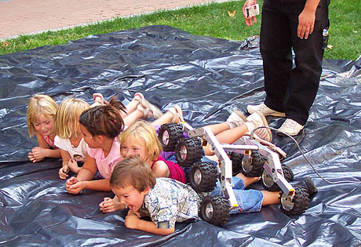
A model Mars Rover suspension system rolls over the backs of participants

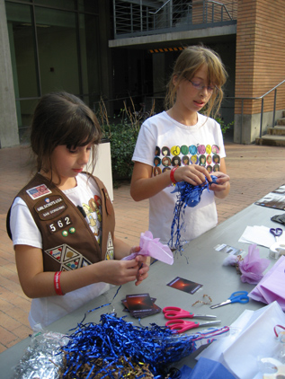
Girl Scouts make their own comets

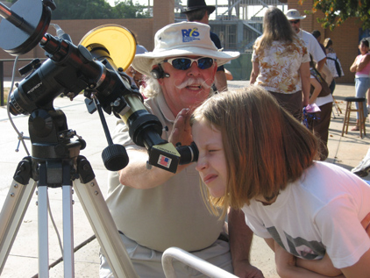
Riverside Astronomical Society volunteers help participants examine solar features

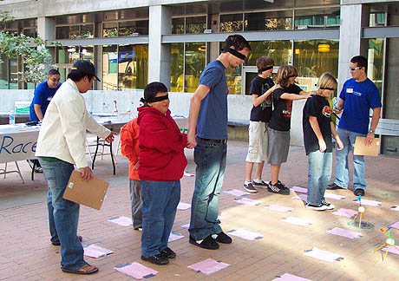
Rover Races

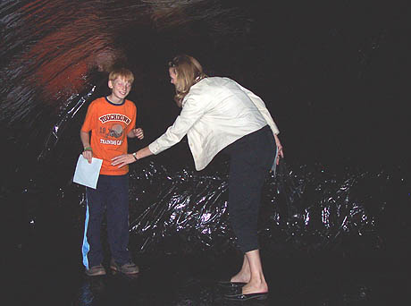
Participants create their own constellations to decorate the ceiling of the Planetarium

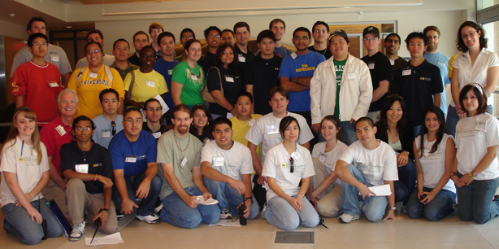
Event volunteers

