ภาคผนวก ก
Source code for MCS

// ------------------------Master node----------------------//
void resetstate(void) {
if(state!=0) {
i++;
if(i==60000) {
flowcontrol();
packet[1]=3;
maxlength=3;
index=3;
packet[2]='x';//request time out
SBUF=packet[maxlength-index];
index--;
i=0;
}
}

}
void flowcontrol(void) {
i=0;
switch(state){
case 0 :
if(packet[2]=='s'){//id master ==>0
P1_1=0;
P1_0=1;
state=1;
}
else {
P1_1=1;
P1_0=1;
state=3;
}
break;
case 1 :
P1_1=0;
P1_0=0;
state=0;
break;
case 2 :
P1_1=0;
P1_0=1;
state=1;
break;
case 3 :
P1_1=1;
P1_0=0;
state=2;

}
}

serial() interrupt 4 using 2 {
ก-2
if (RI){
packet[index] = SBUF;
RI=0;
if(index==1) {
if(packet[1]>11){
packet[1]=11;
maxlength=11;
}
else
maxlength=packet[1];
}
if(packet[0]==':')
index++;
if(index==(maxlength)){
flowcontrol();
SBUF=packet[maxlength-index];
index--;
}
}
if(TI){
TI=0;
if(index==0) {
flowcontrol();
}
else {

SBUF=packet[maxlength-index];
index--;
}
}
}

//----------------Slave node---------------------//

void flowcontrol(void) {
i=0;
switch(state){
case 0 : //----> send to home or master
if(packet[2]==5 && packet[3]==0 && packet[4]==1) { //packet check slave
P1_1=0;
P1_0=1;
state=1;
SBUF=packet[maxlength-index];
index--;
}
else if (packet[2]==5) { //packet all of slave
P1_1=1;
P1_0=1;
state=3;
SBUF=packet[maxlength-index];
index--;
}
else //--->this isn't my packet
index=0;
break;
case 1 : // recive from master
P1_1=0;
ก-3
P1_0=0;
state=0;
break;
case 2 : //send to master
P1_1=0;
P1_0=1;
state=1;
SBUF=packet[maxlength-index];
index--;
break;
case 3 : // recive from home
P1_1=1;
P1_0=0;
state=2;

}
}
serial() interrupt 4 using 2 {
if (RI){
packet[index] = SBUF;
RI=0;
if(index==1) { //-----> init maxlength
if(packet[1]>11){
packet[1]=5;
maxlength=5;
}
else
maxlength=packet[1];
}
if(packet[0]==':') //----> check start bit
index++;
if(index==(maxlength)){ //---->check maxlength
flowcontrol();
}
}
if(TI){
TI=0;
if(index==0) {
flowcontrol();
}
else {

SBUF=packet[maxlength-index];
index--;
}
}
}

//----------------Home node--------------------//
int des_set_key(unsigned char *key)
{
int i;
unsigned char k[64],cd[56];

unbit(k, key, 8);
perm(cd, PC1, k, 56);
for (i = 0; i < 16; i++)
ก-4
{
rot(&cd[0], 28, LS[i]);
rot(&cd[28], 28, LS[i]);
perm(Key_Schedule[i], PC2, cd, 48);
}
return 1;
}

/* des_func(in,out,ks) -- des core function */
void des_func(unsigned char in[64], unsigned char out[64], unsigned char b[16][48], int enc)
{
int i,j;
unsigned char lr[64], rsto[32], si[48], so[32]; // test test test
#define LEFT lr
#define RIGHT &lr[32]

perm(lr, IPP, in, 64); /* initial permutation */
for (i = 0; i < 16; i++)
{ /* 16 rounds */
memcpy(rsto, RIGHT,32); /* store right part */
perm(si, E, RIGHT, 48); /* F-box: permute to subst. input */
add2(si, b[enc ? i : 15-i], 48); /* add key (enc/dec order) */
for (j = 0; j < 8; j++) /* 48 to 32 bit substitute */
subs(&so[j*4],&si[j*6],j);
perm(RIGHT, PP, so, 32); /* permute substitution output: end F*/
add2(RIGHT, LEFT, 32); /* add left part */
memcpy(LEFT, rsto, 32); /* old right part will be new left */
}
memcpy(LEFT, RIGHT, 32); /* swap left and right part */
memcpy(RIGHT,rsto, 32);
perm(out,FP,lr,64); /* final permutation */
}

/* des_ecb_encrypt(in, out, ks, enc) -- des electronic xdata book mode */
int des_ecb_encrypt(unsigned char *in, unsigned char *out, int enc)
{
unsigned char o[64];

unbit(o, (unsigned char *)in, 8);
des_func((unsigned char *)o, (unsigned char *)o, Key_Schedule, enc);
pkbit((unsigned char *)out, o, 8);
return 8;
}

void DesECBEncrypt(unsigned char *Key, unsigned char *In, unsigned char *Out)
{
des_set_key(Key);
des_ecb_encrypt(In, Out, DES_ENCRYPT);

}

void DesECBDecrypt(unsigned char *Key, unsigned char *In, unsigned char *Out)
{
des_set_key(Key);
des_ecb_encrypt(In, Out, DES_DECRYPT);
}
ก-5
void main(void) {
unsigned char cipher[8];
unsigned char temp[8];
init();
while(1){
if(EA==0) {
if(encpy==1){
temp[0]=sen1;
temp[1]=sen2;
temp[2]=dev1;
temp[3]=dev2;
copystr(&temp[4],"beer",4);
DesECBEncrypt(home_key,temp,cipher);
copystr(&packet[2],cipher,8);
maxlength=10;
index=10;
packet[0]=':';
packet[1]=10;
EA=1;
SBUF=packet[maxlength-index];
index--;
} else {
copystr(cipher,&packet[5],8);
DesECBDecrypt(home_key,cipher,temp); // key,cipher,data
dev1=temp[0];
dev2=temp[1];
P1_4=0;
P1 |= 0x0c; // set ----11--
P0=dev1;
P1 &= 0xfb;// set 11--->10
P0=dev2;
P1 |= 0x0c; // set ----11--
P1_4=1;
EA=1;
SBUF=packet[maxlength-index];
index--;
}
}

}
}
void flowcontrol(void) {
switch(state){
case 0 : //wait recive from com--------->send
if(packet[3]=='h'){ // id of home
if(packet[4]=='3') { //------------command to device of home node
encpy=2;
EA=0;
}else
if (packet[4]=='1') { //-------check status of home node
encpy=1;
P1_4=0;
P1 &= 0xf3;// set 00
sen1=P0;
P1 |= 0x04;// set 00--->01
sen2=P0;
P1_4=1;
ก-6
EA=0;
}
else { //error command
packet[1]=3;
maxlength=3;
index=3;
packet[2]='e';
}
P1_1=0;
P1_0=1;
state=1;
if(index!=0 && EA!=0) {
SBUF=packet[maxlength-index];
index--;
}
}
else
index=0;
break;
case 1 : //send to com----------------->receive
P1_1=0;
P1_0=0;
state=0;
packet[0]='^';
break;
}
}
ภาคผนวก ข
Visual basic source code

Private Sub Dev_Click(index As Integer)
Dim indextmp, Slave, indextmp2 As Integer
Dim i As Integer
close_int = 1
delay (0.1)
indextmp = dev1tmp(lasthaddchk)
indextmp2 = dev2tmp(lasthaddchk)
If Dev(index).BackColor = &H80000011 Then
Select Case index
Case 0
indextmp = indextmp - 1
Case 1
indextmp = indextmp - 2
Case 2
indextmp = indextmp - 4
Case 3
indextmp = indextmp - 8
Case 4
indextmp = indextmp - 16
Case 5
indextmp = indextmp - 32
Case 6
indextmp = indextmp - 64
Case 7
indextmp = indextmp - 128
Case 8
indextmp2 = indextmp2 - 1
Case 9
indextmp2 = indextmp2 - 2
Case 10
indextmp2 = indextmp2 - 4
Case 11
indextmp2 = indextmp2 - 8
Case 12
indextmp2 = indextmp2 - 16
Case 13
indextmp2 = indextmp2 - 32
Case 14
indextmp2 = indextmp2 - 64
Case 15
indextmp2 = indextmp2 - 128
End Select
Dev(index).BackColor = &HC0FFC0

Else
Select Case index
Case 0
indextmp = indextmp + 1
Case 1
indextmp = indextmp + 2
Case 2
ข-2
indextmp = indextmp + 4
Case 3
indextmp = indextmp + 8
Case 4
indextmp = indextmp + 16
Case 5
indextmp = indextmp + 32
Case 6
indextmp = indextmp + 64
Case 7
indextmp = indextmp + 128
Case 8
indextmp2 = indextmp2 + 1
Case 9
indextmp2 = indextmp2 + 2
Case 10
indextmp2 = indextmp2 + 4
Case 11
indextmp2 = indextmp2 + 8
Case 12
indextmp2 = indextmp2 + 16
Case 13
indextmp2 = indextmp2 + 32
Case 14
indextmp2 = indextmp2 + 64
Case 15
indextmp2 = indextmp2 + 128
End Select
Dev(index).BackColor = &H80000011
End If
dev1tmp(lasthaddchk) = indextmp
dev2tmp(lasthaddchk) = indextmp2

sql = "SELECT * FROM Home where [Home_Id]='" & lasthaddchk & "'"
If Rst.state = 1 Then Rst.Close
Rst.Open sql, Cnn, adOpenKeyset, adLockOptimistic
Slave = Rst.Fields.Item(3).Value

MSComm1.Output = ":" & Chr(7) & Chr(Slave) & Chr(lasthaddchk) & Chr(3) & Chr(indextmp) & Chr(indextmp2)
delay (0.2)
close_int = 0
polling
End Sub

‘--------------------------------------------------------

Private Sub Form_Load()
Dim i As Integer

For i = 0 To 30
sen1(i) = "00000000"
sen2(i) = "00000000"
sen1tmp(i) = "00000000"
sen1tmp(i) = "00000000"
h_state(i) = 0
s_state(i) = 0
ข-3
s_time(i) = 0
h_time(i) = 0
Next

MSComm1.Settings = "9600,N,8,1"
MSComm1.CommPort = 1
MSComm1.InputLen = 1
MSComm1.RThreshold = 1
MSComm1.PortOpen = True

sql = "SELECT Count(*) FROM [Slave]"
OpenRst sql
slavecount = Rst.Fields.Item(0).Value

sql = "SELECT Count(*) FROM [Home]"
OpenRst sql
homecount = Rst.Fields.Item(0).Value

InitTree
Timer1.Enabled = True
'Master_Click
End Sub

‘---------------------------------------------------------

Private Sub Home_Click(index As Integer)
Dim i, Sensorcount As Integer

For i = 0 To 15
Sen(i).Enabled = False
Sen(i).Visible = False
Next

sql = "SELECT * FROM Home WHERE [Home_Id]= '" & index & "'"
OpenRst sql
Sensorcount = Rst.Fields(2).Value

sen_refresh (index)
For i = 0 To Sensorcount - 1
Sen(i).Caption = "Sensor" & i
Sen(i).Visible = True
Next

lasthaddchk = index

' ----------------Device ----------------------------
Dim devtmp1, devtmp2 As String
Dim devicecount As Integer

For i = 0 To 15
Dev(i).Visible = False
Next

sql = "SELECT * FROM Home WHERE [Home_Id]= '" & index & "'"
OpenRst sql
devicecount = Rst.Fields(1).Value
ข-4
For i = 1 To 8
If Mid(dev1(index), i, 1) = "0" Then
Dev(i - 1).BackColor = &HC0FFC0
Else: Dev(i - 1).BackColor = &H80000011
If Mid(dev2(index), i, 1) = "0" Then
Dev(i + 7).BackColor = &HC0FFC0
Else: Dev(i + 7).BackColor = &H80000011
End If
End If
Next

For i = 0 To devicecount - 1
Dev(i).Caption = "Device" & i
Dev(i).Visible = True
Next
End Sub

‘------------------------------------------------------------

Private Function delay(DelayTime)
Dim LoopTime As Double
Const SecInDay = 86400
LoopTime = Timer + DelayTime
If LoopTime > SecInDay Then
LoopTime = LoopTime - SecInDay
Do While Timer > LoopTime
DoEvents
Loop
End If
Do While Timer < LoopTime
DoEvents
Loop
End Function

‘--------------------------------------------------------------

Private Sub sen_refresh(index As Integer)
Dim sql As String
Dim i As Integer
Dim Sensorcount As Integer

For i = 0 To 15
Sen(i).Enabled = False
Sen(i).Visible = False
Next

sql = "SELECT * FROM Home WHERE [Home_Id]= '" & index & "'"
If Rst.state = 1 Then Rst.Close
Rst.Open sql, Cnn, adOpenKeyset, adLockOptimistic
Sensorcount = Rst.Fields(2).Value

For i = 1 To 8

If Mid(sen1(index), i, 1) = "1" Then
Sen(i - 1).BackColor = &HFF&
Else: Sen(i - 1).BackColor = &HC0FFC0
If Mid(sen2(index), i, 1) = "1" Then
ข-5
Sen(i + 7).BackColor = &HFF&
Else: Sen(i + 7).BackColor = &HC0FFC0
End If
End If
Next

sen1tmp(index) = sen1(index)
sen2tmp(index) = sen2(index)

For i = 0 To Sensorcount - 1
Sen(i).Caption = "Sensor" & i
Sen(i).Visible = True
Next

End Sub

ภาคผนวก ค
Hardware และ วงจร
- Master node
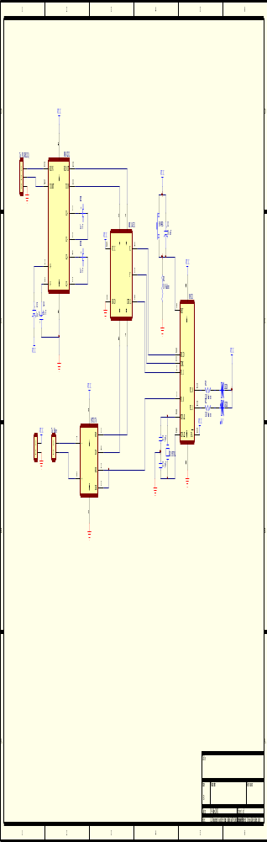

- Slave node
ค-2
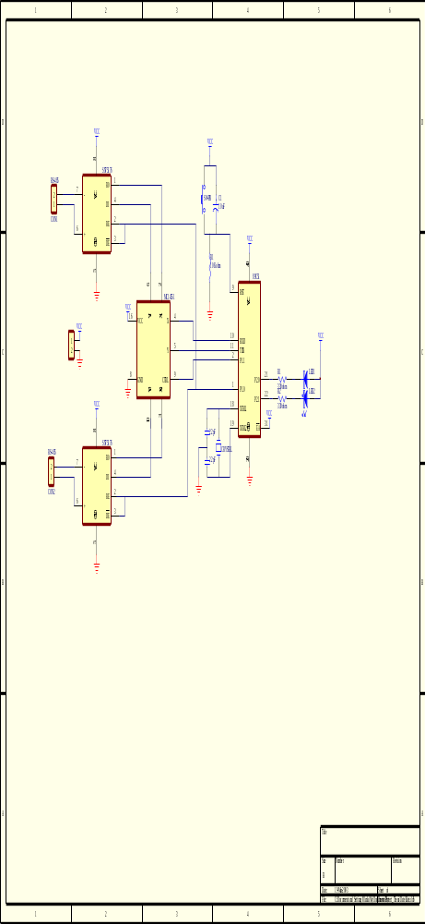
- Home node
ค-3
