ภาคผนวก ข

รายละเอียดของเราเตอร์แต่ละรุ่น

Overview of the Router
Table 1-1 lists the router models discussed in this publication and provides a summary of the interfaces supported on each model. These router models are similar in functionality, but differ in the number of interfaces supported.

Table 1-1: Summary of Router Interfaces
Model | Ethernet AUI¹  (DB-15) | Token Ring  (DB-9) | Serial  (DB-60) | ISDN² BRI³  (RJ-45)
Cisco 2501/  CPA2501 | 1 | - | 2 | -
Cisco 2502/  CPA2502 | - | 1 | 2 | -
Cisco 2503/  CPA2503 | 1 | - | 2 | 1
Cisco 2504/  CPA2504 | - | 1 | 2 | 1
Cisco 2513/  CPA2513 | 1 | 1 | 2 | -
Cisco 2514/  CPA2514 | 2 | - | 2 | -
Cisco 2515⁴ | - | 2 | 2 | -
¹ AUI = attachment unit interface.
² ISDN = Integrated Services Digital Network.
³ BRI = Basic Rate Interface.
⁴ A CPA2515 model is not available.

Note Throughout the remainder of the publication, one model number will be used in text references. For example, references to the model 2501 router will apply to both the Cisco 2501 and CPA2501 routers

Hardware Features

In addition to the interfaces listed in Table 1-1, the routers include the following hardware features:
- Dynamic random-access memory (DRAM) for main memory and shared memory
- Nonvolatile random-access memory (NVRAM) for storing configuration information
- Flash memory for running the Cisco IOS software
- EIA/TIA-232 console port for local system access using a console terminal
- EIA/TIA-232 auxiliary port for remote system access using a modem

Note EIA/TIA-232 and EIA/TIA-449 were known as recommended standards RS-232 and RS-449 before their acceptance as standards by the Electronic Industries Association (EIA) and Telecommunications Industry Association (TIA).

Figure 1-1 to Figure 1-7 show the rear panels of the router models discussed in this publication.
Figure 1-1: Model 2501 Router Rear Panel
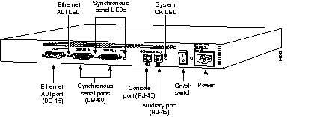
Figure 1-2: Model 2502 Router Rear Panel
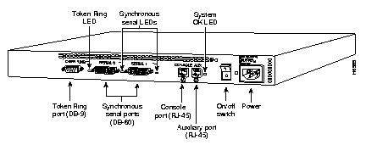
Figure 1-3: Model 2503 Router Rear Panel
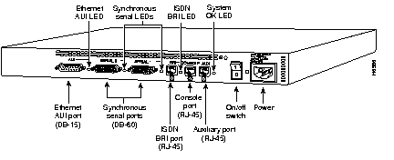
Figure 1-4: Model 2504 Router Rear Panel
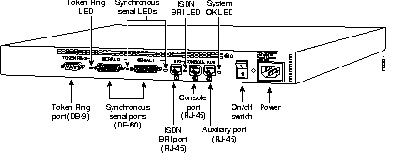
Figure 1-5: Model 2513 Router Rear Panel
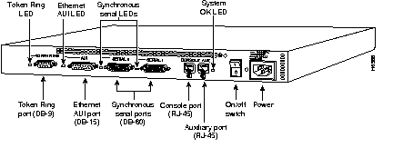
Figure 1-6: Model 2514 Router Rear Panel
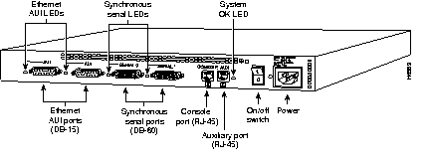
Figure 1-7: Model 2515 Router Rear Panel
