1.
Question: The problem we are addressing is figuring out how the sale price of a home is related to its square footage and if this relationship is different in the NAmes, Edwards and BrkSide neighborhoods.

Model: The model we will be testing is
Sale price(hat)=Bo+B1(square footage)+B2(Edwards)+B3(BrkSide)
Edwards and BrkSide and indicator variables that are 1 if the home is in either of those neighborhoods. If both variables are 0 then the home is in the Names neighborhood.

Assumptions and Influential Points:
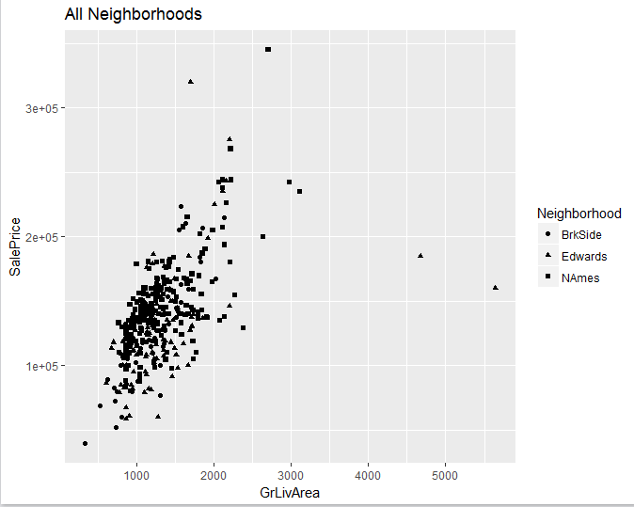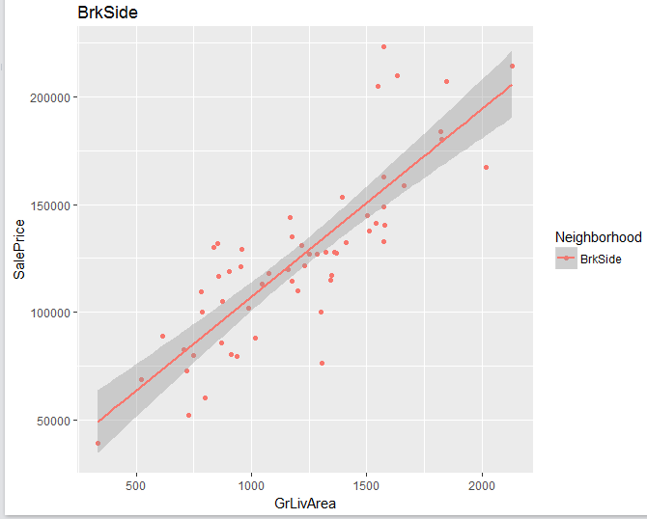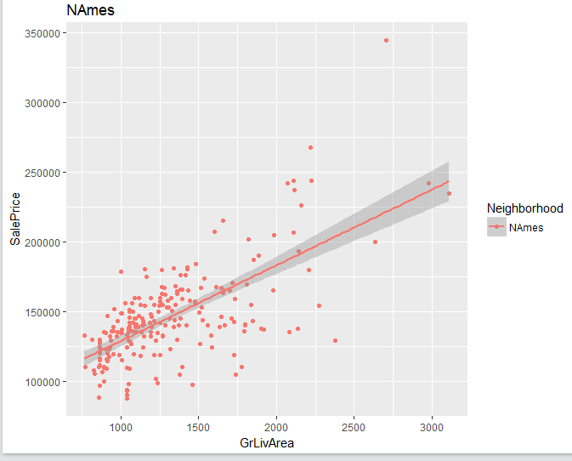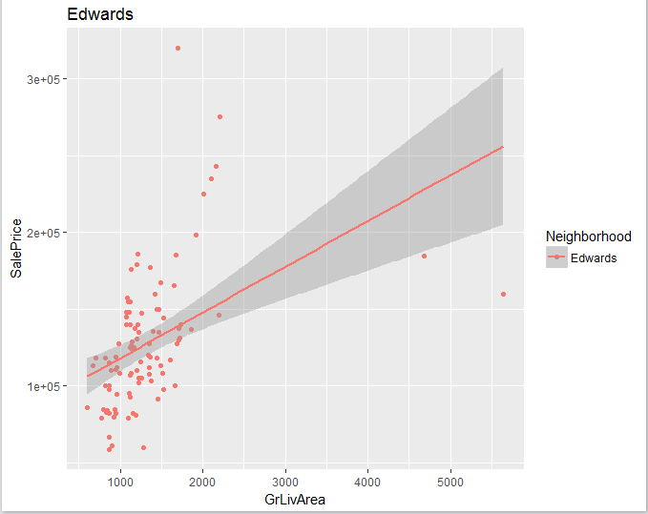
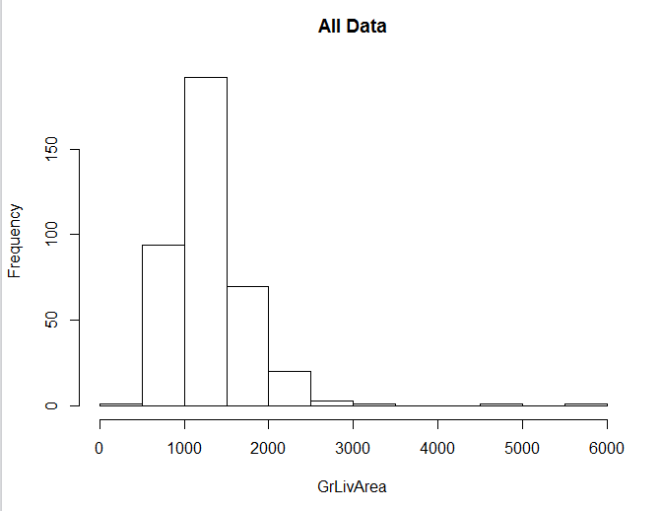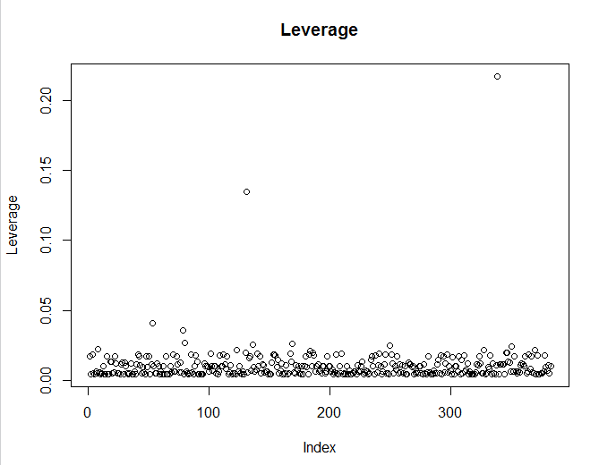
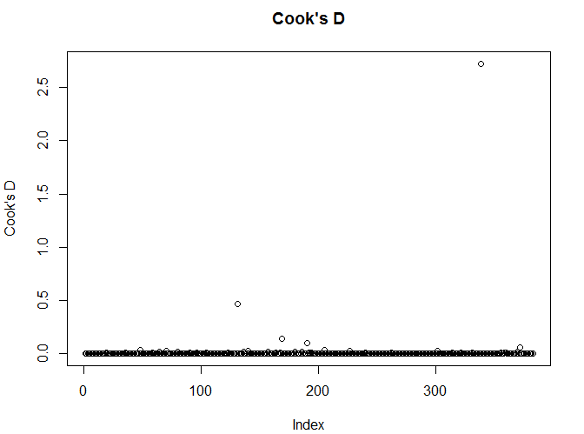
Normality- Looking at the histogram the data looks extremely right skewed which violates the assumption of normality. A log transformation should be conducted before any analysis occurs.
Constant Variance- There is no violation of the constant variance assumption.
Linearity- The overall data and each neighborhood look to have a linear relationship between sale price and square footage of the house.
Independent- There is no evidence against independence in this study.
Influential Points: Looking at the scatterplot of the data it appears that there are a few outliers. These points have considerable higher leverage than all the other points which cause them to also have a very high Cook’s D.
New Model:
Sale price(hat)=Bo+B1(LOG(square footage))+B2(Edwards)+B3(BrkSide)
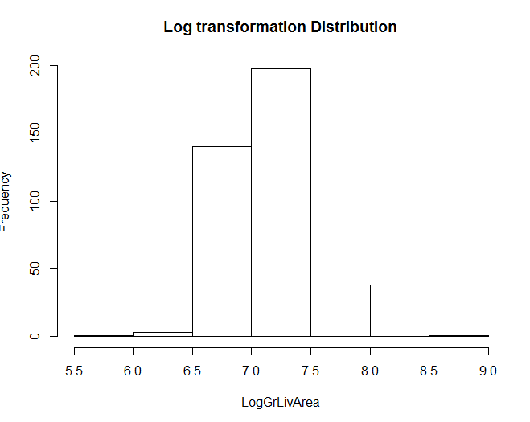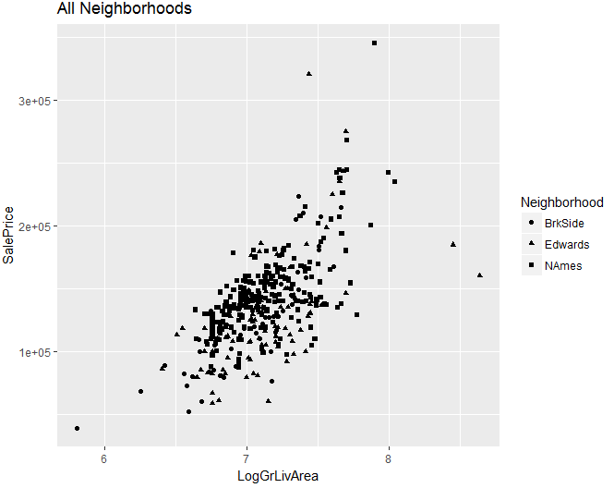
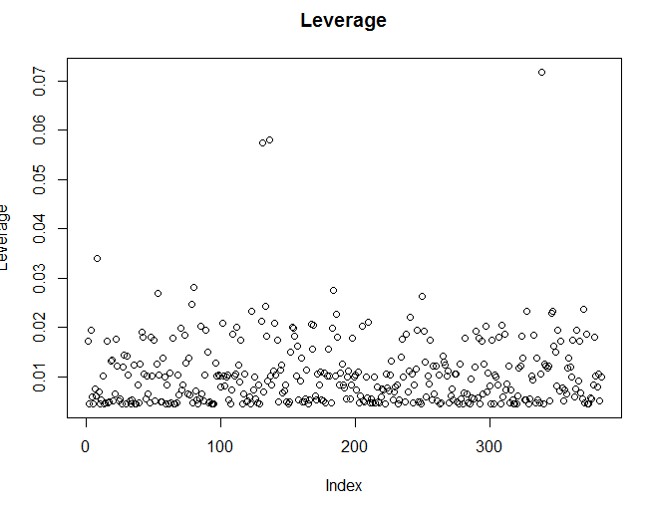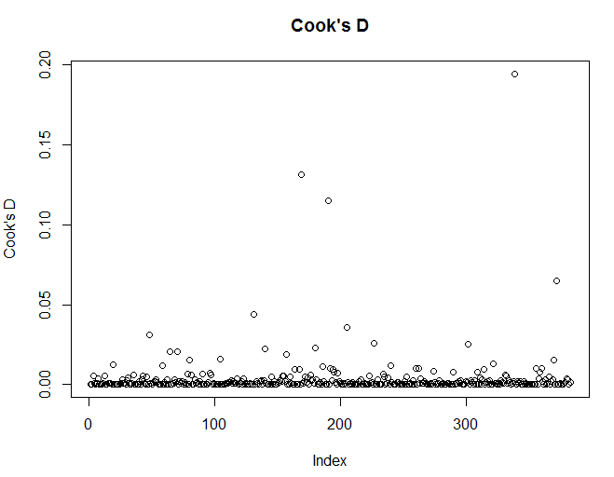
Normality- After the log transformation the data looks much more normally distributed so there is no longer evidence against this assumption.
Constant Variance- There is no violation of the constant variance assumption.
Linearity- The overall data and each neighborhood look to have a linear relationship between sale price and square footage of the house.
Independent- There is no evidence against independence in this study.
Influential Points: The log transformation also lowered the previously influential points’ leverage and Cook’s D by a considerable amount.
All assumptions have been met and all influential points have been dealt with so we will proceed with the log transformed model.

Model Summary:
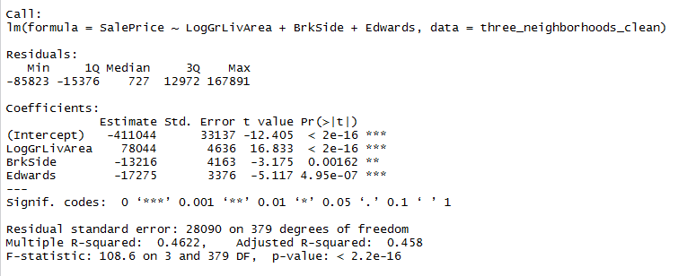
The model equation was calculated as follows:
Overall: Sale price (hat)=-411044+78044(LOG(Square Footage))-13216(BrkSide)-17275(Edwards)
NAmes: sale price (hat)=-41104+78044(LOG(Square footage))
BrkSide: sale price (hat)=-424260+7804(LOG(Square footbage))
Edwards: sale price(hat)=-428319+78044(LOG(Square footage))
The overall model and each parameter where found to be statistically significant. The model had an R-squared of 46.22% which means it is estimated that the log of square footage and the neigborhood the house is in account for 46.22% of the variation in sale price.
Parameter Interpretation:
Intercept (-411044)- This intercept means that for a home in the NAmes neighborhood that is 0 square feet the sale price of this home would be $-411,044. For BrkSide and Edwards that number drops to $-424,260 and $-428,319 respectively. All of these numbers are illogical for numerous reasons. First if a house was 0 square feet it would not exist so it would not be a house. Hypothetically a house could sell for a negative amount if the person selling it gave the person “buying” it money but this would never happen. Lastly, a square footage of 0 is not within the domain of our observed square footage so this is extrapolating which is dangerous.
B1 (78044)- This value means that for a 1% increase in square footage it is predicted that the sale price of the home increases $776.56.
B3 (-13216)- This value means that a home in the BrkSide neighborhood is predicted to be $13,216 less than a home in the NAmes neighborhood that has the same square footage.
B3 (-17275)- This value means that a home in the Edwards neighborhood is predicted to be $17,275 less than a home in the NAmes neighborhood that has the same square footage.
These two variables having a negative coefficient gives evidence that houses in the NAmes are more expensive then homes in the BrkSide and Edwards neighborhoods.
Since all the parameters have a p-value less than 0.05 that means that all of them are significantly different from 0.
Conclusion:
There are two main takeaways from this model. The first is that houses with higher square footage have a higher sale price. This is shown by the coefficient to the log of square footage being positive, as the square footage goes up that number goes up which causes sale price to increase. The other takeaway is that homes in the NAmes neighborhood are the most expensive out of the three neighborhoods examined (NAmes, BrkSide, and Edwards). This is shown by the indicator variables for BrkSide and Edwards having a negative coefficient which means that if the house is in one of those neighborhoods (the value of that variable would be 1) then the coefficient is being subtracted from the sale price. This of course makes the sale price drop. So if there was a house with the same square footage in all three neighborhoods it would be the most expensive in the NAmes neighborhood.

Code:
#libraries required
library(ggplot2)
library(readr)

#import data
train<- read_csv("C:/Users/student/Desktop/IntroToStats/13_14_Project/train.csv")
test <- read_csv("C:/Users/student/Desktop/IntroToStats/13_14_Project/testCleaned.csv")

#Create a dataset with only the three neighborhoods wanted (NAmes, BrkSide and Edwards)
three_neighborhoods_data<-train[which(train$Neighborhood=="NAmes"|train$Neighborhood=="Edwards"|train$Neighborhood=="BrkSide"),]

#Create dataset with only the variables needed (GrLiveArea, neighborhood, sale price)
three_neighborhoods_clean<-data.frame(three_neighborhoods_data$Id,three_neighborhoods_data$Neighborhood,three_neighborhoods_data$GrLivArea,three_neighborhoods_data$SalePrice)
names(three_neighborhoods_clean)<-c("Id","Neighborhood","GrLivArea","SalePrice")
#Create indicator variables for BrkSide and Edwards neighborhoods. These variables will have a value of 1 if the home is the the neighborhood and 0 if they are not.
three_neighborhoods_clean$BrkSide<-ifelse(three_neighborhoods_clean$Neighborhood=="BrkSide",1,0)
three_neighborhoods_clean$NAmes<-ifelse(three_neighborhoods_clean$Neighborhood=="NAmes",1,0)
three_neighborhoods_clean$Edwards<-ifelse(three_neighborhoods_clean$Neighborhood=="Edwards",1,0)

#Scatter plot of Sale price vs GrLivArea. Different shapes represent different neighborhoods
ggplot(three_neighborhoods_clean,aes(x=GrLivArea,y=SalePrice,shape=Neighborhood))+geom_point()+ggtitle("All Neighborhoods")
#Scatter plot of Sale price vs GrLivArea. Different shapes and colors represent different neighborhoods. Regression lines and confidence bands have been added for each neighborhood
ggplot(three_neighborhoods_clean,aes(x=GrLivArea,y=SalePrice,shape=Neighborhood,color=Neighborhood))+geom_point()+geom_smooth(method='lm')
#Scatter plot of Sale price vs GrLivArea for BrkSide neighborhood only. Regression line and confidence bands shown
ggplot(subset(three_neighborhoods_clean,Neighborhood=="BrkSide"),aes(x=GrLivArea,y=SalePrice,shape=Neighborhood,color=Neighborhood))+geom_point()+geom_smooth(method='lm')+ggtitle("BrkSide")
#Scatter plot of Sale price vs GrLivArea for NAmesneighborhood only. Regression line and confidence bands shown
ggplot(subset(three_neighborhoods_clean,Neighborhood=="NAmes"),aes(x=GrLivArea,y=SalePrice,shape=Neighborhood,color=Neighborhood))+geom_point()+geom_smooth(method='lm')+ggtitle("NAmes")
#Scatter plot of Sale price vs GrLivArea for Edwards neighborhood only. Regression line and confidence bands shown
ggplot(subset(three_neighborhoods_clean,Neighborhood=="Edwards"),aes(x=GrLivArea,y=SalePrice,shape=Neighborhood,color=Neighborhood))+geom_point()+geom_smooth(method='lm')+ggtitle("Edwards")

#Histogram of GrLivArea for all data
hist(GrLivArea,main="All Data",data=three_neighborhoods_clean)

#Calculate and graph the leverage of each point in the data set
lev=hat(model.matrix(lm(SalePrice~GrLivArea+BrkSide+Edwards,data=three_neighborhoods_clean)))
plot(lev,ylab="Leverage",main="Leverage")

#Calculate and graph the Cook’s D for each point in the data set
plot(cooks.distance(lm(SalePrice~GrLivArea+BrkSide+Edwards,data=three_neighborhoods_clean)),ylab = "Cook's D",main = "Cook's D")

#Calculate the log square feet for each observation
three_neighborhoods_clean$LogGrLivArea<-log(three_neighborhoods_clean$GrLivArea)
#Histogram of log GrLivArea for all data
hist(three_neighborhoods_clean$LogGrLivArea,xlab="LogGrLivArea",main="Log transformation Distribution")
#Scatter plot of Sale price vs log GrLivArea. Different shapes represent different neighborhoods
ggplot(three_neighborhoods_clean,aes(x=LogGrLivArea,y=SalePrice,shape=Neighborhood))+geom_point()+ggtitle("All Neighborhoods")

#Create model to predict sale price using the log GrLivArea and the two neighborhood indicator variables. Uses NAmes as the reference neighborhood
three_neighborhood_model<-lm(SalePrice~LogGrLivArea+BrkSide+Edwards,data=three_neighborhoods_clean)
#Look at summary of the model
summary(three_neighborhood_model)

#Calculate and graph the leverage of each point in the data set for the log transform model
lev=hat(model.matrix(three_neighborhood_model))
plot(lev,ylab="Leverage",main="Leverage")

#Calculate and graph the Cook’s D of each point in the data set for the log transform model
plot(cooks.distance(three_neighborhood_model),ylab = "Cook's D",main="Cook's D")

