Exercise 7

1. Download php 5 and install it on C:\
2. Go to httpd.conf and then add the below content:

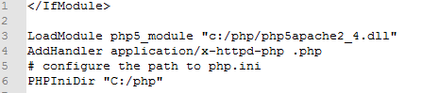

1. Go to htdocs and create a file called phptest.php
2. In phptest.php, add the php code “<?php phpinfo(); ?>”
3. The result is like below:

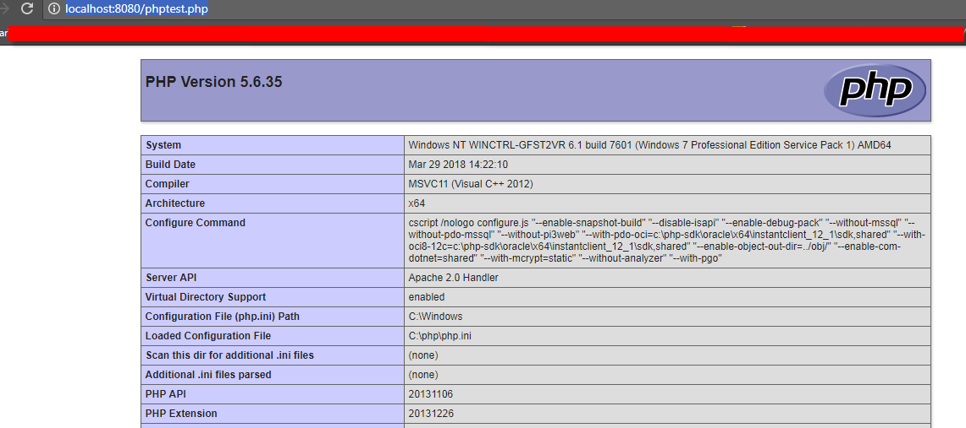

Exercise 8

1. Download MySQL 5.7 x64 and install it
2. Download Workbench and install it
3. Run MySQL once the installation has been finished
4. Run Workbench once the installation has been finished
5. Connect to MySQL by clicking Database tab from the menu, fill out all information needed, and click ok button

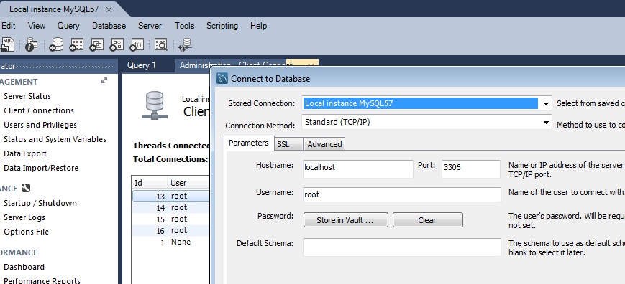

1. Create a schema named as ait
2. Using query to insert three records with three columns made by ID, Name, and Lastname.

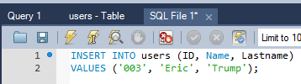

1. Check the overview of the database as the following:

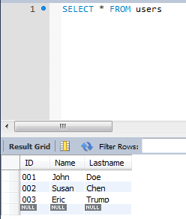

Exercise 9

1. Create a php class as below which contains 4 methods, connect, select_db, query, and close:

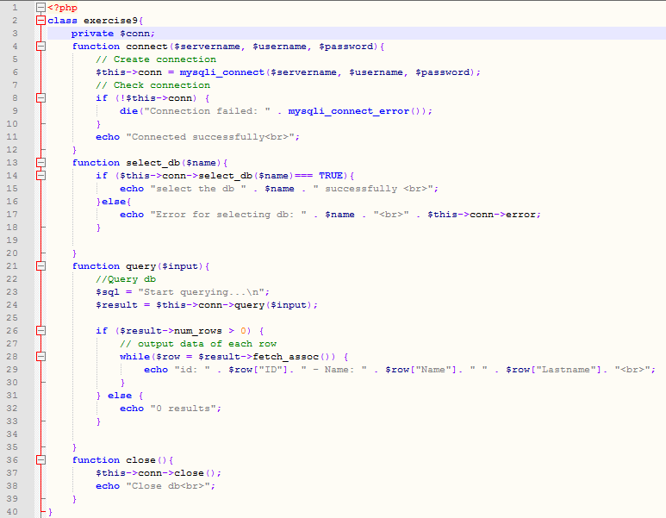

1. Create another php file to call the class and execute for selecting all from users table as below:

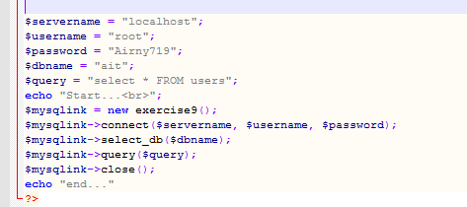

1. Open this php file by web browser

