File reference: https://github.com/khtsai/Lab/tree/master/Lab4

Lab 4

Exercise 10

1. Go to Postgres websites
2. Download and install Windows version of PostgresSQL 10
3. Go to PG Admin 4 website to download and install Windows version
4. Run both and you can see below:

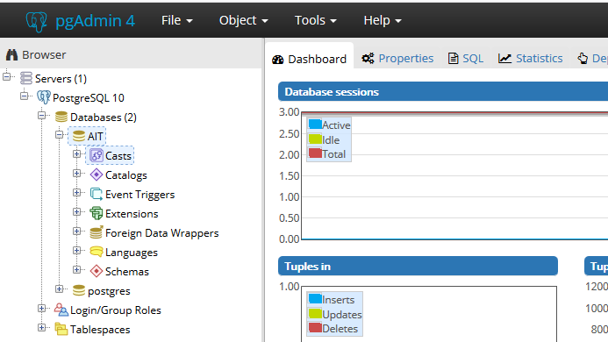

1. Create a database called AIT as above
2. Create a table named users with three columns, ID, Name, and Lastname
3. Select \* from users to see the work:

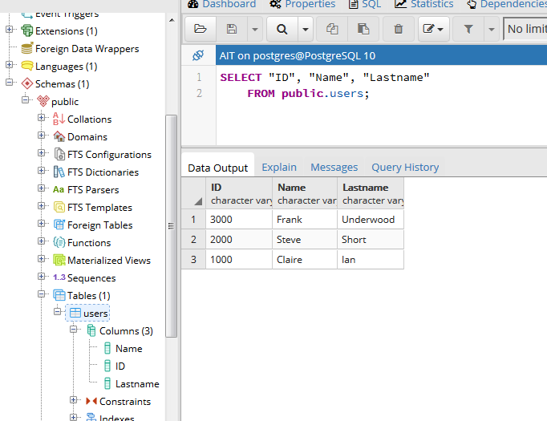

Exercise 11

1. Download JDBC driver from <http://jdbc.postgresql.org/>
2. Move the file to tomat/lib location
3. Open Eclipse and new a Dynamic Web Project
4. Add JDBC.jar into the library of the project
5. Create a java code to connect and query Postgres SQL, which you created on exercise 10

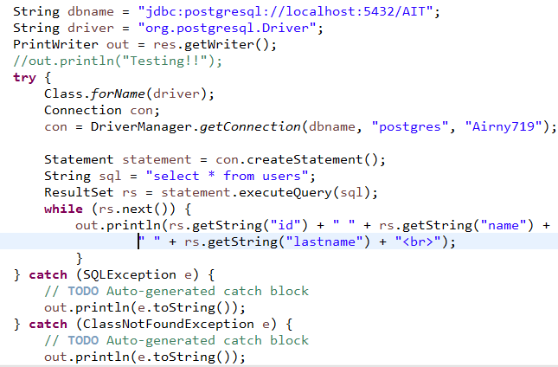

1. Create a web.xml and deploy tomcat application
2. Then the result shows as below:

