Lab 5

Exercise 12

1. Create a html file
2. Put the form with action registration.php and method GET
3. Inside the form, create first name, …, Favorite color as the requirements of this exercise:
4. Add placeholders to some fields and proper types according to the items, such as email should be with email type.
5. Use Javascript function to check if the field with required mark has been filled while submitting
6. The result is below:

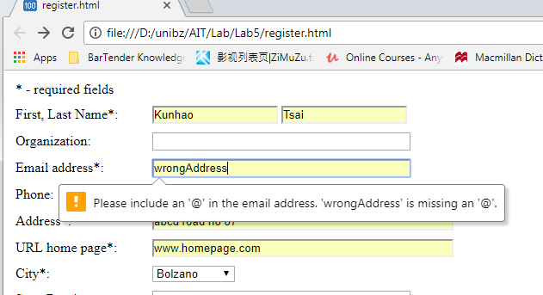

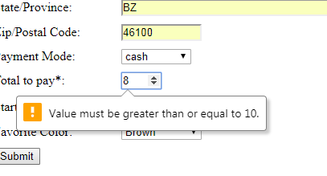

Exercise 13a

1. Create a file called registration.php
2. Develop php code as below to get the data from data which was sent by the html file of exercise12

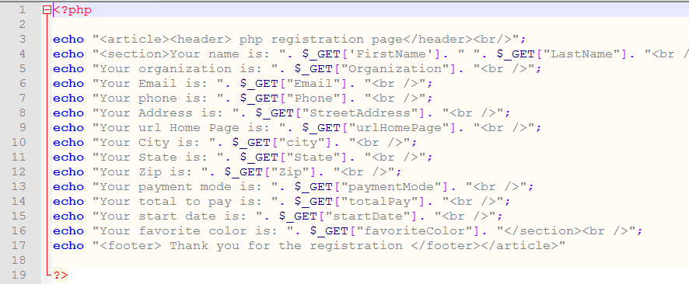

1. The result is below:

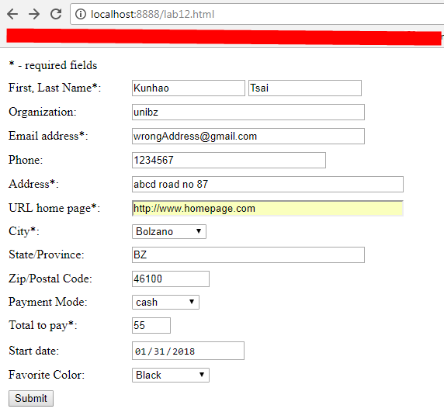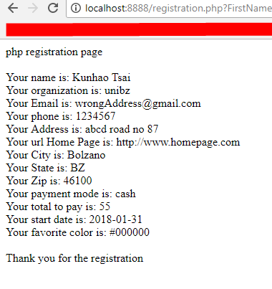

Exercise 13b

1. Open Eclipse and new a dynamic Web project
2. Develop a java code in src folder as below:

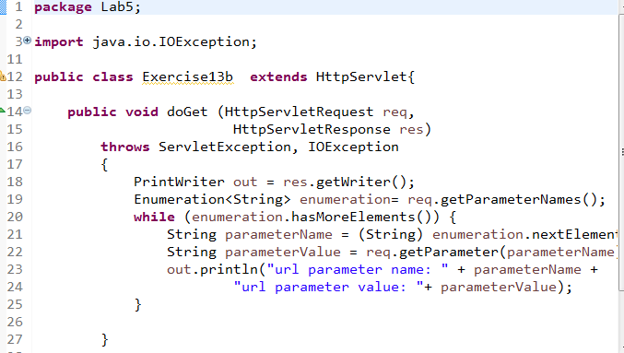

1. Copy the html file from exercise 12 to WebContent folder
2. Create a xml file called web with below content in WebContent/WEB-INF:

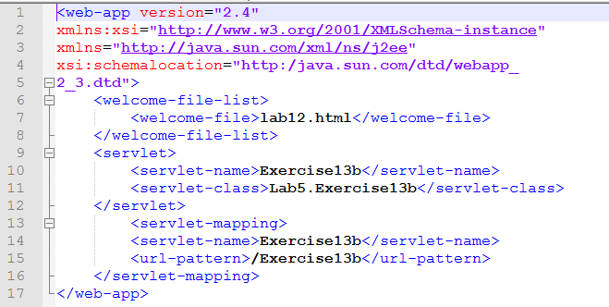

1. The result is below:

