Capstone Kickoff — Planning a Real System
Human-Computer Interaction | Week 14, Meeting 1
This is the start of your final project. Everything you've learned since Week 7, routes, CRUD, SQLite, errors, auth, CORS, deployment, now comes together into one original system you design yourself. You will keep building this exact project over the next several meetings, deploy it for real, and demo it live for your final exam. Today is planning and setup only, no shortcuts here save you time later.

By the End of Today, You Should Have
- Your business idea, written in one or two sentences.
- schema-plan.md and routes-plan.md in your project folder.
- A real project folder (server.js, package.json, .gitignore) that runs with no errors.
- proposal.md combining all three, pushed to GitHub.
No working features yet, that starts next meeting. Today proves you have a solid plan and a server that starts correctly.

Part 1: Choose Your Business
Pick a business idea of your own, not canteen and not laundry. It must have two things that relate to each other, for example customers who book appointments, or products that belong to categories.
- Think of a real business you know (a sari-sari store, a tutoring service, a motor shop, a salon, anything with real customers and real transactions).
- Write one sentence describing what it does.
- List the two related things in it, for example customers and appointments, or products and orders.

Ideas If You're Stuck
- Tutoring service: students and tutoring sessions.
- Motor shop: customers and repair jobs.
- Online seller: products and orders.
- Event organizer: clients and bookings.

Part 2: Design Your Database
Design two tables, not one. One table connects to the other through a foreign key, a column that stores the id of a row in the other table.
- Name your first table (your main "people" table, like customers).
- List its columns, with a type for each (TEXT, INTEGER, or REAL).
- Name your second table (your main "activity" table, like appointments or orders).
- List its columns. Include one column that stores the id of a row in your first table, this is your foreign key.
- Write both table designs into a new file named schema-plan.md
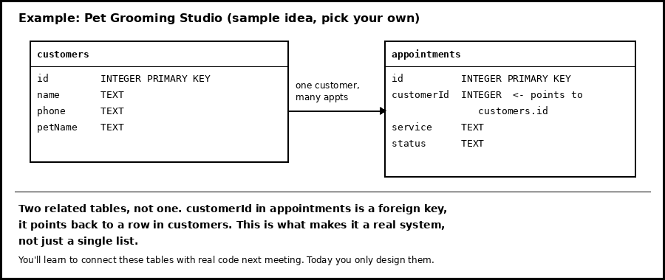
What your schema-plan.md should describe

Part 3: Plan Your Endpoints
List every route your API will need. This becomes your build checklist for the next few meetings.
- Create a new file named routes-plan.md
- For each of your two tables, list a GET route that returns all rows.
- For each table, list a GET route that returns one row by id.
- For your main activity table, list a POST route to create a new row.
- For your main activity table, list a PUT route to update a row's status.
- For your main activity table, list a DELETE route to remove a row.
- Next to each route, write one short sentence saying what it does.

Code Notes
- You should have at least 8 routes listed. This matches everything you already know how to build.
- Writing this now means you're not guessing what to code next meeting, you're just following your own plan.

Part 4: Hands-On — Scaffold Your Project
Set up the real project folder now, so next meeting starts with writing routes, not fighting setup.
- Create a new folder for your capstone project. Open it in VS Code.
- Open the terminal (Ctrl + `) and run: npm init -y
- Run: npm install express cors dotenv better-sqlite3 express-rate-limit
- Create server.js with a basic Express app and one working route:
require('dotenv').config();
const express = require('express');
const cors = require('cors');
const app = express();
app.use(express.json());
app.use(cors());
const PORT = process.env.PORT || 3000;
app.get('/', (req, res) => {
res.json({ status: 'ok', message: 'Capstone project server is running' });
});
app.listen(PORT, () => console.log(`Server running on port ${PORT}`));
- In package.json, add a "start" script: "start": "node server.js"
- Create .gitignore and list node_modules and .env in it.
- Run node server.js and open http://localhost:3000 to confirm you see your status message.
- Create a GitHub repo for this project and push your first commit, including schema-plan.md and routes-plan.md.

Challenge: Capstone Proposal
Combine everything from today into one proposal.md file in your project. Include:
- Your business idea, in one or two sentences.
- Your two table designs, copied from schema-plan.md.
- Your full route list, copied from routes-plan.md.
Push proposal.md to GitHub. I'll review it before next meeting and flag anything that's too big, too small, or missing a real relationship between your two tables, before you start building.

Submission
Push to GitHub as your backup copy, but that alone is not your proof of work. From now until finals, I check everything live on your own PC.
- Push your project folder to GitHub, with schema-plan.md, routes-plan.md, and proposal.md included.
- Make sure server.js, package.json, and .gitignore are all committed.
- Call me over. I'll watch you run node server.js live on your PC and check your status message, then I'll go through your proposal with you. No screen recordings, I check it in person from here on.

