Kendall Hudson

Project Code Name:
The Ravening Toad

(public domain image courtesy of https://www.publicdomainpictures.net/en/view-image.php?image=45671&picture=toad)

Executive Summary
I am creating a dungeon exploration game in which the player takes on the role of a hideous toad-like creature which runs a horrible little cafe in an ancient cellar beneath the crumbling remains of a dying, degenerate city in a grim fantasy world. The creature makes its living by exploring the labyrinthine sewers beneath the city and harvesting whatever semi-edible things it can find there to cook and sell at its cafe. This quest for ingredients makes up the primary experience of this game.
Journeys into the sewers will occur as the toad-creature wanders the tunnels and becomes lost, with the player taking over at that point and exploring a procedurally generated maze until an exit is found at which point they escape with whatever harvest they've managed to find. These mazes are filled with dangers in the form of aggressive creatures and possibly environmental hazards.
As a secondary element, when the player returns from a successful foraging / hunting trip there will be a simple mini-game in which the found ingredients are prepared and sold. This mini-game works by placing ingredients into categories which then fit into recipes, such as a recipe which requires three different ingredients from specific categories, and the resulting dishes then selling for predetermined amounts of money. The money is then spent on new equipment to help with future foraging and possibly upgrades for the cafe as well. After a shift at the cafe, once all the food is sold and the shopping is done, the player then returns to the sewers for more resources.

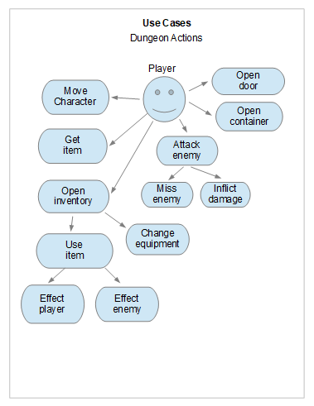
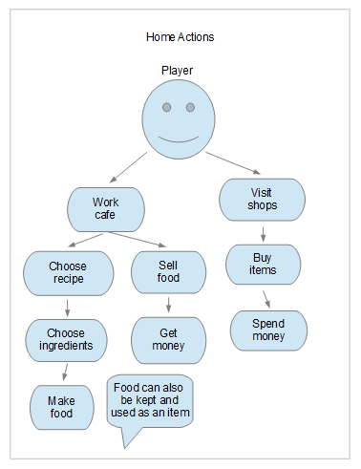

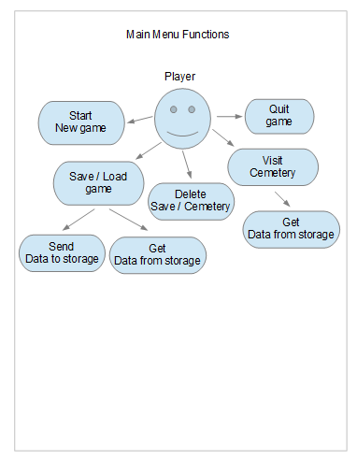

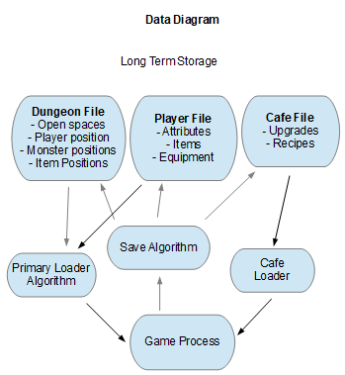
Data is stored in three files: the player file which holds data relating to the player character, the cafe file which stores data relating to the player's cafe, and the dungeon file which holds data about the current dungeon if the player exits the game while exploring. If the player was in the cafe when they exited the game then the dungeon file will be absent and the cafe file will be loaded instead. The cafe file is also loaded whenever the player returns from a dungeon. Dungeon files are deleted when the player returns from them, and a new one is generated for each new exploration.

Screen Mockups

Start Screen
The Ravening Toad
Just a title and basic menu options

New Game
Load Game
View Cemetery
Exit

New Game = Fresh new start.
Load Game = Display list of saved games for loading or deletion.
View Cemetery = Display list of deceased characters and generate reports.

Dungeon Screen

Health : 10

@

m

^

Vital player statistics are in the upper left corner. All objects and terrain are represented by keyboard characters. Open spaces where the player can walk are indicated with a different character than solid obstacles and walls. The '@' is the player, the 'm' is a monster, and the '^' is the exit.
This screen will also include the item and pause menus. The item menu allows players to view and use items. The pause menu allows the player to save the game and exit. Menus are only displayed when summoned by pressing the appropriate key.

Cafe Screen

Money : 100
Simple Graphical Representation
Of Cafe
Displays Upgrades

Cook
Sell
Go Shopping

The “Cook” option allows the player to select a recipe, then ingredients to fulfill the recipe, and then places the resulting food in the player's inventory as an item. The “Sell” option allow the player to sell items from their inventory (items with zero value are simply discarded). The “Go Shopping” option allows the player to use available money to purchase items and equipment.

Report Mockup

There is only one form of report, and this is the Cemetery File. This is a repository of characters who did not survive the dungeons. The files are identical to standard save files, but a flag is set to indicate the character is no longer playable. Viewing a Cemetery File displays a report of the deceased character.

Example:

Name: Toad
Money Earned : 100
Money Spent: 98
Food Served: 17
Monsters Slain: 23
Dungeons Delved: 4

Maintenance Features

The only maintenance feature necessary for this application is the ability to delete save files and cemetery files. This functionality is available from the Main Menu when loading save files or viewing cemetery files respectively. Please see Start Screen Mockup and Main Menu use case diagram for additional information.

Work Breakdown

Week 4
0.1.0 Libtcod Integration
0.1.1 study libtcod documentation
0.1.1.1 study display functions
0.1.1.2 study procedural mapping
0.1.1.3 study pathfinding functions
0.1.2 experiment with simple display outputs

Week 5
0.2.0 First Functional Display
0.2.1 display hardcoded rooms

Week 6
0.3.0 Player Character Development
0.3.1 code player object
0.3.2 instantiate player object in dungeon room
0.3.3 player movement
0.3.4 movement respects barriers

Week 7
0.4.0 Enemy Development
0.4.1 code basic enemy object
0.4.2 instantiate enemy in dungeon room
0.4.3 code enemy pathfinding
0.4.4 code enemy attack

Week 8
0.5.0 Develop Menus
0.5.1 start screen
0.5.2 main menu
0.5.3 pause menu
0.5.4 item menu

Week 9
0.6.0 Develop Cafe
0.6.1 cafe screen
0.6.2 cafe menu
0.6.3 upgrades
0.6.4 recipes

Week 10
0.7.0 Develop Items and Equipment
0.7.1 add different armor and weapons
0.7.2 add usable items
0.7.3 add ingredients

Week 11
0.8.0 Procedural Generation
0.8.1 randomized dungeons
0.8.2 test enemy pathing

Week 12
0.9.0 File Structure, Saving and Loading
0.9.1 player file
0.9.2 cafe file
0.9.3 dungeon file

Week 13 – 14
0.10.0 Finalization
0.10.1 testing and bug fixing
0.10.2 polishing
0.10.3 wish list?
1.0 DELIVERY

Summary

Over the course of about ten weeks I will create a game in which the player can explore dungeons, gather treasure in the form of ingredients, prepare food at their cafe in between adventures, and then sell that food to improve the cafe and fund further adventures.
This plan may appear daunting, and in some regards it definitely is. However, it is my hope that the WBS is a conservative estimate and that tasks will be completed in less than the allotted time. If this is accomplished then I will begin to implement my wish list of additional features.
Additional features include more creatures, ingredients, and recipes as well as improved combat complexity through special moves and attacks by both player and enemies. I would also really like to be able to add themes to the dungeon spaces such that each exploration can have it's own style and stand out from each other. For example, one adventure might occur in a place infested by vermin, another in a place where fires are spreading, and one with toxic gas clouds. This would make adventures more interesting, but may very well be beyond the scope of this class.
The current plan encompasses only the basic functionality necessary to accomplish my vision, so dungeon spaces will be pretty generic.

