Bill of Materials for the construction of mass balance growth chambers. This does not include the additional high power growth lamps required or the main growth chambers (Snijder Labs, climate cabinets MD1400). These can be ordered for approximately 15K EURO.

Item | Cost  (EURO) | # items
Scale EOC 10K-4 | 310 | 8 | 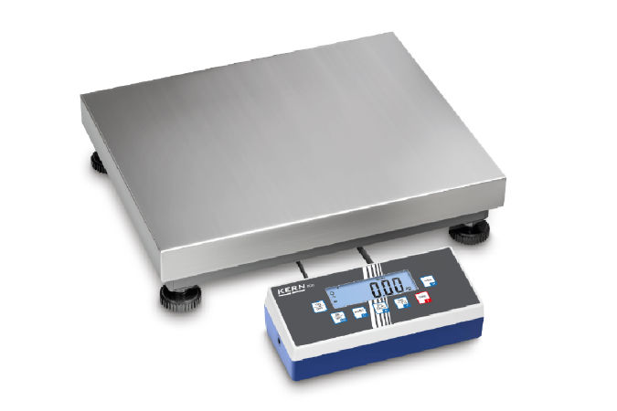
gx16 4 pin connector | 6 | 8 | 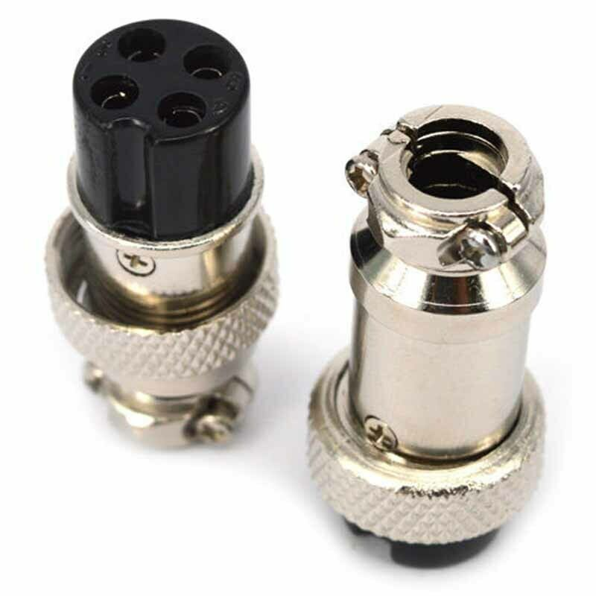
cable 4 pin | 50 | 1
usb / RS232 convertor femal 4 | 100 | 2 | 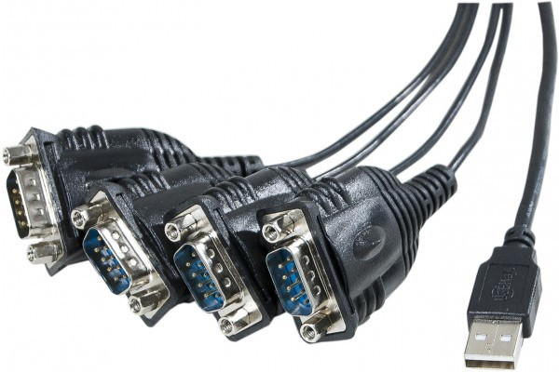
cover sub-d | 5 | 8 | 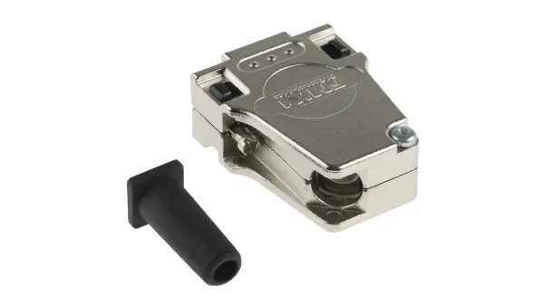
sub-d connector male | 2 | 8 | 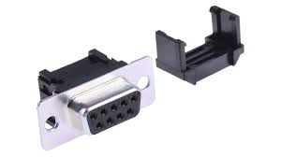
raspberry pi 3B+ | 37 | 1 | 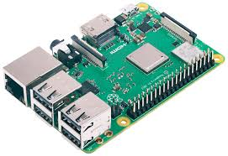
raspberry 7’’ touchscreen display | 50 | 1 | 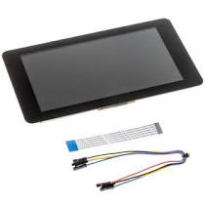
M2.5 standoffs | 1 | 4 | 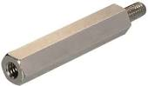
Wooden sign | 50 | 1 | 