Faculty of Engineering, Science & Technology

IQRA UNIVERSITY



Programming Fundamental

Project Report

[Summer-2024]

Name: M.Humayun

Roll no: 17057

Semester: summer

Batch:

*Instructor Name:* Ghazala Shafi Sheikh

Acknowledgment

” The best teacher teaches from the heart not from the BOOK. This report consists of a project.”

I would like to express my sincere gratitude to my teacher, Miss Ghazala, for her continuous guidance, encouragement, and valuable suggestions throughout the development of this project. Her support helped me to understand the concepts of programming and apply them practically in creating the "ChatterChacha" virtual assistant.

Lastly, I appreciate everyone who contributed, directly or indirectly, to this project, and I look forward to continuing my learning journey in programming and software development.

*Thank you*

*Miss Ghazala Shafi Sheikh*

***Index***

***Chapter1 Pages***

Objectives 4

***Chapter 2***

Introduction 5

***Chapter 3***

Description 6

***Chapter 4***

Coding 7-14

***Chapter 5***

Screen Shots 15-20

***Chapter 6***

Conclusion 21

***Objectives:***

The main objective of this project is to create a virtual assistant that can interact with users by responding to their commands and queries. The assistant, named "ChatterChacha," can perform tasks like opening applications, providing time and date information, and greeting users based on the time of day. This project aims to enhance user interaction through a simple command-based system.

***Introduction:***

"ChatterChacha" is a virtual assistant program designed to make life easier by responding to user commands and performing actions like opening applications or providing information. It uses simple logic to handle user inputs and provide appropriate responses. The program greets the user, asks for a password, and then waits for commands. If the password is correct, it proceeds to perform the requested tasks.

***Description:***

The main features of "ChatterChacha" include:

1. **Password Protection**: Users must enter a correct password to access the assistant's functionality.
2. **Time-Based Greetings**: Depending on the time of day, the assistant will greet the user with "Good Morning," "Good Afternoon," or "Good Evening."
3. **Responding to Commands**: The assistant can open applications like Notepad, MS Word, Excel, PowerPoint, and web pages (e.g., Google, YouTube, Instagram).
4. **Handling Conversations**: Simple chat interactions are supported, like replying to greetings ("hi," "hello") and closing the conversation with commands like "bye."
5. **Error Handling**: If the user gives an unrecognized command, the assistant politely asks the user to try again.

***Coding:***

*#include <iostream>*

*#include <windows.h> // for window API structure*

*#include <conio.h> // for getch()*

*#include <stdio.h>*

*#include <string.h>*

*#include <ctime> // for time functions*

*using namespace std;*

*// function to wish user according to time*

*void wishme(){*

*// current date and time based on your system timezone*

*time_t now = time(0);*

*tm *time = localtime(&now);*

*if (time-> tm_hour < 12){*

*cout<< "Good Morning Sir"<<endl;*

*string phrase = "Good Morning Sir";*

*}*

*else if (time-> tm_hour >= 12 && time->tm_hour <= 16){*

*cout<< "Good Afternoon sir"<<endl;*

*string phrase = "Good Afternoon sir";*

*}*

*else if (time-> tm_hour > 16 && time->tm_hour < 24){*

*cout<< "Good Evening sir"<<endl;*

*string phrase = "Good Evening sir";*

*}*

*}*

*// using function to hide password*

*void getPassword(char* password) {*

*char inputChar;*

*int i = 0;*

*while (true) {*

*inputChar = getch();*

*if (inputChar == 13) {*

*password[i] = '\0';*

*break;*

*} else if (inputChar == 8) {*

*if (i > 0) {*

*i--;*

*cout << "\b \b";*

*}*

*} else {*

*password[i++] = inputChar;*

*cout << '*';*

*}*

*}*

*}*

*void datetime(){*

*time_t now = time(0);*

*char *dt = ctime(&now);*

*cout<<"The date and time is "<<endl*

*<< dt <<endl;*

*}*

*int main()*

*{*

*system("cls");*

*cout<<"\t\t<============================================= W E L C O M E =======================================>"<<endl;*

*cout<<"\t\t<============================================= I'M A VIRTUAL ASSISTANT =============================>"<<endl;*

*cout<<"\t\t<============================================= MY NAME IS CHATTERCHACHA ============================>"<<endl;*

*cout<<"\t\t<============================================= I'M HERE TO HELP YOU ================================>"<<endl<<endl;*

*char password[20]; //to take password*

*char ch[100]; // to take command from the user*

*do*

*{*

*cout<<"======================="<<endl;*

*cout<<"| ENTER YOUR PASSWORD |"<<endl;*

*cout<<"======================="<<endl<<endl;*

*getPassword(password);*

*STARTUPINFO startInfo = {0};*

*PROCESS_INFORMATION processInfo = {0};*

*if(strcmp(password, "humayun")==0){*

*cout<<"\n<==================================================================================================>\n";*

*wishme();*

*do{*

*cout<<"\n<==================================================================================================>\n";*

*cout<<endl<<"How can i help you sir...."<<endl<<endl;*

*string phrase = "How can i help you sir";*

*cout<<"Your query ===> ";*

*gets(ch);*

*cout<<endl;*

*cout<<"Here is the result for your query ===> ";*

*// if user say hey then reply "Hello sir"*

*if(strcmp(ch, "hi") == 0 || strcmp(ch, "hey") == 0 || strcmp(ch, "hello") == 0 ){*

*cout<<"Hello sir....."<<endl;*

*string phrase = "Hello sir";*

*}*

*// if user say bye then program will end*

*else if(strcmp(ch, "bye") == 0 || strcmp(ch, "stop") == 0 || strcmp(ch, "exit") == 0 ){*

*cout<<"Good Bye sir, have a nice day!!!!"<<endl;*

*string phrase = "Good Bye sir, have a nice day";*

*exit(0);*

*}*

*// about chatbot*

*else if(strcmp(ch, "who are you") == 0 || strcmp(ch, "tell me about yourself") == 0 || strcmp(ch, "about") == 0 ){*

*cout<<"I'm a virtual assistant created by Humayun !!!"<<endl;*

*string phrase = "I am a virtual assistant created by Humayun";*

*}*

*// felling share*

*else if(strcmp(ch, "how are you") == 0 || strcmp(ch, "whatsup") == 0 || strcmp(ch, "how is your day") == 0 ){*

*cout<<"I'm good sir, tell me how can i help you.."<<endl;*

*string phrase = "I'm good sir, tell me how can i help you";*

*}*

*// Time and Date*

*else if(strcmp(ch, "time") == 0 || strcmp(ch, "date") == 0){*

*// make function to show date and time*

*datetime();*

*}*

*// for opening natepad*

*else if(strcmp(ch, "open notepad") == 0){*

*cout<<"openining notepad....."<<endl;*

*string phrase = "opening notepad";*

*CreateProcess(TEXT("C:\\Windows\\notepad.exe"), NULL, NULL, NULL, FALSE, NULL, NULL, NULL, &startInfo, &processInfo);*

*}*

*// for opening C++ tutorial*

*else if (strcmp(ch, "open c++") == 0) {*

*cout << "Opening video....." << endl;*

*ShellExecute(NULL, "open", "https://www.youtube.com/watch?v=yGB9jhsEsr8&t=349s", NULL, NULL, SW_SHOWNORMAL);*

*}*

*// for opening MS Word*

*else if(strcmp(ch, "open word") == 0){*

*cout<<"openining MsWord....."<<endl;*

*string phrase = "opening Ms word";*

*CreateProcess(TEXT("C:\\Program Files\\Microsoft Office\\root\\Office16\\WINWORD.EXE"), NULL, NULL, NULL, FALSE, NULL, NULL, NULL, &startInfo, &processInfo);*

*}*

*// for opening Excel*

*else if(strcmp(ch, "open excel") == 0){*

*cout<<"openining MsExcel....."<<endl;*

*string phrase = "opening Ms Excel";*

*CreateProcess(TEXT("C:\\Program Files\\Microsoft Office\\root\\Office16\\EXCEL.EXE"), NULL, NULL, NULL, FALSE, NULL, NULL, NULL, &startInfo, &processInfo);*

*}*

*// for opening PPT*

*else if(strcmp(ch, "open ppt") == 0){*

*cout<<"openining MSPowerPoint....."<<endl;*

*string phrase = "opening Ms Power Point";*

*CreateProcess(TEXT("C:\\Program Files\\Microsoft Office\\root\\Office16\\POWERPNT.EXE"), NULL, NULL, NULL, FALSE, NULL, NULL, NULL, &startInfo, &processInfo);*

*}*

*// for opening google*

*else if(strcmp(ch, "open google") == 0){*

*cout<<"opening google....."<<endl;*

*string phrase = "opening google";*

*system("start https://www.google.com");*

*}*

*// for opening youtube*

*else if(strcmp(ch, "open youtube") == 0){*

*cout<<"opeining YouTube....."<<endl;*

*string phrase = "opening youtube";*

*system("start https://www.youtube.com");*

*}*

*// for opening instagram*

*else if(strcmp(ch, "open instagram") == 0){*

*cout<<"openining instagram....."<<endl;*

*string phrase = "opening instagram";*

*system("start https://www.instagram.com/humayun_khuhro/");*

*}*

*// for opening facebook*

*else if(strcmp(ch, "open facebook") == 0){*

*cout << "openining facebook....." << endl;*

*string phrase = "opening facebook";*

*system("start https://www.facebook.com/muhammad.humayou.1");*

*}*

*// Show miss ghazala profile at iqra*

*else if(strcmp(ch, "miss ghazala") == 0){*

*cout << "openining website....." << endl;*

*string phrase = "opening website";*

*system("start https://iqra.edu.pk/teachers/ghazala-shafi/");*

*}*

*// if user ask wrong question this reply show*

*else{*

*cout<<"Sorry could not understand your query please ty again !!!"<<endl;*

*string phrase = "Sorry could not understand your query please ty again";*

*}*

*}while(1);*

*}*

*else*

*{*

*system("cls");*

*cout << "\t\t\t<============================= W E L C O M E=============================>" << endl;*

*cout << "\t\t\t<============================= I'M VIRTUAL ASSISTANT =============================>" << endl;*

*cout << "\t\t\t<============================= MY NAME IS CHATTERCHACHA =============================>" << endl;*

*cout << "\t\t\t<============================= I'M HERE TO HELP YOU AND MAKE YOUR LIFE EASY =============================>" << endl*

*<< endl;*

*cout << "======================" << endl;*

*cout << "X Incorrect Password X" << endl;*

*cout << "======================" << endl*

*<< endl;*

*string phrase = "Incorrect Password, Please enter correct password";*

*}*

*} while (1);*

*return 0;*

*}*

***Screen Shots:***

1. **Home:**

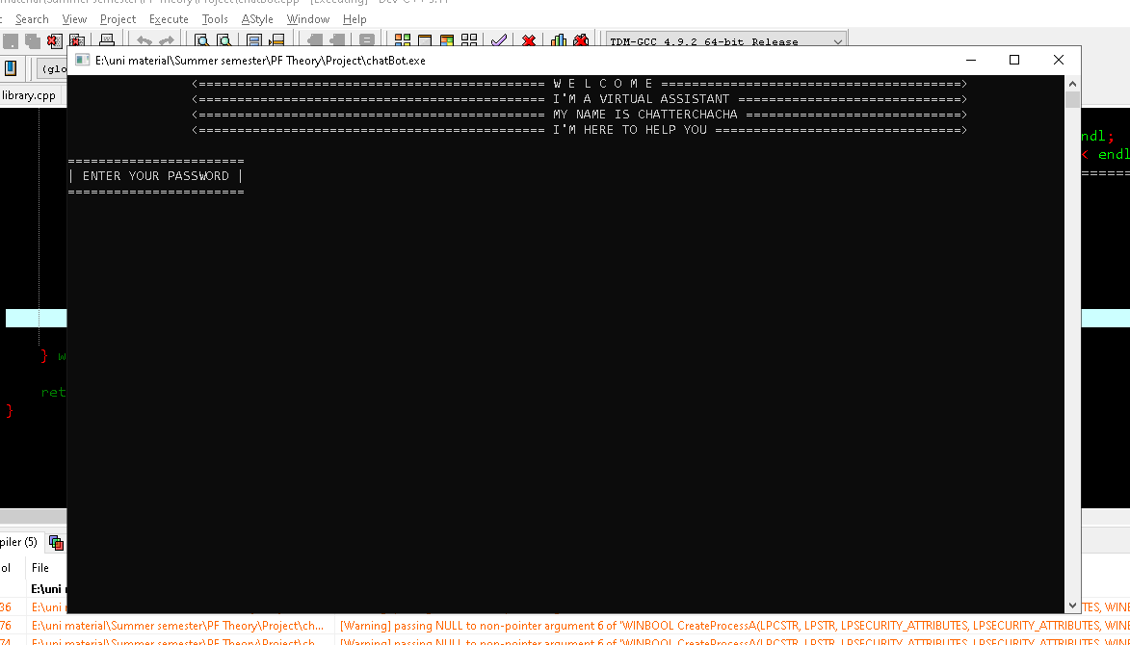

**2.Enter Password:**

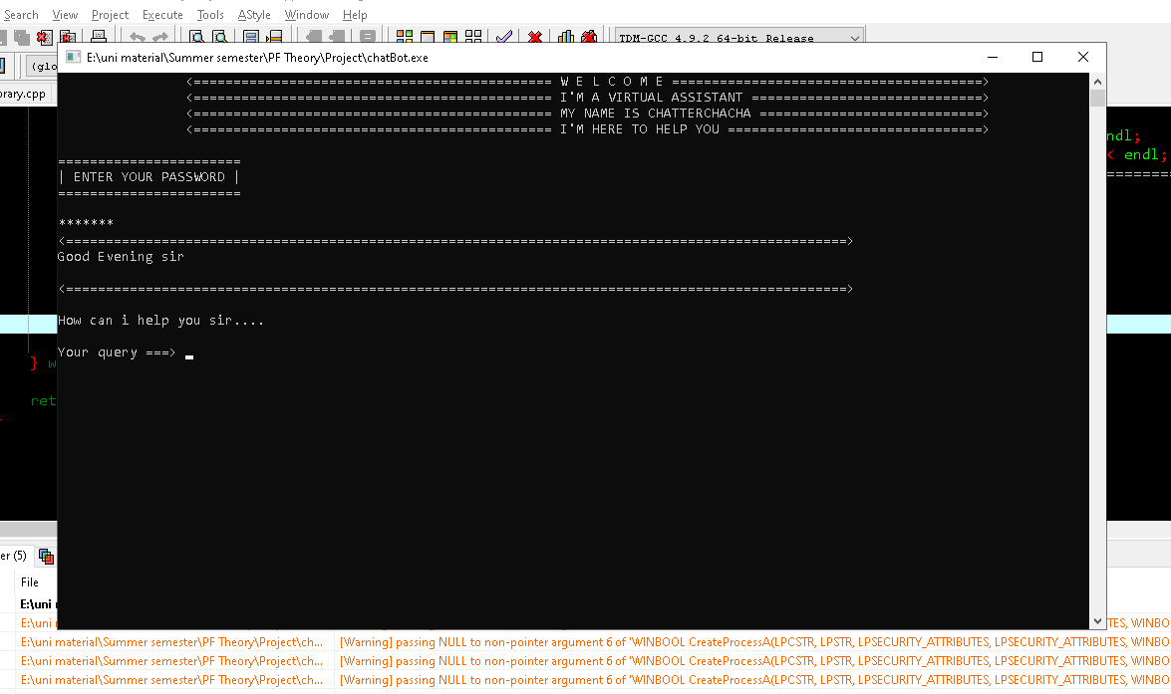

**3.Prompt HI:**

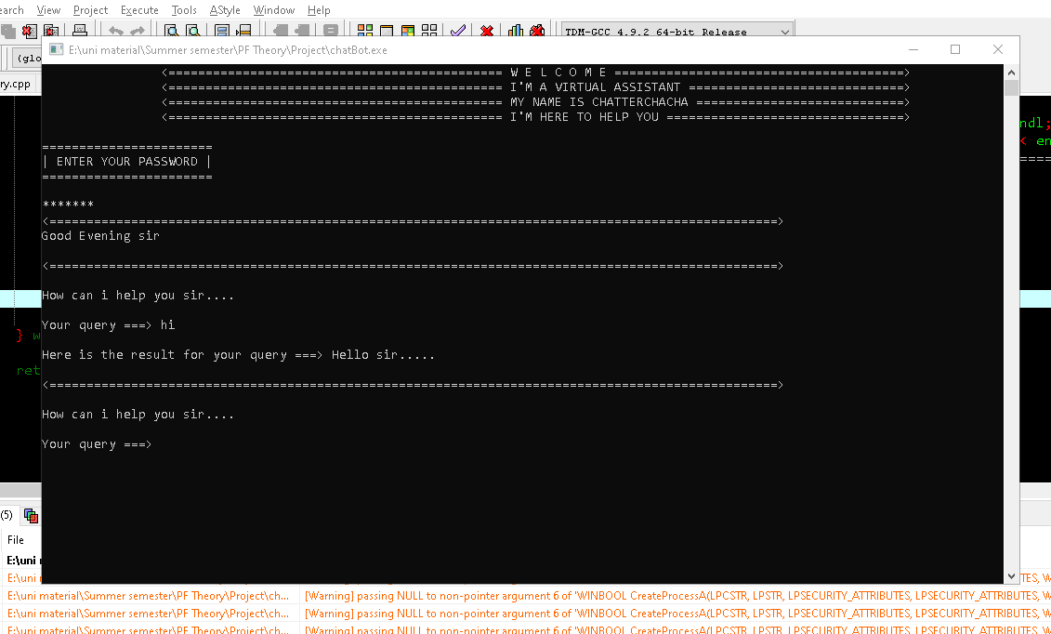

**4.Prompt Open Google:**

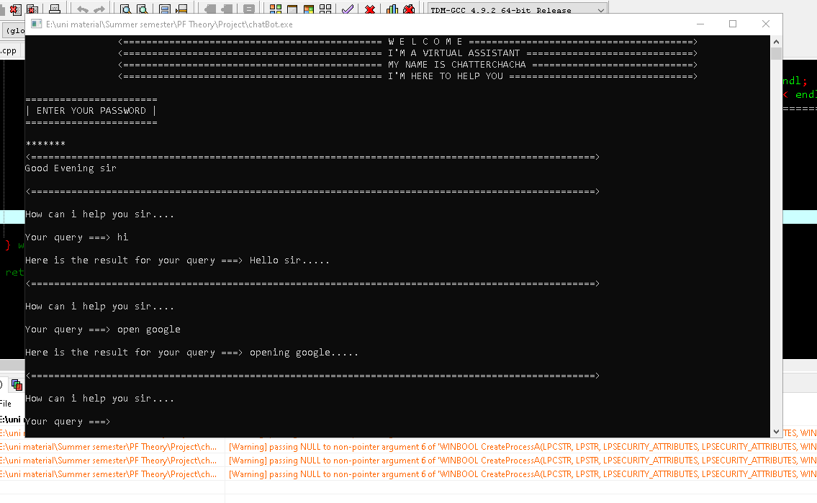

1. **Miss Ghazala-shafi Iqra profile:**

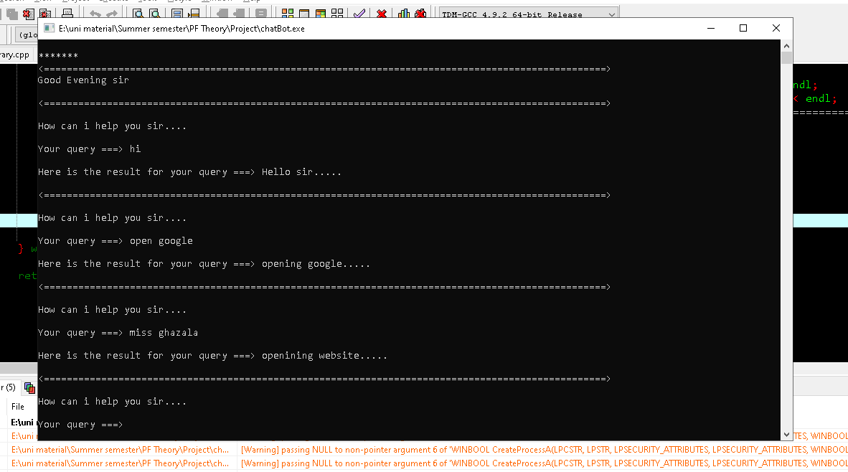

1. **My Facebook Profile:**



1. **Prompt wrong:**

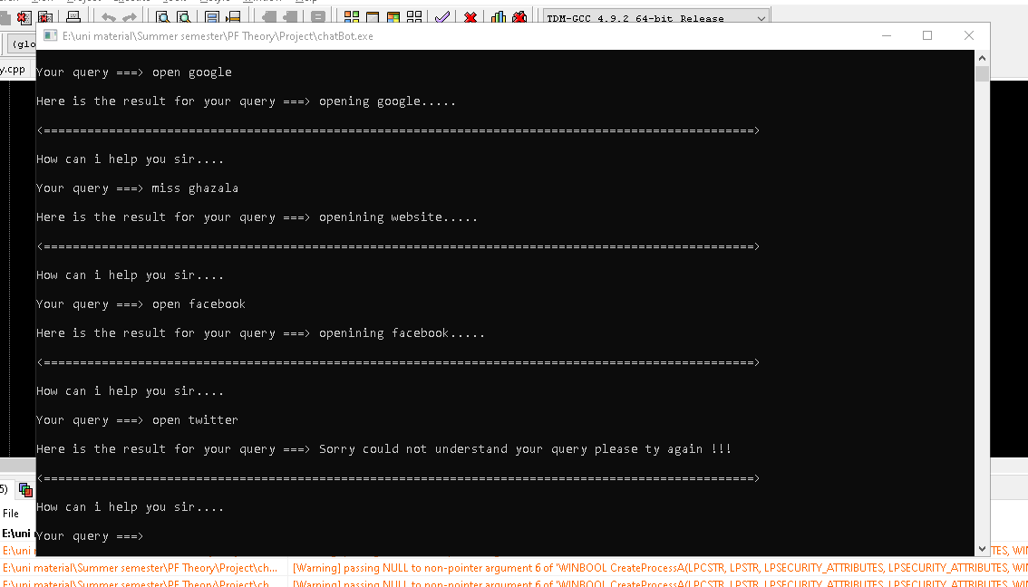

1. **Open YouTube:**

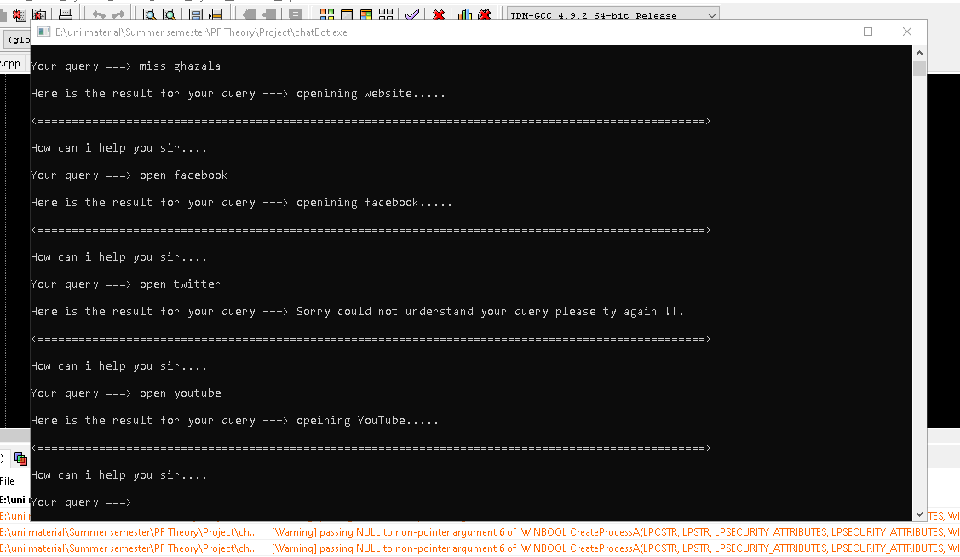

1. **Prompt bye:**

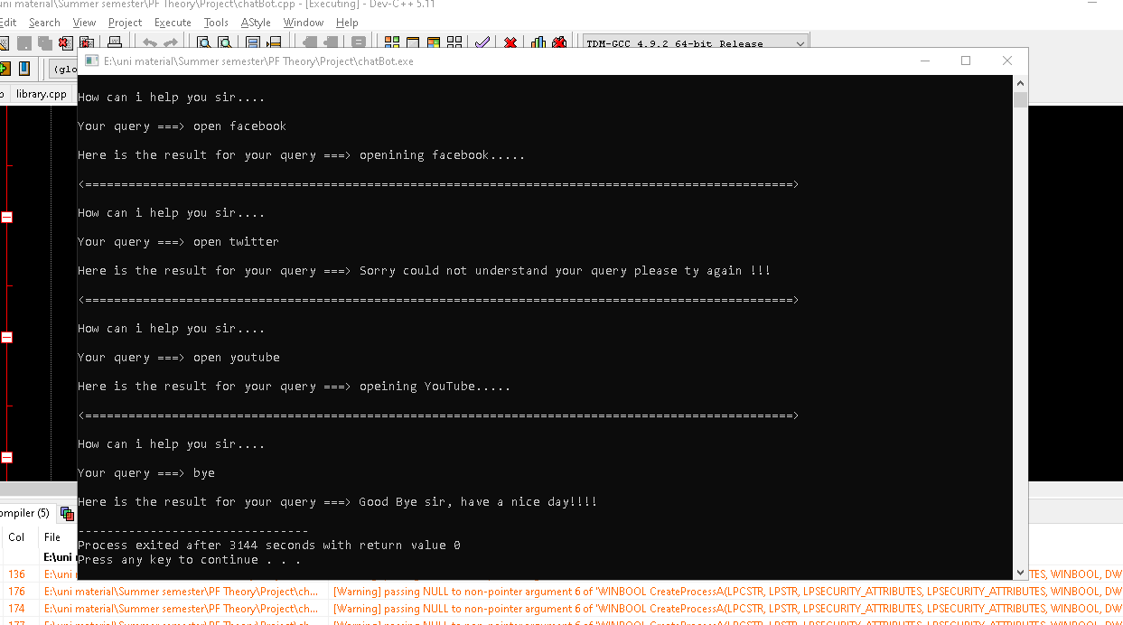

**10.Enter Wrong password:**



**11. Open Notebook:**

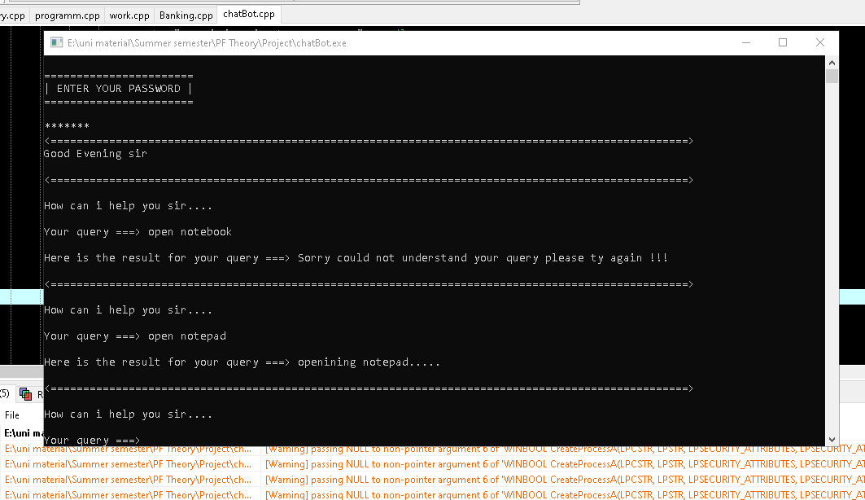

**12. Open Word:**

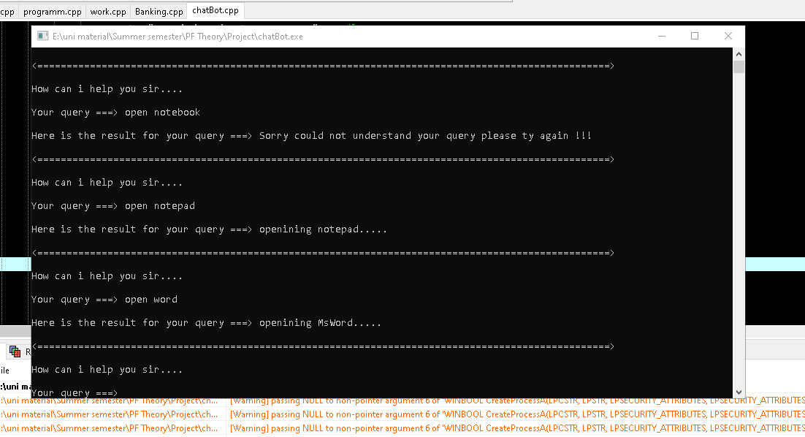

***Conclusion:***

In conclusion, "ChatterChacha" demonstrates how a simple console-based virtual assistant can perform useful tasks and interact with users. The program handles user input, manages tasks like opening applications, and gives responses, making it an effective tool for automating small, repetitive tasks.