Information Technology
Database Design Concept
Module Code: ITDCA0-B22
Project

Collecting raw data
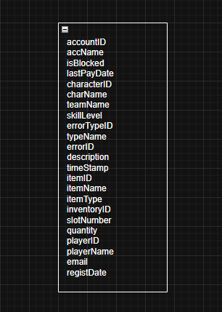

0 Normal Form (0-NF)
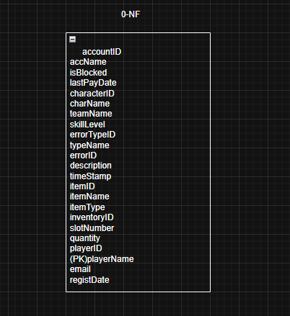

First Normal Form (1-NF)
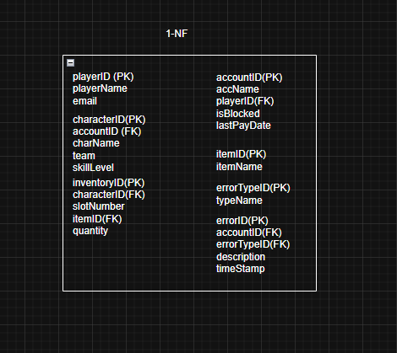

Second Normal Form (2-NF)

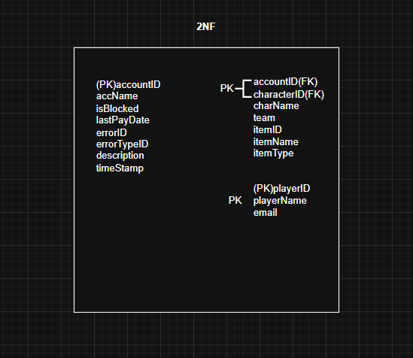

Third Normal Form (3-NF)

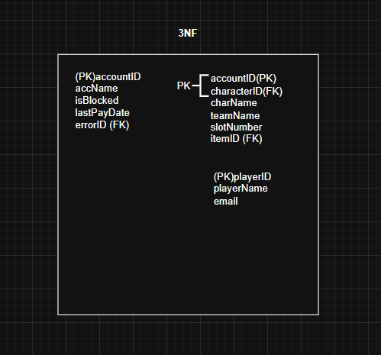
ER Diagram from 3-NF
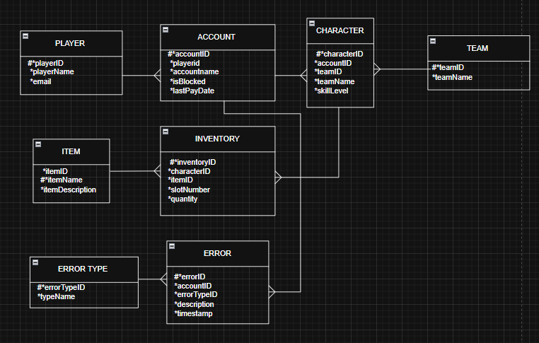

Mapping to Tables
PLAYER
Column names | playerID | playerName | email
Key Type | PK
Nulls | NN | NN | NN
Sample data | 74 | General Xaba | gxaba@gmail.com
Sample data | 61 | Zolani Mzilakazi | zmzila@gmail.com

 | ACCOUNT
Column names | accountID | playerID | accountName | isBlocked | lastPayDate
Key Type | PK | FK
Nulls | NN | NN | NN
Sample data | 55 | 74 | SpikeNoob | No | 2025/06/02
Sample data | 30 | 61 | GenZBoy | Yes | 2025/05/10

CHARACTER
Column names | characterID | accountID | teamID | charName | skillLevel
Key Type | PK | FK | FK
Nulls | NN | NN | NN | NN
Sample data | 23 | 55 | 1 | Tinjaru | 78%
Sample data | 36 | 30 | 2 | Deku | 70%

TEAM
Column names | teamID | teamName
Key Type | PK
Nulls | NN | NN
Sample data | 1 | JJK
Sample data | 2 | Hero Academia

ITEM
Column names | itemID | itemName | itemDescription
Key Type | PK
Nulls | NN | NN
Sample data | 12 | Sword | Sword to fight cursed spirits.
Sample data | 16 | Fire Gear | Fire gear to avoid getting burnt by own powers and opponents.

INVENTORY
Column names | inventoryID | characterID | itemID | slotNumber | quantity
Key Type | PK | FK | FK
Nulls | NN | NN | NN
Sample data | 3 | 23 | 12 | 5 | 1
Sample data | 6 | 36 | 16 | 7 | 1

ERROR TYPE
Column names | errorTypeID | typeName
Key Type | PK
Nulls | NN | NN
Sample data | 14 | Syntax Error
Sample data | 16 | Runtime error

ERROR
Column names | errorID | accountID | errorTypeID | description | timestamp
Key Type | PK | FK | FK
Nulls | NN | NN | NN
Sample data | 11 | 55 | 14 | Code doesn’t respect the syntax rules a program requires. | 2025-06-6 10:30:00
Sample data | 9 | 30 | 16 | Index 3 is out of bounds (is beyond the length of the array). | 2025-06-07 08:47:33

Documentation
Author: Khulani Ngubane
Date: 2025/06/11
Lecturer: Primrose Mthethwa
Campus: Durban

MMORPG Database Design Documentation

Project Title
Massively Multiplayer Online Role Playing Game (MMORPG) – Account Management Database

Project Description
This project involves designing a relational database to manage players, their accounts, characters, in-game items, teams, and error logs in a Massively Multiplayer Online Role Playing Game (MMORPG). The goal is to ensure data integrity, reduce redundancy, and support the management of gameplay data through a normalized and scalable schema.

Objectives
- Store and manage player and account data.
- Track character creation and team membership.
- Maintain inventory slots for each character.
- Record gameplay errors and categorize them by type.
- Enforce referential integrity between entities.

Entity Overview
Entity | Description
Player | Stores information about registered users.
Account | Tracks login credentials and subscription status.
Character | Virtual avatars controlled by players.
Team | Groups characters together for gameplay.
Item | Objects collected during gameplay.
Inventory | Slots for storing items held by characters.
ErrorType | Categories for types of errors (e.g., 'Login Failure').
Error | Specific error instances with timestamps.

Normalization Steps
0NF – Unstructured Data
• All data is stored in a flat file or document with repeating groups.
• Example: Multiple characters, items, and errors inside one account row.
1NF – Eliminate Repeating Groups
• Each field holds only atomic values.
• Separate characters, items, and errors into new tables.
2NF – Remove Partial Dependencies
• Create separate tables for entities that only depend on part of a composite key (e.g., Items, Errors).
3NF – Remove Transitive Dependencies
• Remove derived or indirectly dependent data like team_name from Character.
• Create Team and ErrorType tables.

ERD (Entity-Relationship Diagram)
The ERD shows all entities and their relationships in 3NF.

Relationships
Summary of key entity relationships in the MMORPG database:
Relationship | Type
Player → Account | One-to-Many
Account → Character | One-to-Many
Character → Inventory | One-to-Many
Inventory → Item | Many-to-One
Character → Team | Many-to-One
Account → Error | One-to-Many
Error → ErrorType | Many-to-One

Business Rules
- A player can have multiple accounts.
- Each account can create multiple characters.
- Characters can be grouped into teams.
- Each character has up to 8 inventory slots.
- Errors must be logged with a timestamp and error type.
- Duplicate items are allowed but tracked separately via quantity.

Technologies Used
- Design Tool: Draw.io for ERD creation

Referencing
• Coronel, C. and Morris, S., 2019. Database Systems: Design, Implementation, & Management. 13th ed. Boston: Cengage Learning.
• Elmasri, R. and Navathe, S.B., 2016. Fundamentals of Database Systems. 7th ed. Boston: Pearson.
• Silberschatz, A., Korth, H.F. and Sudarshan, S., 2020. Database System Concepts. 7th ed. New York: McGraw-Hill.
• Haines, L., 2011. Beginning Database Design: From Novice to Professional. 2nd ed. Apress.
• Rollings, A. and Adams, E., 2003. Andrew Rollings and Ernest Adams on Game Design. Indianapolis: New Riders.
• Gregory, J., 2018. Game Engine Architecture. 3rd ed. CRC Press.
• IEEE, 2022. IEEE Standard Glossary of Software Engineering Terminology. [online] Available at: https://ieeexplore.ieee.org [Accessed 11 June 2025].

