WINDOWS REGISTRY
CHANGE MONITORING SYSTEM
Technical Project Report

Prepared for: Unified Mentor
Prepared by: Kinjal Khuman
Project type: Read-only defensive monitoring
Report prepared from recorded implementation notes and test outputs
Accuracy note: This report describes only the features and results supported by the project notes and recorded outputs. Confirm current code and rerun tests before formal submission.

1. Executive Summary
This project develops a Python-based, read-only Windows Registry monitoring toolkit intended to help identify changes that may affect startup behavior and selected Windows security settings. The toolkit includes startup Registry comparison, baseline-based change detection, scheduled polling within the script, selected security-setting checks, file-integrity tamper-detection tests, and simulated error-handling tests.
A detected Registry change is a reason to investigate, not proof of malware. Results depend on the Registry locations and values configured by the scripts and on the baseline or reference data used.

2. Objectives
- Monitor configured autorun locations for new, removed, or modified startup entries.
- Compare current Registry data against saved baseline/reference data.
- Check selected security-related Registry settings, including Firewall, UAC, Shell, and selected Defender policy values.
- Record detected differences in text reports with available timestamps and old/new values.
- Test file-integrity tamper detection and safe handling of simulated errors.
- Provide evidence through test outputs, reports, notes, and screenshots.

3. Scope
Startup monitoring covers these configured locations:
- HKCU\Software\Microsoft\Windows\CurrentVersion\Run
- HKCU\Software\Microsoft\Windows\CurrentVersion\RunOnce
- HKLM\Software\Microsoft\Windows\CurrentVersion\Run
- HKLM\Software\Microsoft\Windows\CurrentVersion\RunOnce
The security-settings monitor checks selected Defender policy values, three Firewall profile values, UAC values, and Shell-related values. Exact keys and values are defined by the project scripts and reference JSON file.
The file-integrity test checks whether a file differs from a stored reference hash. This test demonstrates file-integrity functionality; it does not prove that every Registry-integrity requirement is implemented.

4. Tools and Technologies
- Python 3.14
- Python winreg module for reading Windows Registry values
- JSON files for baseline/reference data
- PowerShell and Visual Studio Code terminal for running and verifying scripts
- Text reports for recording findings
Windows Task Scheduler is optional and is not confirmed as configured in the project evidence.

5. System Design and Workflow
- Define the Registry locations and security settings to inspect.
- Capture or load a reference baseline.
- Read the current configured Registry data.
- Compare current data with the baseline/reference.
- Classify differences as new, removed, or modified entries where supported.
- Write findings to the configured report file and review them.
- Run test scripts using sample data to verify comparison, integrity-detection, and error-handling behavior.
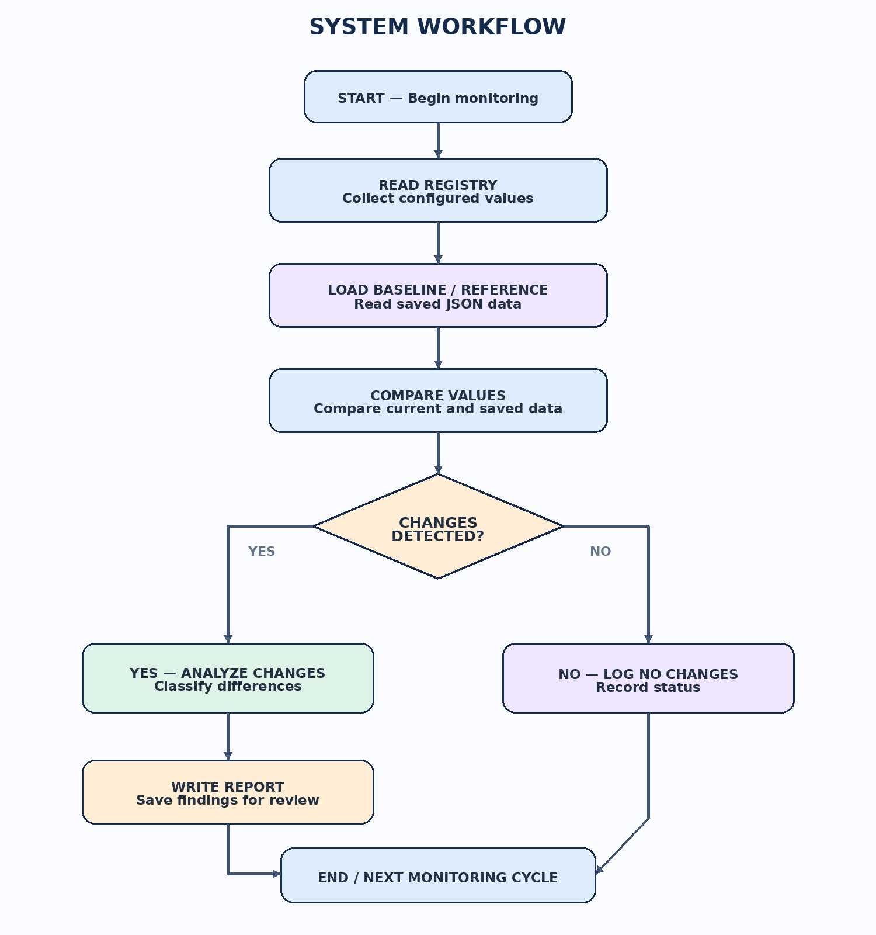
Figure 11. Workflow of the Windows Registry Change Monitoring System.

6. Implemented Components
6.1 Startup Registry comparison. Scripts compare configured Run and RunOnce locations and report detected additions, removals, and modifications.
6.2 Automatic monitoring. automatic_monitor.py polls configured startup Registry locations at intervals and appends findings to an automatic monitoring report. The recorded run used a 60-second polling interval.
6.3 Security settings monitor V2. security_settings_monitor_v2.py checks selected Defender policy, Firewall, UAC, and Shell values against security_settings_reference_v2_corrected.json.
6.4 Baseline/reference files. JSON files store captured startup and security-setting reference data for comparison.
6.5 Integrity tamper test. test_integrity_detection.py checks an original file against its reference, verifies that a modified file is detected, and confirms temporary test files are cleaned up.
6.6 Error handling. test_monitor_errors.py exercises a simulated Registry enumeration failure to verify safe handling of that test condition.

7. Verification and Test Results
Integrity detection test — PASS. Recorded output confirmed that the original file matched its reference, a modified file was detected, and temporary test files were cleaned up.
Security monitor V2 — PASS against configured reference. The recorded run found no differences from the V2 reference. Three selected Defender policy values were reported as NOT_FOUND. This means those exact values were not found; it does not establish Defender health or failure.
Error-handling test — PASS for simulated enumeration failure. The output showed the simulated enumeration error was raised and handled. This is a simulated test, not a real Registry failure.
Sample comparison test — PASS. Sample data demonstrated detection of a new entry, a removed entry, and a modified Microsoft Lists entry.
Real startup Registry comparison — observed differences. A recorded run detected new Microsoft Edge auto-launch entries and a modified Microsoft Lists/OneDrive path. These may be normal software changes and were not confirmed malicious.
Automatic monitoring report — available. A report was confirmed in the project reports folder. A recorded report contained two new Microsoft Edge auto-launch entries and a modified Microsoft Lists/OneDrive path.
These results summarize outputs supplied during development. Rerun tests and capture fresh evidence if current execution proof is required.

8. Project Artifacts
- Code folder: Python scripts, JSON baselines/references, and test scripts.
- Notes folder: Project_Notes.txt, including implementation and testing notes.
- Reports folder: automatic_monitor_report.txt was confirmed present during the latest folder check.
- Screenshots folder: nine screenshots were confirmed, including folder structure, change reports, comparison tests, automatic monitor output, security monitor V2, and error-handling test.
Check exact filenames in File Explorer or PowerShell because some terminal output displayed truncated names.

9. Safety, Limitations, and Interpretation
- The toolkit is designed for read-only Registry inspection and should not modify or delete Registry values.
- A baseline can become outdated as legitimate software changes. Review unexpected differences before drawing conclusions.
- A Registry value marked NOT_FOUND may be absent, named differently, or not applicable; it does not by itself show that a system is secure or compromised.
- The file-integrity tamper test passed, but the scope of the baseline-integrity checker should be checked against project requirements.
- Polling is implemented in the script; automatic start-on-boot or Task Scheduler configuration is not confirmed.
- Coverage of all requested security modifications must be checked against the actual source code before claiming completeness.
- Monitoring is limited to configured Registry locations and values; this is not a complete endpoint-detection or antivirus product.

10. System Architecture
The system reads selected Registry values, compares them with saved baselines or reference configurations, identifies differences, and records findings for review.
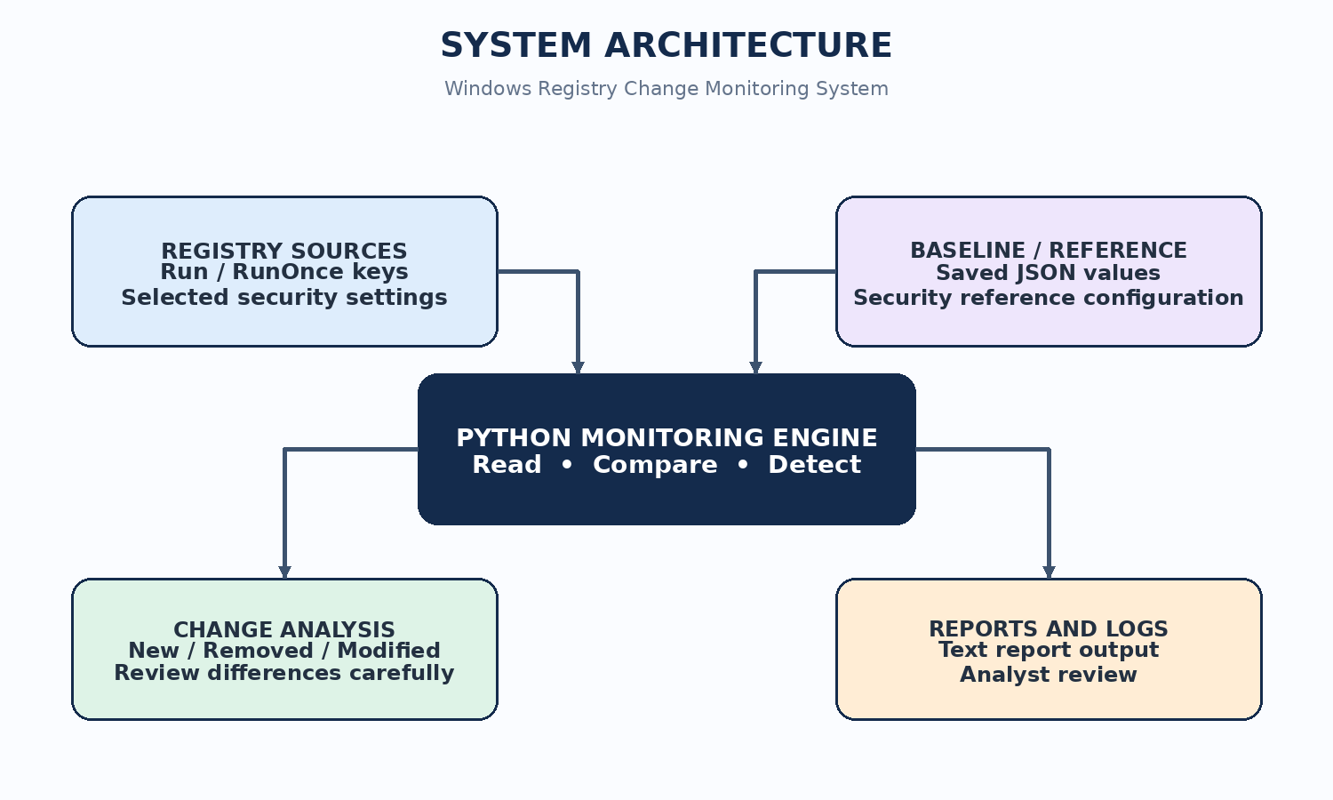
Figure 10. Architecture of the Windows Registry Change Monitoring System, showing Registry sources, baseline/reference data, the Python monitoring engine, change analysis, and reports/logs.

11. Conclusion
The project provides a working foundation for read-only startup Registry monitoring, baseline comparison, selected security-setting comparison, and testing. The recorded integrity tamper-detection and simulated error-handling tests passed. Final submission should include verified code, relevant evidence screenshots, the architecture and workflow diagrams, and a presentation. Claims should remain limited to features verified by actual code and test outputs.

12. Final Submission Checklist
- ☐ Confirm requested detection features against source code.
- ☐ Rerun relevant tests and save fresh terminal screenshots.
- ☐ Verify baseline/reference files and preserve backup copies.
- ☐ Confirm the architecture and workflow diagrams are readable and correctly captioned.
- ☐ Check that all nine screenshots are present and correctly captioned.
- ☐ Review the report for accuracy and remove unsupported claims.
- ☐ Export the approved Word report to PDF and inspect page breaks.
- ☐ Create the final presentation and check all deliverables.

Appendix A — Project Screenshots

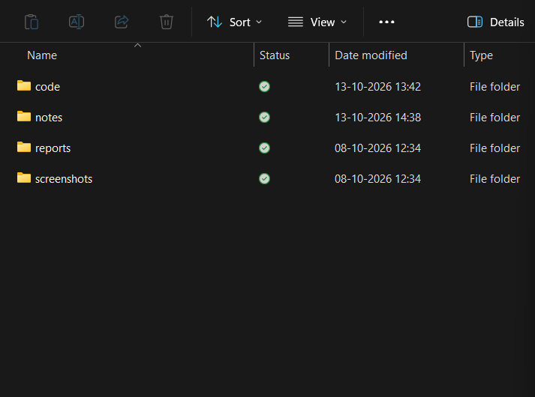
Figure 1. Project folder structure showing the main project folders.
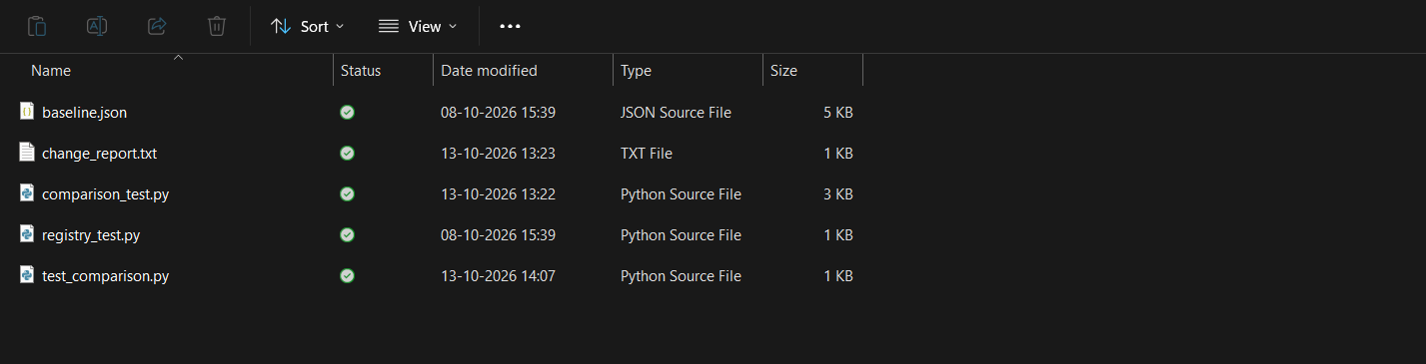
Figure 2. Project folder structure showing project files and organization.

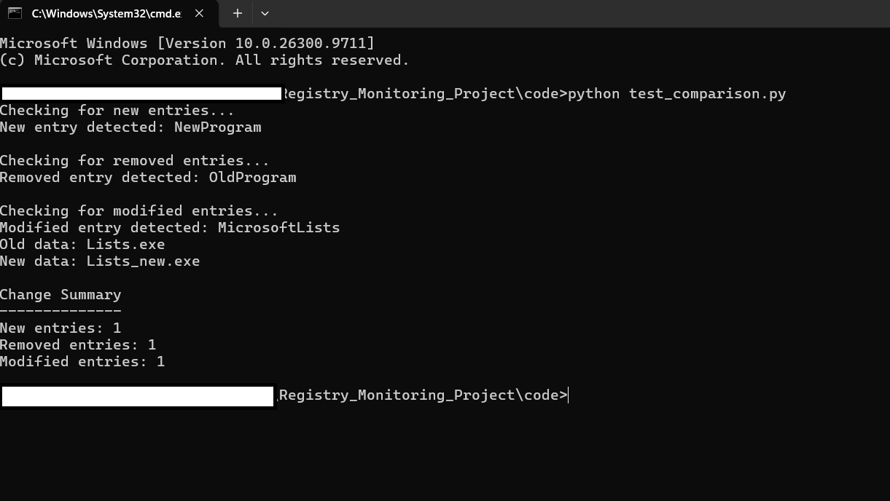
Figure 3. Sample test demonstrating detection of Registry changes.
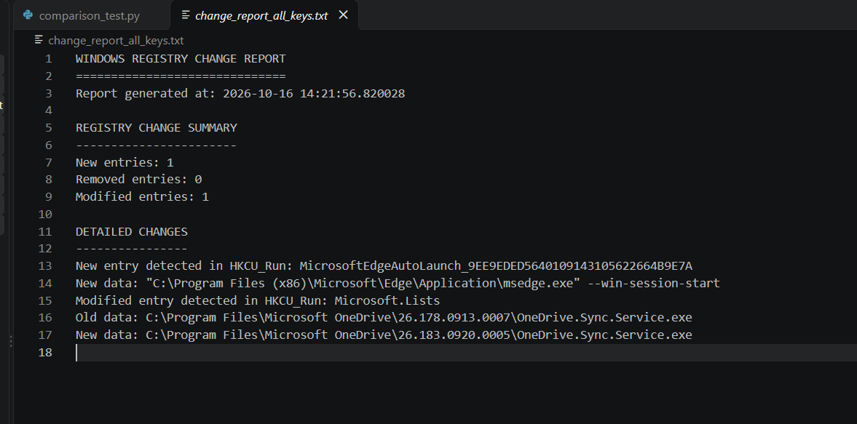
Figure 4. Report showing changes detected during a real Registry comparison. Changes may be caused by normal software updates and are not automatically evidence of malware.

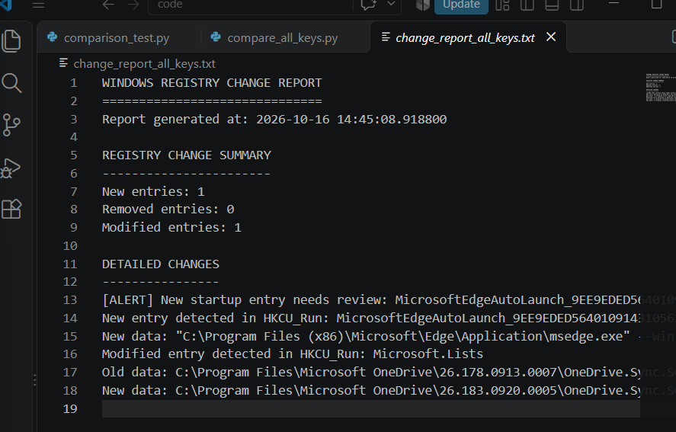
Figure 5. Registry monitoring alert report showing detected changes.
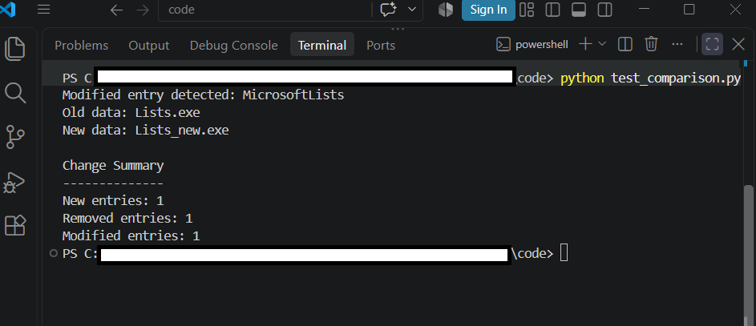
Figure 6. Sample comparison test demonstrating detection of new, removed, and modified Registry entries.

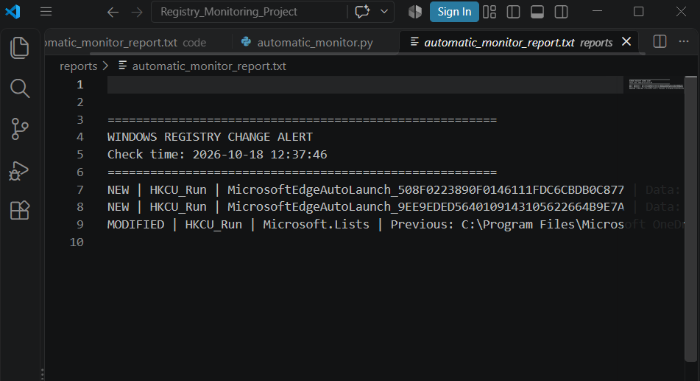
Figure 7. Automatic monitoring report showing results recorded by the monitoring script.
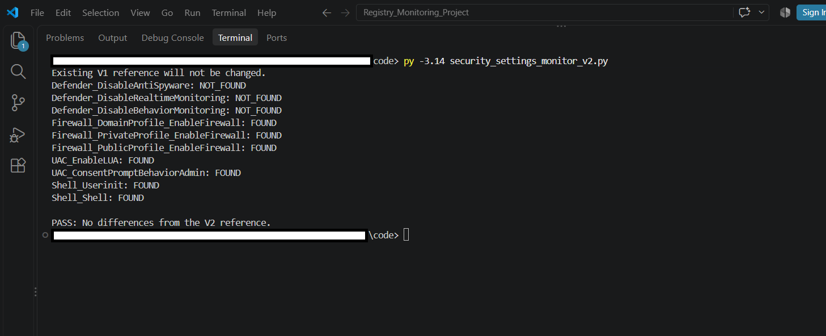
Figure 8. Security settings monitoring test showing comparison results against the saved reference configuration.

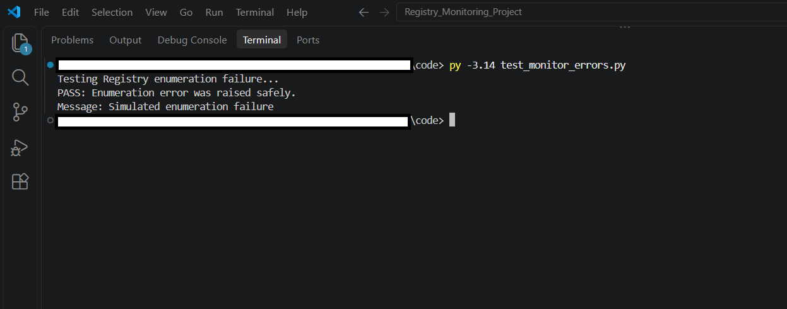
Figure 9. Error-handling test demonstrating response to a simulated Registry enumeration failure.

