>Install NodeJS from: <https://nodejs.org/en/>

> Copy te below highlighted files on Github to a folder on your PC, mine was hydra

> Gitbash here

> “npm install” :This will install all dependancies listed on package.json and put them in node_modules (if you get errors use “npm install -g npm@latest”)

> “npm install –g nodemon” : This willglobally install nodemon for it to auto restart app after changes

>Then you can use your browser / postman / resteasy to test the api endpoints

> “nodemon” to start node and leave it running

This doc is on Git as well

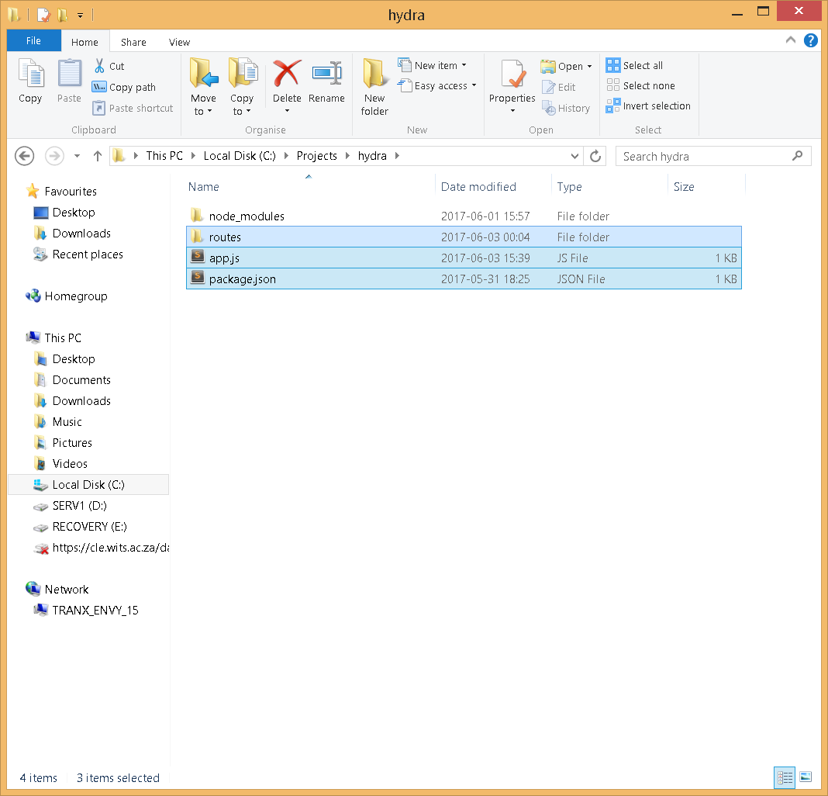

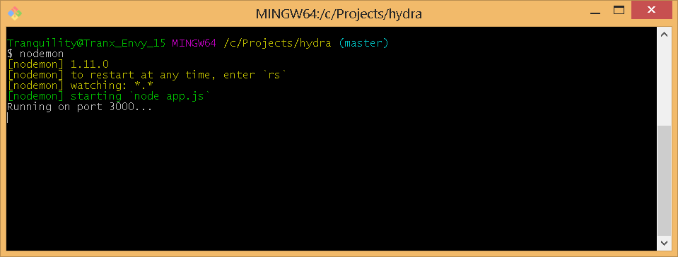

API

Upon Delete: <http://localhost:3000/api/delStation/C1H001&19060807>

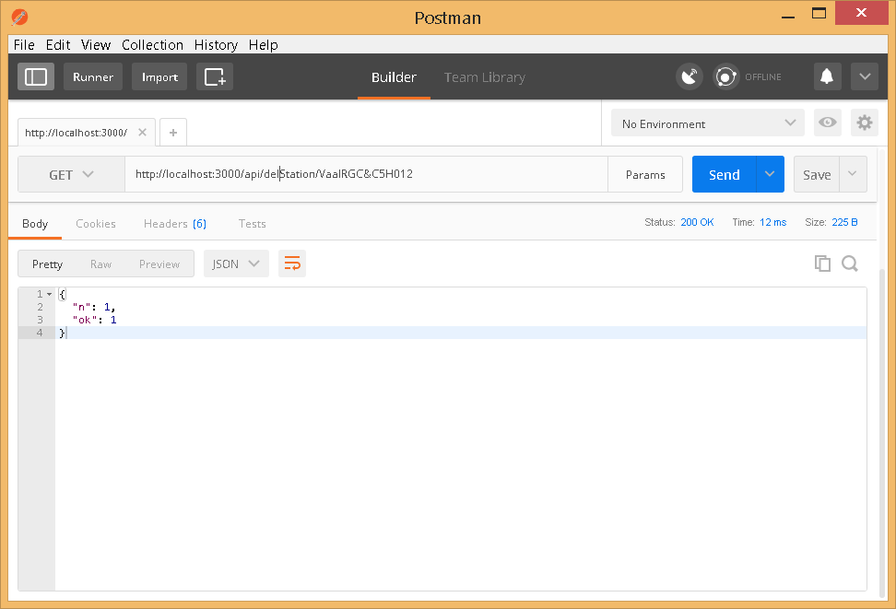

After Delete: <http://localhost:3000/api/listStation/C1H001&19060807>

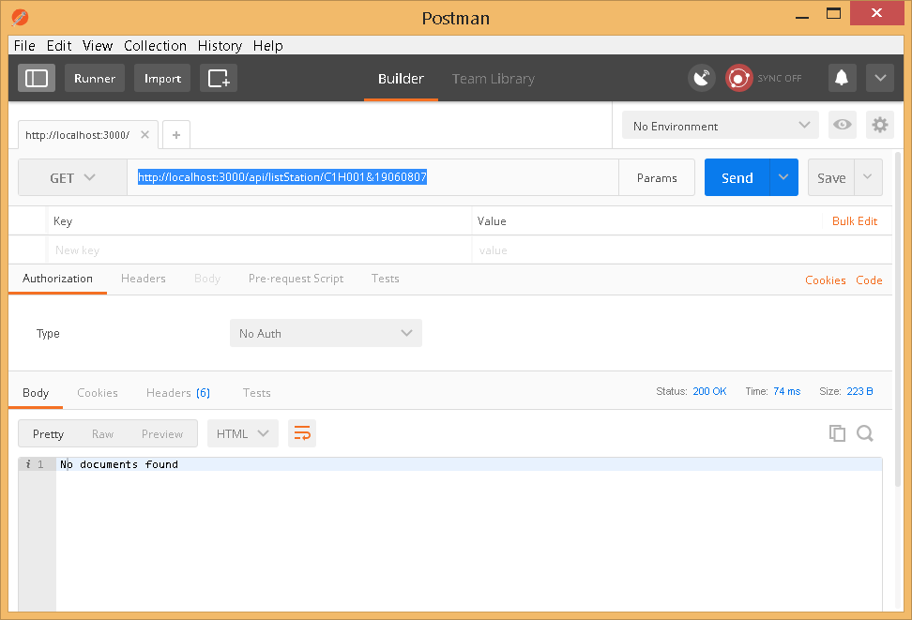

Listing Station Peaks: <http://localhost:3000/api/listStation/C1H001&19060601>

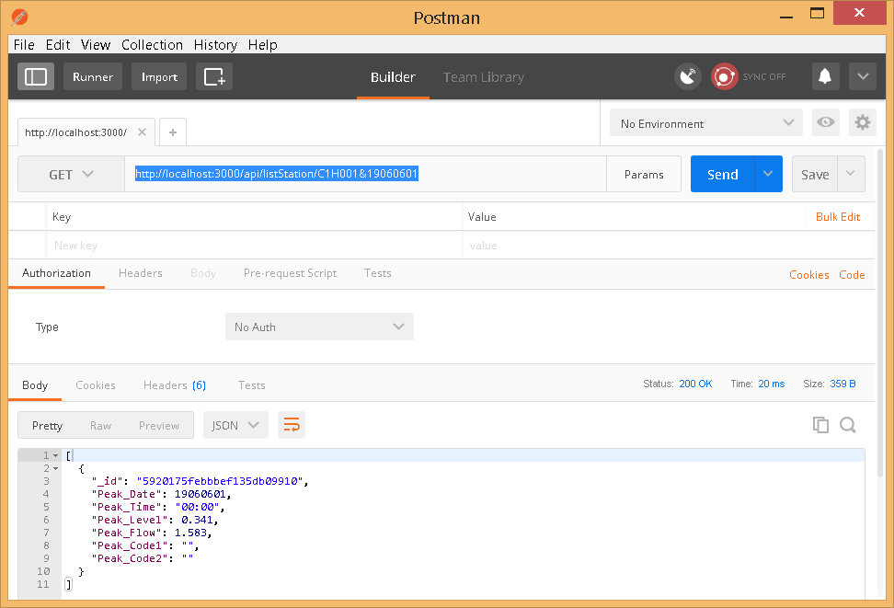

Listing Station Info: <http://localhost:3000/api/listStation/VaalRGC&C1H005>

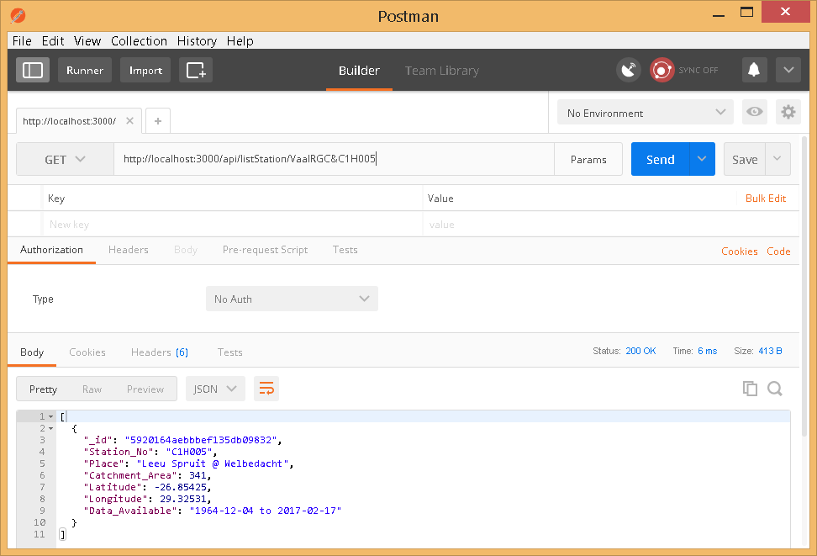

List all station peaks: <http://localhost:3000/api/Stations/all/C5H012>

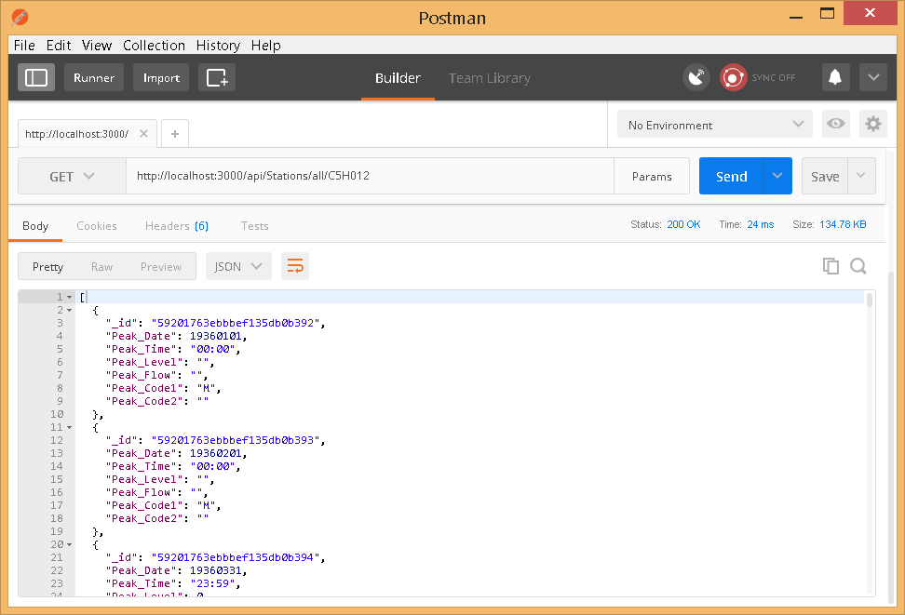

List all station info: <http://localhost:3000/api/Stations/all/VaalRGC>

