12.1-2

ME = 1 if Eve does marketing; 0 if not

MS = 1 if Steve does marketing; 0 if not

CE = 1 if Eve does cooking; 0 if not

CS = 1 if Steve does cooking; 0 if not

DE = 1 if Eve does dishwashing; 0 if not

DS = 1 if Steve does dishwashing; 0 if not

LE = 1 if Eve does laundry; 0 if not

LS = 1 if Steve does laundry; 0 if not

Minimize T = 4.5ME + 7.8CE +3.6DE + 2.9LE + 4.9MS + 7.2CS + 4.3DS + 3.1LS

Subject to

ME+CE+DE+LE=2

MS+CS+DS+LS=2

ME+MS=1

CE+CS=1

DE+DS=1

LE+LS=1

ME, MS, CE, CS, DE, DS, LE, LS are binary variables.

A)
x1 = 1 if invest in project 1; 0 if not
x2 = 1 if invest in project 2; 0 if not
x3 = 1 if invest in project 3; 0 if not
x4 = 1 if invest in project 4; 0 if not
x5 = 1 if invest in project 5; 0 if not

Maximize NPV = x1 + 1.8x2 + 1.6x3 + 0 .8x4 + 1.4x5 Subject to 6x1 + 12x2 + 10x3 + 04x4 + 8x5 ≤ 20
x1 , x2 , x3 , x4 , x5 are binary variables
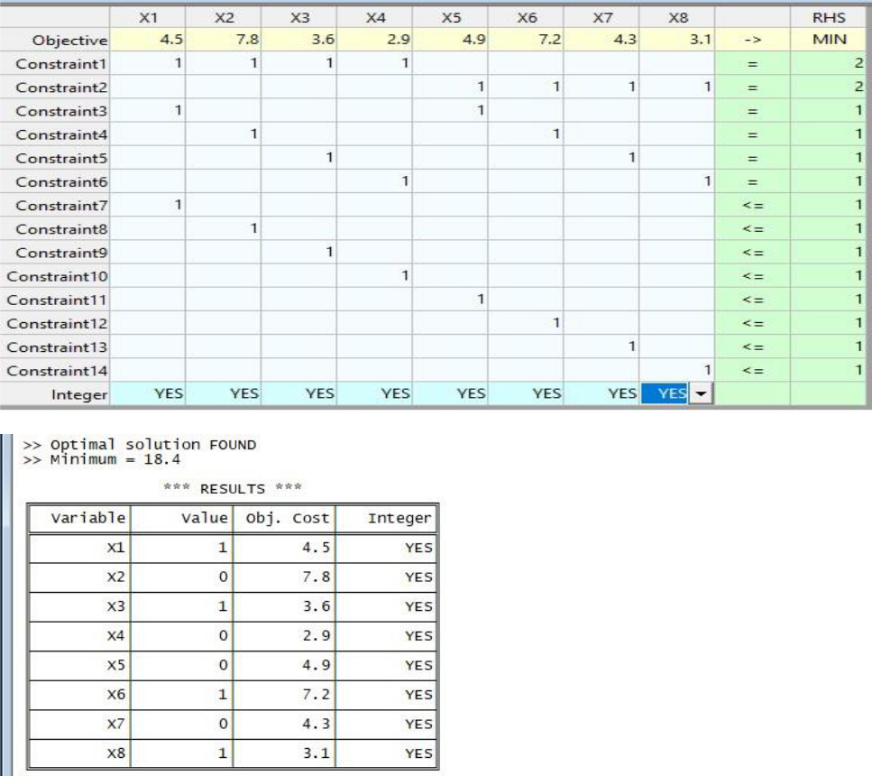

C)
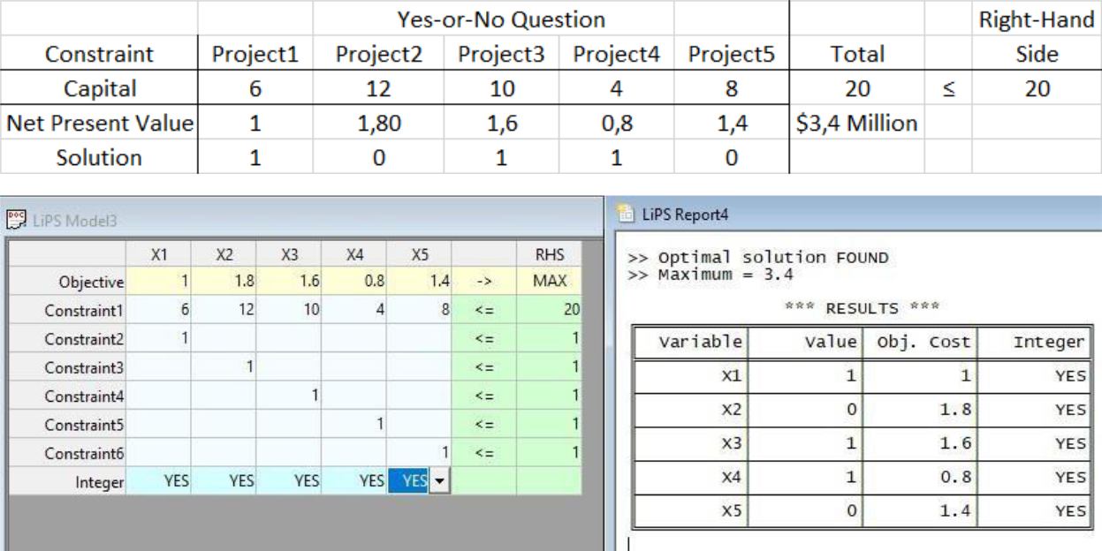
12.3-1

A)

It is stated that the continuous decision variables x1, x2, x3, and x4 are the production levels of products 1, 2, 3, and 4. Likewise, we introduce auxiliary binary variables yi ’s showing the decision: if product line i is developed or not, where i=1, 2, 3, 4.

Then the objective is = total profit = total revenue minus start-up cost =

max Z = (70x1 - 50000y1) + (60x2 - 40000y2) + (90x3 - 70000y3) + (80x4 - 60000y4)

subject to:

( 1 : ) y1 + y2 + y3 + y4 ≤ 2

( 2 : ) y3 ≤ y1 + y2

( 3 : ) y4 ≤ y1 + y2

( 4 : ) 5x1 + 3x2 + 6x3 + 4x4 ≤ 6000 + M y5

( 5 : ) 4x1 + 6x2 + 3x3 + 5x4 ≤ 6000 + M(1- y5), (where y5 is an auxiliary binary variable),

( 6 : ) xi ≤ M yi , for i=1, 2, 3, 4,

where

xi ≥ 0, for i=1, 2, 3, 4, yi = 0 -or- 1, for i=1, 2, 3, 4, 5, and M = (a huge number).
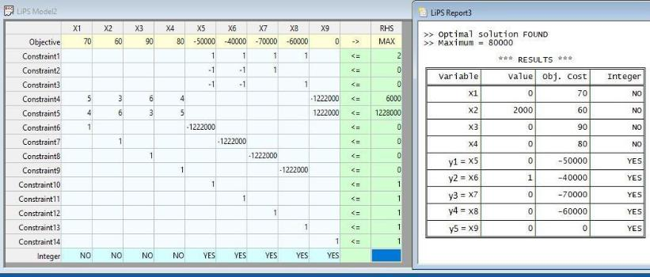
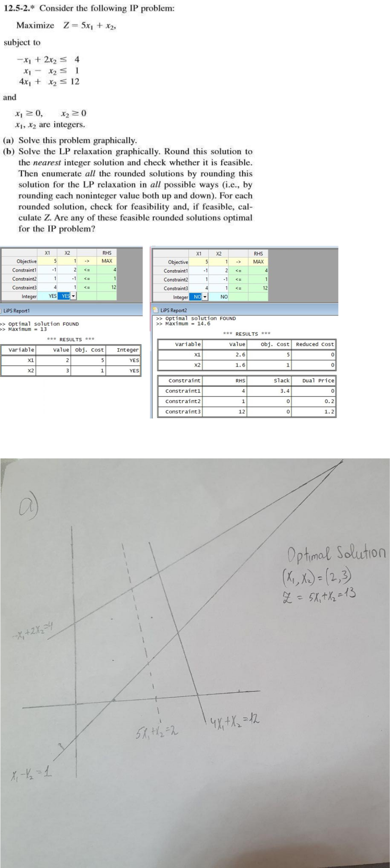
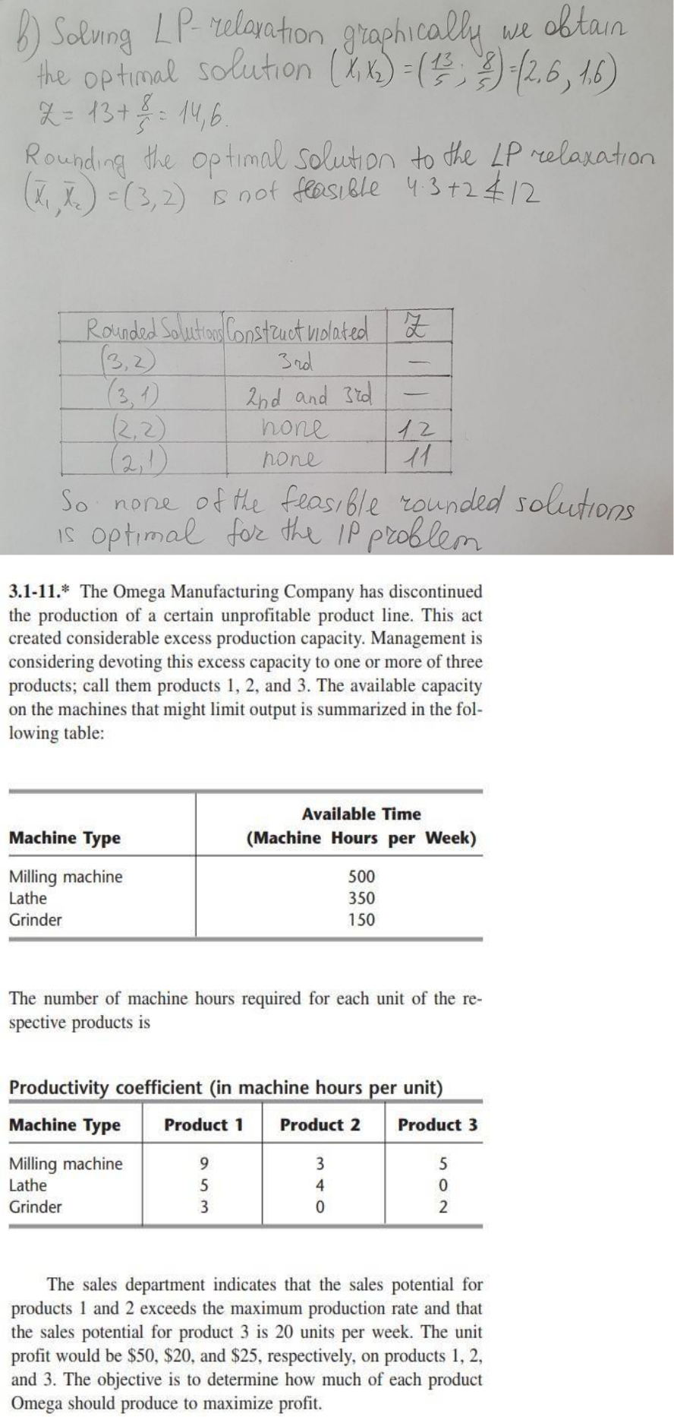
a)Formulate a linear programming (LP) model for this problem.

b)Solve the LP, and the corresponding IP (integer programming model), and discuss the relation, if any, between their solutions.

Let

x1 = number of units of product 1 produced

x2 = number of units of product 2 produced

x3 = number of units of product 3 produced

Maximize z = 50x1 + 20x2 + 25x3

Subject to

9x1 + 3x2 + 5x3 ≤ 500

5x1 + 4x2 ≤ 350

3x1 + 2x3 ≤ 150

x3 ≤ 20
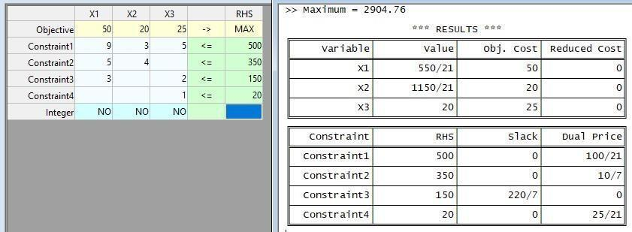

- (x1, x2, x3) (26.19, 54.76, 20); Z = 2,904.76. And one solution for IP model, with our LP Solver, is (30, 50, 16); with Z = 2,900.
