## Urban Carbon Monitoring 2.0: A critical need for carbon cycle science and climate policy

## Kevin Robert Gurney, Karen C. Seto, Miguel Román, Riley Duren

## *The importance of cities*

## The development of cities represents one of largest perturbations to the global carbon cycle. By 2100, the globe’s urban population is expected to reach 8.5 billion, and recent estimates suggest that urban areas globally will nearly triple in size during the first three decades of the 21st century. Though only accounting for less than 3% of the land surface, urban areas account for 70% of the energy-related CO2 emissions globally and if one considers the carbon associated with both energy and materials, the share is even larger. Furthermore, the distribution of emissions within and across cities is logarithmic, with a few very large magacities dominating the urban share.

***Why are urban emissions important?***

The impact on the global carbon cycle from this rapidly increasing anthropogenic component is illuminated by the inverse problem, a key strategy to understand the global carbon cycle. For many years the science community has been studying the uncertainty associated with feedbacks between global climate change and land/ocean carbon uptake (White Paper by *Schimel et al.* – “Carbon and Climate”). Within that context, anthropogenic emissions, particularly the fossil fuel combustion component (FFCO2), are typically used as a near-certain boundary condition in assessing total carbon budgets. It has been shown that errors in the location, timing, or magnitude of FFCO2 fluxes can be transferred onto the remaining flux components of carbon inversion studies. Though traditionally considered well-quantified at the global scale (6-10% error), this error is increasing. More importantly, uncertainty at the spatial scale of individual cities range from 50 to 100% with CH4 uncertainties equally large at all spatial scales. It is precisely at these smaller space and time scales that mechanistic knowledge of land-atmosphere exchange operates.

The large uncertainty associated with urban carbon emissions is due, in large measure, to the relative dearth of systematic, comprehensive, scientifically driven data collection at the urban scale. Emissions monitoring data that have been collected for regulatory or economic purposes are often incomplete or rarely checked against scientific standards and procedures. These problems result in significant space/time scale gaps (between facility- and national-level emissions) and sectoral gaps in understanding.

There are equally important practical ends to better understanding urban carbon emissions. It has become clear that climate policy emerging at the local levels is taking on global importance. For example, over 1000 mayors have signed the U.S. Mayors Climate Protection Agreement, which commits them to meeting or exceeding the Kyoto Protocol reductions within their cities. Cities remain critical participants in the implementation of climate policy because the urban landscape is where the majority of industry operates, consumers live, and power is consumed. It is at the municipal scale that knowledge about local mitigation options, costs, and opportunities is the greatest. The recent attention on urban climate policy, in turn, has placed growing emphasis on understanding and quantifying current urban carbon flows (Fig. 1) and their potential responses to policy. Quantifying baseline emissions, planning emission mitigation efforts, and assessing progress towards climate mitigation targets all require improved monitoring, reporting, and verification (MRV) at the urban scale.



Fig. 1: Urban carbon budget schematic with urban carbon reservoirs (colored boxes), carbon fluxes (blue block arrows), drivers (rounded rectangles) and process linkage examples (colored thin arrows).

***Urban carbon monitoring requirements***

Meeting the scientific challenges and emerging policy needs requires mapping FFCO2 emissions to finer scales in space and time, reflecting the human dimensions at which carbon is emitted. The density of cities requires flux resolution in the range of 1 km or better. Additionally, confident detection and attribution of major point sources and understanding urban-scale processes often requires additional functional information at the scale of individual buildings, road ways, parks, land-fills, natural gas storage facilities, pipelines, factories and power plants. Furthermore, the complexity and transboundary aspects of the urban carbon cycle demands improved spatial and temporal mapping of urban processes that often extends well beyond the traditional administrative boundaries (Fig. 1). Remote sensing combined with new ground-based data and modeling can achieve granular representation of carbon flows and their drivers.

***Current efforts and limitations***

Scientists are starting to meet the challenges arising from city-based carbon monitoring efforts. In the past five years, 'bottom-up' estimations of carbon emissions from fuel reporting, traffic data, building information and human activity (Fig. 2) are being merged with urban scale 'top-down' atmospheric measurements of CO2, methane, carbon monoxide and 14CO2 — an isotope of CO2 that reflects fuel combustion. Such efforts have been underway over the past several years in Paris and in the US cities of Indianapolis, Boston, Salt Lake City and Los Angeles (Fig. 3); more are planned for São Paulo, Brazil, and cities in Australia, China, the United Kingdom and Canada. Each of these pilot project typically requires a few millions dollars to establish (exclusive of remote-sensing platforms), and often involve at least a dozen surface monitoring sites and analysis of remotely sensed data and modelling efforts. Scaling these pilot efforts to thousands of cities around the world including the developing world is not practical; hence satellite observations will pay a critical role in filling observational gaps.

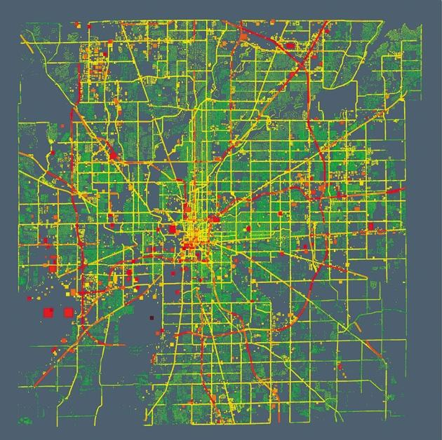

Fig. 2. A visualization of carbon dioxide emissions data from Marion County, Indiana, shows that large buildings and main roads (red areas) emit the most

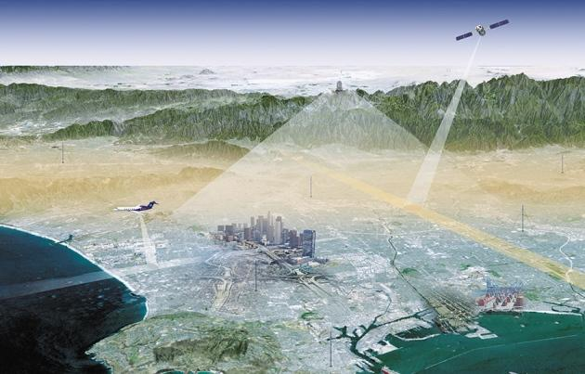

Fig. 3: The Megacities Carbon Project in Los Angeles and other pilot projects are using surface, aircraft and satellite observations to estimate carbon fluxes and study key emission sectors (Credit: JPL/Caltech)

***What could be done from space?***

Satellite observations are needed to complement the growing but still very sparse surface-based greenhouse gas monitoring networks with observations over regional scales, providing boundary conditions to urban scale inverse frameworks as well as insight into trans-boundary (remote) fluxes. Satellites are fundamental to reducing flux uncertainties at the required fine spatial scales given their ability to provide dense sampling and broad coverage spanning thousands of priority areas distributed over most continents. Future satellites with persistent observations and small pixel scales have the potential to overcome fundamental challenges in sample density that currently limit the utility of flux inversions. Satellites are also essential for filling large gaps in bottom-up emission process understanding – particularly in developing, data-poor cities – where satellites can provide information through proxies such as nightlights and land surface imaging.

The recent development of science-quality nighttime environmental products at high temporal resolution (such as VIIRS – *cf*., Fig. 4) is an example of how global land science products can be used to systemically monitor human activity patterns. A new generation of long term consistent data records that go beyond the traditional suite of land climate variables is needed to provide the necessary insights to further promote low carbon and sustainable development in cities and urban-rural areas.

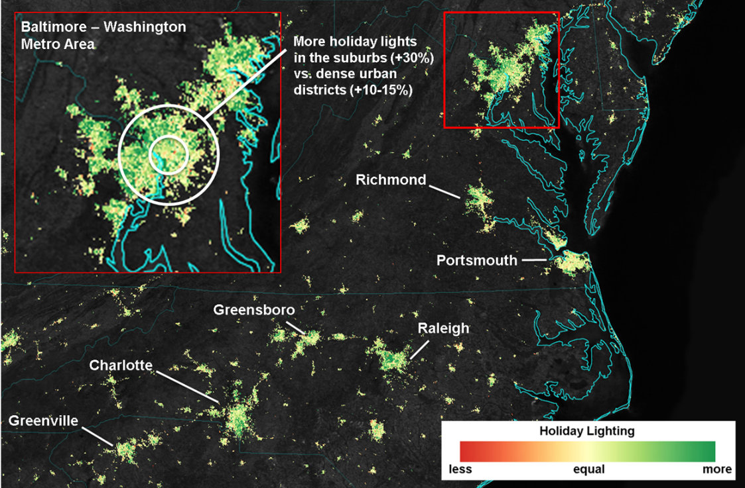

Fig. 4: Nighttime environmental products from Suomi-NPP VIIRS serve as a good descriptor of urban function – i.e., the economic, mobility, informational, and operational connections between urban cores and outside areas

Recent improvements in greenhouse gas remote sensing technology are beginning to offer the surface sensivity and spatial resolution required for urban studies. Japan's GOSAT has demonstrated in a few representative cases that spaceborne CO2 measurements can constrain the 'domes' of the gas that lie above cities. This work is continuing with NASA's OCO-2, which launched in July 2014. None of the existing greenhouse gas measuring satellites have the spatial or temporal coverage required to study more than a few dozen cities. OCO-3, planned for deployment on the International Space Station in 2018 will have a 'city mode' that can monitor up to 80% of the world’s FFCO2 emissions from cities and power plants with at least seasonal revisit. The European Space Agency's Sentinel-5 mission (to launch in 2016) should provide near-global measurements of large methane emitters on the urban scale every few weeks (although the TROPOMI instrument’s 7 km spatial resolution is too coarse for many urban scale studies).

Newly developed remote-sensing technology offers the measurement precision, high spatial resolution, near-continuous mapping and rapid revisit times required for robust monitoring of cities. Three such instruments deployed on geostationary satellites (one each over the Americas, Europe/Africa and Asia) would provide simultaneous measurements of carbon dioxide, methane and carbon monoxide column-averaged mixing ratios for the majority of the Earth’s populated land surface, including nearly every major urban area and power plants.

***What could this do?***

High-resolution monitoring of atmospheric constituents from space, combined with new techniques characterizing carbon fluxes within and across cities could provide a critical constraint to carbon inverse and carbon budget studies, better characterize carbon stocks influenced by cities, and provide much-needed quantification of urban FFCO2 emissions for both the verification and mitigation guidance problems. The use of remote sensing technology has another role to play within this stragetic vision – characterization of emitting infrastructure or “activity” in much of the world where there is no “bottom-up” complement, such as in the United States, could prove crucial to building out urban information systems in those parts of the world where rapid urbanization is anticipated in the coming decades. The combination of techniques – remote sensing CO2 concentration, ground-based models and data using traditional and new (“big data”, crowd-sourcing), remote sensing of “activity” – could deliver new scientific knowledge to carbon cycle science and urban science in addition to practical policy needs.