**Input to NRC Decadal Survey on Community-derived Graphics as Vision and Mission Statements for Applications and Capacity Building using Satellite Earth Observations**

To address this key question and strengthen the global societal applications and capacity building community's voice for the upcoming 2017-2027 NASA Decadal Survey, a three-day workshop was held in Tacoma (Washington) during June 23-25, 2015. The workshop was sponsored by the NASA Applied Sciences Program as an E2 Topical Workshop, Symposium and Conference (TWSC) event. The workshop brought together experts from the applied sciences community across various themes already engaged in capacity building for the stakeholder community; NASA Applied Science and capacity building programmatic personnel; and several international stakeholder agencies with a history of using and a need for earth observation systems and data.

One of the many things the community worked on was the creation of a set of graphics that captures the spirit and a future vision for satellite applications and capacity building for societal good. Figure 1 on next page provides this visual essence of earth observation-based global capacity building and applications. This graphic was created with input provided from various workshop attendees. It conveys the need for a more holistic use of the combined observational power of multiple satellites. This concept, coined as ‘compound eye’, may be considered analogous to the A-train concept, except that herein we are focused on an ‘A-train’ for applications. During the workshop, the term ‘*Compound Eye’* of EO systems (satellites) was used to capture the key question (posed in preceding paragraph) more succinctly.

The scope of the opportunity and abundance of satellite observations confronting us in the not-too-distant future is already apparent. A-train is a series of coordinated satellites passes over the same region in quick succession, using 15 instruments to monitor various aspects of Earth's atmosphere. The best use of the system requires a holistic use of the combined observational power of all of these satellites. Our current and future satellite constellation essentially provides us with a "compound eye" view of the world. Like the composite eye of a fly, coordinated satellites look with many eyes at the same time to see the world from many different angles, using an array of instruments. To take advantage of this composite view is to make better decisions, using an application that is wired to expect and accept all the different observations across multiple platforms simultaneously. Such a capability could be used to address upcoming issues in water management, for example. As we move forward, we must harness this compound eye view provided by multiple satellite missions rather than focus on single mission to achieve greater benefit for society.

The applications and capacity building community also presented theme-specific graphics to make the point on how the combined observational power of satellites can achieve greater benefits for society than a single mission. Figure 2 illustrates how a coordinated group of satellites can be used in surface water management. Figure 3 illustrates a similar case for agricultural crop production and consumptive use.

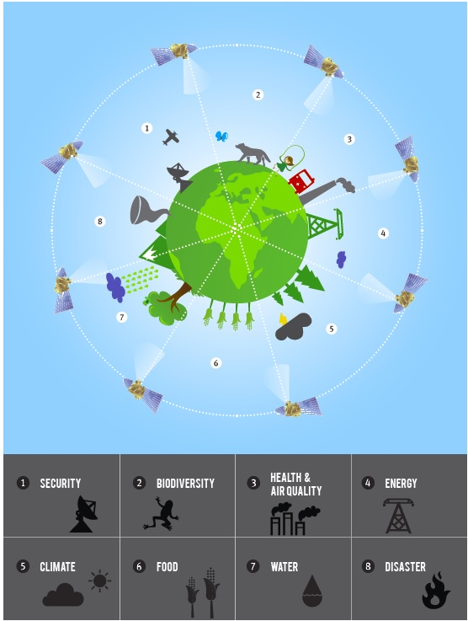

**Figure 1.** The Compound Eye vision and mission for Satellites to Enhance Societal Benefits. Note: the graphic was modified based on input from Decadal Survey workshop attendees in Tacoma to make it communicate more clearly to the public the capacity building vision and mission statement. [Copyright: University of Washington]

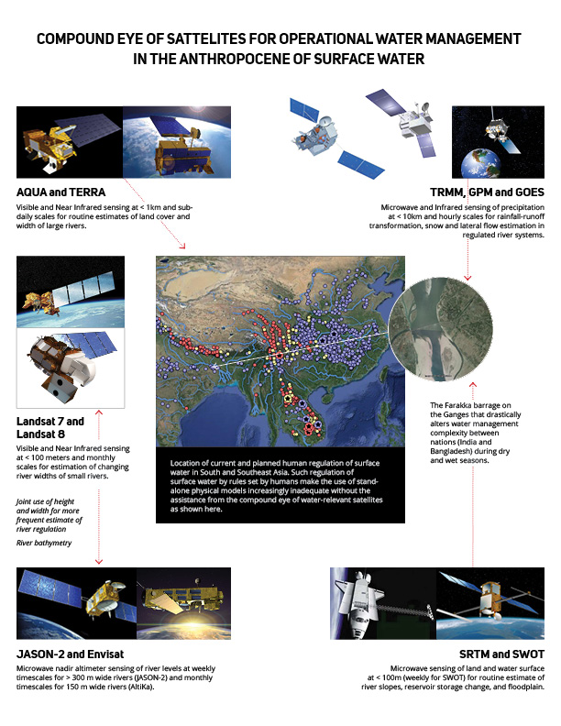

**Figure 2.** Compound eye concept of multiple satellites working together to address surface water management application needs in South Asia where there is extensive regulation (called ‘Anthropocene’ of surface water).

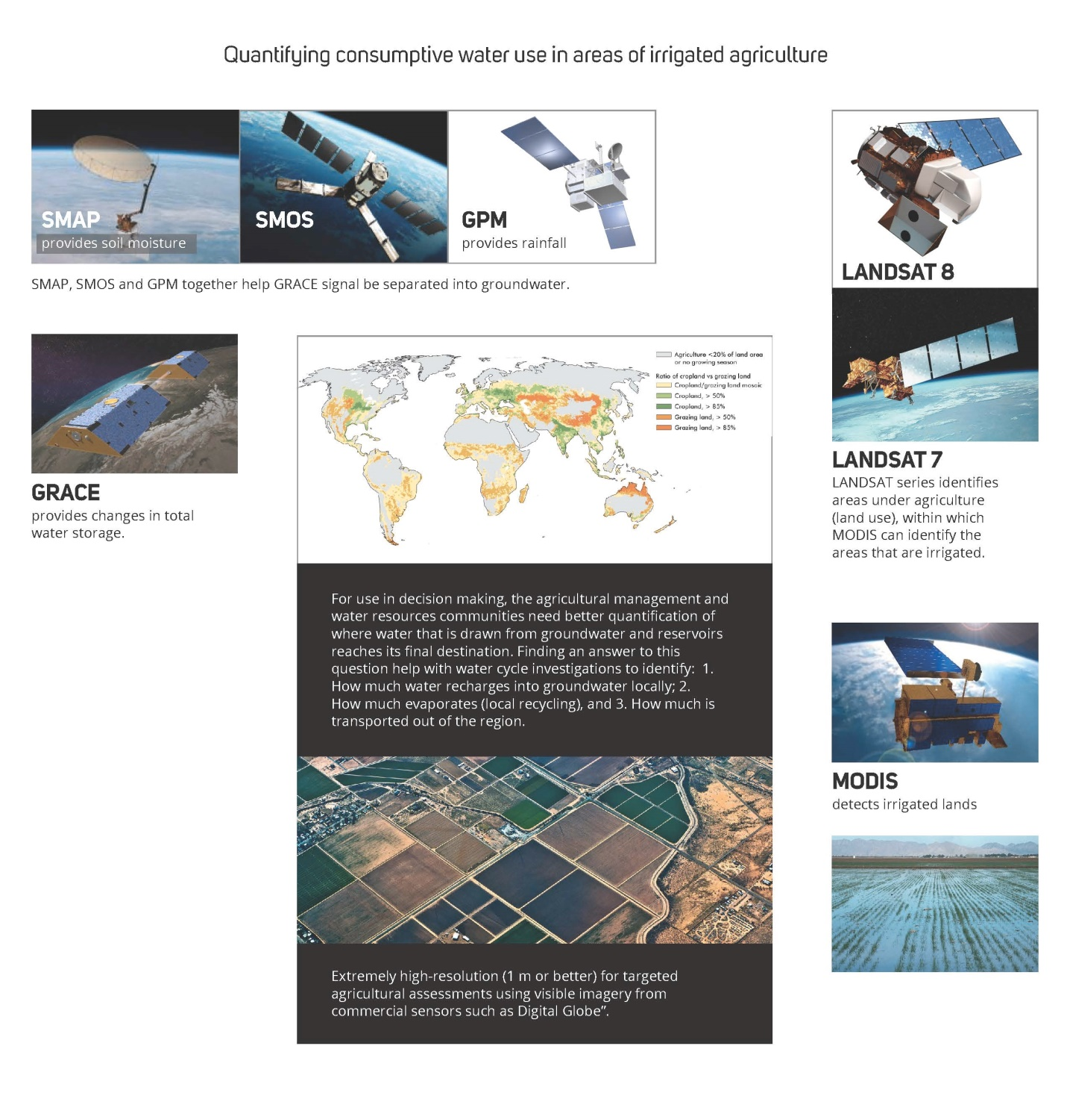

**Figure 3.** Compound eye concept of multiple satellite missions working together to address agricultural and consumptive water use for food security.