**Sea Surface Temperature and Ocean Heat Content from Space**

**Authors: Sheekela Baker-Yeboah1,2, Tim Boyer1, Lynn K. Shay3, Eileen M. Maturi4, and David Donahue5**

***1NOAA/NESDIS/National Center for Environmental Information, 2University of Maryland Earth System Science Interdisciplinary Center Cooperative Institute for Climate and Satellites, 3University of Miami Rosenstiel School of Marine and Atmospheric Science, 4NOAA/NESDIS/Center for Satellite Applications and Research, 5NOAA/NESDIS/Office of Satellite and Product Operations***

**Overview.** The World Ocean absorbs, transports, and releases a vast amount of heat that feeds climate and weather systems. Ocean Heat Content (OHC) can be estimated using surface and subsurface measures of temperature. While space borne measures of sea surface temperature (SST) yield abundant spatial coverage, in situ measures of subsurface temperature are more dominantly used to estimate OHC given their vertical extent. World OHC for 0–2000 m and 700–2000 m (Figure 1) reveal that approximately one third of the total warming of the upper 2000 m of the ocean is derived from the 700–2000 m layer (Levitus *et. al*, 2012).

|  |
| --- |
| C:\Documents and Settings\levitus\Local Settings\Temp\fig01-2km-and-700m-2kmDATAcoverage-2.jpg |
| Figure 1. World OHC pentadal time series for 0–2000 m and 700–2000 m (from Levitus et al, 2012). Vertical bars represent +/-2 times the standard error about the pentadal estimate for the 0–2000 m estimates and the grey-shaded area represent +/-2 times the standard error about the pentadal estimate for the 0–700 m estimates, where pentadal estimates are plotted at the midpoint of the 5-year period. |

Space-based Sea Surface Height (SSH) altimeter data can also be used to estimate OHC. As detailed in Jayne et al. (2002), an increasing number of studies use satellite altimeters to estimate OHC changes [[*Gill and Niiler*, 1973](http://onlinelibrary.wiley.com/doi/10.1029/2002JC001619/full#jgrc9205-bib-0018); [*Repert et al.*, 1985](http://onlinelibrary.wiley.com/doi/10.1029/2002JC001619/full#jgrc9205-bib-0033); [*White and Tai*, 1995](http://onlinelibrary.wiley.com/doi/10.1029/2002JC001619/full#jgrc9205-bib-0052); [*Hendricks et al.*, 1996](http://onlinelibrary.wiley.com/doi/10.1029/2002JC001619/full#jgrc9205-bib-0020); [*Wang and Koblinski*, 1997](http://onlinelibrary.wiley.com/doi/10.1029/2002JC001619/full#jgrc9205-bib-0049); [*Chambers et al.*, 1997](http://onlinelibrary.wiley.com/doi/10.1029/2002JC001619/full#jgrc9205-bib-0002), [1998](http://onlinelibrary.wiley.com/doi/10.1029/2002JC001619/full#jgrc9205-bib-0003); [*Leuliette and Wahr*, 1999](http://onlinelibrary.wiley.com/doi/10.1029/2002JC001619/full#jgrc9205-bib-0027); [*Sato et al.*, 2000](http://onlinelibrary.wiley.com/doi/10.1029/2002JC001619/full#jgrc9205-bib-0036); [*Polito et al.*, 2000](http://onlinelibrary.wiley.com/doi/10.1029/2002JC001619/full#jgrc9205-bib-0031); [*Chen et al.*, 2000](http://onlinelibrary.wiley.com/doi/10.1029/2002JC001619/full#jgrc9205-bib-0006); [*Ferry et al.*, 2000](http://onlinelibrary.wiley.com/doi/10.1029/2002JC001619/full#jgrc9205-bib-0011); Jayne *et al.,* 2002]. Improved understanding of altimeter SSH ocean signals provided a gateway into extracting the OHC. Jayne et al. (2002) combined satellite altimetry for sea surface height (SSH) and the Gravity Recovery and Climate Experiment (GRACE) satellite for mass changes (transfer of water between land and ocean) to isolate ocean heat content. *In situ* measurements can be used to decompose SSH into barotropic and baroclinic components and when combined, show complete agreement with altimeter SSH measurements (Baker-Yeboah et. al., 2010). Shay and Brewster (2010) and Meyers et al. (2014) developed a revised algorithm, which estimates the depth of the 20⁰C and 26⁰C isotherms as well as mixed layer depth (MLD) from satellite altimetry and *in situ* profiles (Argo, XBT) and mooring data. This information is then combined with SST from satellite to calculate ocean heat content. This is the basis for a NOAA operational product that calculates OHC daily (Figures 2-3, [http://www.ospo.noaa.gov/Products/ocean/ ocean_heat.html](http://www.ospo.noaa.gov/Products/ocean/%20ocean_heat.html)).

|  |  |
| --- | --- |
| <http://www.ospo.noaa.gov/data/ocean/ohc/images/h20_naQG3_ddc.gif> | ttp://www.ospo.noaa.gov/data/ocean/ohc/images/h26_naQG3_ddc.gif |
| Figure 2. Altimeter sea surface height and *in situ* based estimate of 20° (left panel) and 26° (right panel) isotherm depths. | |

A different approach is posited by Tyler *et al.* (under review), which applies changes in the conductivity of the ocean to calculate OHC. Conductivity is measured routinely by Argo floats and other oceanographic instruments, but is usually converted to salinity before use. Tyler *et al.* (under review) construct a long-term mean conductivity climatology at different depths in the ocean that can then be used as a baseline, using geomagnetic data from the ESA magnetic field mission SWARM to get conductivity change and then changes in global ocean heat content. A comparison of both methods is needed to improve our assessment of OHC.

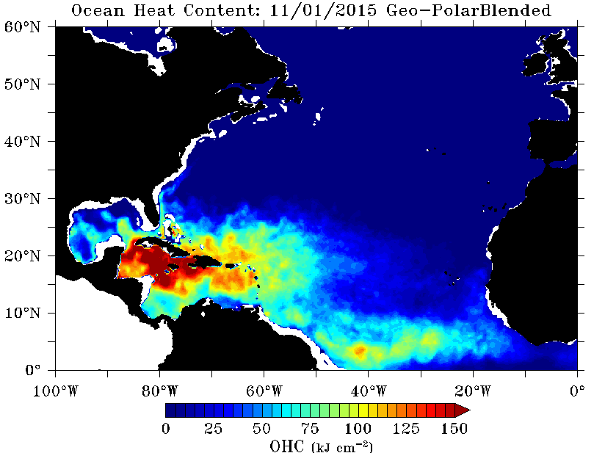

|  |
| --- |
| Figure 3. Altimeter and *in situ* derived ocean heat content: a NOAA operational product as described in Shay et al. (2015). |

***A Key Challenge***. A key challenge is to provide a consistent decadal climate data record of satellite altimeter data, which can then be used to generate an operational decadal satellite based OHC product. With the upcoming launch plans for Jason 3 this December 2015 (U.S. and international programs) to aid the continuity of space borne time records of SSH altimeter data and the concerted effort of the NOAA Climate Data Record Program (see Privette, Zhao, and Kearns, 2015, companion white paper) to support operational Reference Environmental Data Records (REDRs), this is a timely effort, especially with respect to operational readiness. Space-based observations from altimeters and AVHRR sensors provide decadal records of high-resolution data that can be used to provide continuous assessments of ocean dynamics and OHC to improve our understanding of how climate and weather is changing. Comparing these estimates of OHC with *in situ* based estimates not only provide uncertainty bars for the calculation, but provide new insight on important environmental variables and ocean processes that relate to our changing weather (*Shay, 2010*; *Jaimes et al., 2015*) and climate patterns. Challenges summarized by Wijffels *et. al* (2010) continue to be addressed by the science and operational communities: to (a) sustain and increase our existing core observational systems above and within the vastly under sampled ocean, (b) fill data gaps in the global ocean temperature observing system for key regions such as the deep ocean, ice-covered oceans and marginal seas, (c) reconstruct historical ocean temperature changes from records with the challenges of data quality and instrument biases (identification and removal), and (d) extend existing short term forecasting observation systems into climate monitoring and prediction systems, given concerns with accuracy, meta-data, as well as archiving. Important stakeholders have been addressed in a companion white paper (Privette, Zhao, and Kearns, 2015). Overall, SST and OHC are important environmental variables in the study of Ocean Climate and Weather and this study supports the examination of both *in situ* and satellite data from an operational perspective within NOAA over an extended time period for decadal studies.

**References**

*Baker-Yeboah, S., D. A. Byrne, and D. R. Watts. Observations of Mesoscale Eddies in the South Atlantic Cape Basin: Baroclinic and Deep Barotropic Eddy Variability, J. Geophys. Res., VOL. 115, C12069, doi:10.1029/2010JC006236, 2010.*

*Chambers, D. P., B. D. Tapley, and R. H. Stewart, Long-period ocean heat storage rates and basin-scale heat fluxes from TOPEX, J. Geophys. Res., 102, 10,525–10,533, 1997.*

*Chen, J. L., C. K. Shum, C. R. Wilson, D. P. Chambers, and B. D. Tapley, Seasonal sea level change from TOPEX/Poseidon observations and thermal contribution, J. Geodesy, 72, 638–647, 2000.*

*Ferry, N., G. Reverdin, and A. Oschlies, Seasonal sea surface height variability in the North Atlantic Ocean, J. Geophys. Res., 105, 6307–6326, 2000*

*Gill, A. E., and P. P. Niiler, The theory of the seasonal variability in the ocean, Deep Sea Res., 20, 141–178, 1973.*

*Hendricks, J. R., R. R. Leben, G. H. Born, and C. J. Koblinsky, Empirical orthogonal function analysis of global TOPEX/Poseidon altimeter data and implications for detection of global sea level rise, J. Geophys. Res., 101, 14,131–14,145, 1996.*

*Jaimes, B., L. K. Shay and E. W. Uhlhorn, Observed enthalpy fluxes during the rapid intensity change of hurricane Earl. Mon. Wea. Rev., 131, 111-131, 2015.*

*Jayne, S. R., J. M. Wahr, and F. O. Bryan (2003), Observing ocean heat content using satellite gravity and altimetry, J. Geophys. Res., 108(C2), 3031, doi:10.1029/2002JC001619.*

*Leuliette, E. W., and J. M. Wahr, Coupled pattern analysis of sea surface temperature and TOPEX/Poseidon sea surface height, J. Phys. Oceanogr., 29, 599–611, 1999.*

*Levitus,* S., J. I. Antonov, T. P. Boyer, O. K. Baranova, H. E. Garcia, R. A. Locarnini, A. V. Mishonov, J. R. Reagan, D. Seidov, E. S. Yarosh, and M. M. Zweng, World ocean heat content and thermosteric sea level change (0–2000 m), 1955–2010, Geophysical Research Letters, Vol. 39, 2012, doi:10.1029/2012GL051106.

*Meyers, P. C., L. K. Shay, and J. K. Brewster, The development of the systematically merged Atlantic regional temperature and salinity climatology for hurricane intensity forecasting. J. Atmos. Oceanogr. Tech.,* ***31****, 131-149, 2014.*

*Polito, P. S., O. T. Sato, and W. T. Liu, Characterization and validation of heat storage variability from TOPEX/Poseidon at four oceanographic sites, J. Geophys. Res., 105, 16,911–16,921, 2000.*

*Privette, J. L., X. Zhao, and E. J. Kearns, Space Observation Requirements to Support NOAA’s Reference Environmental Data Records, White Paper submitted, November 2, 2015.*

*Repert, J. P., J. R. Donguy, G. Elden, and K. Wyrtki, Relations between sea level, thermocline depth, heat content, and dynamic height in the tropical Pacific Ocean, J. Geophys. Res., 90, 11,719–11,725, 1985.*

*Sato, O. T., P. S. Polito, and W. T. Liu, Importance of salinity measurements in the heat storage estimation from TOPEX/Poseidon, Geophys. Res. Lett., 27, 549–551, 2000.*

*Shay, L. K., Air-sea interactions in tropical cyclones (Chapter 3). In Global Perspectives of Tropical Cyclones, 2nd Edition, Eds. Johnny C. L. Chan, J. Kepert, and C. P. Chang, World Scientific Publishing Company: Earth System Science Publication Series, London, UK, 93-131, 2010*

*Shay, L. K., and J. Brewster, Oceanic heat content variability in the eastern Pacific Ocean for hurricane intensity forecasting. Mon. Wea. Rev.,* ***138****, 2110-2131, 2010.*

*Shay, L. K., J. K. Brewster, and E. Maturi, Algorithm Theoretical Testbed Document: Satellite derived oceanic heat content product suite. Technical Report, Satellite Services and Review Board, NOAA National Environmental Satellite Data Information Service, World Weather Research Building, College Park, MD, 20742, V3.1, 49 pp, 2015.*

*Tyler, R. H., T. P. Boyer, T. Minami, M. M. Zweng, J. R. Reagan, Electric conductivity of the Global Ocean, Geophys. Res. Lett., under review.*

*Wang, L., and C. Koblinski, Can the TOPEX/Poseidon altimetry data be used to estimate air-sea heat flux in the North Atlantic?, Geophys. Res. Lett., 24, 139–142, 1997.*

*White, W. B., and C.-K. Tai, Inferring interannual changes in the global upper ocean heat storage from TOPEX altimetry, J. Geophys. Res., 100, 24,943–24,954, 1995.*

Wijffels, S. E., M. Palmer, N. Rayner, G. Goni, S. Garzoli , G.C. Johnson, J. Willis, B. Dushaw, D. Roemmich, J. Church, G. Meyers, *Proceedings of the" OceanObs' 09: Sustained Ocean Observations and Information for Society" Conference*. Vol. 1.,p.40, 2010.*09.*