Spaced-Based Measurement and Evaluation of Sea Surface Temperatures and Oceanic Heat Content Variability

NRC Decadal Survey Response

E. Maturi1 , L. K. Shay2, J. K Brewster2, B. Jaimes2,

J. Lillibridge1, L. Miller1, D. Donahue1

1 NESDIS, National Oceanic and Atmospheric Administration, College Park MD

2 RSMAS, University of Miami, Miami, FL

*1.      Key Challenges for Earth System Science across the spectrum of basic research, applied research, applications, and/or operations in the coming decade?*

The sea surface is a critical link that couples oceanic and atmospheric processes for both weather and climate studies affecting the Earth System. Insufficient knowledge of surface processes at and across the interface and its linkage to subsurface heat and mass balances induces significant errors in the representation of the ocean’s thermal structure and oceanic heat content variations. Global sea surface temperature (SST) and sea surface topography missions using sea surface height anomalies (SSHA) are central to improving estimates of the spatial variability of oceanic heat content (OHC) values, which have been shown to be central to weather forecasting (e.g. hurricane intensity forecasting), seasonal to annual variability in these signals (e.g., El Niño Southern Oscillation , Madden Julian Oscillation), coral reef bleaching at the deeper reefs and more recently fisheries oceanography.

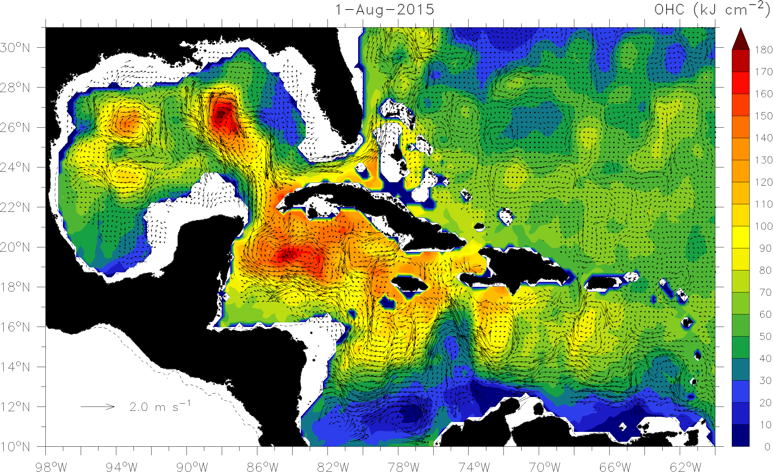

Figure 1: OHC estimate (relative to 26oC: color bar) and geostrophic velocity vectors from space-based measurements of satellite altimetry and sea surface temperatures on 1 Aug 2015 in the IAS.

Evidence exists that OHC (essentially vertically integrated thermal profiles that includes SSTs from the NESDIS SST Product) becomes important in hurricane intensity forecasting in the western parts of ocean basins such as the IntraAmerican Seas (IAS) in the North Atlantic and the Main Development region in the Western Pacific. In the IAS regime (Figure 1), sources of high OHC such as the warm Caribbean Current, Loop Current (LC) and the warm anticyclonic eddy field have provided additional thermal energy to major hurricanes over the past decade (Katrina). Some of the strongest North Atlantic Ocean basin hurricanes have occurred over the warm pool regime in the IAS (Fig. 2). This variability points to the importance of the OHC on intensity in the IAS. Examination of these hurricanes relative to OHC (Meyers *et al*., 2014) shows that they often reach maximum intensity over the high-OHC Subtropical Water of the Caribbean Sea, Florida Current, Gulf of Mexico LC, or Gulf Stream. Approximately seventy percent of hurricanes with maximum winds > 120 knots experience eyewall replacement cycles (ERCs) after reaching maximum intensity levels. Hurricanes subsequently weaken due to the combination of ERCs, increasing shear, and movement over the lower-OHC Gulf Common Water (e.g., thin mixed layers) where upwelling and vertical mixing via shear instability cools the SST quickly, reduces OHC, and diminishes enthalpy fluxes. Hurricanes striking the US Atlantic Eastern Seaboard encounter similarly oceanic environments passing over the Gulf Stream and then cooler shelf waters. Such behavior in hurricanes has become much clearer now that there is an evaluated OHC product available for forecasting.

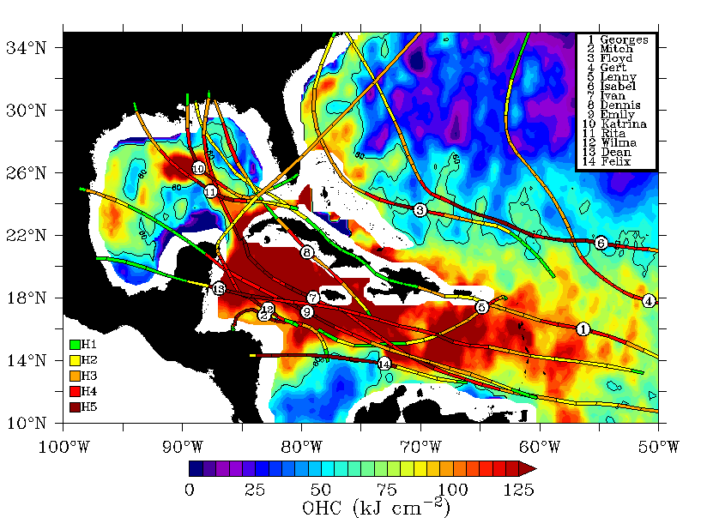

Figure 2: Tracks and positions of maximum intensity for fourteen of the strongest hurricanes recorded in HURDAT from 1998-2011, plotted over OHC relative to the 26oC isotherm for Sept 2005 from SMARTS climatology. The deep red color is the “heat reservoir or hurricane gas tank”, depicting the Caribbean warm pool that extends into the Gulf of Mexico via the LC.

To improve our ability to resolve the sources and sinks of OHC in all the basins, at least three radar altimeter missions are needed for sea surface height anomalies (SSHA) for daily imaging and to provide a realistic product for mesoscale oceanography. Given that only 17-years of OHC mapping has been done, such applied research efforts must continue over the next decade to build an evaluated data base for weather and climate studies. While the product has been principally used during hurricane (tropical cyclone) seasons in the basins, daily mapping also provides valuable data to address key science questions related to climate such as the extent of warming (or cooling) in the warm pools of the Atlantic and Pacific ocean basins, thermodynamic processes in the equatorial wave guides associated with eastward propagating Kelvin Waves (ENSO), and when the Indian ocean basin is completed, linkages to the Madden-Julian Oscillation across the tropics. We seek to build a global, evaluated Ocean Heat Content suite of products based on future altimetry missions.

2*.       Why are these challenge/questions timely?*

Additional space-based missions are on the horizon from late 2015 through 2020 for global SSHA measurements from space that includes newer technologies, as listed in Table 1. That said, we must ensure that these missions are launched in a timely manner to avoid gaps in the SSHA measurements for these OHC estimations. As noted above OHC is used in forecasting intensity change particularly in the western parts of the ocean basins where the signals are large and have an impact on tropical cyclones. When linked to planned new sensors over the next decade, a more complete picture of the air-sea interface and linkages to the upper ocean structure will lead to improved products for weather and climate, coral reef structure and fisheries oceanography.

|  |  |  |  |  |
| --- | --- | --- | --- | --- |
| **Satellite** | **Instrument** | **Frequency** | **Repeat Track** | **Years Active** |
| Topex/Poseidon | Poseidon | 5.3 GHz (C-band), 13.575 GHz (Ku-band) | 10 day | 1992-2005 |
| ERS-2 | RA1 | 13.8 GHz (Ku-band) | 35 day | 1995-2011 |
| GFO | GFO-RA | 13.5 GHz (Ku-band) | 17 day | 1998-2008 |
| Jason 1 | Poseidon 2 | 5.3 GHz (C-band), 13.575 GHz (Ku-band) | 10 day | 2001-2013 |
| EnviSat | RA2 | 13.575 Ghz (Ku-band), 3.2GHz (S-band) | 35 day | 2002-2012 |
| Jason 2 | Poseidon 3 | 5.3 GHz (C-band), 13.575 GHz (Ku-band) | 10 day | 2008-Pres |
| CryoSat 2 | SIRAL 2-LRM | 13.6 GHz (Ku-band) | 369/30 day | 2010-Pres |
| SARAL | Altika | 35.75 GHz (Ka-band) | 35 day | 2013-Pres |
| Sentinel 3 | SRAL-LRM | 5.4 GHz (C-band), 13.575 GHz (Ku-band) | 27 day | Dec 2015 |
| Jason 3 | Poseidon 3B | 5.3 GHz (C-band), 13.575 GHz (Ku-band) | 10 day | Dec 2015 |
| Sentinel 6/  Jason CS | Poseidon 4 | Similar to Jason 3 and Sentinel 3 | 10 day | 2020 |
| SWOT | KaRIn/ Poseidon 3C | 35.75 GHz (Ka-band) | 16 day (2X) | 2020 |

Table 1: Satellite altimetry missions used in building an evaluated OHC product that began in 1998.

*3.       Why are space-based observations fundamental to challenges?*

Space-based observing techniques are the most effective platform to provide daily updated basin scale measurements of SST, SSHA and OHC variations. The combination of different ground tracks from the various altimetry missions provides the necessary spatial and temporal sampling to produce daily grids of OHC in the various ocean basins.

*The NRC also asks that in responding to these questions:*

*a.       Existing and planned U.S. and international programs will provide the capabilities necessary to make substantial progress on the challenge and associated questions. What additional investments are needed?*

Given the import of severe weather forecasting globally across all basins, we must encourage and foster collaborations on these satellite missions as well as building new and enhanced products globally. The same can be said for exploiting the climate variations out of the archived data set and products as new insights in global oceanic changes would be potentially addressed with international colleagues.

*b.     Linking space-based observations with other observations increases the value of data for addressing scientific questions aimed at societal needs;*

The value of these investments is several fold especially when simultaneous spaced-based high-resolution ocean topography are coupled to in-situ measurements such as profiling ARGO floats, APEX floats (electromagnetic for current profiles), long-term ocean moorings (TAO), XBT transects and ocean surveys from various research aircraft (e.g., NOAA WP-3D). The importance of the aircraft surveys is that a large area can be sampled from research aircraft. The in-situ measurements provide a means of assessing the errors on the OHC estimates from spaced-based measurements of SST and SSHA. These additional measurements provide valuable profiles of temperature, salinity and current to link directly the SSHA and SST variability to ocean structure (including the challenge of mapping the surface mixed layer).

In the coastal regime, the linkages to the nation-wide array of high frequency surface current radars and glider technologies will allow one to get OHC even closer to the coast. Thus a more complete picture will emerge of OHC variability for use in basic and applied research as well as operations such as forecasting hurricane intensity change.

*c.       Anticipated scientific and societal benefits; and*

Anticipated benefits include new understanding of upper ocean thermodynamics, dynamics and air-sea processes relevant to tropical cyclone intensity forecasting, climate variability (e.g., SST anomalies and OHC anomalies over various time scales), fisheries, coral reef bleaching and air-sea fluxes. Over the longer term, the benefits are for climate variability including SST and OHC anomalies across the ocean basins.

*d.      Science communities involved.*

Relevant science communities include air-sea interaction, physical oceanography including coastal oceanography, severe weather forecasting, climate dynamics, and fisheries oceanography. The altimetric Ocean Surface Topography Science Team is also a relevant community for OHC studies.

**Relevant Publications for Oceanic Heat Content:**

DeMaria, M. Mainelli M., L.K. Shay, J.A. Knaff, and J. Kaplan, 2005: Further improvements to the statistical hurricane intensity prediction scheme (SHIPS). *Wea. and Forecasting,* **20(4)**, 531-543.

Jaimes, B., L. K. Shay and E. W. Uhlhorn, 2015: Observed enthalpy fluxes during the rapid intensity change of hurricane Earl. *Mon. Wea. Rev.,* **131***,* 111-131*.*

Jaimes, B., and L. K. Shay, 2015: Upwelling and mixing processes induced by hurricane Isaac over

geostrophically balanced ocean eddies. *J. Phys. Oceanogr.* **45,**1667-1689.

Halliwell, G. R., V. Kourafalou, M.Le Hénaff, L. K. Shay, and R. Atlas, 2014: OSSE impact analysis of airborne ocean surveys for improving upper-ocean dynamical and thermodynamical forecasts in the Gulf of Mexico. *Progress in Oceanogr., DOI:10.1016/j.pocean.2014.09.004.*

Hong, X., S.W. Chang, S. Raman, L.K. Shay and R. Hodur. 2000: The interaction between Hurricane Opal (1995) and a warm core eddy in the Gulf of Mexico. *Mon. Wea. Rev.*, **128(5)**, 1347-1365.

Jacob, S.D., L.K. Shay, A.J. Mariano and P.G. Black, 2000: The 3-D oceanic mixed-layer response to Hurricane Gilbert. *J. Phys. Oceanogr.*, **30(6)**, 1407-1429.

Jaimes, B., L. K. Shay and J. K. Brewster, 2015: Enthalpy fluxes observed during tropical storm Isaac across the Gulf of Mexico, *Dyn. Atmos. Ocean*. *(submitted),*

Luo, J., J. S. Ault, L. K. Shay, J.P. Hoolihan, E. D. Princeand J. R. Rooker, 2015: Ocean heat content improves satellite-based tracking of fish movements. Plus One, PONE-D-15-07430, DOI: 10.137/journal.pone 0141101, 20 Oct 2015 1-19.

McCaskill, E. C., J. K. Brewster, and L. K. Shay, 2015: Creation of the systematically merged Pacific Ocean temperature and salinity (SPORTS) climatology for typhoon intensity forecasts. *J. Atmos. and Oceanogr. Tech (submitted)*

Meyers, P. C., L. K. Shay, J. K. Brewster, and B. Jaimes, 2015: In-situ and satellite measurements of ocean thermal structure during Hurricanes Gustav and Ike, *J. Geophys. Res*. (accepted and resubmitted).

Meyers, P. C., L. K. Shay, and J. K. Brewster, 2014: The development of the systematically merged Atlantic regional temperature and salinity climatology for hurricane intensity forecasting. *J. Atmos. Oceanogr. Tech*., **31**, 131-149.

Rappaport, E. N., J. L. Franklin, M. DeMaria, A. B. Shumacher, L. K. Shay and E. J. Gibney, 2010: Tropical cyclone intensity change before U. S. Gulf coast landfall. *Wea. and Forecast.,* 25, 1380-1396.

Mainelli, M., M. DeMaria, L. K. Shay and G. Goni. 2008: Application of oceanic heat content estimation to operational forecasting of recent category 5 hurricanes, *Wea and Forecast.*, **23***, 3-16.*

Shay, L.K., G.J. Goni and P.G. Black, 2000: Effects of a warm oceanic feature on Hurricane Opal. *Mon. Wea. Rev.*, **125(5)**, 1366-1383.

Shay, L. K., and E. Uhlhorn, 2008: Loop Current response to hurricanes Isidore and Lili, *Mon. Wea Rev.*, **137**, 3248-3274, *DOI: 10.1175/2008MWR2169*

Shay, L. K., and J. Brewster. Oceanic heat content variability in the eastern Pacific Ocean for hurricane intensity forecasting. *Mon. Wea. Rev*., **138**, 2110-2131.

Shay, L. K., 2010: Air-sea interactions in tropical cyclones (Chapter 3). In *Global Perspectives of Tropical Cyclones*, 2nd Edition, Eds. Johnny C. L. Chan, J. Kepert, and C. P. Chang, World Scientific Publishing Company: Earth System Science Publication Series, London, UK, 93-131.

Shay, L. K., B. Jaimes, J. K. Brewster, P. Meyers, C. McCaskill, E. W. Uhlhorn, F. D. Marks, G. R. Halliwell, O. M. Smedsted and P. Hogan, 2011:. Airborne surveys of the Loop Current complex from NOAA WP-3D during the Deep Water Horizon oil spill. AGU Geophysical Monograph Series, *Monitoring and Modeling the Deep Water Horizon Oil Spill: A Record Breaking Enterprise*, eds Y. Liu, D. Streets and R. W. Weisberg, **195**, 131-151.

Shay, L. K., J. K. Brewster, and E. Maturi, 2015: Algorithm Theoretical Testbed Document: Satellite derived oceanic heat content product suite. Technical Report, Satellite Services and Review Board, NOAA National Environmental Satellite Data Information Service, World Weather Research Building, College Park, MD, 20742, V3.1, 49 pp.

Shay, L. K., 2006: Air-sea interface and oceanic influences (Chapter 1.3). Topic Chairman and Rapporteurs Report for Tropical Cyclone Structure and Structure Change of the 6th WMO International Workshop On Tropical Cyclones (IWTC-6) 20 Nov - 30 Nov 2006 in San Jose, Costa Rica, World Meteorological Organization Tropical Meteorology Research Series, ***WMO TMRP 1383 (WWRP 2007-1),*** Ed. Hugh Willoughby, Geneva, Switzerland, 120-150.

Shay, L. K., 2010: Air-sea interface and oceanic influences (Chapter 1.3). Topic Chairman and Rapporteurs Report for Tropical Cyclone Structure and Structure Change of the 7th WMO International Workshop on Tropical Cyclones (IWTC-7) 15-21 Nov 2010 in St. Denis, La ReUnion, France, World Meteorological Organization Tropical Meteorology Research Series, ***WMO TMRP No. 1561 (WWRP 2011-1)*** , Eds.C. Velden, J. Kepert, and R. Rogers, Geneva, Switzerland (In Press: 48pp).

Shay, L. K., 2014: Air-sea interface and oceanic influences (Chapter 4.4). Topic Chairman and Rapporteurs Report for Tropical Cyclone Structure and Structure Change of the 8th WMO International Workshop on Tropical Cyclones (IWTC-8) 2-10 Dec 2014 in Jeju Island, South Korea, World Meteorological Organization Tropical Meteorology Research Series, ***WMO TMRP***, Eds.A. Burton and J. Evans, Geneva, Switzerland (60 pp.) *In Press*