Evaluating changes in continental water resources

Donald Argus, Felix Landerer, David Wiese, J.T. Reager, Tom Farr, Jay Famiglietti
(Jet Propulsion Laboratory, California Institute of Technology,
Email: Donald.F.Argus@jpl.nasa.gov)

What are the key challenges or questions for Earth System Science across the spectrum of basic research, applied research, applications, and/or operations in the coming decade?
How are water resources in North America, Europe, and the Earth changing? Are water changes sustained during periods of drought and heavy precipitation, and if so, how? How fast are Earth's groundwater basins being depleted? Are water changes in each continent raising or lowering global sea level?

Space observations are providing new, comprehensive information on changes in continental water, providing a fresh perspective on the analysis and application of conventional hydrologic measurements.

Why are space-based observations fundamental to addressing these challenges/questions?
Space measurements from GPS, InSAR, and GRACE are fundamental to answering these questions because they provide new, comprehensive information on total water changes and land subsidence generated by groundwater withdrawal.

GPS measurements of vertical and horizontal displacement of Earth's surface are being used to estimate changes in total water storage in the western U.S., in North America, and in Europe (where the network of GPS sites is dense). Solid Earth's elastic response to a surface load is known and GPS vertical displacements have been rigorously inverted for changes in water load in the western U.S. each month at pixels 30 km apart (Argus et al. 2014, Borsa et al. 2014, Fu et al. 2015).

We (Argus et al., ms. in prep.) have generated a time series of changes in the western U.S. from Jan 2006 through Sep 2015. Changes in water storage are being found to be sustained over periods of either drought or heavy precipitation. For example, GPS is providing a striking map of water change during the recent California drought from Oct 2011 to Oct 2014 (Fig. 1).

GRACE gravity measurements have for 12 years been used to determine regional changes in ice, snow, and groundwater, thus providing new knowledge of changes in Earth's dynamic water resources. Recent research by Richey, Famiglietti et al. (2015a,b) have applied GRACE’s unique observations to determine that 1/3 of Earth's primary groundwater aquifers are losing water at an unsustainable rate, highlighting the risk of eventual exhaustion.

GRACE has also been applied to estimate how extremes in the amount of water present in a river basin help to define flood and drought conditions [e.g. Reager et al., 2014; Thomas et al., 2014]. The unique ability of GRACE to measure changes in water beneath the land surface – where approximately 80% of hydrologic activity and runoff generation occurs – makes GRACE an extremely valuable tool to understand changing hydrological processes under changing climate conditions. GRACE is also currently being applied to estimate hydrology contributions to sea level change, due to both human and natural drivers, on decadal intervals.

The GPS and GRACE data are complementary and are being simultaneously analyzed to separate changes in ice, snow, and water from solid Earth's viscous response to unloading of the ice-age ice sheets. GPS measurements are being used to improve the spatial resolution of GRACE estimates of mass change, effectively sharpening the images of the GRACE maps. ICE-6G (VM5a) [Argus et al. 2014, Peltier et al. 2015], the model of postglacial rebound fit to most available geologic and geodetic data, including about 2000 relative sea level histories from beach markers and coral reefs, is being used to correct GRACE estimates of change in ice, snow, and water for postglacial rebound.

InSAR is showing southern Central Valley to be subsiding at spectacular rates of 50 mm/yr to 200 mm/yr due to groundwater being withdrawn from the aquifer. InSAR measurements provide a comprehensive, high-resolution description of land subsidence. We have generated a rough model of Central Valley groundwater loss by distributing the 3 km³ of total groundwater loss inferrred from GRACE across the areas measured with InSAR and GPS to be subsiding the fastest. Integrating InSAR, GPS, GRACE, well water level data, and subsurface geologic information will improve our understanding of how the aquifer system responds to stresses induced by lowering water tables.

Whether existing and planned U.S. and international programs will provide the capabilities necessary to make substantial progress on the identified challenge and associated questions. If not, what additional investments are needed?
Existing and planned U.S. and international missions will advance the science described in this RFI. There are more than 10,000 GPS sites throughout the world supported by U.S. and international programs. GPS sites in the existing Plate Boundary Observatory in the western U.S. are nearly sufficient but must be kept active. We advocate adding 25 new GPS sites in key locations in the Sierra Nevada and Colorado Plateau to further monitor water change. GRACE, by NASA and GFZ, has been measuring Earth's gravity from 2002 through the present. GRACE Follow-On is planned to start in 2017. InSAR measurements of subsidence from Sentinel-1, by ESA, and from NISAR, by NASA and India, will provide a wealth of data on subsidence of Earth's surface in response to groundwater withdrawal. Technical advances in GPS, including those from an antenna in space with all four geodetic techniques (GRASP), will be used to more accurately determine vertical displacements and changes in continental water.

How to link space-based observations with other observations to increase the value of data for addressing key scientific questions and societal needs;
Measurements of groundwater loss from GRACE, continental water changes from GPS, and subsidence of Earth's surface from InSAR will provide state and national drought managers with comprehensive measurements can be readily compared to in situ measurements of precipitation, snowpack, soil moisture, and reservoir water levels.

The anticipated scientific and societal benefits; and
Estimates of change in water storage inferred from integrating GRACE, GPS, and InSAR must be communicated to national, state, and local water authorities for application to water resource management to strengthen impact. Subsidence maps are already being used by water agencies to manage groundwater pumping and as early warnings of infrastructure damage.

The science communities that would be involved.
A range of scientific communities will benefit from NASA space measurements, consisting of hydrologists, geophysicists, seismologists, and geodesists. Distinguishing displacements generated by water changes from tectonic deformation will allow UNAVCO, SCEC, and NHERP scientists to better estimate earthquake strain accumulation and evaluate earthquake hazard. Measurements of groundwater loss from GRACE, continental water changes from GPS, and subsidence of Earth's surface from InSAR will provide state and national drought managers with comprehensive measurements to complement conventional in situ data. Integrating InSAR and GPS measurements to place comprehensive line of sight (and nearly vertical) displacements into an absolute reference frame fixed to Earth's mass center will allow city managers and constructional engineers to effectively evaluate urban infrastructure. University scientists will have a wealth of new information to broaden scientific investigation into a range of natural and anthropogenic phenomena.

Water loss in California
during drought
Oct 2011– Oct 2014
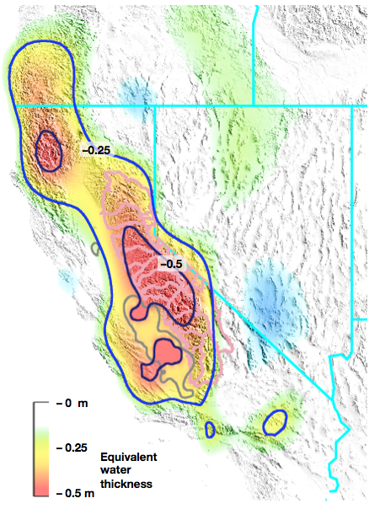
Fig. 1. Water loss (in meters) during drought from October 2011 to October 2014 estimated from GPS vertical displacements using solid Earth's known response to a surface mass load. An elastic model of water change in California's 20 largest reservoirs has been removed. Groundwater loss in the southern Central Valley (gray outline) is constrained to be 9 km³ as estimated from GRACE [Famiglietti et al. 2011] and produces less than half of the observed uplift of the mountains during the drought. Snow in California in October is insignificant. Water loss therefore consists of soil moisture, surface water other than reservoirs, and mountain fracture groundwater. Drought is interpreted to impact California's mountains. Water loss is distributed across a wide area in California's mountains.

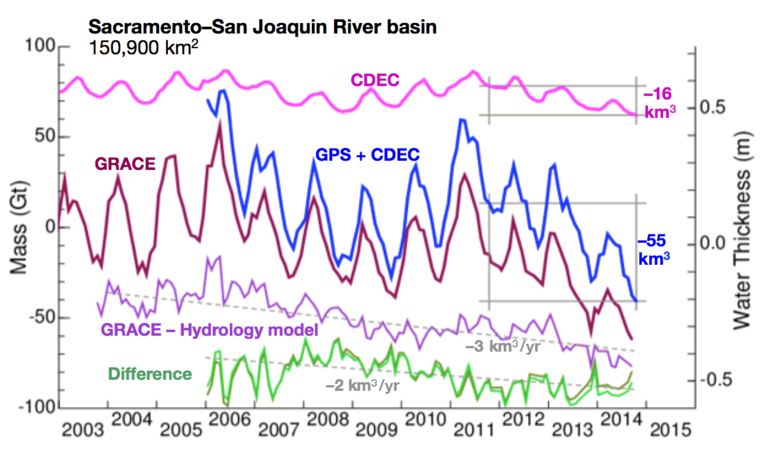

Fig. 2. Change in water storage in the Sacramento–San Joaquin River basin from 2006 to 2014 estimated from GPS (blue curve) is compared to that estimated from GRACE (maroon curve). The effect of changes in reservoir storage, which are known from the California Data Exchange Center (CDEC), have been modeled and removed from the GPS data. The CDEC data is then added to the GPS data (blue curve) for comparison against GRACE. The GRACE estimate is from the JPL RL05M mascon solution [Watkins et al. 2015]. Total water change inferred from GPS is similar to that estimated from GRACE. The GPS estimate does not include water change in snow, soil moisture, and groundwater in the Central Valley. Since snow is negligible and changes in soil moisture are less than 6 km³ in the Central Valley, we can difference GRACE and GPS to infer groundwater loss in the Central Valley (green curve). Groundwater loss in Central Valley inferred from GRACE minus GPS (green curve) is at a lower rate (–2 km³/yr) than that inferred from differencing GRACE and a composite hydrology model that represents all terms except for groundwater (violet curve).

