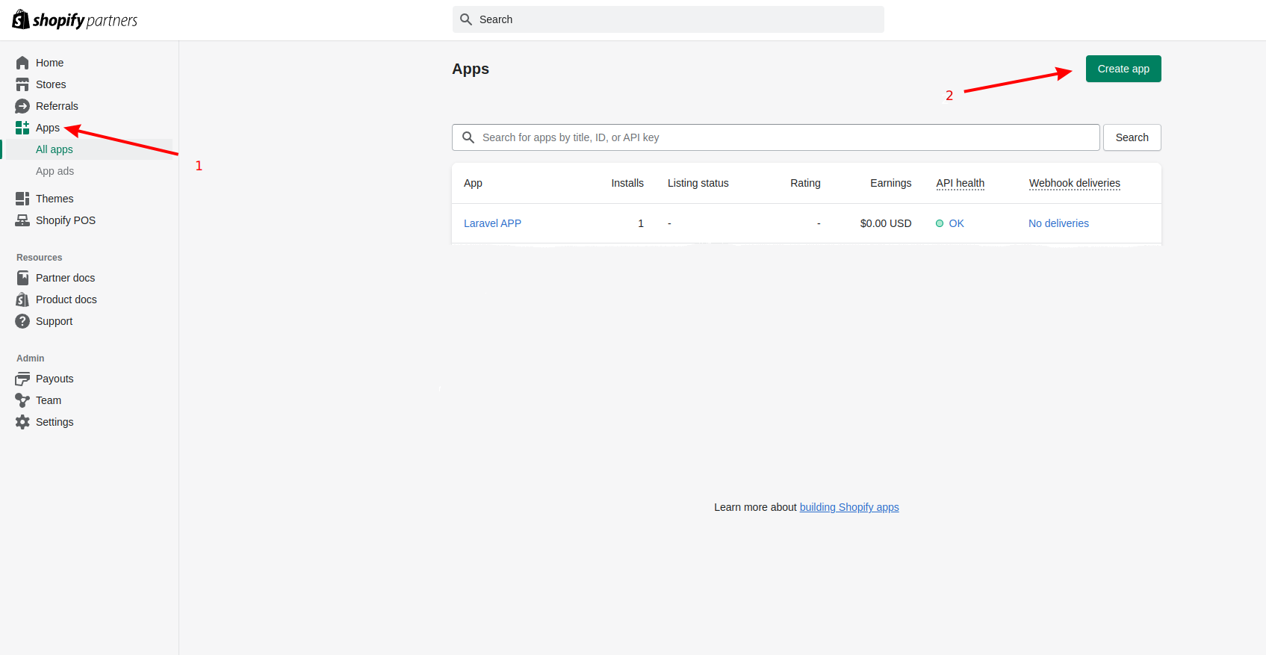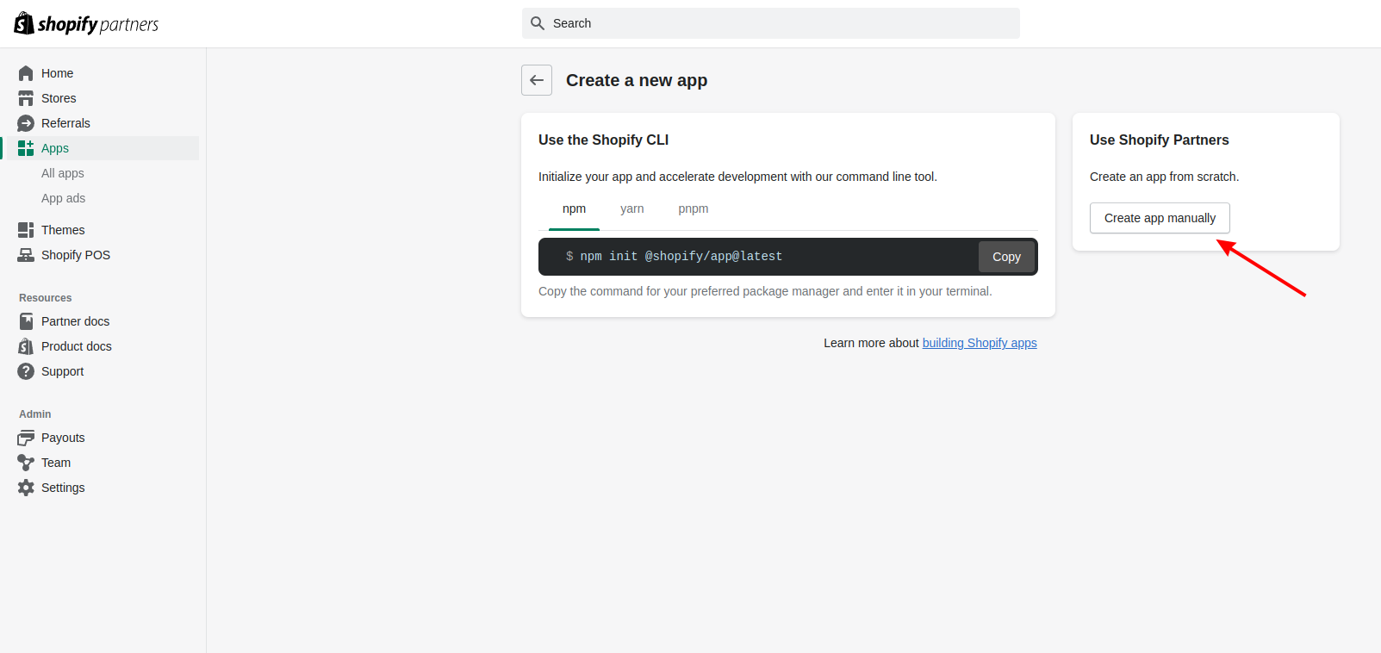**Setup and install Shopify Custom App using Laravel**

**Create new App using Shopify Partner account:**

Login Shopify Partner account ([https://partners.shopify.com](https://partners.shopify.com/)) and create new App:

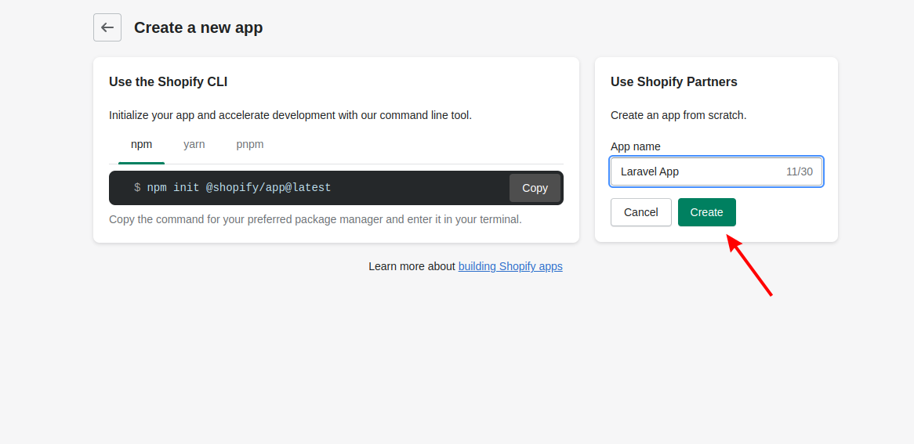

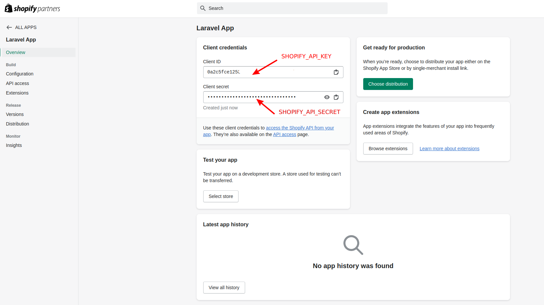

**Setup Docker containers and Laravel instance:**

From project root directory, open terminal and do these steps:

Build docker containers:

*docker-compose up --build -d*

Start docker containers and access to Laravel docker instance:

*./start*

Install PHP dependencies:

*composer install*

Copy source/.env.example to source/.env and setup .env file:

*cp .env.example .env*

Generate Laravel key and migrate DB by these commands:

*php artisan key:generate*

*php artisan migrate*

Provide permissions for Laravel directories:

*chown -R :www-data ./*

*find ./ -type d -exec chmod 755 {} \;*

*find ./ -type f -exec chmod 777 {} \;*

*chmod -R 777 storage*

*chmod -R 777 bootstrap/cache/*

Access to [http://localhost:8000](http://localhost:8000/) to test Laravel app

**Setup and install Custom App:**

Setup **ngrok** and run the command to export port 8000 to the internet (Need to install **ngrok** first <https://ngrok.com/docs/getting-started/>):

*ngrok http 8000*

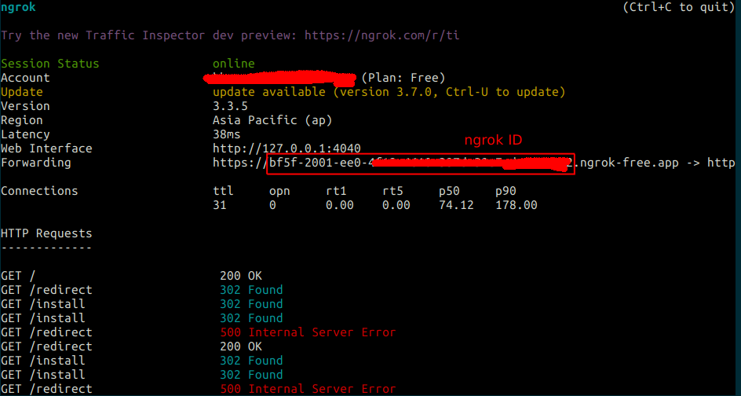

Update .env file in Laravel source code:

*APP_URL=https://{ngrok ID}.ngrok-free.app*

*SHOPIFY_API_KEY={App Client ID}*

*SHOPIFY_API_SECRET={App Client Secret}*

*SHOPIFY_APP_HOST_NAME={ngrok ID}.ngrok-free.app*

*SHOPIFY_SHOP_NAME={Store ID – Getting from* [*https://admin.shopify.com/store/*](https://admin.shopify.com/store/dawnchild/)*{Store ID}}*

Copy ngrok generated domain to App Configuration on Shopify Partner panel

*App URL: https://{ngrok ID}.ngrok-free.app/*

*Allowed redirection URL(s): https://{ngrok ID}.ngrok-free.app/redirect*

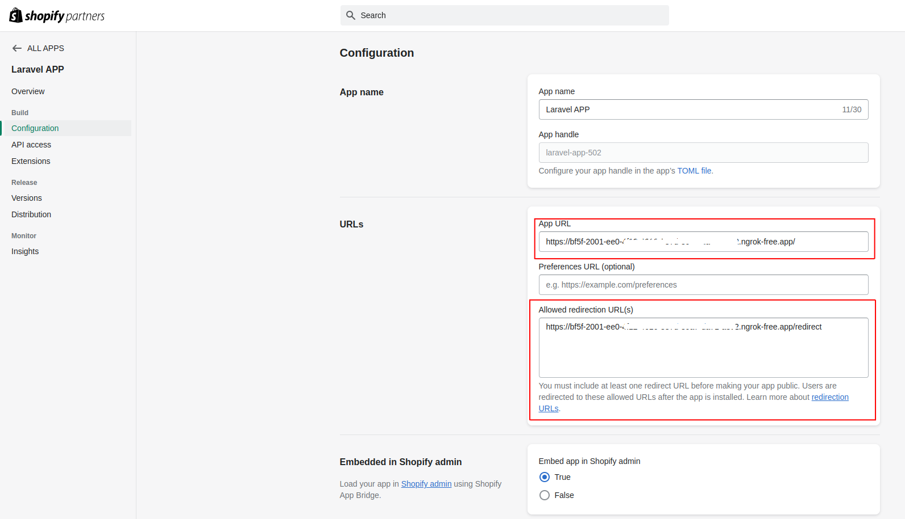

From browser, access to this route to redirect to Shopify App installation page:

*https://{ngrok ID}.ngrok-free.app/install*

Click Install to install custom app in Shopify Store and retrieve access token for testing REST API:

