


ISSUE

LIBRARY MANAGEMENT SOFTWARE

Student: Ta Nguyen Thuy Vy
Bui Minh Triet
Vu Duc Huy
Nguyen Hoang Gia Khuong

Instructor: Luong Hoang Huong

Nguye

Can Tho, March 2020

Library Management

Preface

In the world as well as in Vietnam, information technology has become a spearhead technology, it is an indispensable science and technology field in applying to social activities such as managing library systems. books, economics, information, business, and all activities in the field of research In our country today, the application of computerization in management in agencies, enterprises and organizations is very popular and become urgent, because every profession requires people to handle a huge amount of work, and the knowledge, thoughts, intensive training. An urgent issue in management is how to standardize the way data is handled in schools, so we chose the topic "Analysis of the design of a library library management system". Despite great efforts to complete the work, but due to the limited time and inexperience as well as low skills, the analysis and design are still many shortcomings, respectfully, teachers and friends would like to comment , complementing us to perfect the workouts even better. We sincerely thank you!

LIST OF PICTURES
Figure 1: Functional hierarchy diagram 7

Figure 2: Activity diagram of creating reader card 8

Figure 3: Chart activity for adding books 9

Figure 4: Chart activity for borrowing book 10

Figure 5: Chart activity for borrowing book 11

Figure 6: Generalized Use Case model 12

Figure 7: Decomposition Use Case managing readers 13

Figure 8: Decomposition Use case of book management 14

Figure 9: Decomposition Use case management to return books 15

Figure 10: Decomposition Use case statistics 16

Figure 11: CDM data model 17

Figure 12:PDM data model 18

Library Management

Content

Part 1: Problem statement
1.1 Problems
Today libraries need a library management system that replaces traditional management with large data volumes, involving many users. If only managed through books and papers, it is not possible to improve the efficiency of managing and using existing library resources. Therefore, we chose the topic "Library Management" with the desire to improve efficiency in management and use.

1.2 Management objectives
Library management replaces traditional, accurate, easy, convenient and faster management.
Manage the number of books borrowed and left in the library.
Manage readers who borrow books, return books on time and late

1.3 Object and scope of the study
The object of this document is students or Java programming on NetBeans, SQL Server database management system.

1.4 Research content
Content of the topic:
- Programming with Java language
- Connect to the server database csdl sql server.
1.5 Major Cintributins of the topic
1.5.1Contributions of the topic:
- Java programming knowledge using NetBeans tool
- Knowledge of server management system sqdl sql server.

1.5.2 About products
Library management software. Meet practical business needs.
1.6 Literature of the thesis
The composition of the thesis consists of three parts:
- Introduce the introduction of the problem and solve the problem, the goals of the topic, the object and the scope of the research as well as the research content.
- The content consists of 6 chapters, chapter 1 describes the problem, chapter 2 defines management objectives, chapter 3 analyzes, chapter 4 Entity models - entity relations, chapter 5 data dictionary and tables, chapter 6 Test.

Library Management

Part 2: Define management goals

2.1 Activities to be managed by the library
The activities of a regular book library can be summarized as follows:
- The library that creates book information includes: book code, title, publisher, year of publication, price, quantity, quantity, position, type of book, brief description of the book's content.
- Each reader will be issued with a reader card with the following information: reader code, name, year of birth, gender, address, sdt
- Readers who want to borrow a book need to save the book's information on the loan slip.
- After checking and confirming the information of the loan slip, the librarian will check the loan conditions of the reader and confirm the permission to borrow the book and collect the deposit of the reader. Save the loan slip information so the librarian can manage it.
- When readers return books: confirm readers cards, confirm loan coupons. After confirming the information on the loan slip, the librarian will check the status of the book if the book is still intact and allow the return of the book.
- Late books will be fined.
2.2 System requirements:
Library management system is built to stop the following functions:
- Help readers search for books by type of book.
- Provide information to librarians for book lists and return dates
- Statistics of overdue books, the past 1 month turnover, the books still in the library, the list of readers who borrow books.
- Support librarians to update book information, confirm borrowing and returning books.
- Supports managing reader information based on readership cards, loan card information.
- Support general system administration function, allowing librarians to be able to change information or add or remove books.
Library Management

2.3 Diagram of function hierarchy
- Determining the functions of the system:
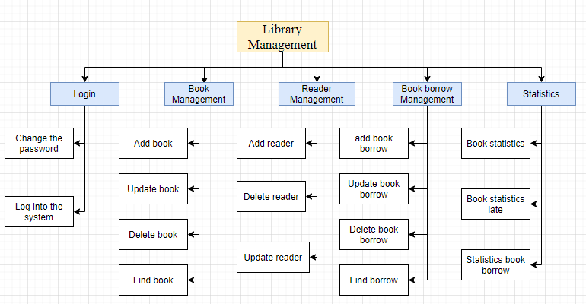
Figure 1: Functional hierarchy diagram
Function description:
Login: The librarian uses the login function to log in to the system, allowing the librarian to change the password when necessary.
Book management: Allows managing all information of all library books including allowing to add, delete and edit information of books.
Management readers: The system allows managing information of each reader allows librarians can add, delete, modify readers' information.
Statistics: The system allows statistics of all books in the library, statistics of late books, and lists of books borrowed from readers. Help librarians manage the library's borrowing and returning of books.
2.4 Entities to manage:
a. Librarian: librarian code, admin name, username, password
b. Books: book code, title, publisher, year of publication, price, quantity, quantity, location, type of book, description
c. Readers: readership code, name, year of birth, gender, address, phone number
d.Book borrow Card: borrowed code, reader code, borrow date, repay date,amount

Library Management

Part 3: Analysis
1.Activities
3.1.1 Activity creating reader card
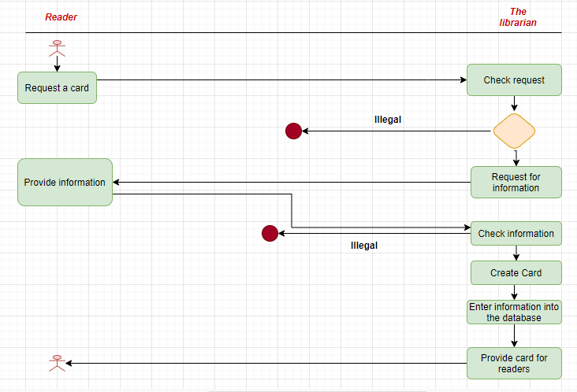
Figure 2: Activity diagram of creating reader card

Library Management

3.1.2 Activity for adding books
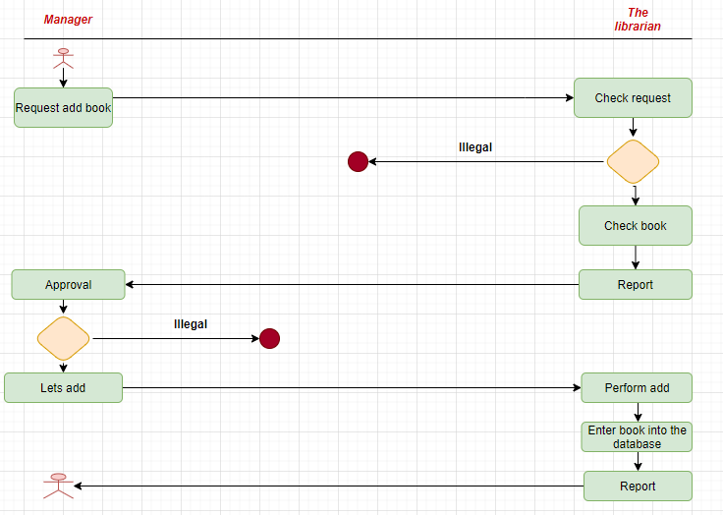
Figure 3: Chart activity for adding books

Library Management

3.1.3 Activity for borrowing book
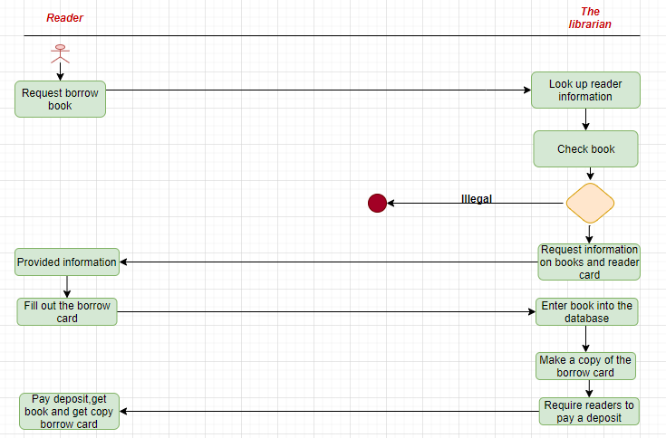
Figure 4: Chart activity for borrowing book

Library Management

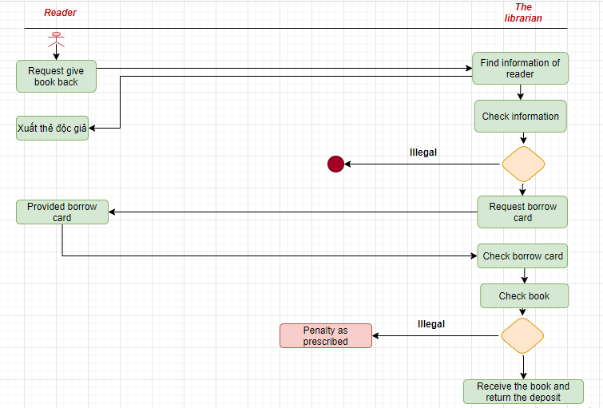
Figure 5: Chart activity for borrowing book

Part 4: Models
4.1 Mô hình use case mức tổng quát
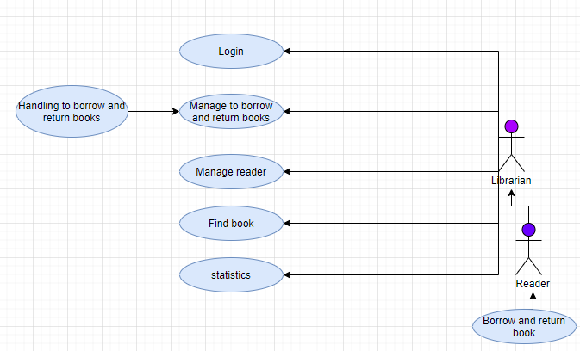
Figure 6: Generalized Use Case model

Library Management

Describe the use of bookstore management:
Purpose: Used to manage book details in the warehouse, process more, delete, edit book information.
Implemented by: Librarian.
Steps to follow: Select the "Manage bookstore" function, the system will display the sub-functions in the warehouse management section.
Librarians enter new book information entered, corrected or deleted.
4.2 Phân rã Use case

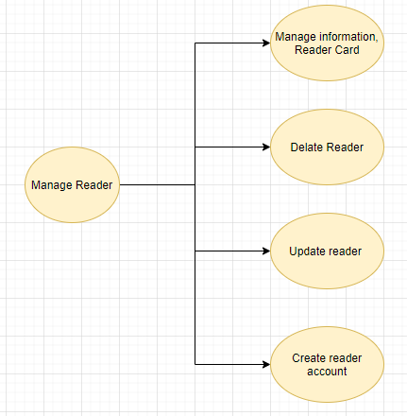
Figure 7: Decomposition Use Case managing readers

Library Management

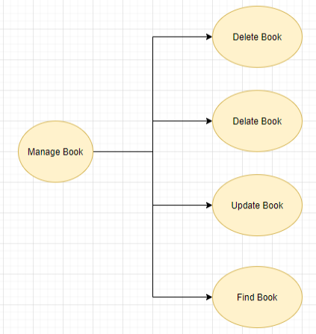
Figure 8: Decomposition Use case of book management

Library Management

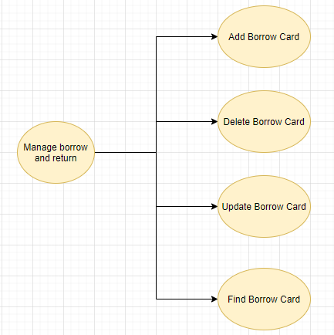
Figure 9: Decomposition Use case management to return books

Library Management

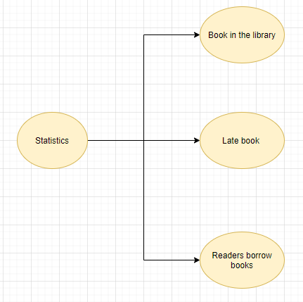

Figure 10: Decomposition Use case statistics

Library Management

4.3 CDM data model

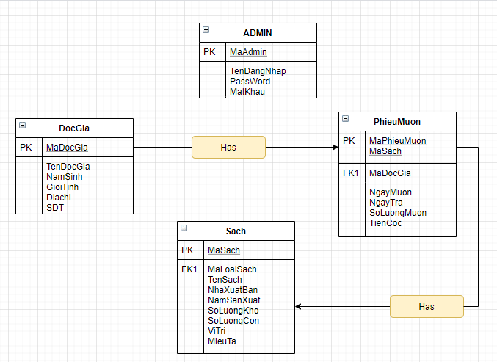

Library Management

4.4 PDM data model 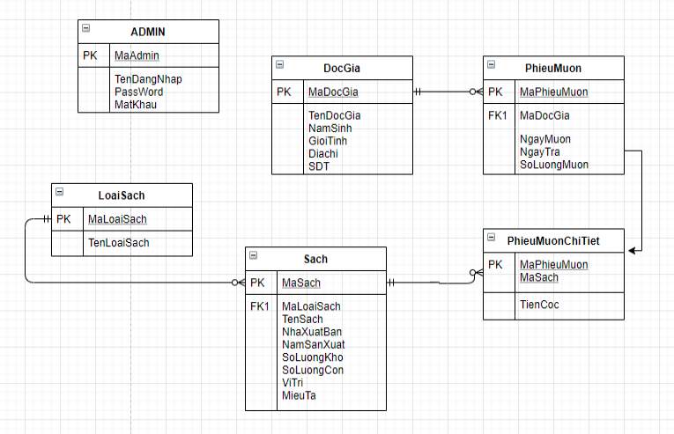

Library Management

Part 5: Data dictionary
1. Create database
Name the database "QuanLiThuVien"
Database creation statement:
-- Tao co so du lieu ten la QuanLiThuVien
CREATE DATABASE QuanLiThuVien
- Sử dụng cơ sở dữ liệu là “QuanLiThuVien” để tiến hành tạo bảng, thêm thông tin và truy xuất dữ liệu theo yêu cầu

2. Defining the tables
a) Table ADMIN
Tên trường | Kiểu dữ liệu | Default | Check | Key/Index/Ràng buộc
MaAdmin | nvarchar(20) |  | Not null | PK
TenDangNhap | nvarchar(20) |  | Not null
MatKhau | nvarchar(20) |  | Not null
TenAdmin | nvarchar(20)

- Câu lệnh tạo bảng:
-- Bang KHACHHANG
CREATE TABLE ADMIN(
MaAdmin nvarchar(20),notnull
TenDangNhap nvarchar(20),notnull
MatKhau nvarchar(20),notnull
TenAdmin nvarchar(20),

NGDAT DateTime CONSTRAINT CHECKNG CHECK ([NGDAT]<=GETDATE()),
CMT int CONSTRAINT CHECKCMT CHECK (LEN([CMT])=9 OR LEN([CMT])=10),
SLVE int CONSTRAINT CHECKVE CHECK (SLVE>0),
PRIMARY KEY (MaAdmin)
);

b) Table SACH
Tên trường | Kiểu dữ liệu | Default | Check | Key/Index/Ràng buộc
MaSach | nvarchar(20) |  | Not null | PK
TenSach | nvarchar(50)
MaLoaiSach | nvarchar(20) |  | Not null | FK
NamXuatBan | Int |  | <=Namht
NhaXuatBan | nvarchar(50)
Gia | Int |  | >0
Vitri | nvarchar(20)
MieuTa | nvarchar(50)
SoLuongCon | Int |  | >0
SoLuong | Int |  | >0

- Câu lệnh tạo bảng:
-- Bang Sach
CREATE TABLE SACH (
MaSach nvarchar(20),
TenSach nvarchar(50),
MaLoaiSach nvarchar(20),
NamXuatBan int CONSTRAINT CHECKNGSX CHECK ([NamXuatBan]<=GETDATE()),
NhaXuatBan varchar(50),
Gia int CONSTRAINT CHECKGIA CHECK (Gia>0),
Vitri nvarchar(50),
MieuTa nvarchar(50),
MaLoaiSach int references LOAISACH(MaLoaiSach),
SoLuongCon int CONSTRAINT CHECKSLC CHECK (SoLuong>0),
SoLuong int CONSTRAINT CHECKSL CHECK (SoLuongCon>0),
PRIMARY KEY (MaSach)
);

c) Table DOCGIA
Tên trường | Kiểu dữ liệu | Default | Check | Key/Index/Ràng buộc
MaDocGia | Int |  | Not null | PK
TenDocGia | nvarchar(20)
GioiTinh | nvarchar(7)
NamSinh | Int |  | <= Namht
Sdt | Int |  | Len
DiaChi | nvarchar(100)

- Câu lệnh tạo bảng:
-- Bang DOCGIA
CREATE TABLE DOCGIA(
MaDocGia int not null,
TenDocGia varchar(30),
GioiTinh nvarchar(7),
DiaChi varchar(100),
Sdt int CONSTRAINT CHECKSDT CHECK LEN([Sdt])=10,
NamSinh int CONSTRAINT CHECKNAM CHECK ([NamSinh]<=GETDATE()),
PRIMARY KEY (MaDocGia)
);

d) Table PHIEUMUON
Tên trường | Kiểu dữ liệu | Default | Check | Key/Index/Ràng buộc
MaMuonSach | Int |  | Not null | PK
MaDocGia | Int |  | Not null | FK
NgayMuon | DateTime
NgayTra | DateTime
SoLuongMuon | Int

- Câu lệnh tạo bảng:
-- Bang PHIEUMUON
CREATE TABLE PHIEUMUON(
MaMuonSach int not null,
MaDocGia int not null references DOCGIA(MaDocGia),
NgayMuon DateTime,
NgayTra DateTime,
PRIMARY KEY (MaMuonSach)
);

e) Table PHIEUMUONCHITIET
Tên trường | iểu dữ liệu | Default | Check | Key/Index/Ràng buộc
MaMuonSach | Int |  | Not null | PK
MaSach | nvarchar(20) |  | Not null | PK
TienCoc | Int

- Câu lệnh tạo bảng:
-- Bang PHIEUMUONCHITIET
CREATE TABLE PHIEUMUONCHITIET(
MaMuonSach int not null,
MaSach nvarchar(20),
TienCoc int,
PRIMARY KEY (MaMuonSach,MaSach)
);

f) Table LOAISACH
Tên trường | Kiểu dữ liệu | Default | Check | Key/Index/Ràng buộc
MaLoaiSach | Nvarchar(20) |  | Not null | PK
TenSach | Nvarchar(20)

- Câu lệnh tạo bảng:
-- Bang LOAISACH
CREATE TABLE LOAISACH(
MaLoaiSach int not null,
TenSach int ,
PRIMARY KEY (MaLoaiSach)
);

