


Lục Tấn Phúc
Your text here
Your text here

VIETNAM NATIONAL UNIVERSITY HO CHI MINH CITY HO CHI MINH CITY UNIVERSITY OF TECHNOLOGY FACULTY OF COMPUTER SCIENCE AND ENGINEERING


EEC REPORT
CLASS CC01- ASSIGNMENT
Instructor: Nguyễn Thiên Ân
Student ID
2352638
Trần Đình Duy Khương

TABLE OF CONTENT
1.SCHEMATIC
2.PCB DESIGN AND LAYOUT
- 2D and 3D view

1.SCHEMATIC
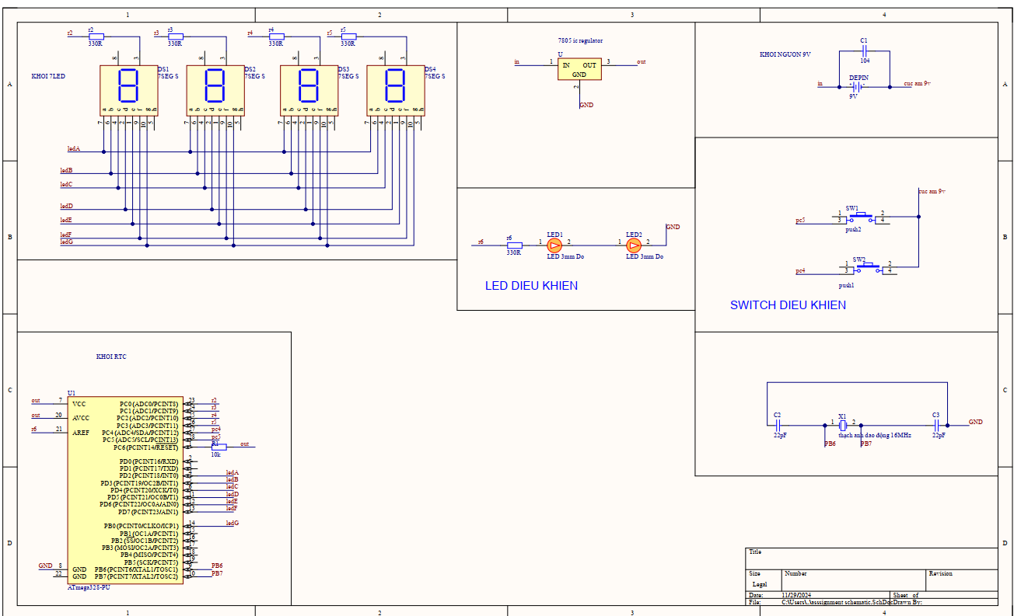

2.PCB DESIGN

2D PCB LAYOUT
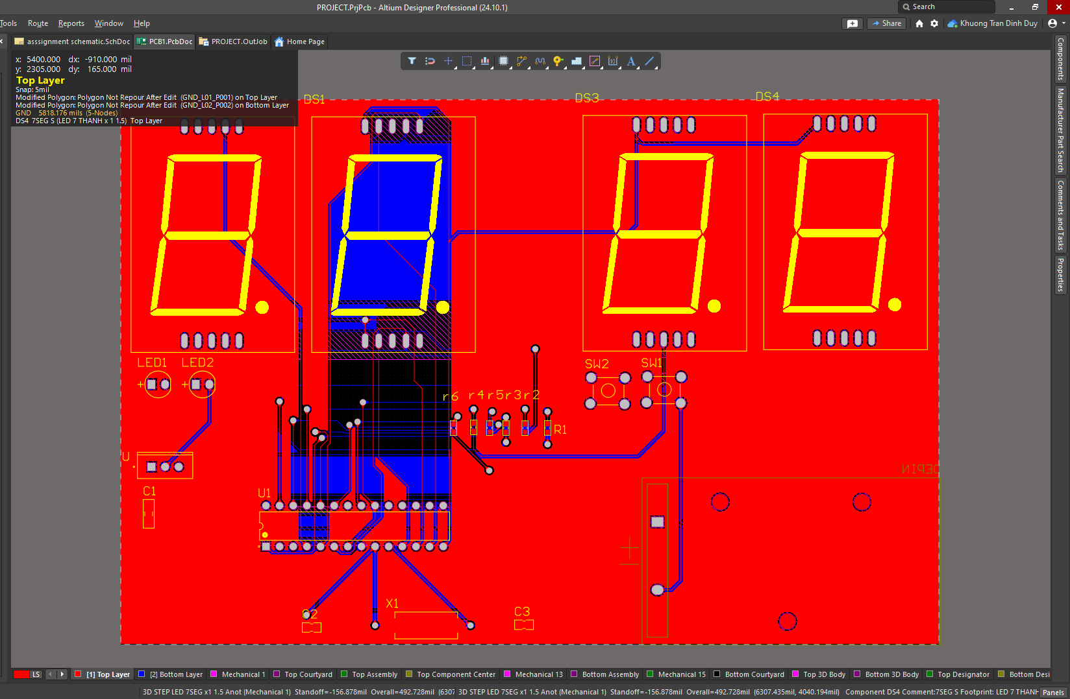

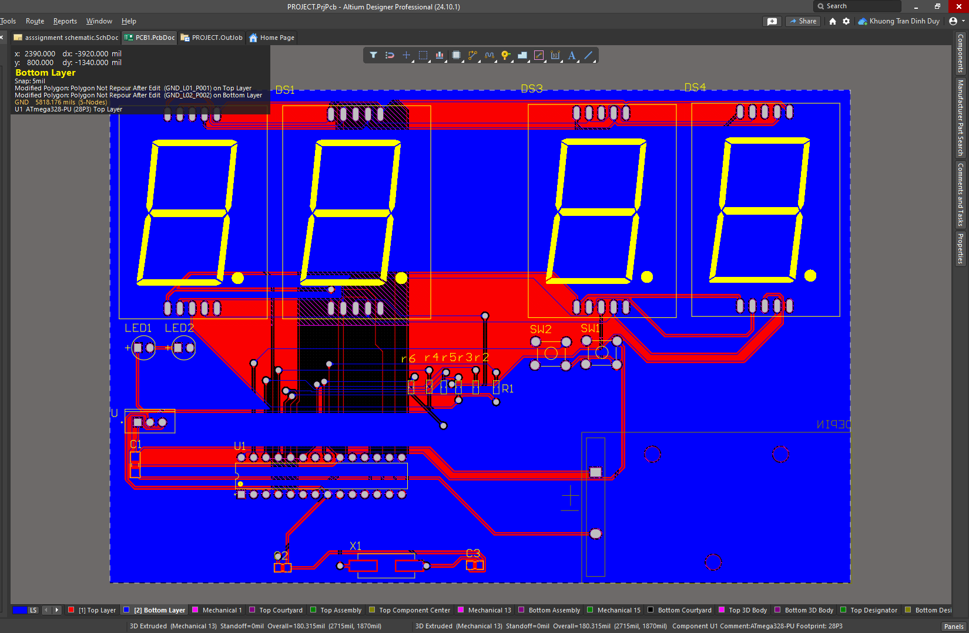

3D PCB LAYOUT



